COURSE CODE & NAME: ECE1408- EMEBEDDED SYSTEM
NAME: CH.AKHIL
ROLL NO: 192512151

EX NO: 3
I²C-BASED HEALTH MONITORING NODE FOR PULSE AND TEMPERATURE ACQUISITION
1. Aim
To design and simulate an I²C-based health monitoring node using Arduino UNO to acquire temperature and pulse readings and display the monitoring information.
2. Software and Hardware Requirements
Software:
- Arduino IDE
- Proteus Design Suite
Hardware / Simulation Components:
- Arduino UNO
- LM75AD temperature sensor
- Pulse signal input
- Resistors (4.7 kΩ pull-up resistors for the I²C lines)
- Virtual Terminal
- Connecting wires
3. Program code:
#include <Wire.h>
#define LM75_ADDRESS 0x48
#define PULSE_PIN 8
unsigned long pulseCount = 0;
unsigned long lastTempTime = 0;
unsigned long lastBpmTime = 0;
int previousPulseState = LOW;
float readTemperature()
{
Wire.beginTransmission(LM75_ADDRESS);
Wire.write(0x00);
Wire.endTransmission();
Wire.requestFrom(LM75_ADDRESS, 2);
if (Wire.available() >= 2)
{
byte msb = Wire.read();
byte lsb = Wire.read();
int16_t rawTemperature =
((int16_t)msb << 8) | lsb;
return rawTemperature / 256.0;
}

return -999.0;
}
void setup()
{
Serial.begin(9600);
Wire.begin();
pinMode(PULSE_PIN, INPUT);
Serial.println("I2C HEALTH MONITORING NODE");
Serial.println("---------------------------");
}
void loop()
{
unsigned long currentTime = millis();
/* Pulse counting */
int currentPulseState = digitalRead(PULSE_PIN);
if (currentPulseState == HIGH &&
previousPulseState == LOW)
{
pulseCount++;
}
previousPulseState = currentPulseState;

/* Temperature acquisition every 1 second */
if (currentTime - lastTempTime >= 1000)
{
lastTempTime = currentTime;
float temperature = readTemperature();
Serial.print("Temperature: ");
if (temperature > -100)
{
Serial.print(temperature, 1);
Serial.println(" C");
}
else
{
Serial.println("Sensor Error");
}
}
/* BPM calculation every 5 seconds */
if (currentTime - lastBpmTime >= 5000)
{
lastBpmTime = currentTime;
float bpm = (pulseCount * 60.0) / 5.0;
Serial.print("Pulse Rate: ");
Serial.print(bpm, 0);
Serial.println(" BPM");
Serial.println("---------------------------");
pulseCount = 0;
}
}

4. OUTPUT:
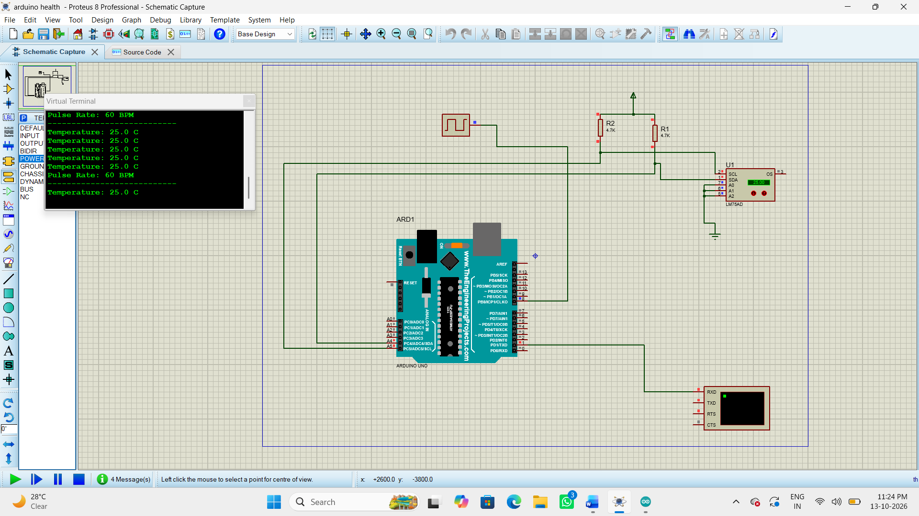
5. Result
Thus, the I²C-based health monitoring node was designed and simulated using Arduino UNO. The system acquires temperature data through the LM75AD sensor and processes the pulse signal to display the monitoring readings through the Virtual Terminal.

