

EXP. NO: 4 | GENERATION AND ANALYSIS OF FREQUENCY MODULATED (FM) AND OF PHASE MODULATED (PM) SIGNALS USING MATLAB
DATE:

Objectives:
To generate and analyze Frequency Modulated (FM) and Phase Modulated (PM) signals using MATLAB by varying the instantaneous frequency and phase of a carrier signal in accordance with the message signal.
PROGRAM (MATLAB CODE)
clc; clear; close all;
Am=1; Ac=1; fm=5; fc=50; beta=5; kp=5; fs=1000; t=0:1/fs:1;
m = Am*cos(2*pi*fm*t); c = Ac*cos(2*pi*fc*t);
fm_sig = Ac*cos(2*pi*fc*t + beta*sin(2*pi*fm*t));
pm_sig = Ac*cos(2*pi*fc*t + kp*m);
Df = beta*fm;
fprintf('Frequency Deviation = %d Hz\n',Df);
fprintf('FM Modulation Index = %d\n',beta);
figure('Position',[100 100 900 800]);
subplot(4,1,1), plot(t,m), title('Message Signal'), grid on
subplot(4,1,2), plot(t,c), title('Carrier Signal'), grid on
subplot(4,1,3), plot(t,fm_sig), title('FM Signal'), grid on
subplot(4,1,4), plot(t,pm_sig), title('PM Signal'), xlabel('Time (s)'), grid on

Procedure
- Open MATLAB and create a new script file.
- Define the simulation parameters, including the sampling frequency, time vector, message frequency, carrier frequency, message amplitude, and carrier amplitude.
- Generate the message signal using a low-frequency sinusoidal waveform.
- Generate the carrier signal using a high-frequency sinusoidal waveform.
- Generate the Frequency Modulated (FM) signal by varying the instantaneous frequency of the carrier in accordance with the message signal and the selected frequency modulation index.
- Generate the Phase Modulated (PM) signal by varying the instantaneous phase of the carrier according to the message signal and the selected phase modulation index.
- Plot the message signal, carrier signal, FM signal, and PM signal using MATLAB subplots.
- Observe and compare the time-domain waveforms of the FM and PM signals with the original message signal.
- Analyze the variation in the instantaneous frequency of the FM signal and the instantaneous phase of the PM signal due to changes in the message signal.
- Compare the characteristics of FM and PM signals by studying their modulation behavior and waveform variations.
- Verify the successful generation of FM and PM signals based on the simulation results.

OUTPUT GRAPH
Simulated Result (Screenshot)
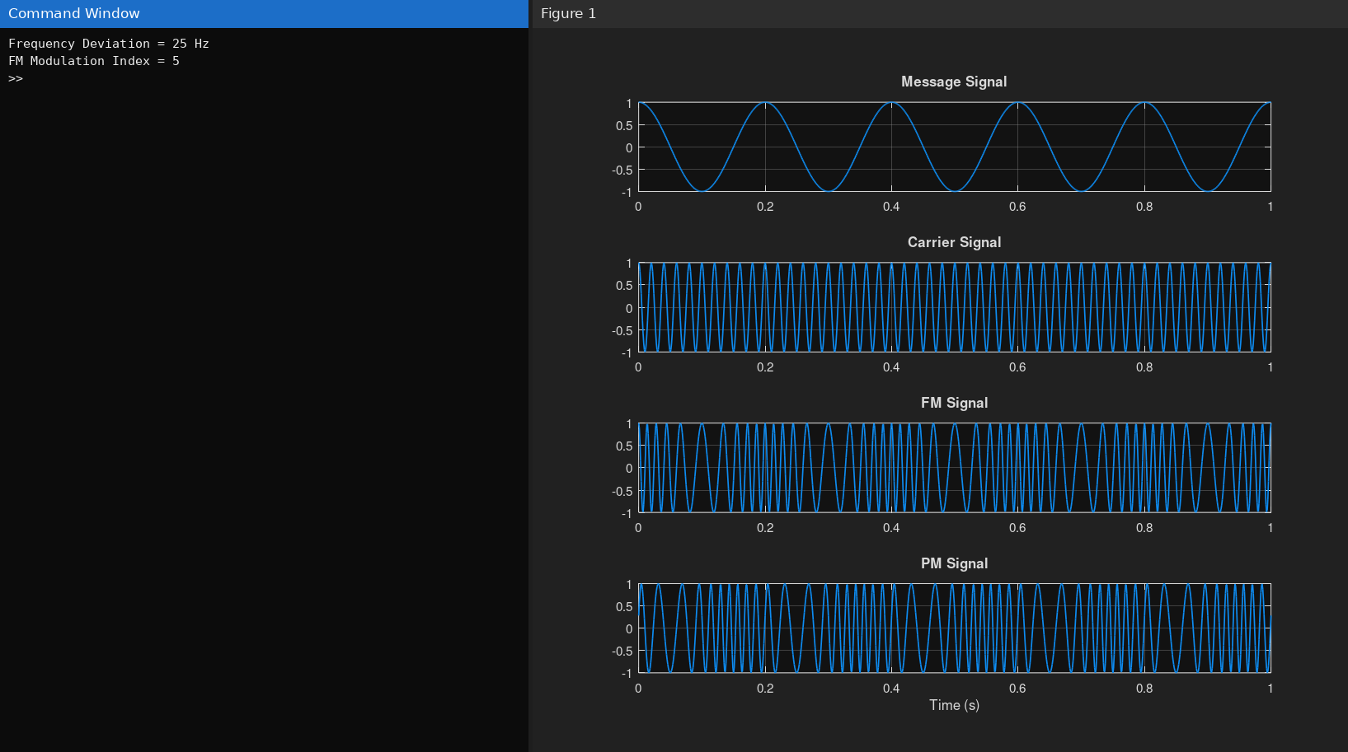
Fig. 4.1 Simulated result of Experiment 4
Result
The Frequency Modulated (FM) and Phase Modulated (PM) signals were successfully generated using MATLAB by varying the instantaneous frequency and phase of the carrier signal according to the message signal.
  - Frequency Deviation (Δf) = 25 Hz
  - FM Modulation Index (β) = 5

