

EXP. NO: 2 | MATLAB-BASED MODELLING OF VSB MODULATOR AND  DEMODULATOR FOR ANALOG TELEVISION
DATE: | COMMUNICATION APPLICATIONS

Objectives:
i) To generate and analyse the Vestigial Sideband (VSB) modulated signal by performing DSB-SC modulation and applying a suitable filter using MATLAB. ii) To implement coherent demodulation and recover the original message signal from the VSB signal, and compare the transmitted and recovered waveforms.
PROGRAM (MATLAB CODE)
clc; clear; close all;
fs = 100000; t = 0:1/fs:0.02; fm = 500; fc = 5000;
m = cos(2*pi*fm*t); c = cos(2*pi*fc*t);
dsb = m .* c;
[b,a] = butter(4, fc/(fs/2)); vsb = filter(b,a,dsb);
demod = vsb .* (2*cos(2*pi*fc*t));
[b1,a1] = butter(4, 1000/(fs/2)); rec = filter(b1,a1,demod);
figure('Position',[100 100 900 850]);
subplot(5,1,1), plot(t,m), title('Message Signal'), grid on
subplot(5,1,2), plot(t,c), title('Carrier Signal'), grid on
subplot(5,1,3), plot(t,dsb), title('DSB-SC Signal'), grid on
subplot(5,1,4), plot(t,vsb), title('VSB Signal'), grid on
subplot(5,1,5), plot(t,rec,'r'), title('Recovered Message'), xlabel('Time (s)'), grid on
fprintf('Message frequency : %d Hz\nCarrier frequency : %d Hz\n',fm,fc);
fprintf('Peak of recovered message = %.3f (original = 1.000)\n',max(rec(round(end/2):end)));

Procedure
- Open MATLAB and create a new script file.
- Define the simulation parameters such as sampling frequency, message frequency, carrier frequency, and time vector.
- Generate the message signal using a low-frequency cosine waveform.
- Generate the carrier signal using a high-frequency cosine waveform.
- Perform DSB-SC modulation by multiplying the message signal with the carrier signal.
- Design a Butterworth filter to approximate the Vestigial Sideband (VSB) filter.
- Apply the VSB filter to the DSB-SC signal to obtain the VSB modulated signal.
- Perform coherent demodulation by multiplying the VSB signal with a synchronized carrier signal.
- Design and apply a low-pass filter to the demodulated signal to recover the original message signal.
- Plot the message signal, carrier signal, DSB-SC signal, VSB signal, demodulated signal, and recovered message signal using MATLAB subplots.
- Compare the recovered message signal with the original message signal to verify successful modulation and demodulation.
- Analyze the simulation results and conclude the performance of the VSB modulation and demodulation process for analog television communication applications.

OUTPUT (GRAPH)
Simulated Result (Screenshot)
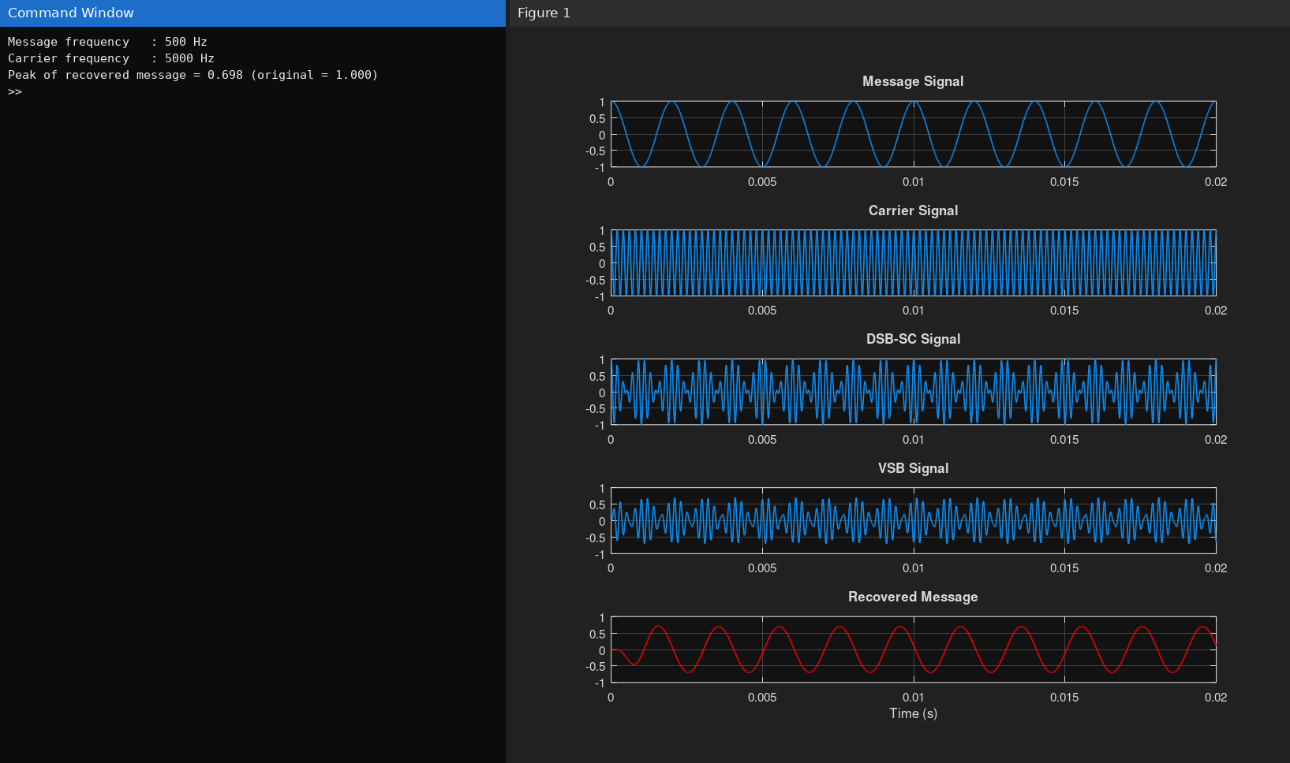
Fig. 2.1 Simulated result of Experiment 2
Result 1:
- The VSB modulated signal was successfully generated from the DSB-SC signal using MATLAB and verified through the displayed waveforms.
- The original message signal was successfully recovered through coherent demodulation and low-pass filtering, confirming the correct implementation of the VSB communication system.
Plot the message, carrier, DSB-SC, VSB, demodulated, and recovered signals.

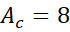
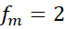
2. Using MATLAB simulation, for the given parameters, Carrier Amplitude, , Carrier
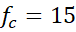
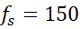
Frequency, kHz, Message Amplitude, 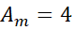V, Message Frequency, kHz,
Sampling Frequency, kHz; do the following tasks
Tasks
- Generate the message signal and carrier signal.
- Generate the DSB-SC modulated signal.
- Design a Butterworth filter to obtain the VSB signal.
- Perform FFT analysis of the VSB signal.
- Identify the carrier frequency and the upper and lower sideband frequencies.
- Perform coherent demodulation and recover the original message signal.
- Compare the time-domain waveforms before and after demodulation and comment on the effectiveness of the VSB modulation-demodulation process.

