

EXP. NO: 1 | CHARACTERISTICS STUDY OF SIDE BAND POWER AND
DATE: | FREQUENCIES IN AM USING MATLAB

Objectives:
- To generate an Amplitude Modulated (AM) signal in MATLAB using specified carrier and modulating signal parameters.
- To determine and verify the upper sideband (USB) and lower sideband (LSB) frequencies of the AM signal using frequency spectrum analysis in MATLAB.
- To calculate the carrier power, sideband power, and total transmitted power of the AM signal for a given modulation index using MATLAB.
- To analyze the effect of varying the modulation index on sideband power distribution and overall transmission efficiency through MATLAB simulation.

Objective 1:
To generate an Amplitude Modulated (AM) signal in MATLAB using specified carrier and modulating signal parameters
PROGRAM (MATLAB CODE)
clc; clear; close all;
Am=1; fm=500; Ac=5; fc=5000; fs=20*fc; t=0:1/fs:4/fm;
m = Am*sin(2*pi*fm*t);
c = Ac*sin(2*pi*fc*t);
mu = Am/Ac;
am = Ac*(1+mu*sin(2*pi*fm*t)).*sin(2*pi*fc*t);
dem = abs(hilbert(am)); dem = dem-mean(dem);
N = length(am); f = linspace(-fs/2,fs/2,N);
AM_FFT = abs(fftshift(fft(am)))/N;
USB = fc+fm; LSB = fc-fm;
Pc = Ac^2/2; Psb = (mu^2*Pc)/4; Pt = Pc + 2*Psb;
figure('Position',[100 100 1000 750]);
subplot(3,2,1), plot(t,m,'LineWidth',1.2), title('Message Signal m(t)'), xlabel('Time (s)'), ylabel('Amplitude (V)'), grid on
subplot(3,2,2), plot(t,c), title('Carrier Signal c(t)'), xlabel('Time (s)'), ylabel('Amplitude (V)'), grid on
subplot(3,2,3), plot(t,am), title('AM Modulated Signal s(t)'), xlabel('Time (s)'), ylabel('Amplitude (V)'), grid on
subplot(3,2,4), plot(t,dem,'LineWidth',1.2), title('Demodulated Message'), xlabel('Time (s)'), ylabel('Amplitude (V)'), grid on
subplot(3,2,5), plot(f,AM_FFT,'LineWidth',1.2), xlim([fc-3*fm fc+3*fm]), title('AM Spectrum (USB, Carrier, LSB)'), xlabel('Frequency (Hz)'), ylabel('|S(f)|'), grid on
subplot(3,2,6), bar([Pc Psb Psb]), set(gca,'XTickLabel',{'Carrier','USB','LSB'}), title('Power Distribution'), ylabel('Power (W)'), grid on
fprintf('Modulation Index (mu) : %.2f\n',mu);
fprintf('Carrier Frequency : %d Hz\n',fc);
fprintf('USB Frequency : %d Hz\n',USB);
fprintf('LSB Frequency : %d Hz\n',LSB);
fprintf('Carrier Power (Pc) : %.3f W\n',Pc);
fprintf('Power per Sideband : %.4f W\n',Psb);
fprintf('Total Power (Pt) : %.3f W\n',Pt);
% Objective 4: effect of modulation index
mus = [0.2 0.5 0.8 1.0];
fprintf('\n mu Pc(W) Psb(W) Pt(W) Efficiency(%%)\n');
Psbs=zeros(size(mus)); Pts=Psbs; eff=Psbs;
for k=1:numel(mus)
Psbs(k)=mus(k)^2*Pc/4; Pts(k)=Pc*(1+mus(k)^2/2); eff(k)=100*(mus(k)^2/2)/(1+mus(k)^2/2);
fprintf(' %.1f %6.3f %7.4f %6.3f %8.2f\n',mus(k),Pc,Psbs(k),Pts(k),eff(k));
end
figure('Position',[100 100 900 380]);
subplot(1,2,1), bar(mus,[Pc*ones(size(mus));2*Psbs]','stacked'), legend('Carrier','Both sidebands','Location','northwest'), xlabel('Modulation index \mu'), ylabel('Power (W)'), title('Power vs Modulation Index'), grid on
subplot(1,2,2), plot(mus,eff,'-o','LineWidth',1.5), xlabel('Modulation index \mu'), ylabel('Efficiency (%)'), title('Transmission Efficiency'), grid on

Procedure
- Open MATLAB and create a new script for AM signal generation and analysis.
- Specify the sampling frequency, carrier frequency, modulating frequency, carrier amplitude and modulation index.
- Generate the modulating signal using, m(t)=Amcos(2πfmt)
- Generate the carrier signal using, c(t)=Accos(2πfct)
- Generate the AM signal using, s(t)=Ac[1+mcos(2πfmt)]cos(2πfct).
- Plot the modulating signal, carrier signal and AM signal in the time domain.
- Calculate the theoretical frequencies of the lower and upper sidebands.
- Obtain the frequency spectrum of the AM signal using MATLAB FFT analysis.
- Identify the carrier, LSB and USB peaks from the frequency spectrum.
- Verify the theoretically calculated frequencies with the frequencies observed from the MATLAB spectrum.
- Calculate the carrier power using the specified load resistance.
- Calculate the power contained in each sideband and the total transmitted power.
- Calculate the transmission efficiency for the selected modulation index.
- Repeat the simulation for different modulation-index values such as m=0.2, 0.5, 0.8 and 1.0.
- Observe the change in sideband power and transmission efficiency as the modulation index is varied.
- Record the results and compare the theoretical and MATLAB-simulated values.
OUTPUT (GRAPH)
Simulated Result (Screenshot)
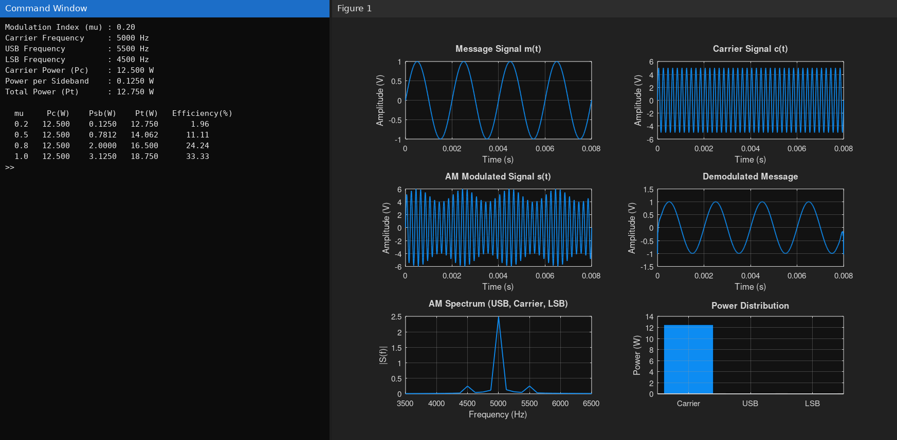
Fig. 1.1 Simulated result of Experiment 1
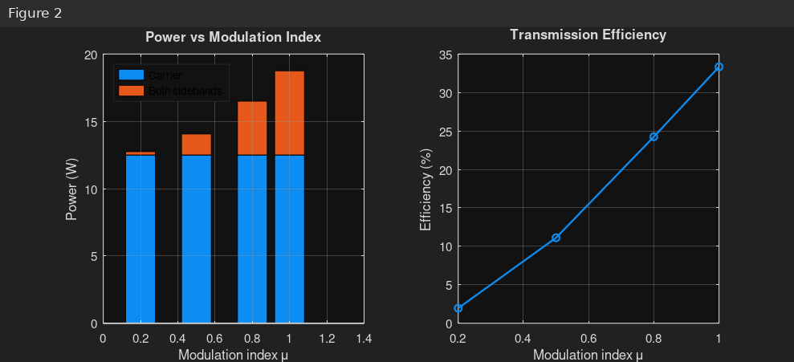
Fig. 1.2 Simulated result of Experiment 1
Result:
The AM signal was successfully generated and analyzed in MATLAB.
Objective 2:
To determine and verify the upper sideband (USB) and lower sideband (LSB) frequencies of the AM signal using frequency spectrum analysis in MATLAB.

Upper Sideband Frequency (USB)

Lower Sideband Frequency (LSB)

Result:
i) Upper Sideband Frequency (USB) = 55 Hz ii) Lower Sideband Frequency (LSB) = 45 Hz
Objective 3:
To calculate the carrier power, sideband power, and total transmitted power of the AM signal for a given modulation index using MATLAB.

Sideband Power
For an AM signal,
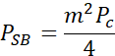W:

Substituting
and
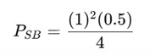
Therefore,
- Upper Sideband Power (USB Power) = 0.125 W
- Lower Sideband Power (LSB Power) = 0.125 W 4. Total Sideband Power

5. Total Transmitted Power

Result
i) Carrier Power = 0.5 W ii) Upper Sideband Power = 0.125 W iii) Lower Sideband Power = 0.125 W iv) Total Sideband Power = 0.25 W
v) Total Transmitted Power = 0.75 W

