Exp. 1. Simulation of scattering and absorption of Multi-layer Sphere and
Core-Shell Nanoparticle using Mie-Plot tool
Aim:
To simulate and analyze the scattering, absorption, and extinction characteristics of multi-layer
spheres and core–shell nanoparticles using the Mie-Plot tool.
Output:
Scattering and absorption spectra for a core–shell nanoparticle.
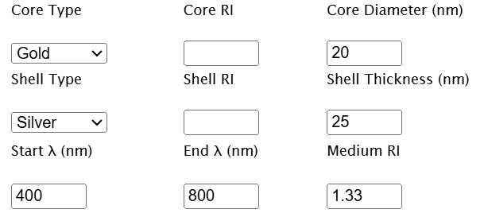
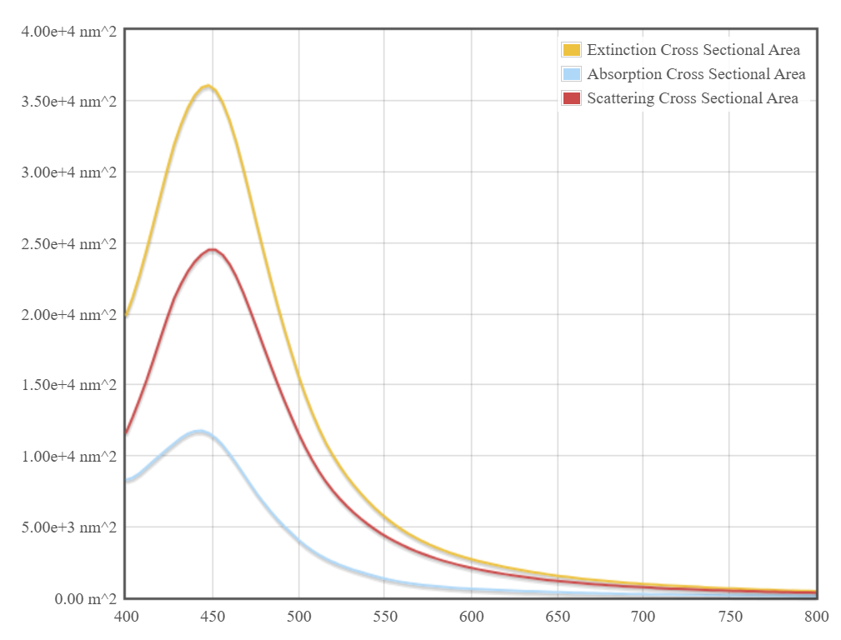
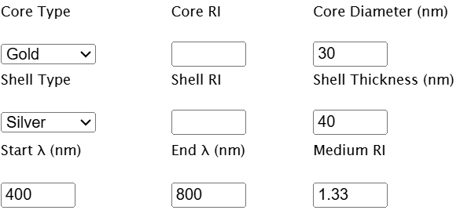
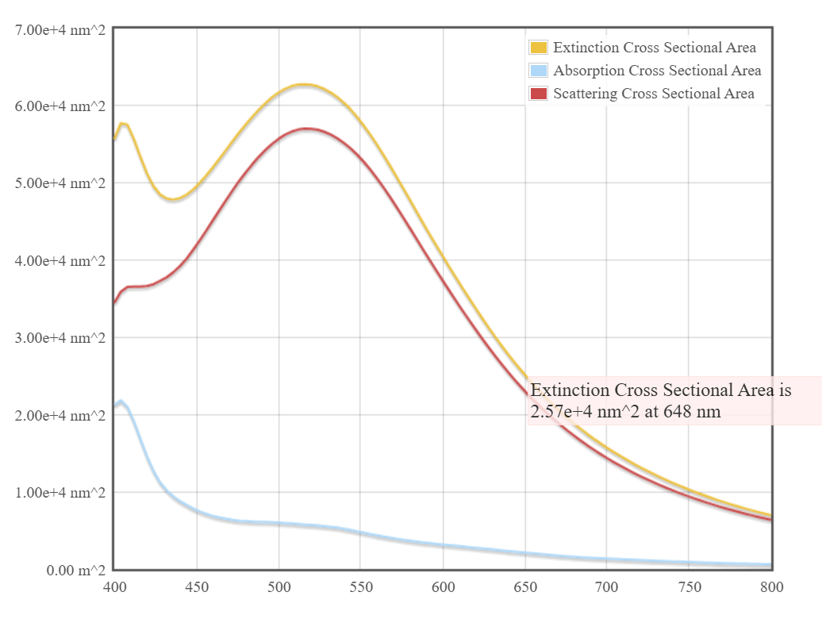
Case Study 1: Scattering and absorption spectra for a single-layer sphere (core only).
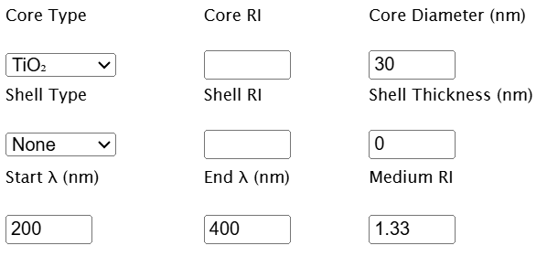
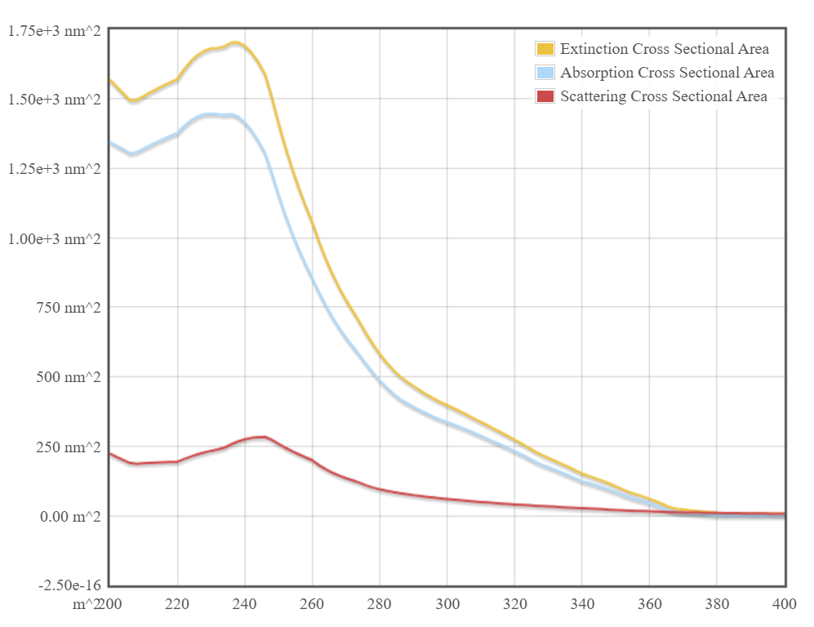
Case Study 2: Simulate the optical response of a gold (Au) nanoparticle of 50 nm diameter
in water medium.
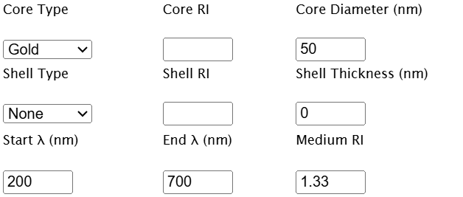
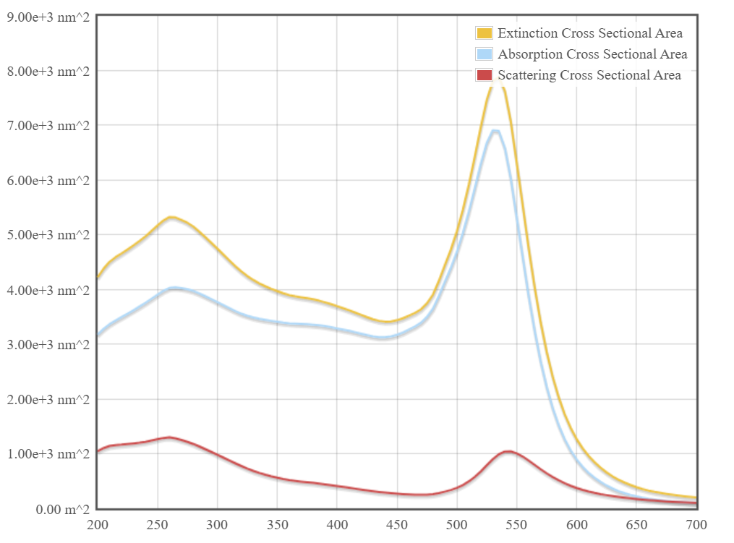

Case Study 3: Simulate a core shell nanoparticle with a gold core (30 nm) and a silica shell (10mm)
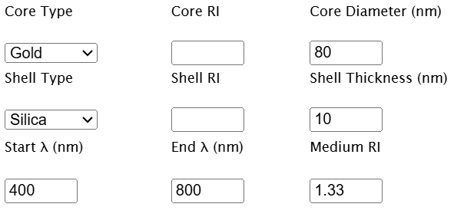
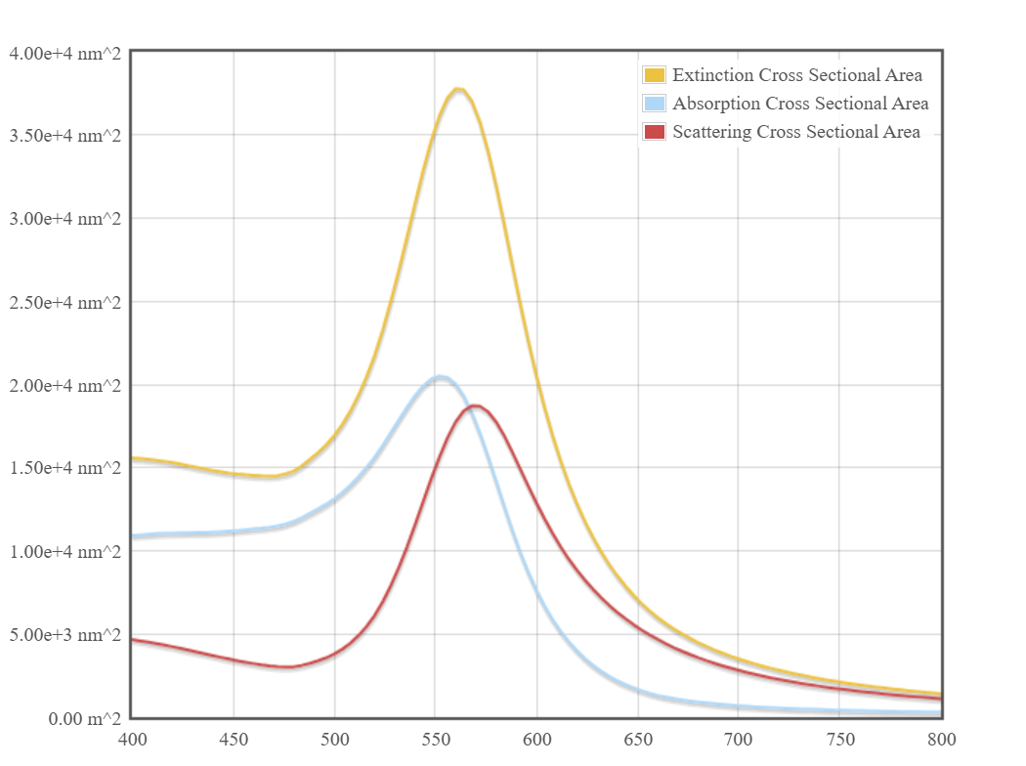
Result:
The scattering, absorption, and extinction spectra for multi-layer spheres and core–shell
nanoparticles are obtained using the Mie-Plot tool. The results demonstrate the effect of particle
size, shell thickness, and refractive index on the optical resonance behavior of nanoparticles.

