Exp. 9. Simulation of Tunneling Magnetoresistance (TMR) by Varying Barrier Height using NanoHUB
Aim: To obtain the Tunnelling Magnetoresistance (TMR) by varying barrier height.
Software: NanoHub Online Tub
OUTPUT:
Case Study 1: Characteristics of TMR
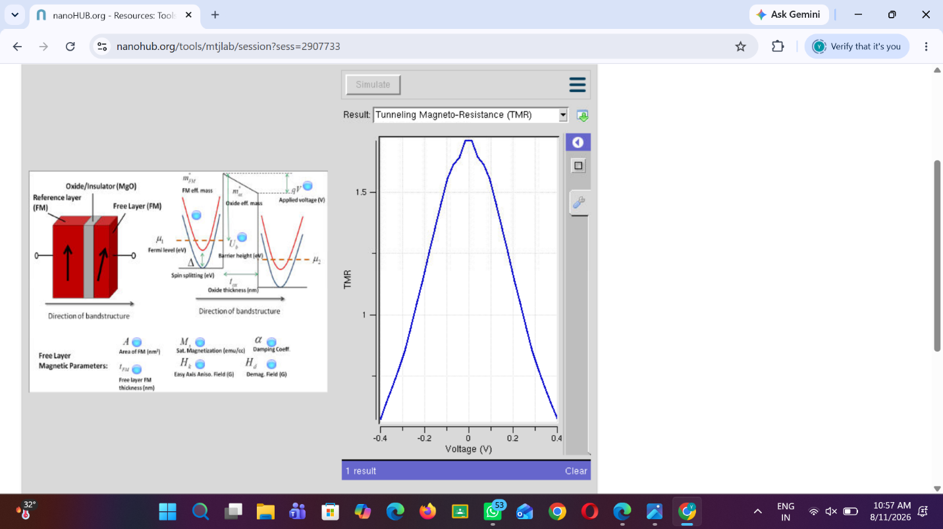
Case Study 2: Characteristics of TMR with with barrier height of 1.0eV
