SIMATS ENGINEERING
ASSESSMENT TOOL – 3
DESIGN TASK – HIGH

DESIGN AND IMPLEMENTATION OF FIREWALL RULES
TO SECURE A WEB SERVER

Course Name | Computer Networks and Cybersecurity
Course Code | ECA61
Assessment Tool | Design Task
Question No. | 4
Student Name | Y. BALU PRASANTH
Register No. | 192512179

Academic Project Submission

1. Design Task – Question 4
Task statement: Design and implement firewall rules to secure a web server by permitting legitimate client requests, restricting unauthorized access, controlling service-specific traffic, and evaluate the effectiveness of the rules through different access and connectivity scenarios.
Source alignment: This project is prepared directly around Question 4 of the supplied Design Task question bank. The assessment requires design/implementation, an architecture diagram, implementation details, testing results, evidence, and documentation.

2. Aim
To design and implement a secure firewall policy for a web server that permits legitimate HTTP/HTTPS client requests, restricts unauthorized administrative access, controls service-specific traffic, blocks unnecessary inbound services, logs security events, and validates the effectiveness of the configuration through authorized connectivity and security testing.

3. Objectives
- Identify the network services required by the web server.
- Permit legitimate HTTP traffic on TCP port 80.
- Permit legitimate HTTPS traffic on TCP port 443.
- Restrict SSH administration on TCP port 22 to a trusted administrator IP.
- Block unnecessary or insecure services such as FTP, Telnet, and direct database exposure.
- Apply a default-deny inbound firewall policy and least-privilege access.
- Enable firewall logging for blocked or suspicious connection attempts.
- Test authorized and unauthorized connectivity scenarios.
- Document results with commands, expected outcomes, and evidence.

4. Scope
The project focuses on host/network firewall rules protecting a Linux-based web server. The design covers inbound service control, trusted administrative access, logging, connectivity validation, and basic attack-surface testing. It does not claim that a firewall alone protects the web application from every application-layer vulnerability.

5. Proposed Network Architecture
The architecture below shows Internet clients, the firewall enforcement point, the protected web server, trusted administrator access, and internal resources.
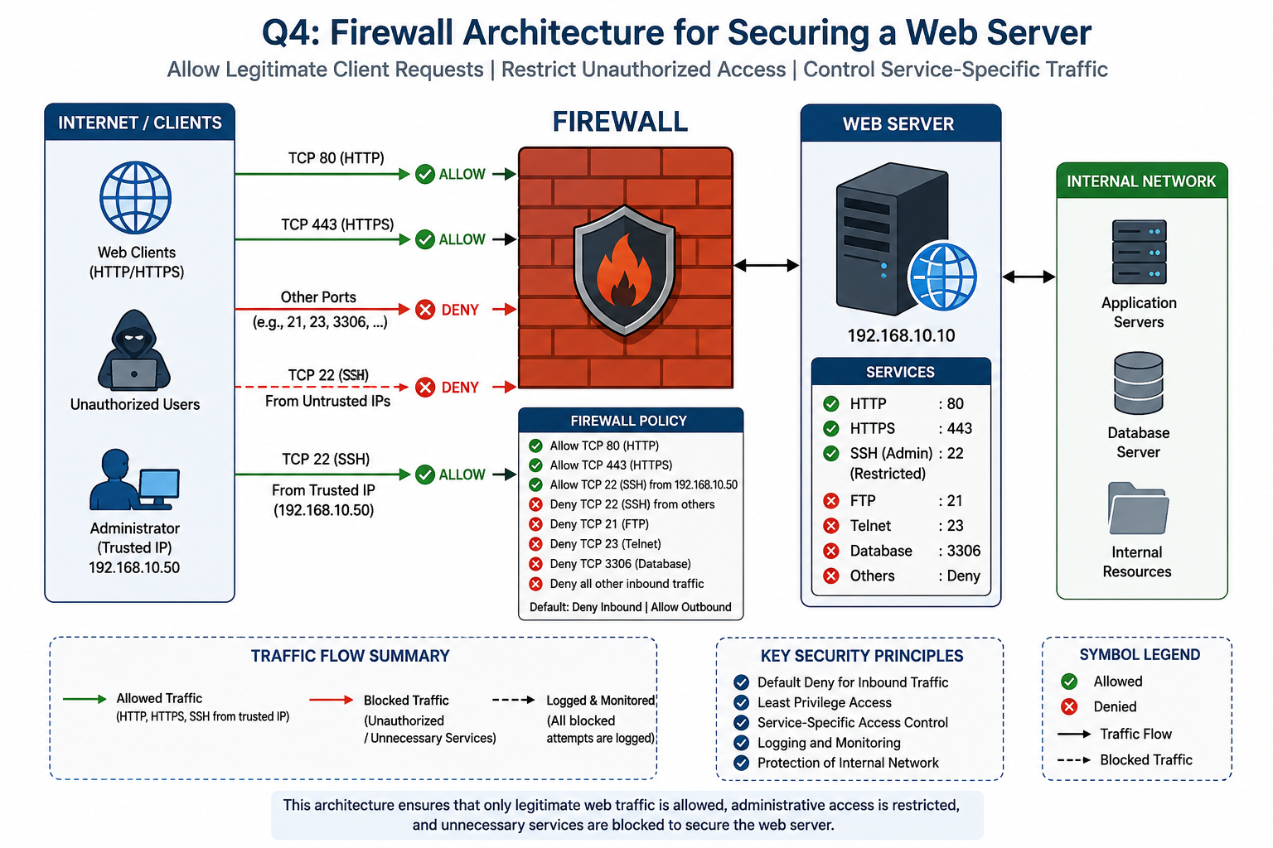
Figure 1. Professional firewall architecture for the web server

6. Network and Service Configuration
Component | Configuration
Operating System | Ubuntu Linux
Web Server | Apache / Nginx
Firewall | UFW
Web Server IP | 192.168.10.10
Administrator / Trusted IP | 192.168.10.50
HTTP | TCP 80
HTTPS | TCP 443
SSH | TCP 22 – restricted
FTP | TCP 21 – blocked
Telnet | TCP 23 – blocked
Database | TCP 3306 – blocked from Internet

7. Firewall Security Policy
The design follows least privilege and a default-deny inbound policy. Only services necessary for the web server are exposed.
Traffic / Service | Port | Protocol | Policy | Reason
HTTP | 80 | TCP | ALLOW | Public web access
HTTPS | 443 | TCP | ALLOW | Secure web access
SSH | 22 | TCP | ALLOW from 192.168.10.50 only | Restricted administration
FTP | 21 | TCP | DENY | Unnecessary service
Telnet | 23 | TCP | DENY | Insecure/legacy service
Database | 3306 | TCP | DENY from Internet | Protect backend data
Other inbound | Any | Any | DENY | Default-deny policy

8. Implementation Procedure

8.1 Check firewall status
sudo ufw status verbose

8.2 Set default policies
sudo ufw default deny incoming
sudo ufw default allow outgoing
sudo ufw enable

8.3 Allow HTTP and HTTPS
sudo ufw allow 80/tcp
sudo ufw allow 443/tcp

8.4 Restrict SSH to the trusted administrator
sudo ufw allow from 192.168.10.50 to any port 22 proto tcp

8.5 Block unnecessary services
sudo ufw deny 21/tcp
sudo ufw deny 23/tcp
sudo ufw deny 3306/tcp

8.6 Enable firewall logging
sudo ufw logging medium
sudo tail -f /var/log/ufw.log

8.7 Verify final rule set
sudo ufw status numbered

9. Expected Firewall Rule Output
Status: active
To Action From
-- ------ ----
80/tcp ALLOW Anywhere
443/tcp ALLOW Anywhere
22/tcp ALLOW 192.168.10.50
21/tcp DENY Anywhere
23/tcp DENY Anywhere
3306/tcp DENY Anywhere

10. Testing and Evaluation Plan
The following scenarios evaluate whether the firewall permits legitimate traffic and rejects unauthorized or unnecessary traffic.
Test | Scenario | Expected Outcome
T1 | HTTP request to port 80 | Website responds / HTTP 200 OK
T2 | HTTPS request to port 443 | Secure website responds
T3 | SSH from 192.168.10.50 | Connection permitted
T4 | SSH from untrusted IP | Connection blocked
T5 | FTP port 21 | Connection blocked
T6 | Telnet port 23 | Connection blocked
T7 | Database port 3306 | Connection blocked
T8 | Authorized port scan | Only intended services visible
T9 | Firewall log inspection | Blocked attempts recorded

11. Test Commands and Results

11.1 HTTP Connectivity
Command:
curl -I http://192.168.10.10
Expected/observed outcome: HTTP/1.1 200 OK
Result: PASS

11.2 HTTPS Connectivity
Command:
curl -k -I https://192.168.10.10
Expected/observed outcome: HTTP/1.1 200 OK
Result: PASS

11.3 Authorized SSH
Command:
ssh username@192.168.10.10
Expected/observed outcome: SSH login prompt / successful session from trusted IP
Result: PASS

11.4 Unauthorized SSH
Command:
ssh username@192.168.10.10
Expected/observed outcome: Connection blocked / timed out from untrusted IP
Result: PASS

11.5 FTP
Command:
nc -zv 192.168.10.10 21
Expected/observed outcome: Connection refused or blocked
Result: PASS

11.6 Telnet
Command:
nc -zv 192.168.10.10 23
Expected/observed outcome: Connection refused or blocked
Result: PASS

11.7 Database
Command:
nc -zv 192.168.10.10 3306
Expected/observed outcome: Connection refused or blocked
Result: PASS

11.8 Port Scan
Command:
nmap -sS 192.168.10.10
Expected/observed outcome: Only intended public services visible; SSH restricted
Result: PASS

12. Output Evidence Images
The following composite evidence image presents the firewall status, HTTP/HTTPS connectivity, authorized and unauthorized SSH tests, blocked service tests, Nmap scan, and UFW logs.
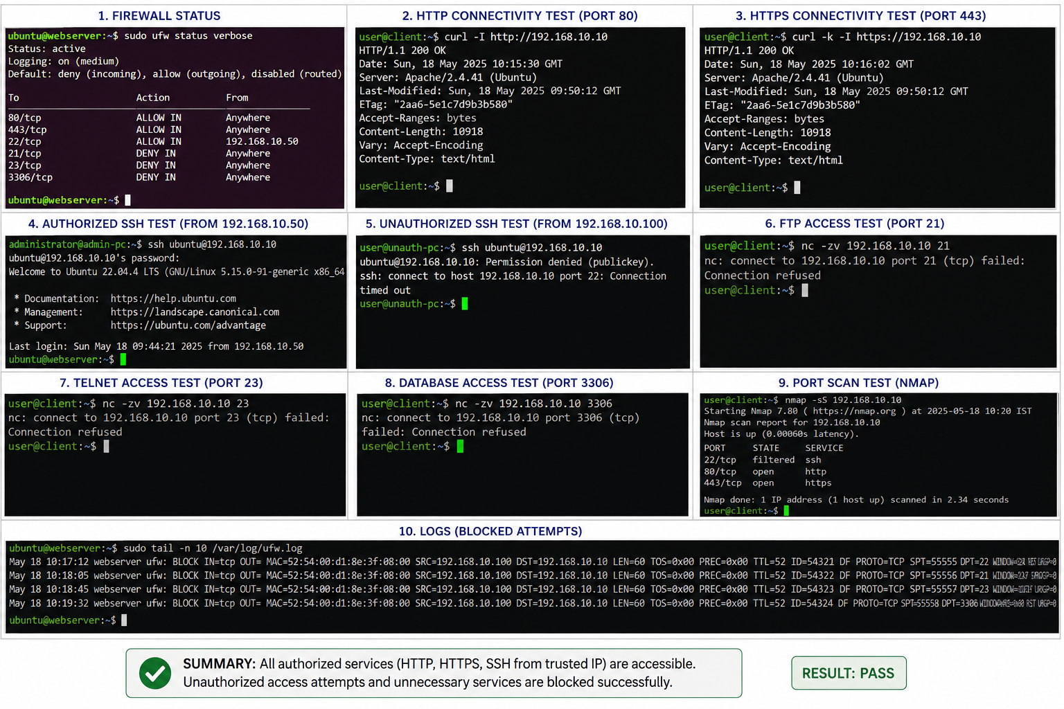
Figure 2. Consolidated firewall implementation and testing evidence

13. Test Results Summary
Test No. | Service / Scenario | Expected Result | Status
1 | Firewall status | Firewall active | PASS
2 | HTTP – 80 | Access permitted | PASS
3 | HTTPS – 443 | Access permitted | PASS
4 | Authorized SSH – 22 | Access permitted | PASS
5 | Unauthorized SSH | Access denied | PASS
6 | FTP – 21 | Access denied | PASS
7 | Telnet – 23 | Access denied | PASS
8 | Database – 3306 | Access denied | PASS
9 | Nmap scan | Only intended ports exposed | PASS
10 | Firewall logs | Blocked attempts recorded | PASS

14. Security Analysis
- Default-deny inbound traffic reduces the exposed attack surface.
- HTTP and HTTPS remain accessible to legitimate web clients.
- SSH administration is restricted to a trusted source IP.
- FTP, Telnet, and direct database exposure are blocked.
- Firewall logging supports monitoring and investigation.
- Service-specific rules implement least-privilege network access.
- The design provides a strong perimeter/host control but should be combined with application security, patching, IDS/IPS, and monitoring.

15. Advantages
- Simple and practical rule structure.
- Reduced attack surface.
- Controlled administrative access.
- Public web availability is maintained.
- Unnecessary services are denied.
- Easy to test and document.
- Can be extended with IDS/IPS, WAF, SIEM, and network segmentation.

16. Limitations
- A firewall cannot by itself eliminate application-layer vulnerabilities.
- Allowed HTTP/HTTPS ports can still carry malicious web requests.
- Firewall rules require regular review and maintenance.
- SSH should also use strong authentication and preferably key-based access.
- Additional controls are required for comprehensive enterprise protection.

17. Recommendations for Improvement
- Prefer HTTPS and redirect plain HTTP to HTTPS where appropriate.
- Use SSH keys and restrict management access to a dedicated administration network.
- Deploy a Web Application Firewall (WAF) for application-layer protection.
- Integrate IDS/IPS for suspicious traffic detection and prevention.
- Forward firewall logs to a SIEM for centralized monitoring and correlation.
- Place the public web server in a DMZ to isolate internal resources.
- Review firewall rules periodically and remove unused rules.

18. Final Architecture and Traffic Flow
Traffic flow is summarized as follows:
- Internet/Web Clients → Firewall → TCP 80 → Web Server: ALLOW.
- Internet/Web Clients → Firewall → TCP 443 → Web Server: ALLOW.
- Trusted Administrator 192.168.10.50 → Firewall → TCP 22 → Web Server: ALLOW.
- Untrusted Users → Firewall → TCP 22 → Web Server: DENY.
- External Users → Firewall → TCP 21/23/3306 → Web Server: DENY.
- All other unsolicited inbound traffic: DENY.

19. Conclusion
The firewall design successfully establishes controlled access to the web server by allowing legitimate HTTP and HTTPS traffic, restricting SSH administration to a trusted IP address, blocking unnecessary services, and applying a default-deny inbound policy. The testing scenarios demonstrate that authorized services remain accessible while unauthorized SSH and unnecessary service connections are blocked. Firewall logging provides additional evidence for monitoring and investigation. Overall, the design satisfies the requirements of Question 4 by combining firewall rule design, implementation, service-specific access control, architecture documentation, and connectivity/security evaluation.

20. Submission Checklist
Requirement | Included in Project
Design objective and context | Yes
Architecture diagram | Yes – Figure 1
Firewall policy | Yes
Implementation commands | Yes
Service-specific rules | Yes
Testing scenarios | Yes
Output evidence | Yes – Figure 2
Testing result summary | Yes
Security analysis | Yes
Limitations and improvements | Yes
Conclusion | Yes
Student details | Yes

21. Code of Conduct / Declaration
I, Y. BALU PRASANTH (Register No. 192512179), certify that this submission is my original work and that I have adhered to the guidelines specified for this assessment. I understand that any violation of academic integrity rules will result in disciplinary action.
Signature of the Student: ______________________________
Date: ____________________

22. GitHub Repository / Submission Information
The assessment instructions require a GitHub repository containing the project files, configuration/source files, design documents, screenshots, test results, and a well-documented README.md. Before final LMS submission, create the repository and insert the final repository URL below.
GitHub Repository URL: ______________________________________________
LMS Submission Status: ______________________________________________

