GENERATION AND ANALYSIS OF FREQUENCY MODULATED
(FM) SIGNALS USING MATLAB DATE:
.Objectives
(i) To generate a Frequency Modulated (FM) signal using MATLAB by varying the frequency of
a high-frequency carrier in accordance with the amplitude of the message signal and to observe
the resulting waveform in the time domain.
(ii) To analyze the frequency spectrum of the generated FM signal using FFT and identify the
carrier component, sideband frequencies, and the bandwidth of the FM signal based on Carson's
rule.

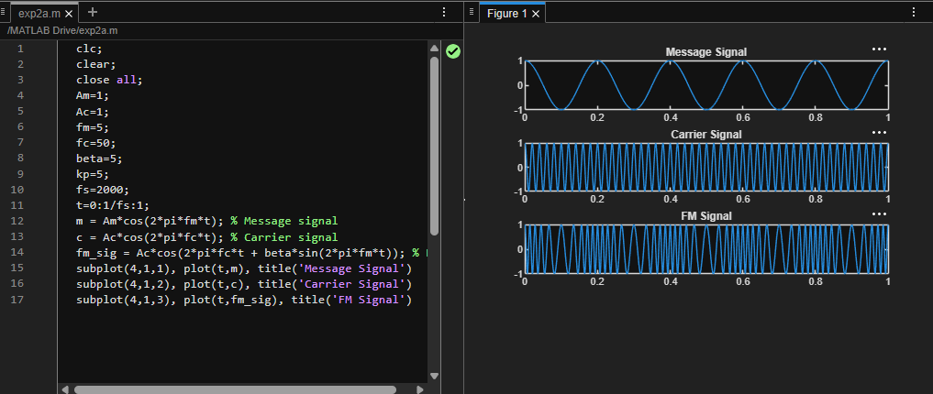
CALCULATION AND VERIFICATION OF FREQUENCY
DEVIATION AND MODULATION INDEX OF FM SIGNALS
Objectives:
To generate a Frequency Modulated (FM) signal in MATLAB using specified message and
carrier signal parameters, and to determine the frequency deviation and modulation index of the
FM signal while analyzing the relationship between frequency deviation, message frequency,
and modulation index.
