GENERATION OF PHASE MODULATED (PM) SIGNALS AND
CALCULATION OF PHASE DEVIATION USING MATLAB SIMULATION
OBJECTIVES:
i) To generate a Phase Modulated (PM) signal in MATLAB using specified carrier and message
signal parameters.
ii) To observe and analyze the time-domain characteristics of the message signal, carrier signal,
and phase modulated signal through MATLAB simulation.
iii) To calculate the phase deviation of the PM signal using the phase sensitivity constant and
message signal amplitude.
iv) To determine the modulation index of the PM signal and examine its relationship with phase
deviation.
v) To investigate the effect of varying message signal amplitude on the phase deviation and
modulation characteristics of the PM signal.
vi) To compare PM waveforms obtained for different phase deviation values and analyze their
modulation behavior using MATLAB.

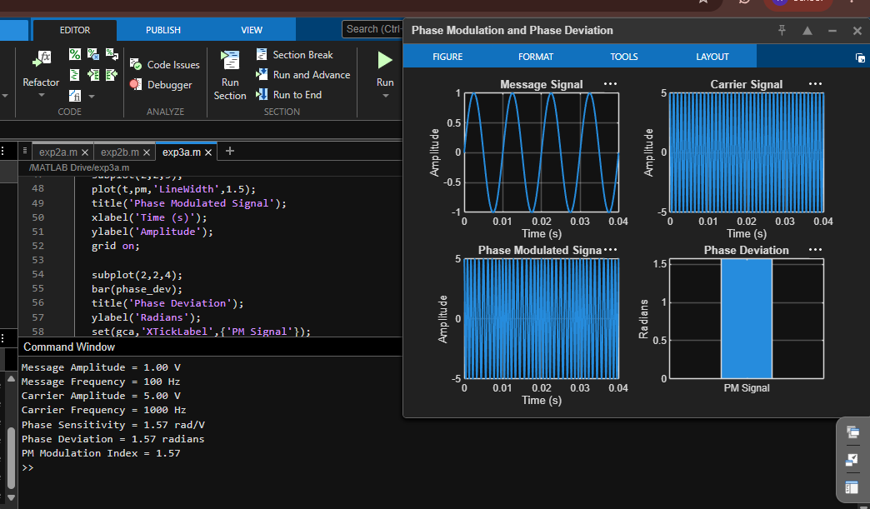

POWER SPECTRAL DENSITY (PSD) ANALYSIS OF PHASEMODULATED (PM) SIGNALS USING MATLAB

Objectives
i) To generate a Phase Modulated (PM) signal in MATLAB using specified carrier and message
signal parameters.
ii) To compute the frequency spectrum of the PM signal using the Fast Fourier Transform (FFT).
iii) To calculate and plot the Power Spectral Density (PSD) of the PM signal using MATLAB.
iv) To identify the carrier component and sideband frequencies present in the PM spectrum.
v) To analyze the effect of phase modulation on the spectral distribution and bandwidth of the
transmitted signal.
vi)To investigate the influence of modulation index on the Power Spectral Density characteristics
of the PM signal.

