SIMULATION AND ANALYSIS OF BPSK MODULATION USING CONSTELLATION DIAGRAMS IN MATLAB

OBJECTIVE
i) To generate BPSK symbols from a binary data sequence using phase-shift keying principles.
ii) To Plot and analyze the BPSK signal constellation in the In-Phase (I) and Quadrature (Q) plane.
iii) To investigate the effect of noise on constellation points and evaluate the resulting degradation
in symbol detection performance.

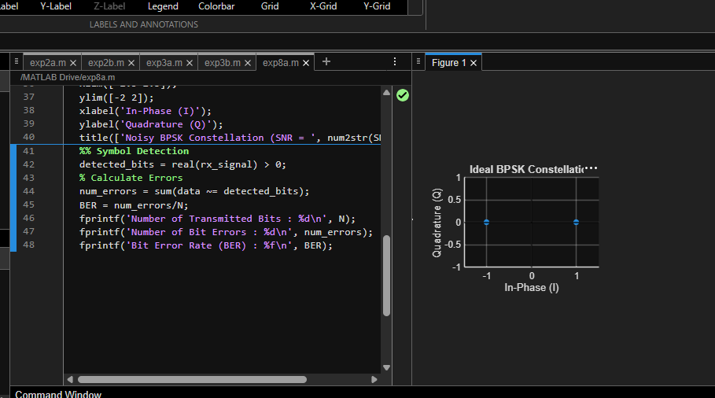

SIMULATION AND ANALYSIS OF QPSK MODULATION USING CONSTELLATION DIAGRAMS IN MATLAB
OBJECTIVE
i) To generate QPSK symbols from a binary data sequence using quadrature phase-shift keying
principles.
ii) To plot and analyze the QPSK signal constellation in the In-Phase (I) and Quadrature (Q) plane.
iii) To investigate the effect of noise on constellation points and evaluate the resulting degradation
in symbol detection performance.

