EXPERIMENT 12:
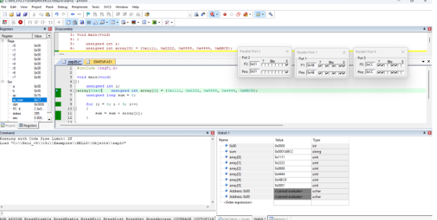
SOURCE CODE:
#include <reg51.h>
void main(void)
{ unsigned int i;
array[00x00 unsigned int
array[5] = {0x1111, 0x2222, 0x8888, 0x4444, 0xABCD};
unsigned long sum = 0;
for (i = 0; i < 5; i++)
{
} sum = sum + array[i];
P0 = (unsigned char)(sum & 0xFF);
// Lower 8 bits P1 = (unsigned char)((sum >> 8) & 0xFF);
// Next 8 bits P2 = (unsigned char)((sum >> 16) & 0xFF);
// Upper 8 bits while(1);
// keep output stable }

