EXPERIMENT 4
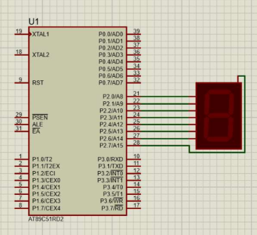
SOURCE CODE:
