EXPERIMENT 18:
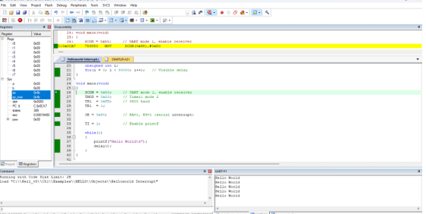
SOURCE CODE:
#include <reg51.h>
#include <stdio.h>

// Function declarations
void delay(void);

// Serial Interrupt Service Routine
void serial_ISR(void) interrupt 4 {
char ch;

// Check if interrupt was triggered by reception
if (RI) {
RI = 0; // Clear receive interrupt flag
ch = SBUF; // Read received character

// Print character safely (avoids mixing with printf in main)
putchar('\n');
putchar('>');
putchar('>');
putchar('>');
putchar(' ');
putchar(ch);
putchar('\n');
}
}

// Visual delay loop
void delay(void) {
unsigned int i;
for(i = 0; i < 50000; i++);
}

void main(void) {
// Hardware Initialization
SCON = 0x50; // UART mode 1 (8-bit, variable baud), REN=1
TMOD = 0x20; // Timer 1, mode 2 (8-bit auto-reload)
TH1 = 0xFD; // 9600 Baud rate (at 11.0592 MHz crystal)
TR1 = 1; // Start Timer 1

// Interrupt Configuration
IE = 0x90; // Enable global interrupts (EA=1) and Serial interrupt (ES=1)
TI = 1; // Set TI to 1 to kickstart printf

// Main execution loop
while(1) {
printf("Hello World\n");
delay();
}
}

