EXPERIMENT 28:
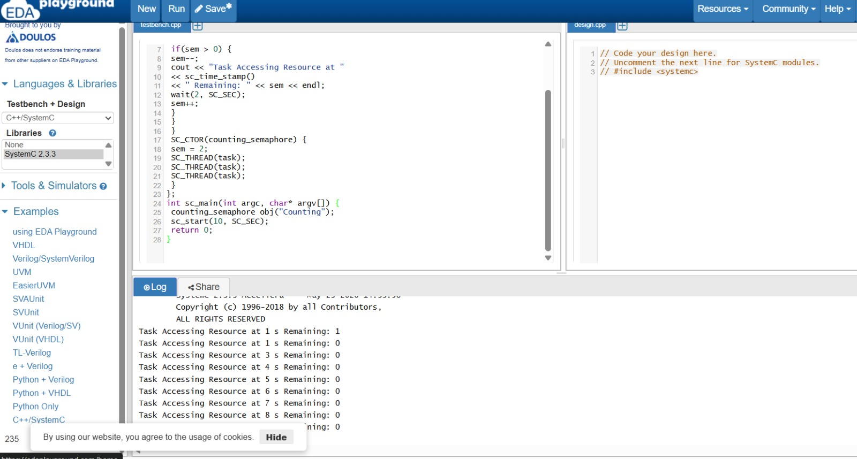
SOURCE CODE:
#include <systemc.h>

SC_MODULE(counting_semaphore) {
int sem;

// Split into distinct thread functions to avoid SystemC process naming conflicts
void task1() {
while(true) {
wait(1, SC_SEC);
if(sem > 0) {
sem--;
cout << "Task 1 Accessing Resource at " << sc_time_stamp() << " Remaining: " << sem << endl;
wait(2, SC_SEC);
sem++;
}
}
}

void task2() {
while(true) {
wait(1, SC_SEC);
if(sem > 0) {
sem--;
cout << "Task 2 Accessing Resource at " << sc_time_stamp() << " Remaining: " << sem << endl;
wait(2, SC_SEC);
sem++;
}
}
}

void task3() {
while(true) {
wait(1, SC_SEC);
if(sem > 0) {
sem--;
cout << "Task 3 Accessing Resource at " << sc_time_stamp() << " Remaining: " << sem << endl;
wait(2, SC_SEC);
sem++;
}
}
}

SC_CTOR(counting_semaphore) {
sem = 2; // Initializing counting semaphore to allow 2 concurrent accesses
SC_THREAD(task1);
SC_THREAD(task2);
SC_THREAD(task3);
}
};

int sc_main(int argc, char* argv[]) {
counting_semaphore obj("Counting");
sc_start(10, SC_SEC);
return 0;
}

