EXPERIMENT 2
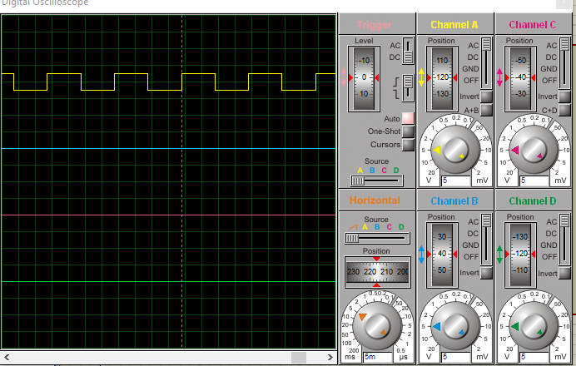
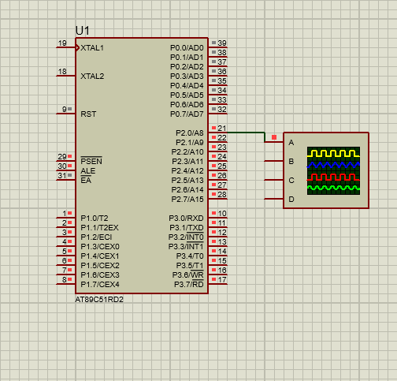
SOURCE CODE;
ORG 0000H
START:
SETB P2.0
ACALL DELAY
CLR P2.0
ACALL DELAY
SJMP START
DELAY:
MOV R4,#20
L1: MOV R3,#250
L2: DJNZ R3,L2
DJNZ R4,L1
RET
END

