EXPERIMENT 15:
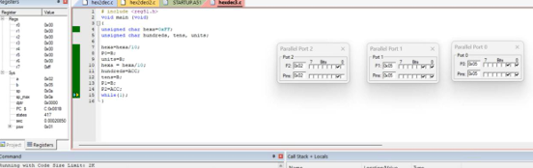
SOURCE CODE:
#include <reg51.h>

void main(void) {
// Variable declarations
unsigned char hexa = 0x08;
unsigned char hundreds, tens, units;

// Isolate the units digit
units = hexa % 10;

// Isolate the tens digit
tens = (hexa / 10) % 10;

// Isolate the hundreds digit
hundreds = hexa / 100;

// Output digits to hardware ports
P0 = units;
P1 = tens;
P2 = hundreds;

// Infinite loop to halt execution
while(1);
}

