EXPERIMENT 30:
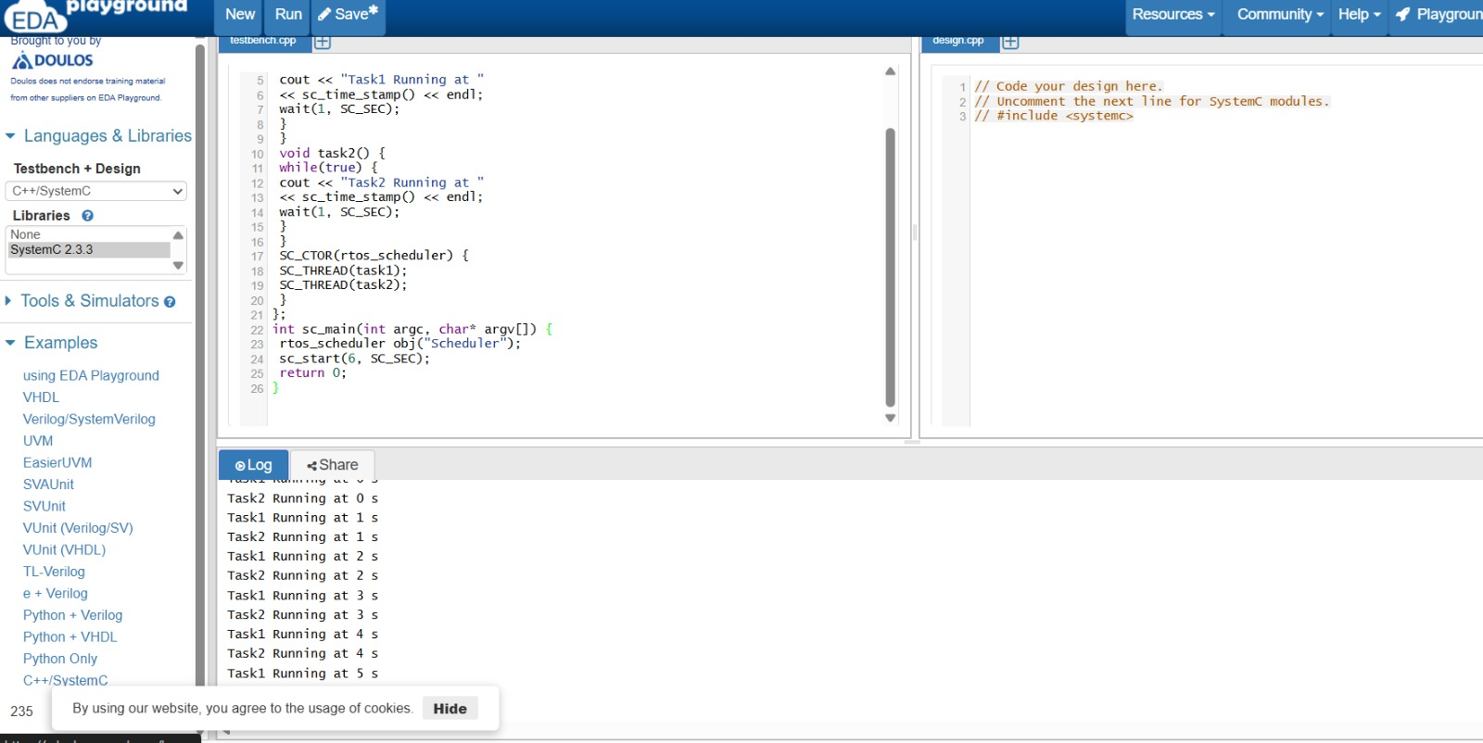
SOURCE CODE:
#include <systemc.h>

SC_MODULE(rtos_scheduler) {
void task1() {
while(true) {
cout << "Task1 Running at " << sc_time_stamp() << endl;
wait(1, SC_SEC);
}
}

void task2() {
while(true) {
cout << "Task2 Running at " << sc_time_stamp() << endl;
wait(1, SC_SEC);
}
}

SC_CTOR(rtos_scheduler) {
SC_THREAD(task1);
SC_THREAD(task2);
}
};

int sc_main(int argc, char* argv[]) {
rtos_scheduler obj("Scheduler");
sc_start(6, SC_SEC);
return 0;
}

