EXPERIMENT 11:
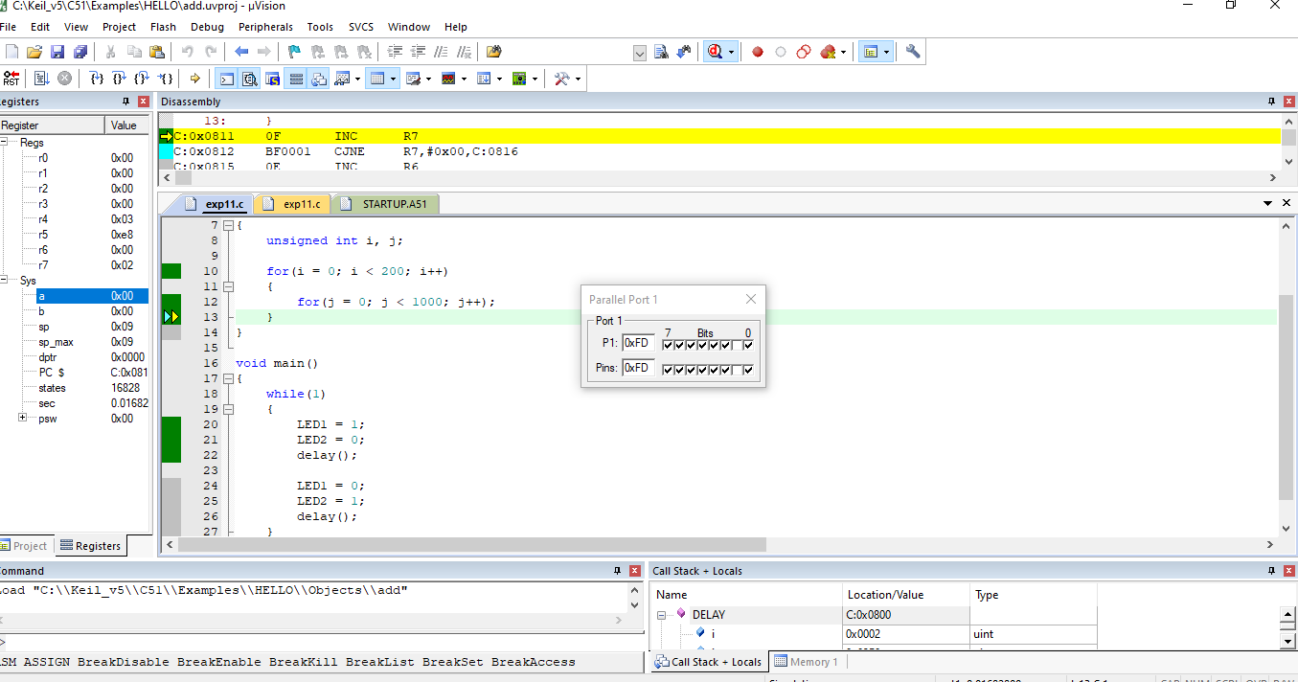
SOURCE CODE:
#include <reg51.h>

sbit LED1 = P1^0;
sbit LED2 = P1^1;

void delay()
{
unsigned int i, j;

for(i = 0; i < 200; i++)
{
for(j = 0; j < 1000; j++);
}
}

void main()
{
while(1)
{
LED1 = 1;
LED2 = 0;
delay();

LED1 = 0;
LED2 = 1;
delay();
}
}

