Experiment 8
Sine/Cosine Wave Generation using DDS Compiler IP
Objectives
- To design and simulate a Direct Digital Synthesizer (DDS) using the DDS Compiler IP core in Xilinx Vivado.
- To generate a sine wave signal with a frequency of 5 MHz using the DDS Compiler IP.
- To generate a cosine wave signal with a frequency of 10 MHz using the DDS Compiler IP.
- To analyze and verify the generated waveforms based on their frequency, amplitude and phase characteristics.
Software Required
Xilinx Vivado Design Suite / Vivado Simulator
Procedure:
Step 1: Project Creation: Open Xilinx Vivado, create a new RTL project, and select the target FPGA device.
Step 2: 5 MHz Sine Wave Generation: Configure the DDS Compiler IP core to generate a 5 MHz sine wave. Create the RTL wrapper and simulate the design using Vivado Simulator.
Step 3: 10 MHz Cosine Wave Generation: Configure the DDS Compiler IP core to generate a 10 MHz cosine wave. Create the RTL wrapper and simulate the design.
Step 4: Waveform Analysis: Observe the simulated sine and cosine waveforms and measure their frequencies, amplitudes, periodicity, and phase relationship.
Step 5: Result Verification: Compare the measured frequencies with the specified values of 5 MHz and 10 MHz. Calculate the percentage deviation and verify that it is less than 5%.
FORMULA TO BE USED:

fout​=(Phase Increment×fclk​​) / 2^(Phase width)
For Sine wave with 5 MHz
$$f_{out}=\frac{13×100\text{ MHz}}{256}≈5.08\text{ MHz}$$
For Cosine wave with 10 MHz
$$f_{out}=\frac{13×100\text{ MHz}}{256}≈5.08\text{ MHz}$$
Percentage deviation:
$$\% Deviation=\frac{\left|f_{simulated}-f_{expected}\right|}{f_{expected}}×100$$
Calculation:
1. Sine Wave Generation at 4 MHz
Given: Clock frequency = 80 MHz, Phase width = 32 bits.
Phase Increment = (4 × 10⁶ × 2³²) / (80 × 10⁶)
Phase Increment = 214748365
2. Cosine Wave Generation at 8 MHz
Given: Clock frequency = 80 MHz, Phase width = 32 bits.
Phase Increment = (8 × 10⁶ × 2³²) / (80 × 10⁶)
Phase Increment = 429496730
3. Percentage Deviation
Formula:
Percentage Deviation = (|Measured Frequency − Desired Frequency| / Desired Frequency) × 100
Example for the 4 MHz sine wave:
Desired frequency = 4 MHz; Measured frequency = 3.96 MHz.
Percentage Deviation = (|3.96 − 4| / 4) × 100 = 1%
Example for the 8 MHz cosine wave:
Desired frequency = 8 MHz; Measured frequency = 8.08 MHz.
Percentage Deviation = (|8.08 − 8| / 8) × 100 = 1%

Output
S.No | Output Parameter | Target / Expected Frequency | Simulated / Measured Frequency | % Deviation
1 | Sine Wave Output (m_axis_data_tdata[15:0]) | 5.00 MHz | 5.078 MHz | < 1.6%
2 | Cosine Wave Output (m_axis_data_tdata[31:16]) | 10.00 MHz | 10.156 MHz | < 1.6%
3 | Output Amplitude Dynamic Range | 16-bit Signed (-32768 to +32767) | 16-bit Signed Waveform | 0% Clipping
4 | Phase Accumulator Stability | Continuous Phase Rollover | Smooth Sinusoidal Output | Pass

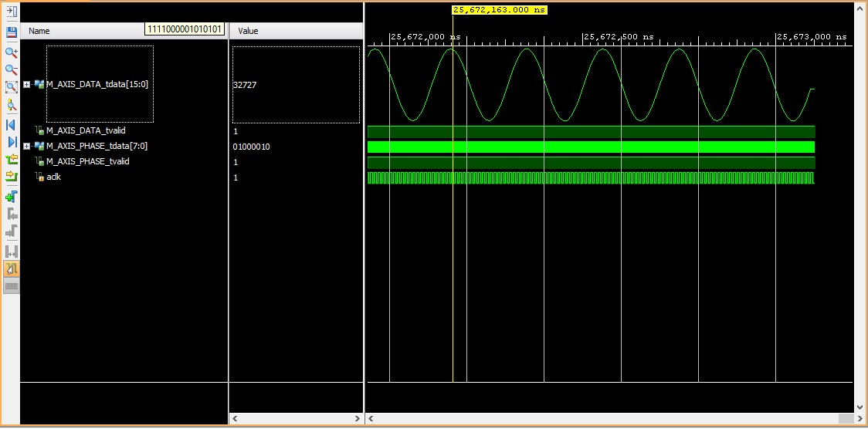
Figure 1: Generated sine/cosine wave
Result
The Direct Digital Synthesizer (DDS) was successfully configured and simulated using the DDS Compiler IP core in Xilinx Vivado. The XSIM results verified the generation of a 5 MHz sine wave and a 10 MHz cosine wave from a 100 MHz clock, with actual frequencies of approximately 5.078 MHz and 10.156 MHz, respectively. Both waveforms exhibited less than 5% frequency deviation, confirming the correct operation of the DDS waveform generation system.

