Experiment 5
Counter Design using Vivado IP
Objectives
  - To configure an 8-bit Binary Counter IP core in Xilinx Vivado with an increment value of 2.
  - To design and configure a 16-bit Binary Counter IP core in down-counter mode with a decrement value of 1.
  - To construct top-level modules and HDL wrappers connecting system clock, reset, enable, and counter output buses.
  - To perform behavioral simulation in Vivado Simulator (XSIM) to verify counter progression, down-counting sequence, and rollover behavior.

Software Required:
Xilinx Vivado Design Suite,
Vivado IP Catalog,
Vivado Simulator (XSIM).
Procedure
A. Design of an 8-Bit Up-Counter (Increment by 2)
- Create a new project in Xilinx Vivado and select the target FPGA device.
- Add the Binary Counter IP from the IP Catalog and configure it for an 8-bit output with an increment of 2.
- Create a top-level module and connect the clock, reset, increment input, and output signals.
- Develop a Verilog testbench to generate the clock, apply reset, and monitor the counter output.
- Run the simulation using XSIM and verify the counting sequence: 0, 2, 4, 6, ..., 254, 0.
B. Design of a 16-Bit Down-Counter (Decrement by 1)
- Create a new RTL project in Xilinx Vivado and select the target FPGA device.
- Add the Binary Counter IP from the IP Catalog, configure it for a 16-bit output, and enable down-counting mode.
- Generate an HDL wrapper and connect the clock, reset, enable, and 16-bit output signals.
- Develop a Verilog testbench to generate the clock, apply reset, enable counting, and initialize the counter to FFFFH.
- Run the simulation using XSIM and verify that the counter decrements by 1 on each rising edge of the clock.

Program
1. Verilog Testbench Code for 8-Bit Up-Counter
`timescale 1ns / 1ps
module tb_clock_divider_by4;
reg clk;
reg rst;
wire [7:0] out1;
// Instantiate 8-bit Binary Counter IP core (Increment by 2)
c_counter_binary_0 uut (
.CLK(clk),
.Q(out1)
);
// Clock generation (100 MHz clock)
always #5 clk = ~clk;
initial begin
clk = 0;
rst = 1;
#20 rst = 0;
#100000;
$stop;
end
endmodule
2. Verilog Testbench Code for 16-Bit Down-Counter
`timescale 1ns / 1ps
module tb_16bit_down_counter;
reg clk;
reg rst;
reg enable;
wire [15:0] count_out;
// Instantiate 16-bit Down Counter IP core
c_counter_binary_1 uut_down (
.CLK(clk),
.SCLR(rst),
.CE(enable),
.Q(count_out)
);
always #5 clk = ~clk;
initial begin
clk = 0;
rst = 1;
enable = 0;
#20 rst = 0;
#10 enable = 1;
#1000;
$stop;
end
endmodule
Formulas
1. Up-Counter Increment and Rollover Calculation:
- Total number of states = 2^WIDTH = 2^8 = 256
- Maximum count = 2^8 - 1 = 255
- For increment = 2, maximum even count = 254.
- Number of counting steps before rollover = 256 / 2 = 128
- Next state = (254 + 2) mod 256 = 0
2. Down-Counter Decrement and Underflow Calculation:
Initial count = 2^16 - 1 = 65535 = FFFFH
For decrement = 1, the counting sequence is FFFFH, FFFEH, FFFDH, ..., 0001H, 0000H.
Clock pulses required to reach zero = 65535
Next state = (0 - 1) mod 65536 = 65535 = FFFFH

Output
S.No | Output Parameter | Target / Expected Behavior | Simulated / Measured Result | Status
1 | 8-Bit Up-Counter Step | Increment by +2 | Increment by +2 | Verified
2 | 16-Bit Down-Counter Step | Decrement by -1 | Decrement by -1 | Verified
3 | Up-Count Sequence & Rollover | 0, 2, 4, ..., 254 -> 0 | 0, 2, 4, ..., 254 -> 0 | Verified
4 | Down-Count Sequence | FFFFH, FFFEH, FFFDH, ... | FFFFH, FFFEH, FFFDH, ... | Verified
5 | Operation Stability | Stable Count Transitions | Validated in XSIM Waveform | Pass

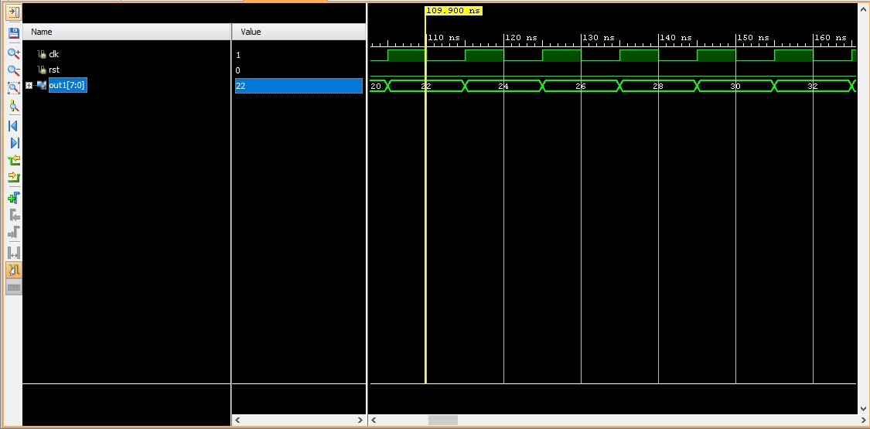
Figure: Example of upcounting by 2

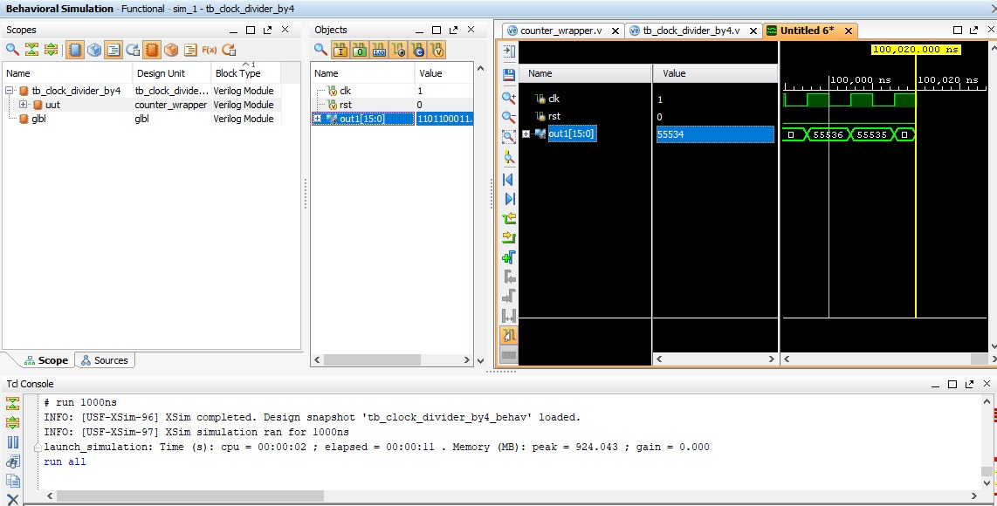
Figure: Example of downcounting by 1

Result
The 8-bit up-counter with an increment of 2 and the 16-bit down-counter with a decrement of 1 were successfully designed and simulated using the Vivado Binary Counter IP core. The simulation waveforms verified that the up-counter increases by 2 on each rising clock edge and rolls over to 0 after reaching 254. Similarly, the down-counter decreases by 1 on each active clock edge, counting from FFFFH to 0000H and then rolling over to FFFFH, confirming the correct operation of both counter designs.

