Experiment 4
Design of image Intensity Inversion circuit in Zynq SoC
Objectives
- To develop a Verilog-based image intensity inversion module for functional simulation using Xilinx Vivado Simulator (XSIM).
- To process a 256 × 256 grayscale image containing 65,536 pixels using a Verilog testbench.
- To implement 8-bit grayscale intensity inversion using the equation (P_{out}=255-P_{in}).
- To verify the inverted pixel values and analyze the input and output signals using Vivado simulation waveforms.
Software Required
- Xilinx Vivado Design Suite,
- Vivado Simulator (XSIM), and a text editor for preparing Verilog RTL and testbench files.
- Python
Procedure
A. Grayscale Image Pre-processing
- Prepare a 256 × 256 grayscale image with 65,536 pixels, each represented by an 8-bit value (0–255).
- Convert the image pixels into sequential values and save them in image_in.txt, with one pixel per line.
- Create a Vivado RTL project for behavioral simulation without FPGA hardware implementation.
B. RTL Design of Intensity Inversion
- Develop a Verilog module named intensity_inversion with 8-bit input and output signals.
- Implement the inversion equation: pixel_out = 255 - pixel_in.
- If required, include clock, reset, and valid signals for synchronous operation.
- Verify sample values: 0 → 255, 100 → 155, 128 → 127, and 255 → 0.
C. Simulation and Verification
- Create a Verilog testbench named tb_intensity_inversion to read pixel values from image_in.txt using $fopen and $fscanf.
- Apply the input pixels sequentially and capture the inverted outputs in image_out.txt using $fdisplay.
- Run behavioral simulation using Vivado Simulator (XSIM) and observe the input, output, clock, and control signals.
- Verify that each output satisfies pixel_out = 255 - pixel_in.
- Confirm that all 65,536 pixels are processed correctly and record the results with sample values and waveform observations.

Program
- Verilog RTL Module
module intensity_inversion (
input wire clk,
input wire rst,
input wire [7:0] pixel_in, // 0 to 255
input wire valid_in,
output reg [7:0] pixel_out,
output reg valid_out
);
always @(posedge clk or posedgerst) begin
if (rst) begin
pixel_out<= 8'd0;
valid_out<= 1'b0;
end
else begin
if (valid_in) begin
pixel_out<= 8'd255 - pixel_in; // Intensity inversion
valid_out<= 1'b1;
end
else begin
valid_out<= 1'b0;
end
end
end
endmodule
- Verilog Testbench Code
`timescale 1ns/1ps
module tb_intensity_inversion;
reg clk, rst;
reg [7:0] pixel_in;
reg valid_in;
wire [7:0] pixel_out;
wire valid_out;
integer infile, outfile;
integer r;
intensity_inversion UUT (
.clk(clk),
.rst(rst),
.pixel_in(pixel_in),
.valid_in(valid_in),
.pixel_out(pixel_out),
.valid_out(valid_out)
);
// Clock Generation (100 MHz / 10 ns period)
always #5 clk = ~clk;
initial begin
clk = 0;
rst = 1;
valid_in = 0;
pixel_in = 0;
#20 rst = 0;
infile = $fopen("image_in.txt", "r");
outfile = $fopen("image_out.txt", "w");
if (infile == 0 || outfile == 0) begin
$display("File open error");
$finish;
end
while (!$feof(infile)) begin
r = $fscanf(infile, "%d\n", pixel_in);
valid_in = 1'b1;
@(posedge clk); // input accepted
@(posedge clk); // output available
if (valid_out)
$fdisplay(outfile, "%d", pixel_out);
end
valid_in = 0;
#20;
$fclose(infile);
$fclose(outfile);
$display("Intensity inversion simulation finished.");
$finish;
end
endmodule
Formulas
1. Pixel Intensity Inversion Examples:
Formula: P_out = 255 - P_in
- Input = 0 → Output = 255 - 0 = 255
- Input = 50 → Output = 255 - 50 = 205
- Input = 100 → Output = 255 - 100 = 155
- Input = 128 → Output = 255 - 128 = 127
- Input = 200 → Output = 255 - 200 = 55
- Input = 255 → Output = 255 - 255 = 0
2. Total Number of Pixels Calculation:
Formula: N = Width × Height
- For a 64 × 64 image: N = 64 × 64 = 4,096 pixels
- For a 128 × 128 image: N = 128 × 128 = 16,384 pixels
- For a 256 × 256 image: N = 256 × 256 = 65,536 pixels
- For a 512 × 512 image: N = 512 × 512 = 262,144 pixels

Output
S.No | Output Parameter | Expected / Calculated Output | Simulated / Measured Output | Result / Deviation
1 | Processed Frame Size | 65,536 Bytes | 65,536 Bytes | 0% Byte Loss
2 | Sample Inversion (Input: 0) | P_out = 255 | P_out = 255 | 0% Error
3 | Sample Inversion (Input: 100) | P_out = 155 | P_out = 155 | 0% Error
4 | Sample Inversion (Input: 255) | P_out = 0 | P_out = 0 | 0% Error
5 | Image Inversion Accuracy | 100% | 100% | 0% Deviation

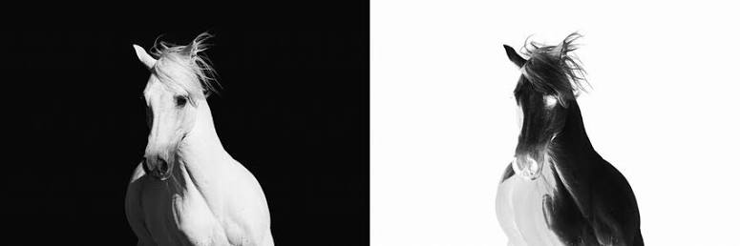
Figure 1 Example of image intensity inversion
Result

The image intensity inversion circuit was successfully designed and simulated using Verilog RTL in Xilinx Vivado. The XSIM simulation verified that all 65,536 pixels of the 256 × 256 grayscale image were correctly inverted using the equation P_out = 255 − P_in. The results confirmed accurate pixel inversion, with low-intensity values converted to high-intensity values and no arithmetic errors.

