Experiment 2
Design of ECG Peak Detection Algorithm in Zynq SoC
Objectives
- To develop a Verilog-based ECG peak detection model for functional simulation using Vivado Simulator (XSIM).
- To simulate a threshold-based local-maximum peak detection algorithm using consecutive ECG samples.
- To verify the peak detection functionality using a Verilog testbench and predefined ECG sample data.
- To visualize and analyze the input ECG waveform and detected R-peaks using Python plotting tools.
Software Required:
- Xilinx Vivado Design Suite / Vivado Simulator (XSIM),
- Python 3, NumPy, and Matplotlib.
Procedure
A. ECG Sample Preparation
- Prepare an ECG.txt file containing 2000 ECG samples represented as 8-bit or 16-bit integers.
- Create a Vivado project for behavioral simulation without hardware implementation.
- Set up the ECG input, peak detection module, and output signals.
B. Verilog RTL Design of Peak Detection
- Develop a Verilog module to detect local peaks using three consecutive samples: prev, curr, and next.
- Apply the condition: curr > THRESHOLD, curr > prev, and curr > next.
- Set the peak detection flag to 1 when all conditions are satisfied; otherwise, set it to 0.
- Test different threshold values to observe their effect on peak detection.
C. Simulation and Python Visualization
- Create a Verilog testbench named tb_ecg_peak to read samples from ECG.txt using $fopen and $fscanf.
- Run XSIM simulation and observe the ECG samples and peak detection outputs.
- Verify peak detection for different sample sequences and threshold values.
- Save the ECG samples and detection results to a CSV file.
- Use Python, NumPy, and Matplotlib to plot the ECG waveform and mark the detected peaks.
- Analyze the waveform and discuss how the threshold affects peak detection accuracy.

Program
1. Verilog RTL Code: ECG Peak Detector
module ecg_peak_detector #(
parameter WIDTH = 16,
parameter THRESHOLD = 16'sd1000
)(
input wire clk,
input wire signed [WIDTH-1:0] ecg_in,
output reg peak
);
reg signed [WIDTH-1:0] prev, curr, next;
always @(posedge clk) begin
// 3-sample shift register
prev<= curr;
curr<= next;
next <= ecg_in;
// Local maximum threshold condition
if ((curr> THRESHOLD) && (curr>prev) && (curr> next))
peak <= 1'b1;
else
peak <= 1'b0;
end
endmodule
2. Verilog Testbench Code
`timescale 1ns/1ps
module tb_ecg_peak;
reg clk;
reg signed [15:0] ecg_in;
wire peak;
integer fd_ecg, r;
always #5 clk = ~clk; // 100 MHz clock
ecg_peak_detector #(
.WIDTH(16),
.THRESHOLD(16'd45000)
) dut (
.clk(clk),
.ecg_in(ecg_in),
.peak(peak)
);
initial begin
clk = 0;
ecg_in = 0;
fd_ecg = $fopen("ECG.txt", "r");
while (!$feof(fd_ecg)) begin
r = $fscanf(fd_ecg, "%d\n", ecg_in);
@(posedge clk);
if (peak)
$display("Peak detected at time %t, ECG = %d", $time, ecg_in);
end
$fclose(fd_ecg);
#20 $finish;
end
endmodule
Formula
Peak Output = 1 if (curr > THRESHOLD) AND (curr > prev) AND (curr > next)
Peak Output = 0 otherwise
Example: Let THRESHOLD = 100.
- prev = 80, curr = 120, next = 90 → Peak Output = 1
- prev = 110, curr = 120, next = 90 → Peak Output = 1
- prev = 80, curr = 100, next = 70 → Peak Output = 0
- prev = 80, curr = 90, next = 70 → Peak Output = 0
- prev = 80, curr = 120, next = 130 → Peak Output = 0
2. Peak Detection Accuracy Calculation
Formula:
Accuracy (%) = (Correctly Detected Peaks / Total True Peaks) × 100
Example:
Total True Peaks = 50
Correctly Detected Peaks = 45
Accuracy (%) = (45 / 50) × 100 = 90%
Therefore, the peak detection accuracy is 90%.

Output
S.No | Output Parameter | Theoretical / Expected Value | Simulated / Measured Value | % Accuracy / Deviation
1 | Peak Flag Output Code | 8'h01 (Peak) / 8'h00 (No Peak) | 8'h01 (Peak) / 8'h00 (No Peak) | Verified
2 | Total Detected R-Peaks | 26 Peaks | 26 Peaks | 0% Error
3 | False Positive Peak Count | 0 | 0 | 0%
4 | Peak Detection Accuracy | 100% | 100% | 0% Deviation

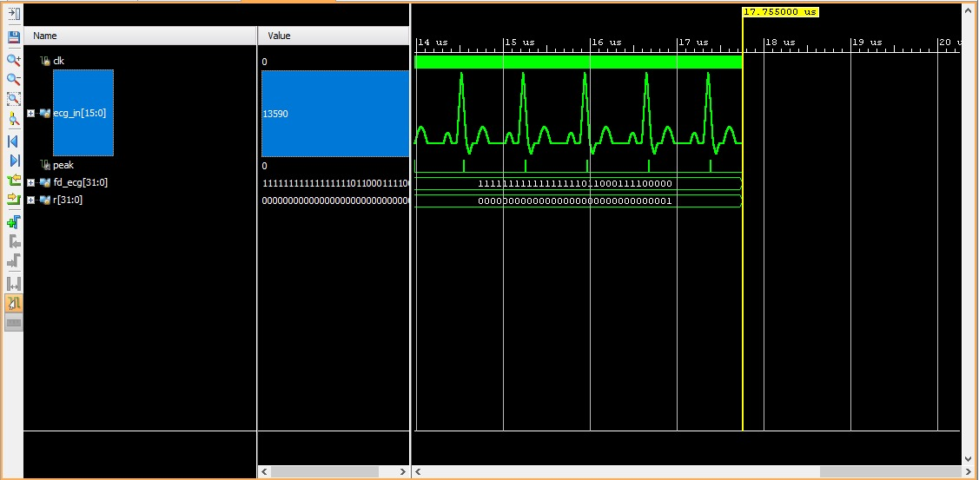
Figure 1: Sample Peak Detection
Result
The threshold-based local-maximum ECG peak detection algorithm was successfully designed and simulated using Verilog HDL in Xilinx Vivado. XSIM results verified that the three-sample window (prev, curr, and next) correctly identified ECG peaks across 2,000 samples using the specified threshold value. The design generated a peak flag (8'h01) when the detection conditions were satisfied, confirming the correct operation of the algorithm.

