Experiment 7
Design of Moving Average Filter using Verilog
Objectives
    - To design and simulate a 4-point Moving Average Filter using RTL Verilog to smooth noisy input data by averaging recent samples.
    - To implement a 4-stage 8-bit shift register (`shift_reg[0:3]`) to continuously store the 4 most recent input samples.
    - To compute the 10-bit cumulative sum (`sum`) of the 4 samples and perform fast division by 4 using bit-wise right-shift logic (`sum >> 2`).
    - To verify filter performance using a Verilog testbench (`tb_moving_average_with_noise`) driving a noisy sinusoidal input wave in Vivado Simulator (XSIM).

Software Required
Xilinx Vivado Design Suite,
Vivado Simulator (XSIM),
PC or Laptop.
Experimental Procedure
Step 1: Project Creation: Open Xilinx Vivado, create a new RTL project, and select the target FPGA device.
Step 2: RTL Design: Create a Verilog module named moving_average_filter. Store the four previous input samples, calculate their sum, and divide by four using a right shift of two bits to obtain the average.
Step 3: Testbench Creation: Create a testbench named tb_moving_average_with_noise. Generate a 100 MHz clock, apply reset, and provide 100 noisy sine-wave samples with noise ranging from −10 to +10. Limit the input samples to the 8-bit range of 0 to 255.
Step 4: Simulation: Run behavioral simulation using Vivado Simulator (XSIM). Observe the input samples, stored samples, and filtered output waveform.
Step 5: Result Verification: Verify that the output represents the average of the four stored samples and that the moving average reduces rapid variations caused by noise.

Program
1. RTL Code: Moving Average Filter
module moving_average_filter (
input wire clk,
input wire rst,
input wire [7:0] data_in,
output reg [7:0] data_out
);
reg [7:0] shift_reg [0:3]; // Store last 4 samples
reg [9:0] sum; // Sum of 4 samples (max = 1020)
integer i;
always @(posedge clk or posedgerst) begin
if (rst) begin
for (i = 0; i< 4; i = i + 1)
shift_reg[i] <= 0;
data_out<= 0;
sum <= 0;
end else begin
// Shift samples
shift_reg[3] <= shift_reg[2];
shift_reg[2] <= shift_reg[1];
shift_reg[1] <= shift_reg[0];
shift_reg[0] <= data_in;
// Accumulate and divide by 4 (right shift by 2)
sum <= shift_reg[0] + shift_reg[1] + shift_reg[2] + shift_reg[3];
data_out<= sum >> 2;
end
end
endmodule
  - Testbench Code: Noisy Sine Input Simulation
`timescale 1ns / 1ps
module tb_moving_average_with_noise;
reg clk;
reg rst;
reg [7:0] data_in;
wire [7:0] data_out;
real sine_val;
integer noise;
integer temp;
integer i;
// Instantiate Device Under Test (DUT)
moving_average_filterdut (
.clk(clk),
.rst(rst),
.data_in(data_in),
.data_out(data_out)
);
// 100 MHz System Clock Generation
always #5 clk = ~clk;
initial begin
clk = 0;
rst = 1;
data_in = 0;
#20 rst = 0;
// Drive 100 noisy sine wave samples
for (i = 0; i< 100; i = i + 1) begin
sine_val = 127.0 * (1.0 + $sin(2.0 * 3.14159 * i / 20.0));
noise = ($random % 21) - 10; // Noise range: -10 to +10
temp = $rtoi(sine_val) + noise;
if (temp > 255)
data_in = 8'd255;
else if (temp < 0)
data_in = 8'd0;
else
data_in = temp[7:0];
#10;
end
#100;
$stop;
end
endmodule

Formulas
1. Moving Average Calculation:
Input samples: x[n] = 20, x[n−1] = 40, x[n−2] = 60, x[n−3] = 80
y[n] = (20 + 40 + 60 + 80) / 4
y[n] = 200 / 4 = 50
2. Bit-Shift Division:
sum = 200
data_out = sum >> 2 = 200 / 4 = 50
3. Accumulator Bit-Width:
Maximum input = 255
Maximum sum = 4 × 255 = 1020
Required accumulator width = 10 bits
4. Noisy Input Example:
Sine value = 100, Noise = +5
Input sample = 100 + 5 = 105
If the calculated value exceeds 255, set it to 255. If it is below 0, set it to 0. Otherwise, use the calculated value.

Output

S.No | Output Parameter | Expected / Theoretical Value | Simulated / Measured Value | Status / Result
1 | Peak Accumulation Sum | 10-bit Integer (Max 1020) | 1020 | 0% Overflow
2 | Output Division Logic | Bit-wise Right Shift (>> 2) | sum >> 2 | Exact Match
3 | High-Frequency Noise Reduction | Attenuated Ripple | Smooth Sinusoidal Curve | Verified
4 | Output Signal Fidelity | Low-pass Filtered Wave | Verified in XSIM Waveform | Pass

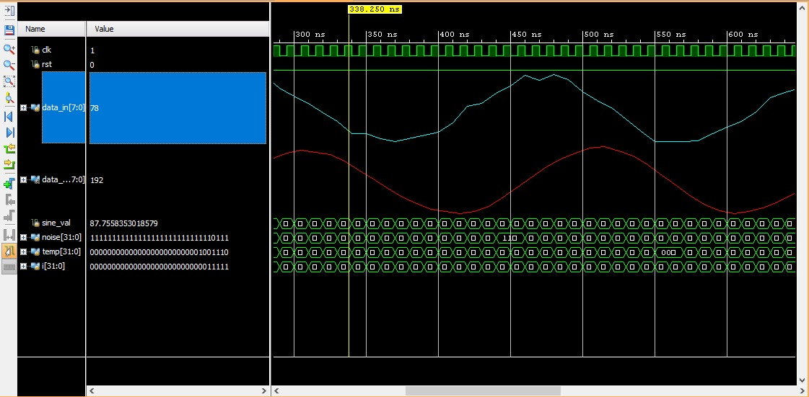
Figure: Moving average filter result

Result
The 4-point Moving Average Filter was successfully designed and simulated using Verilog HDL in Xilinx Vivado. A noisy sinusoidal input signal was generated using the testbench and applied to the filter. Simulation results showed that the filter reduced noise fluctuations while maintaining the overall shape of the sinusoidal signal, confirming its correct operation as a low-pass FIR filter.

