Experiment 10
Design of Fully Connected Neural Network using RTL
Objectives
  - To design and simulate a Fully Connected (FC) neural network layer with five input neurons (x0–x4), five weight inputs (w0–w4), and one output neuron (y) using RTL (Verilog HDL).
  - To implement fixed-point signed 8-bit x 8-bit parallel multipliers, a 5-input adder tree accumulator (sum), and a 16-bit signed bias addition stage.
  - To construct a comprehensive Verilog testbench (tb_fully_connected_5in) applying positive, scaled, and signed 2's complement test vectors.
  - To simulate in Vivado Simulator (XSIM), record output waveforms, and verify 100% computational accuracy against manual theoretical MAC calculations.
Software Required
Xilinx Vivado Design Suite,
Vivado Simulator (XSIM),
Verilog HDL, Windows / Linux Operating System.

Procedure
(i) Step 1: Project Creation – Create a new RTL project in Xilinx Vivado and select the target FPGA device.
(ii) Step 2: Module Design – Create a Verilog module named fully_connected_5in with five 8-bit signed inputs (x0–x4), five 8-bit signed weights (w0–w4), a 16-bit bias, and an 18-bit output (y).
(iii) Step 3: MAC Implementation – Multiply each input by its corresponding weight, add the five products, and add the bias to obtain the output.
(iv) Step 4: Testbench Development – Create tb_fully_connected_5in and test the design using all-ones weights with bias 10, weights scaled by 2 with zero bias, and mixed positive and negative inputs with bias 5.
(v) Step 5: Simulation and Verification – Run behavioral simulation using Vivado Simulator (XSIM), observe the output waveforms, and compare the results with manual calculations.

Program

1. Verilog RTL Code: Fully Connected Layer
module fully_connected_5in (
input signed [7:0] x0, x1, x2, x3, x4, // 5 inputs
input signed [7:0] w0, w1, w2, w3, w4, // 5 weights
input signed [15:0] bias, // single bias
output signed [17:0] y // output
);
wire signed [15:0] m0, m1, m2, m3, m4;
wire signed [17:0] sum;
assign m0 = x0 * w0;
assign m1 = x1 * w1;
assign m2 = x2 * w2;
assign m3 = x3 * w3;
assign m4 = x4 * w4;
assign sum = m0 + m1 + m2 + m3 + m4;
assign y = sum + bias;
endmodule

2. Verilog Testbench Code
`timescale 1ns / 1ps
module tb_fully_connected_5in;
reg signed [7:0] x0, x1, x2, x3, x4;
reg signed [7:0] w0, w1, w2, w3, w4;
reg signed [15:0] bias;
wire signed [17:0] y;
// Instantiate the DUT
fully_connected_5in uut (
.x0(x0), .x1(x1), .x2(x2), .x3(x3), .x4(x4),
.w0(w0), .w1(w1), .w2(w2), .w3(w3), .w4(w4),
.bias(bias),
.y(y)
);
initial begin
// Test Case 1: Positive inputs, all-ones weights, bias = 10
x0 = 8'd10; x1 = 8'd20; x2 = 8'd30; x3 = 8'd40; x4 = 8'd50;
w0 = 8'd1; w1 = 8'd1; w2 = 8'd1; w3 = 8'd1; w4 = 8'd1;
bias = 16'd10;
#10;
// Test Case 2: Scaled weights x2, bias = 0
x0 = 8'd5; x1 = 8'd10; x2 = 8'd15; x3 = 8'd20; x4 = 8'd25;
w0 = 8'd2; w1 = 8'd2; w2 = 8'd2; w3 = 8'd2; w4 = 8'd2;
bias = 16'd0;
#10;
// Test Case 3: Mixed signed negative values, bias = 5
x0 = -8'd10; x1 = 8'd20; x2 = -8'd5; x3 = 8'd15; x4 = 8'd10;
w0 = 8'd1; w1 = 8'd1; w2 = 8'd1; w3 = 8'd1; w4 = 8'd1;
bias = 16'd5;
#10;
$stop;
end
endmodule

Formulas
1. Fully Connected Neuron MAC Formula:
Output = (x0 × w0) + (x1 × w1) + (x2 × w2) + (x3 × w3) + (x4 × w4) + bias
2. Test Case Calculations:
- Test Case 1 – All weights = 1, bias = 10:
Sum = (10 × 1) + (20 × 1) + (30 × 1) + (40 × 1) + (50 × 1) = 150
Output = 150 + 10 = 160
- Test Case 2 – All weights = 2, bias = 0:
Sum = (5 × 2) + (10 × 2) + (15 × 2) + (20 × 2) + (25 × 2) = 150
Output = 150 + 0 = 150
- Test Case 3 – Mixed positive and negative inputs, bias = 5:
Sum = (-10 × 1) + (20 × 1) + (-5 × 1) + (15 × 1) + (10 × 1) = 30
Output = 30 + 5 = 35
3. Bit-Width and Precision Calculation:
- 8-bit signed input × 8-bit signed weight = 16-bit signed product.
- Five products require 3 additional guard bits because ceil(log2(5)) = 3.
- Accumulator width = 16 + 3 = 19 bits for full worst-case precision.
- An 18-bit accumulator may overflow for certain input combinations. A 19-bit accumulator is safer for accumulating five full-range signed 8-bit products.
- The final output width must also accommodate the bias addition without overflow.
Output
S.No | Test Scenario / Parameter | Expected Theoretical Output | Simulated Hardware Output | % Deviation / Status
1 | Test Case 1 (Positive Inputs) | y = 150 + 10 = 160 | y = 160 | 0% Error
2 | Test Case 2 (Scaled Weights x2) | y = 150 + 0 = 150 | y = 150 | 0% Error
3 | Test Case 3 (Mixed Negative Values) | y = 30 + 5 = 35 | y = 35 | 0% Error
4 | Accumulator Precision | 18-bit Signed Accumulator | No Arithmetic Overflow | Verified

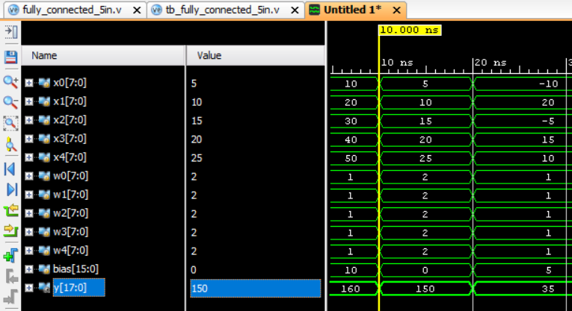
Figure 1: Output of fully connected network process

Result
The five-input Fully Connected (FC) neural network layer was successfully designed and simulated using Verilog RTL in Xilinx Vivado. The circuit performed five parallel signed 8-bit multiplications, accumulated the products, and added the 16-bit bias. Simulation results for all three test cases—positive inputs, scaled weights, and mixed signed inputs—matched the theoretical MAC calculations, confirming the correct functional operation of the neuron.

