Experiment 1
Design of Clock Divider Circuit using RTL
Objectives:
- To design and verify a clock divider by two circuit using RTL (Verilog HDL) that generates a 50 MHz output clock from a 100 MHz input base clock.
- To design and verify a clock divider by four circuit using RTL (Verilog HDL) that generates a 25 MHz output clock from a 100 MHz input base clock.
- To implement flip-flop toggle logic for divide-by-2 operation and a 2-bit synchronous counter for divide-by-4 operation with active-high asynchronous reset.
- To perform behavioral simulation in Vivado Simulator (XSIM), measure output clock periods, and verify frequency division factors.
Software Required:
Xilinx Vivado Design Suite,
Vivado Simulator (XSIM),
PC or laptop.
Procedure:
(a) Generation of 50 MHz Clock from 100 MHz Clock (Divide by 2)
- Create a new RTL project in Xilinx Vivado and select the target FPGA device.
- Create a Verilog module named clock_divider_by2 with clock, reset, and output ports.
- Implement the clock division using toggle logic on the rising edge of the input clock.
- Create a testbench named tb_clock_divider_by2 to generate a 100 MHz clock and apply reset.
- Run XSIM simulation and verify the 50 MHz output waveform.
(b) Generation of 25 MHz Clock from 100 MHz Clock (Divide by 4)
- Create a new RTL project or add a Verilog module named clock_divider_by4.
- Define the clock, reset, and output ports, along with a 2-bit counter register.
- Implement the counter logic to toggle the output clock at the appropriate count to achieve divide-by-4 operation.
- Create a testbench named tb_clock_divider_by4 to generate a 100 MHz clock and apply reset.
- Run XSIM simulation and verify the 25 MHz output waveform.
Program
- Clock Divider by Two Module

module clock_divider_by2 (
input wire clk,
input wirerst,
output reg clk_out
);
always @(posedge clk or posedgerst) begin
if (rst)
clk_out<= 1'b0;
else
clk_out<= ~clk_out;
end
endmodule
- Testbench Program for Clock Divider by Two

timescale 1ns / 1ps
module tb_clock_divider_by2;
reg clk;
reg rst;
wire clk_out;
clock_divider_by2 uut (
.clk(clk),
.rst(rst),
.clk_out(clk_out)
);
always #5 clk = ~clk; // 100 MHz clock generation
initial begin
clk = 0;
rst = 1;
#20 rst = 0;
#100;
$stop;
end
endmodule

- Clock Divider by Four Module
module clock_divider_by4 (
input wire clk,
input wirerst,
output reg clk_out
);

reg [1:0] count;

always @(posedge clk or posedgerst) begin
if (rst) begin
count <= 2'b00;
clk_out<= 1'b0;
end else begin
count <= count + 1'b1;

if (count[0] == 1'b1)
clk_out<= ~clk_out;
end
end

endmodule
- Testbench Program for Clock Divider by Four
`timescale 1ns / 1ps
module tb_clock_divider_by4;
reg clk;
reg rst;
wire clk_out;
clock_divider_by4 uut (
.clk(clk),
.rst(rst),
.clk_out(clk_out)
);
always #5 clk = ~clk; // 100 MHz clock generation
initial begin
clk = 0;
rst = 1;
#20 rst = 0;
#1000;
$stop;
end
endmodule
Output
S.No | Output Parameter | Theoretical / Expected Value | Simulated / Measured Value | % Deviation
1 | Input Clock Period (clk) | 10.0 ns | 10.0 ns | 0%
2 | Divide-by-2 Frequency (clk_out1) | 50.0 MHz | 50.0 MHz | 0%
3 | Divide-by-2 Clock Period | 20.0 ns | 20.0 ns | 0%
4 | Divide-by-4 Frequency (clk_out2) | 25.0 MHz | 25.0 MHz | 0%
5 | Divide-by-4 Clock Period | 40.0 ns | 40.0 ns | 0%
6 | Output Duty Cycle | 50% | 50% | 0%

Calculation
1. Clock Period Calculation:
Formula: T = 1 / f
Input frequency = 100 MHz
T_in = 1 / (100 × 10⁶) = 10 ns
2. Frequency Division Calculation:
Formula: f_out = f_in / N
- Divide-by-2:
f_out1 = 100 / 2 = 50 MHz
T_out1 = 1 / (50 × 10⁶) = 20 ns
- Divide-by-4:
f_out2 = 100 / 4 = 25 MHz
T_out2 = 1 / (25 × 10⁶) = 40 ns
3. Percentage Frequency Deviation:
Formula: Deviation (%) = |(f_simulated − f_theoretical) / f_theoretical| × 100
- Divide-by-2 example: Simulated frequency = 49.8 MHz
Deviation = |(49.8 − 50) / 50| × 100 = 0.4%
- Divide-by-4 example: Simulated frequency = 24.9 MHz
Deviation = |(24.9 − 25) / 25| × 100 = 0.4%

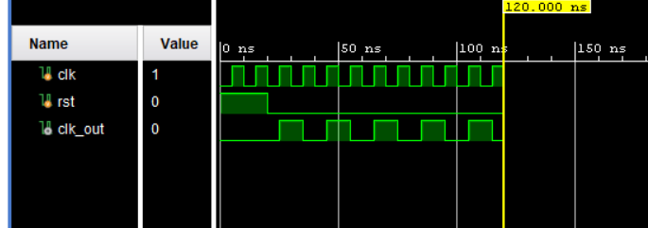
Figure 1: Clock division by 2
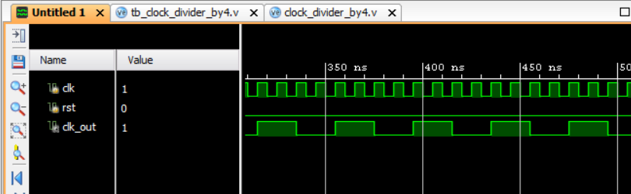

Figure 2: Clock division by 4

Result
The divide-by-2 (50 MHz) and divide-by-4 (25 MHz) clock divider circuits were successfully designed and simulated using Verilog RTL in Xilinx Vivado. XSIM results verified that the 100 MHz input clock was correctly divided to produce output frequencies of 50 MHz and 25 MHz, with corresponding periods of 20 ns and 40 ns, confirming the correct operation of both circuits.

