Exp. No. 3: Spectrum Analysis of Sub-1 GHz, Mid-band & mm Wave by Plotting Propagation Loss.
Objective:
1. To compute the Propagation Loss (dB) for Sub-1 GHz, Mid-band, and mm Wave frequency ranges using standard path loss models.
Objective 1: Matlab Code :
clc; clear; close all;
d = 0.1:0.1:5; % Distance (km)
f = [900 3500 28000]; % Frequency (MHz)
PL1 = 32.44 + 20*log10(f(1)) + 20*log10(d);
PL2 = 32.44 + 20*log10(f(2)) + 20*log10(d);
PL3 = 32.44 + 20*log10(f(3)) + 20*log10(d);
figure
% -------- Graph 1 --------
subplot(2,1,1)
plot(d,PL1,'b','LineWidth',2); hold on
plot(d,PL2,'r','LineWidth',2)
plot(d,PL3,'k','LineWidth',2)
title('Propagation Loss vs Distance')
xlabel('Distance (km)')
ylabel('Loss (dB)')
grid on
% -------- Graph 2 (NO legend used to avoid error) --------
subplot(2,1,2)
Freq = [900 3500 28000];
Loss = [PL1(10) PL2(10) PL3(10)];
plot(Freq,Loss,'-o','LineWidth',2)
title('Propagation Loss vs Frequency')
xlabel('Frequency (MHz)')
ylabel('Loss (dB)')
grid on
OUTPUT:
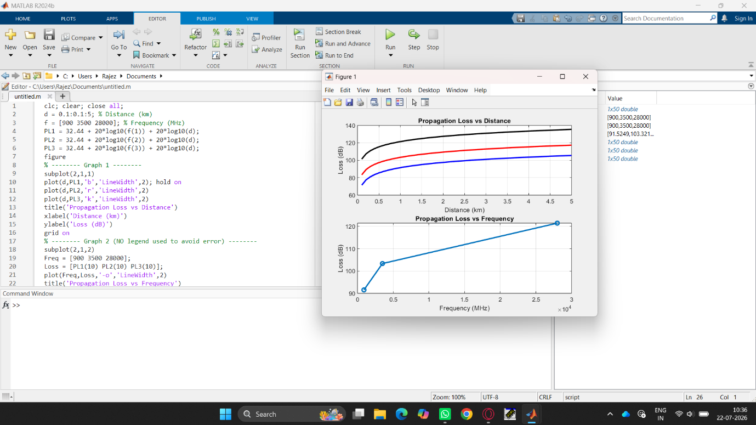
Objective:
2. To evaluate the impact of different Operating Frequencies (GHz) on signal attenuation and coverage performance.
Objective 2: Matlab Code :
clc; clear; close all;
d = 2; % fixed distance (km)
f = [900 3500 28000]; % MHz
PL = 32.44 + 20*log10(f) + 20*log10(d);
figure
% -------- Graph 1: Frequency vs Loss --------
subplot(2,1,1)
plot(f,PL,'-o','LineWidth',2)
title('Propagation Loss vs Operating Frequency')
xlabel('Frequency (MHz)')
ylabel('Propagation Loss (dB)')
grid on
% -------- Graph 2: Band Comparison --------
subplot(2,1,2)
bar(PL)
title('Comparison of Propagation Loss Across Bands')
xlabel('Frequency Bands (Index: 1=Sub-1GHz, 2=Mid-band, 3=mmWave)')
ylabel('Propagation Loss (dB)')
xticklabels({'Sub-1GHz','Mid-band','mmWave'})
grid on
OUTPUT:
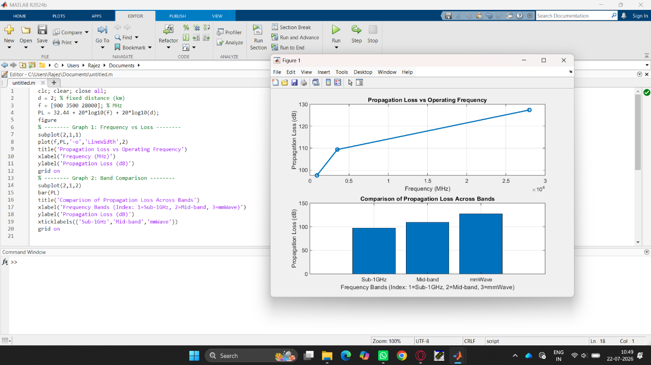

Objective:
3. To analyze how Communication Distance (km) affects propagation loss across different spectrum bands.
Objective 3: Matlab Code:
clc; clear; close all;
% Frequency bands (MHz)
f = [900 3500 28000];
% Distance (km)
d = 2;
% Propagation Loss (FSPL)
PL = 32.44 + 20*log10(f) + 20*log10(d);
figure
% -------- Graph 1: Simple Line Plot (SAFE) --------
subplot(2,1,1)
plot(f, PL, '-o', 'LineWidth', 2)
title('Propagation Loss vs Operating Frequency')
xlabel('Frequency (MHz)')
ylabel('Propagation Loss (dB)')
grid on
% -------- Graph 2: Safe Comparison Plot --------
subplot(2,1,2)
plot(1:3, PL, '-s', 'LineWidth', 2)
title('Band-wise Propagation Loss Comparison')
xlabel('Band Index (1=Sub1GHz, 2=Mid-band, 3=mmWave)')
ylabel('Propagation Loss (dB)')
grid on
OUTPUT:
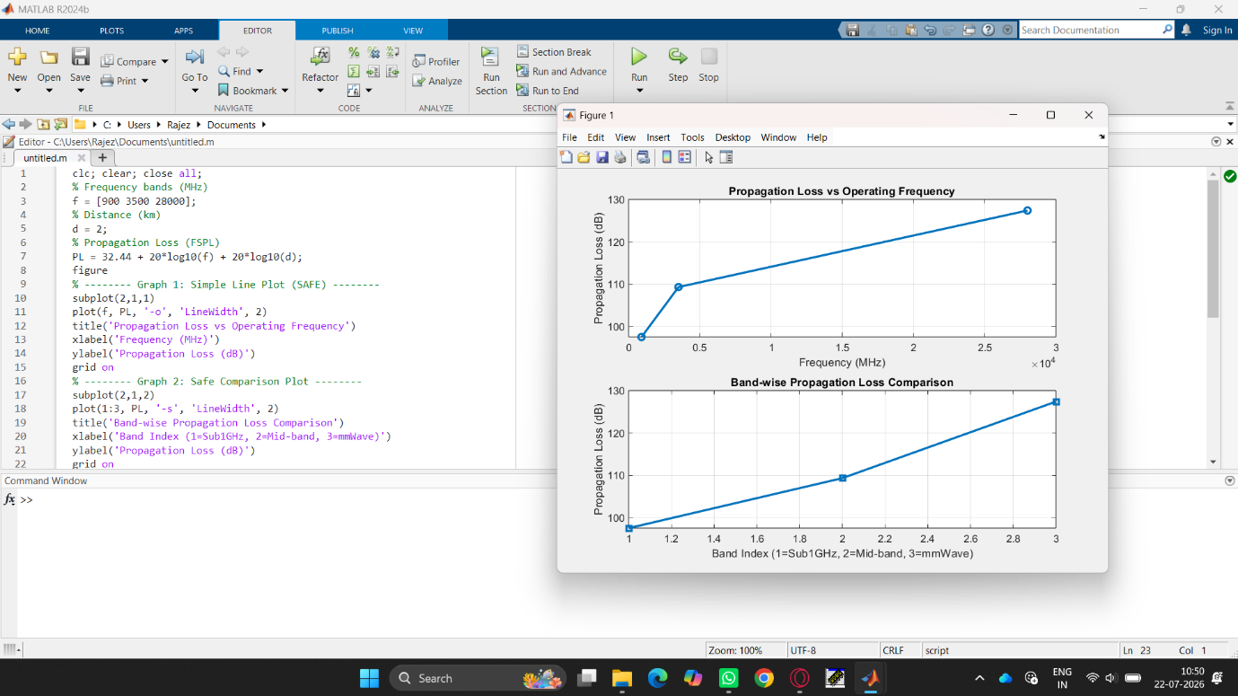

Result:
1. The propagation loss was successfully computed for Sub-1 GHz, Mid-band, and mm Wave frequency bands using the Free Space Path Loss (FSPL) model.
2. It was observed that propagation loss increases with increase in operating frequency, with mm Wave showing the highest attenuation and Sub-1 GHz showing the lowest loss.
3. The comparative analysis of spectrum bands clearly demonstrates that lower frequency bands are more suitable for long-range communication, while higher frequency bands require advanced techniques like beamforming for efficient performance.

