ECA08 – ANALOG AND DIGITAL COMMUNICATION
CO3 APPLICATION-ORIENTED ASSIGNMENT
DIGITAL VOICE AND DATA LINK DESIGN
From Sampling and Pulse Transmission to Deployment

ENGINEERING DESIGN REPORT
Submission detail | Information
Course code | ECA08
Course name | Analog and Digital Communication
Course outcome | CO3
Student name | K. Shalini
Register number | 192512270
Department / section | B.E.ECE

ABSTRACT
This report develops an engineering design for a digital communication system carrying industrial voice commands, control information and monitoring data. The specified voice bandwidth is 3.4 kHz, with a baseline sampling rate of 8 kHz, an 8-bit uniform quantizer and a bandwidth-limited channel affected by additive white Gaussian noise (AWGN) and inter-symbol interference (ISI). The report applies the Nyquist sampling criterion, calculates quantization parameters and SQNR, compares PCM, DPCM, DM, ADM and ADPCM, and evaluates PAM, PWM and PPM. It further investigates Nyquist zero-ISI pulse shaping, eye patterns, TDM/FDM multiplexing, digital modulation, MLSD, equalization and synchronization. The baseline 8-bit PCM stream is 64 kb/s per voice channel. A 32 kb/s ADPCM option is recommended where codec interoperability permits. Root-raised-cosine pulse shaping, adaptive MMSE equalization, timing recovery and QPSK are selected as a robust conceptual link architecture. VoIP, DSL and fibre-optic deployment require different access and multiplexing adaptations. All figures are analytical/modelled illustrations generated from stated assumptions; they are not claimed to be measured hardware outputs or proof of an executed MATLAB/Simulink run.

CONTENTS
- 1. Interpret the design requirement
- 2. Quantization and voice coding
- 3. PAM, PWM and PPM
- 4. ISI, Nyquist zero-ISI and eye pattern
- 5. Digital multiplexing and transmission
- 6. Digital modulation, MLSD, equalization and synchronization
- 7. VoIP, DSL and fibre-optic validation
- 8. MATLAB-oriented verification and final decision
- 9. Specification-verification table
- 10. Conclusion
- Appendix A – Calculations
- References
1. STAGE 1 – INTERPRET THE DIGITAL COMMUNICATION DESIGN REQUIREMENT

1.1 Given requirements and design assumptions
Parameter | Value | Design significance
Voice bandwidth | 3.4 kHz (given) | Required speech band.
Sampling rate | 8 kHz baseline (given) | Exceeds the 6.8 kHz Nyquist minimum.
Quantizer | 8-bit uniform (given) | 256 quantization levels.
Channel | Bandwidth-limited + AWGN + ISI | Requires pulse shaping, equalization and synchronization.
Baseline source coding | PCM | 64 kb/s per voice channel.
Rate-reduced option | 4-bit/sample ADPCM | 32 kb/s per channel if supported at both ends.
Multiplexing | Synchronous TDM baseline | Combines fixed-rate streams.
Digital modulation | QPSK conceptual baseline | Robust power-efficient choice versus higher-order QAM.

1.2 End-to-end communication block diagram
Transmitter | Channel | Receiver
Microphone/voice source → anti-aliasing low-pass filter → sampler/sample-and-hold → quantizer → PCM/ADPCM encoder → framing/TDM multiplexer → channel coding → QPSK modulator → pulse shaping | Bandwidth limitation, AWGN, attenuation and ISI | Matched filter → timing recovery → equalizer/MLSD → QPSK demodulator → channel decoder → frame/TDM demultiplexer → voice decoder → reconstruction low-pass filter → speaker/control output

The transmitter converts the analogue voice into a sequence of digital symbols. The physical channel may spread pulses, add noise and introduce timing distortion. The receiver synchronizes, compensates for channel distortion, detects the symbols and reconstructs the information.

1.3 Nyquist sampling calculation
Given fmax = 3.4 kHz. Nyquist minimum sampling frequency: fs(min) = 2fmax = 2 × 3.4 = 6.8 kHz. The selected fs = 8 kHz is greater than 6.8 kHz and therefore satisfies the ideal sampling criterion. Sampling interval Ts = 1/8000 = 125 μs. The margin above the minimum is 1.2 kHz.
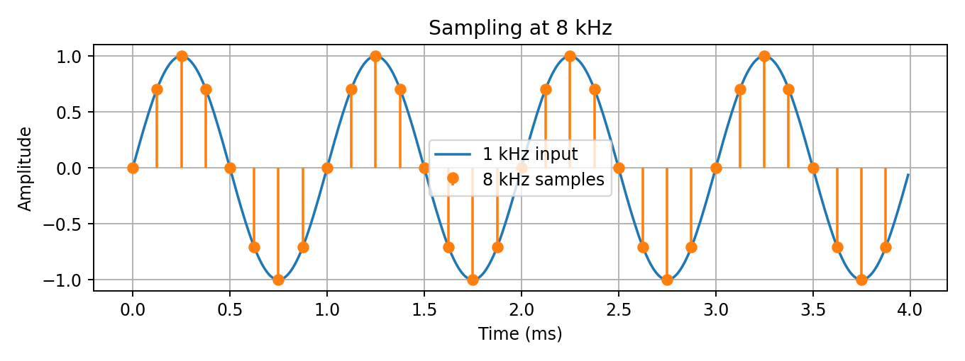
Figure 1. Sampling of an illustrative 1 kHz component at 8 kHz.

1.4 Anti-aliasing filter and under-sampling
An anti-aliasing low-pass filter is placed before the sampler. At fs = 8 kHz, the Nyquist frequency is 4 kHz. The filter should pass the required voice band up to approximately 3.4 kHz and attenuate unwanted components approaching or exceeding 4 kHz. A practical filter requires a transition band and sufficient stop-band attenuation.
If a 6 kHz tone is sampled at 8 kHz, the samples correspond to an apparent 2 kHz tone. This is aliasing because the input component is above the 4 kHz Nyquist frequency.
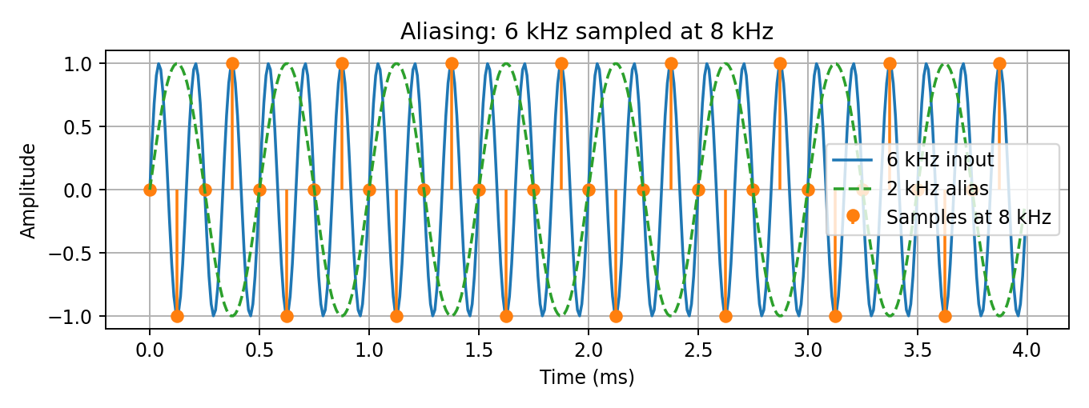
Figure 2. Aliasing: a 6 kHz input sampled at 8 kHz appears as a 2 kHz component.

1.5 Initial information bit rate
For 8-bit PCM at 8,000 samples/s: Rb = fs × bits/sample = 8,000 × 8 = 64,000 bit/s = 64 kb/s per voice channel. This is the uncoded payload rate; framing, error-control coding and physical-layer overhead increase the transmitted rate.

1.6 Bandwidth, noise, ISI, timing and implementation constraints
- Bandwidth: the channel must accommodate symbol rate and pulse-shaping roll-off.
- Noise: AWGN reduces detection reliability; adequate SNR and possibly error-control coding are required.
- ISI: channel dispersion causes adjacent pulses to overlap; pulse shaping and equalization reduce it.
- Timing: sampling instants must align with symbol centres; timing error reduces eye opening.
- Implementation: codec, filter, equalizer and synchronization complexity must be balanced against cost, power and latency.
- Application: VoIP emphasizes low delay and packet handling; DSL has copper-loop attenuation and frequency-selective distortion; fibre links emphasize capacity and optical receiver performance.

1.7 VoIP, DSL and fibre requirements

Application | Main requirements | Design implication
VoIP | Low delay, jitter/loss control, voice quality and bandwidth efficiency | Codec selection, packetization, jitter buffer and QoS; PCM is a baseline, not always the most efficient payload.
DSL | Copper attenuation, crosstalk, frequency-selective channel and ISI | DMT multicarrier transmission, channel estimation, per-tone bit loading and adaptive equalization.
Fibre optic | High data rate, optical attenuation/dispersion and receiver recovery | Optical modulation/detection, suitable multiplexing, dispersion/equalization and clock recovery.

1.8 Digital communication design requirement statement
The system shall acquire a 3.4 kHz voice signal through an anti-aliasing filter and sample it at 8 kHz. The baseline quantizer shall use 8 bits and 256 levels, producing 64 kb/s PCM per voice channel. A 32 kb/s ADPCM mode may be used when codec interoperability and quality requirements permit. The channel is assumed to introduce AWGN and ISI; pulse shaping, receiver equalization, frame synchronization and timing recovery are therefore required. Synchronous TDM is selected for fixed-rate aggregation. The system objective is intelligible voice reconstruction, acceptable error performance, efficient bandwidth use and adaptation to VoIP, DSL and fibre-optic deployment.

2. STAGE 2 – QUANTIZATION AND VOICE-CODING TECHNIQUE

2.1 8-bit uniform quantizer
For n = 8 bits, the number of quantization levels is L = 2^8 = 256. Assume a normalized input range from −1 V to +1 V, giving a full-scale range of 2 V. Step size Δ = (Vmax − Vmin)/L = 2/256 = 0.0078125 V. The ideal maximum absolute quantization error is Δ/2 = 0.00390625 V (excluding overload/clipping).
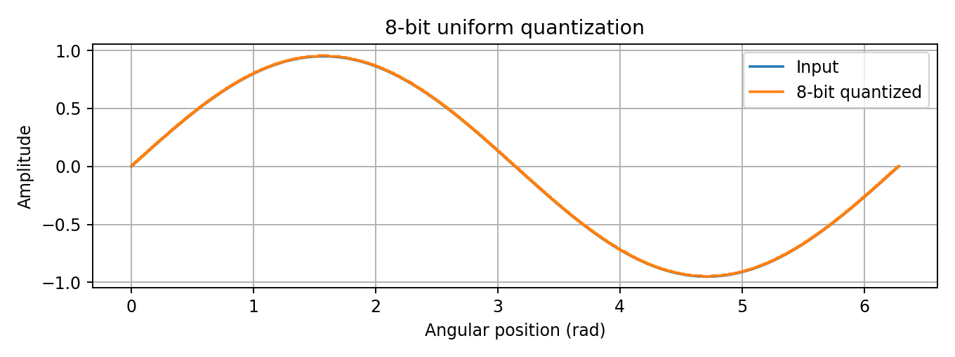
Figure 3. Illustrative input and 8-bit uniform quantized output.

2.2 Theoretical SQNR
For a full-scale sinusoidal input and an ideal n-bit uniform quantizer, SQNR(dB) ≈ 6.02n + 1.76. For n = 8: SQNR ≈ 6.02(8) + 1.76 = 49.92 dB. This is a theoretical full-scale sine-wave estimate. A simulated result depends on input amplitude, clipping, quantizer convention and signal statistics; a smaller input amplitude generally gives lower SQNR with a fixed step size.

2.3 PCM operation and serial output
PCM independently quantizes each sample and represents the result by an 8-bit binary code. The binary words are transmitted serially. PCM offers predictable quality and straightforward regeneration, but requires 64 kb/s at 8 kHz sampling.
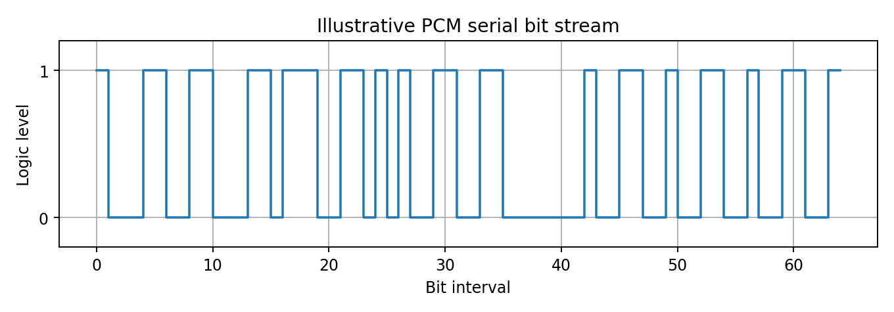
Figure 4. Example serial PCM bit stream; bit pattern is illustrative.

2.4 Comparison of PCM, DPCM, DM, ADM and ADPCM
Technique | Operation | Rate trend | Main limitation | Evaluation
PCM | Each sample is quantized and encoded independently | 8 × 8 kHz = 64 kb/s | Quantization noise | Simple, robust reference and widely interoperable.
DPCM | Encodes prediction error/difference | Can use fewer bits/sample than PCM | Prediction error and predictor mismatch | Exploits correlation between adjacent samples.
DM | One bit indicates increase or decrease | 1 bit/sample; nominal 8 kb/s at 8 kHz | Slope-overload and granular noise | Very simple; step size is critical.
ADM | Adapts delta step to signal activity | Often 1 bit/sample | Residual granular/slope-overload effects | Improves DM when signal slope varies.
ADPCM | Predicts signal and adaptively quantizes prediction error | 4-bit example: 32 kb/s | Quantization and predictor limitations | Good rate/quality compromise when compatible codec is available.

2.5 Coding selection and trade-off
Recommended: 32 kb/s ADPCM (4 bits/sample) as a rate-saving operating mode, while retaining 64 kb/s PCM as the baseline and fallback. ADPCM rate = 8,000 × 4 = 32,000 bit/s. This halves the raw payload rate compared with 8-bit PCM. Exact voice quality and interoperability depend on the selected ADPCM profile and implementation.
PCM is retained when simplicity and compatibility dominate. DPCM can reduce redundancy but depends on prediction. DM and ADM have low nominal rates but can suffer slope-overload and granular noise. ADPCM provides a practical compromise for voice.
Decision 1 | Selected technique | Reason
Voice coding | 4-bit ADPCM (32 kb/s) where supported; 8-bit PCM baseline | Halves raw payload rate relative to PCM; PCM remains the compatibility/reference mode.

3. STAGE 3 – PAM, PWM AND PPM DESIGN

3.1 Principles and generated waveforms
PAM varies pulse amplitude according to the message. PWM varies pulse duration/width. PPM varies pulse position in time while ideally maintaining fixed amplitude and width.
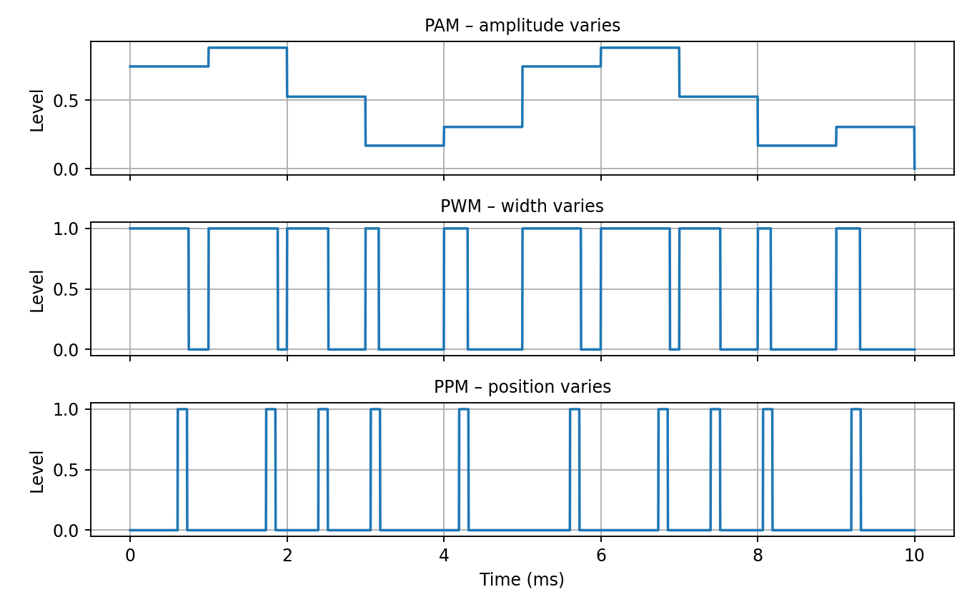
Figure 5. Analytical PAM, PWM and PPM waveforms generated from a common low-frequency message.

3.2 Comparative performance
Parameter | PAM | PWM | PPM
Information variable | Amplitude | Pulse width | Pulse position
Noise immunity | Sensitive to amplitude noise | Less sensitive to amplitude changes with threshold detection | Amplitude robust; timing noise matters
Bandwidth | Often lower than PWM/PPM | Can require wider bandwidth due to variable edges | Often high; depends on timing resolution
Synchronization | Moderate | Moderate | High
Power / hardware | Amplitude linearity required | Constant pulse amplitude; duty cycle varies | Constant amplitude/width; timing varies
Complexity | Low | Moderate | Higher timing complexity

3.3 Industrial control selection
PWM is recommended for actuator or motor-speed control. It represents the command through duty cycle while pulse amplitude remains approximately constant. A timer or low-pass filter can recover the duty cycle. PWM is convenient for switching power drivers and is less sensitive than PAM to moderate amplitude variations. The PWM frequency must be chosen to suit the driver, switching losses and mechanical response.
PAM is directly affected by gain and amplitude noise. PPM is amplitude-robust but needs accurate timing and may consume more bandwidth. A control technique is not necessarily the best voice/data technique: voice requires faithful reconstruction and coding efficiency, while a motor controller often needs a robust duty-cycle command.

3.4 Amplitude noise, timing jitter and pulse distortion
- Amplitude noise changes PAM pulse heights and may cause incorrect amplitude decisions.
- Timing jitter shifts PWM edges and PPM positions, changing duty cycle or symbol timing.
- Finite channel bandwidth rounds edges, alters pulse widths and may cause adjacent pulses to overlap.
- Use suitable thresholding, filtering, timing margin and error detection; a control receiver should enter a defined safe state after invalid commands.

3.5 RCC Standard 106-20 Annex A-1
The assignment requests a PAM discussion with reference to RCC Standard 106-20 Annex A-1. The supplied assignment document does not reproduce the annex clauses or test limits. Therefore, this report does not invent a clause number or claim compliance. PAM is discussed here as an amplitude-bearing pulse technique; any formal compliance statement must be checked against the official standard text.
Decision 2 | Selected technique | Reason
Industrial control | PWM | Duty-cycle representation suits motor/actuator control and timer-based decoding; timing distortion remains a design constraint.

4. STAGE 4 – ISI, NYQUIST ZERO-ISI AND EYE PATTERN

4.1 Inter-symbol interference
ISI occurs when the response to one transmitted symbol extends into adjacent symbol intervals. A bandwidth-limited channel spreads pulses in time, so the receiver sample contains contributions from neighbouring symbols. This increases detection errors.

4.2 Nyquist zero-ISI criterion
For the overall response g(t) of transmitter filter, channel and receiver filter, the Nyquist condition is g(0) = 1 at the desired sampling instant and g(kT) = 0 for all non-zero integer k, where T is the symbol interval. At the correct sampling instant, all other symbols then contribute zero ISI.
Raised-cosine pulse shaping is a common zero-ISI method. Its roll-off factor α controls excess bandwidth. Ideal baseband bandwidth is B = (1 + α)Rs/2. Lower α saves bandwidth but requires longer/more sensitive filters; higher α uses more bandwidth but eases practical filter design.
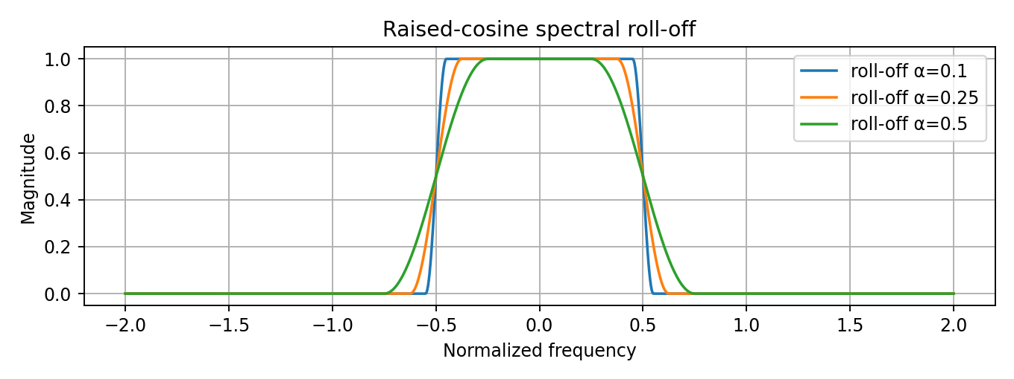
Figure 6. Raised-cosine spectrum illustration showing roll-off and bandwidth trade-off.

4.3 Eye pattern analysis
An eye diagram overlays many waveform segments over a common symbol interval. A wide-open eye indicates good noise and timing margin. Eye height represents vertical decision/noise margin; eye width represents timing margin. AWGN, ISI and jitter close the eye and increase symbol-error probability.
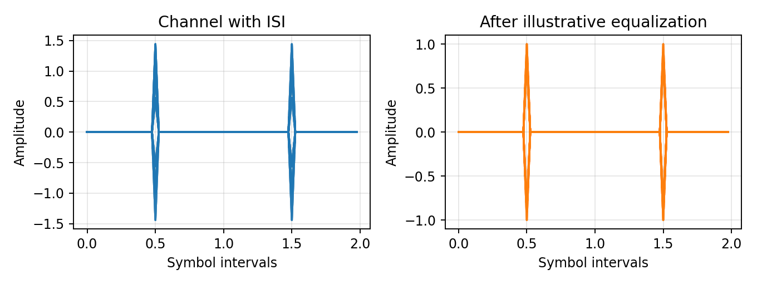
Figure 7. Modelled eye patterns with channel ISI and after a simple illustrative equalization operation; not measured channel data.

4.4 Pulse shaping and equalization alternatives
Method | Function | Advantages | Limitations
Raised-cosine / root-raised-cosine | Controls spectrum and gives Nyquist response when Tx/Rx filters are paired | Limits bandwidth and ideal sampling-time ISI | Requires timing accuracy; practical truncation leaves residual ISI.
Zero-forcing linear equalizer | Attempts to invert channel response | Can remove linear channel distortion | May amplify noise near channel spectral nulls.
MMSE equalizer | Minimizes combined mean-square error | Balances residual ISI and noise enhancement | Needs channel/noise estimates.
Decision-feedback equalizer | Uses past decisions to cancel post-cursor ISI | Can avoid some linear equalizer noise enhancement | Decision errors can propagate.
MLSD / Viterbi | Finds most likely symbol sequence for a channel-memory model | Strong sequence detection in channels with memory | Complexity grows with channel memory and constellation size.

Recommended baseline: root-raised-cosine transmit/receive filtering with adaptive MMSE equalization. Consider DFE or MLSD if measured channel memory and performance requirements justify added complexity. Eye closure reduces the receiver's timing and threshold margin; noise or timing error can move a sample across the decision boundary.
Decision 3 | Selected approach | Reason
Pulse shaping / equalization | Root-raised-cosine with adaptive MMSE; optional DFE/MLSD | Controls bandwidth and ideal sampling-time ISI; MMSE balances channel correction against noise enhancement.

5. STAGE 5 – DIGITAL MULTIPLEXING AND TRANSMISSION ARCHITECTURE

5.1 Digital multiplexer
A digital multiplexer combines multiple source streams into one higher-rate stream. In synchronous TDM, each source receives a recurring time slot. At the receiver, frame synchronization identifies the frame boundary and routes each slot to the correct output.
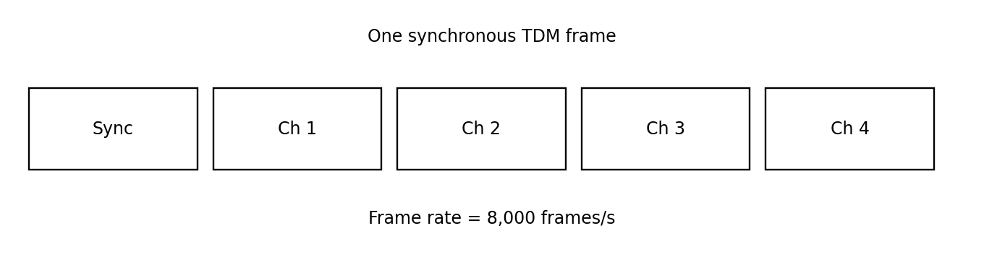
Figure 8. Illustrative synchronous TDM frame with four voice slots and a synchronization field.

5.2 TDM aggregate bit-rate calculation
Assume four voice channels, each using 8-bit PCM at 8 kHz. Each channel produces 64 kb/s. One sample from each channel is inserted in each frame. With four 8-bit slots and one framing bit per frame, each frame contains 4 × 8 + 1 = 33 bits. Frame rate = 8,000 frames/s. Aggregate rate = 33 × 8,000 = 264,000 bit/s = 264 kb/s. Payload alone is 4 × 64 = 256 kb/s.
If 32 kb/s ADPCM is used per channel, four payload streams total 128 kb/s; framing and line/packet overhead must be added separately.

5.3 TDM and FDM comparison
Feature | TDM | FDM
Allocation | Users occupy different time slots | Users occupy different frequency bands
Synchronization | Frame and slot timing | Frequency stability and channel separation
Guard requirement | Guard time may be used | Guard bands separate channels
Scalability | Add slots or increase frame capacity | Allocate additional spectrum
Typical use | Digital fixed-rate streams | Radio, broadcast and frequency-division access
Complexity | Timing, framing and buffering | Filters, oscillators and frequency planning

5.4 Application mapping
- VoIP: IP packet/statistical multiplexing is common; codec rate, packet interval, headers and QoS determine network load. TDM is a useful fixed-rate design model.
- DSL: DMT divides copper spectrum into orthogonal subcarriers and adapts bit loading to each subcarrier's channel quality.
- Fibre: TDM aggregation, wavelength-division multiplexing (WDM), or both may be used. WDM carries parallel channels on separate optical wavelengths.
Decision 4 | Selected architecture | Reason
Multiplexing | Synchronous TDM baseline; packet multiplexing for VoIP; WDM for high-capacity fibre | TDM gives deterministic recurring slots; actual network architecture is adapted to the access/backbone medium.

6. STAGE 6 – DIGITAL MODULATION, MLSD, EQUALIZATION AND SYNCHRONIZATION

6.1 Digital modulation comparison
Scheme | Bits/symbol | Bandwidth / power behaviour | Complexity and use
BPSK | 1 | Robust and power efficient; lower spectral efficiency | Low complexity; robust low-rate link.
QPSK | 2 | Good power efficiency; twice BPSK bit efficiency at same symbol rate | Moderate; selected robust baseline.
16-QAM | 4 | Higher spectral efficiency; requires higher SNR and linearity | Higher receiver complexity.
64-QAM | 6 | High spectral efficiency; more sensitive to noise and phase error | High complexity; strong channel conditions required.

Higher modulation order transmits more bits per symbol but places constellation points closer together. This reduces noise margin and requires higher SNR, more accurate synchronization and more complex receiver processing.

6.2 Selected digital modulation
QPSK is selected as a robust conceptual baseline. It carries two coded bits per symbol. For an uncoded 64 kb/s stream, the ideal symbol rate is 32 ksymbols/s before framing, channel coding and overhead. With raised-cosine shaping, ideal baseband bandwidth is B ≈ (1 + α)Rs/2; actual occupied RF/IF bandwidth depends on the physical implementation.

6.3 Equalization
Equalization compensates channel distortion that causes ISI. The receiver estimates the channel impulse response and applies a filter to reduce delayed signal components. Zero-forcing attempts to invert the channel but may amplify noise near spectral nulls. MMSE balances residual ISI and noise. DFE cancels estimated post-cursor ISI using previously detected symbols.

6.4 Maximum Likelihood Sequence Detection
MLSD estimates the most likely transmitted sequence given received samples and a channel model. For a finite-memory ISI channel, the receiver evaluates candidate state transitions and accumulates path metrics. The Viterbi algorithm can find the minimum-metric path. MLSD can outperform symbol-by-symbol detection in channels with memory, but its complexity rises with channel memory and constellation size.

6.5 Timing synchronization and carrier recovery
Timing recovery estimates the correct symbol sampling instants. Early or late sampling moves the sample away from the eye centre and increases adjacent-symbol interference. Carrier recovery estimates frequency and phase offset for coherent QPSK. Frequency offset rotates the constellation over time; phase error rotates constellation points and can cause incorrect decisions.
- Timing error reduces the eye width and timing margin.
- Carrier frequency offset causes a steadily rotating constellation.
- Carrier phase error rotates received points relative to the decision boundaries.
- Loss of lock or cycle slips can cause bursts of errors and require reacquisition.
Decision 5 | Selected methods | Reason
Modulation | QPSK | Robust baseline with two bits per symbol and lower SNR demand than higher-order QAM.
Equalization | Adaptive MMSE; optional DFE/MLSD | Balances residual ISI and noise enhancement; advanced detection is available for difficult channels.
Synchronization | Frame/preamble synchronizer, timing recovery loop and carrier phase/frequency recovery | Provides frame boundaries, symbol-centre sampling and coherent QPSK detection.

7. STAGE 7 – APPLICATION VALIDATION FOR VoIP, DSL AND FIBRE OPTICS
Design element | VoIP | DSL | Fibre optic
Voice coding | PCM or compatible low-rate codec; minimize delay | Voice is carried as payload over access link | Voice is carried as payload in optical transport
Multiplexing | IP packet/statistical multiplexing | DMT multicarrier with per-tone bit loading | TDM and/or WDM
Main impairments | Packet loss, jitter, congestion and codec delay | Copper attenuation, crosstalk, frequency-selective fading and ISI | Optical attenuation, chromatic dispersion, polarization effects and receiver noise
Equalization / recovery | Physical access equalization; jitter buffer and packet-loss concealment | Adaptive frequency-domain equalization and channel estimation | Optical/electrical equalization and dispersion compensation as required
Synchronization | Packet timing and playout clock | Symbol timing, frame alignment and multicarrier synchronization | High-precision clock/symbol recovery; coherent systems also recover carrier phase
Recommendation | Low-delay codec, packetization, QoS and jitter buffer | DMT, channel estimation, bit loading and adaptive equalization | Optical modulation, FEC, receiver recovery and WDM where required

7.1 Engineering recommendations
- VoIP: choose a codec for voice quality and interoperability. Keep packetization delay low, apply QoS and jitter buffering, and monitor loss and latency. The 64 kb/s PCM stream is a baseline rather than a universal VoIP payload.
- DSL: use DMT with per-subcarrier bit loading and adaptive equalization because the copper channel is frequency selective and varies with loop length and interference.
- Fibre optic: select optical transmission and multiplexing for the required capacity and reach. Apply suitable FEC, dispersion/equalization and clock/carrier recovery; WDM can increase capacity.

7.2 Common, optional and unsuitable techniques
Sampling, quantization, source coding, framing and synchronization are common functional concepts. PWM is useful for control signalling but does not replace a voice codec. DMT is associated with DSL-style multicarrier access, while WDM is a fibre multiplexing method. The physical modulation and equalizer must match the medium.

8. STAGE 8 – MATLAB VERIFICATION AND FINAL ENGINEERING DECISION

8.1 Verification plan
The following tests can be implemented in MATLAB/Simulink or an equivalent tool. Figures in this report are analytical/modelled illustrations created from the assumptions and calculations; they are not a MATLAB execution log.
Test | Model/input | Expected output and check
Sampling/aliasing | 3.4 kHz band-limited input, fs=8 kHz; test 6 kHz tone | Correct in-band sampling; aliasing when components exceed 4 kHz without anti-alias filtering.
Quantization | Normalized sine, 8-bit uniform quantizer | 256 levels; Δ=0.0078125 V for ±1 V; error ≤0.00390625 V.
PCM and voice coding | Encode/decode same input using PCM, DPCM, DM, ADM and ADPCM | Compare reconstructed waveforms, bit rate, MSE and SQNR.
PAM/PWM/PPM | Common message input | Three labelled waveforms; compare amplitude, width and position.
AWGN/ISI | Add Gaussian noise and finite-memory channel | Degraded waveform, eye closure and BER/SER versus SNR.
Pulse shaping | Root-raised-cosine Tx/Rx filters | Reduced out-of-band energy and open eye at correct sampling instants.
Equalization | No equalizer, ZF and MMSE/DFE | Compare eye opening and BER/SER; note ZF noise enhancement.
Synchronization | Apply timing offset and carrier phase/frequency offset | Show impairment and recovery after synchronization.

8.2 Interpretation of included outputs
Figure 1 demonstrates 8 kHz sample timing. Figure 2 shows why anti-alias filtering is necessary. Figure 3 shows discrete quantizer levels. Figure 4 illustrates a PCM bit sequence. Figure 5 compares PAM, PWM and PPM. Figure 6 shows the raised-cosine roll-off trade-off. Figure 7 illustrates eye closure from channel memory and the conceptual effect of equalization. Figure 8 shows a TDM frame. The numerical calculations provide theoretical checks for a future MATLAB/Simulink implementation.

8.3 Final engineering decision – YES, with validation conditions
Deployment decision: YES, subject to channel-specific validation. The 8 kHz sampling rate exceeds the 6.8 kHz Nyquist minimum. An 8-bit uniform quantizer gives 256 levels, a theoretical full-scale sinusoidal SQNR of approximately 49.92 dB and a baseline 64 kb/s PCM rate per channel. ADPCM can reduce payload to 32 kb/s where both ends support the same codec profile.
For the digital channel, root-raised-cosine pulse shaping, adaptive MMSE equalization, timing recovery and coherent QPSK form a reasonable robust baseline. TDM suits fixed-rate aggregation; practical VoIP uses packet multiplexing, DSL uses DMT and fibre links may use TDM/WDM. Deployment should proceed only after measured BER/SER, end-to-end delay, voice quality, channel bandwidth, eye opening and synchronization margin satisfy the system requirements.
If measured channel performance is inadequate, redesign may include a lower-rate codec, stronger channel coding, lower-order modulation, a more capable equalizer/MLSD receiver, a different roll-off factor or a higher-capacity channel. These changes trade bandwidth, latency, complexity and power.

9. FINAL SPECIFICATION-VERIFICATION TABLE
Parameter | Selected value | Verification / status
Voice bandwidth | 3.4 kHz | Given requirement retained.
Nyquist minimum | 6.8 kHz | 2 × 3.4 kHz.
Sampling rate | 8 kHz | Passes ideal Nyquist criterion; Ts=125 μs.
Quantizer | 8-bit uniform | 256 levels.
Step size | 0.0078125 V (−1 V to +1 V) | Calculated.
Maximum quantization error | ±0.00390625 V | Ideal quantizer bound.
Theoretical SQNR | 49.92 dB | Full-scale sinusoidal approximation.
PCM rate | 64 kb/s/channel | 8,000 × 8.
ADPCM example | 32 kb/s/channel | 8,000 × 4; codec quality depends on implementation.
Control pulse method | PWM | Selected for duty-cycle motor/actuator control.
Pulse shaping | Root-raised-cosine | Nyquist pulse-shaping choice; select α to fit bandwidth.
Equalization | Adaptive MMSE; optional DFE/MLSD | Conceptual selection; validate on channel model.
Four-channel TDM | 264 kb/s with 1 framing bit/frame | (4×8 + 1) × 8,000.
Digital modulation | QPSK | Robust conceptual baseline.
Synchronization | Frame, timing and carrier recovery | Required at receiver; loop parameters to be designed.
Application mapping | VoIP packet; DSL DMT; fibre TDM/WDM | Adapted to application.
Simulation status | Analytical/modelled graphs included | Actual MATLAB/Simulink execution and measured BER/SER remain to be performed.

10. CONCLUSION
The design has been developed from the specified 3.4 kHz voice bandwidth, 8 kHz baseline sampling and 8-bit quantization. The Nyquist minimum is 6.8 kHz, so 8 kHz is suitable under ideal band-limited assumptions. The baseline PCM rate is 64 kb/s per voice channel and theoretical full-scale sine SQNR is approximately 49.92 dB. ADPCM is a lower-rate option when codec compatibility is available.
PWM is selected for the industrial control example because it represents commands through duty cycle. For the digital link, Nyquist pulse shaping, equalization, timing recovery and QPSK provide a practical conceptual baseline. TDM illustrates fixed-rate aggregation, while deployment adapts to packet multiplexing in VoIP, DMT in DSL and TDM/WDM in fibre. The final recommendation is to proceed after channel-specific simulation and testing confirm bandwidth, BER/SER, delay, voice quality and synchronization margins.

APPENDIX A – CALCULATION SUMMARY
Quantity | Calculation | Result
Nyquist sampling minimum | 2 × 3.4 kHz | 6.8 kHz
Sampling interval | 1/8000 | 125 μs
Quantization levels | 2^8 | 256
Quantizer step | 2/256 | 0.0078125 V
Max. quantization error | Δ/2 | 0.00390625 V
SQNR | 6.02×8+1.76 | 49.92 dB
PCM rate | 8,000×8 | 64 kb/s
ADPCM example | 8,000×4 | 32 kb/s
Four-channel payload | 4×64 kb/s | 256 kb/s
TDM with framing | (4×8+1)×8,000 | 264 kb/s

REFERENCES
- [1] H. Nyquist, “Certain Topics in Telegraph Transmission Theory,” Transactions of the AIEE, vol. 47, pp. 617–644, 1928.
- [2] C. E. Shannon, “Communication in the Presence of Noise,” Proceedings of the IRE, vol. 37, no. 1, pp. 10–21, 1949.
- [3] J. G. Proakis and M. Salehi, Digital Communications, 5th ed., McGraw-Hill, 2008.
- [4] B. Sklar, Digital Communications: Fundamentals and Applications, 2nd ed., Prentice Hall, 2001.
- [5] A. V. Oppenheim and R. W. Schafer, Discrete-Time Signal Processing, 3rd ed., Pearson, 2010.
- [6] ITU-T Recommendation G.726, 40, 32, 24, 16 kbit/s Adaptive Differential Pulse Code Modulation (ADPCM).
- [7] ITU-T Recommendation G.711, Pulse Code Modulation (PCM) of Voice Frequencies.
- [8] ITU-T Recommendation G.992.1, Asymmetric Digital Subscriber Line (ADSL) Transceivers.
- [9] RCC Standard 106-20, Annex A-1. Consult official text for applicable PAM requirements; clause-level compliance is not asserted.

