Experiment No. 1 Generation and Classification of Continuous-Time and Discrete-Time Signals
(i) To generate and visualize basic continuous-time signals such as unit step, unit impulse, ramp, sinusoidal, and exponential signals.
Output Graphs
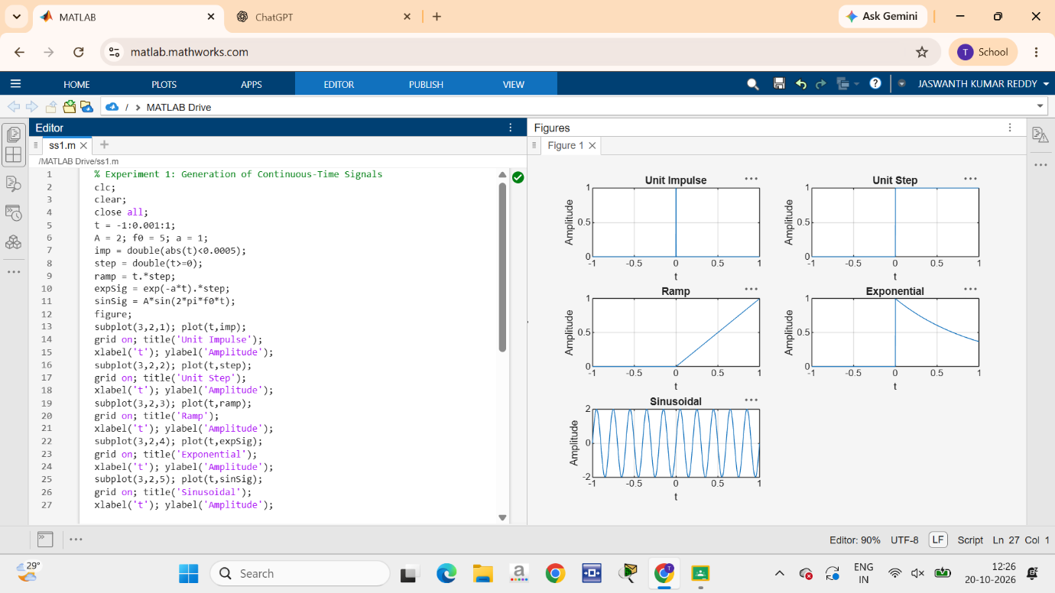
(ii) To generate and visualize basic discrete-time signals and analyze their amplitude and their time-index characteristics; Output Graphs:
