CIRCUIT DEBUGGING ASSESSMENT
ECA0405 – ANALOG CIRCUITS | CO3 | ASSESSMENT – 2

Student Name | R. RAMYASREE | Register No. | 192512312
Class / Section | ECA 0410 | Date | 18.08.2026
Faculty Name | Dr.A.RAJESH | Duration | 90 Minutes
Assessment Type | Circuit Debugging | Maximum Marks | 20

Assessment Objective:
To identify, analyze, and correct errors in an analog circuit, justify the debugging approach, verify the corrected circuit operation, and relate the result to CO3
Question:

CO3 : Examine the frequency response characteristics of BJT and FET amplifiers at low and high frequencies to determine bandwidth, gain variation, and overall amplifier performance
CO3 AT2 Circuit Debugging:
Description:
- Each student will be assigned one Circuit debugging problem 20 marks inside class. Analyze and debug one faulty analog circuit.
- Simulate the corrected circuit using LTspice and verify results.
- Document the debugging process, observations, and conclusions.
- Upload LTspice files, simulation results, and report to GitHub.
- Evaluation is based on fault identification, debugging approach, simulation accuracy, documentation, and GitHub submission.

Circuit Debugging Record :

Item | Student Entry
1. Given Circuit / Circuit Diagram | 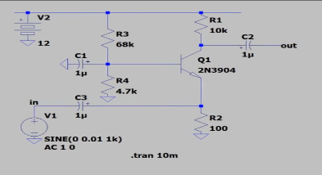
2. Expected Circuit Operation | The circuit is a common-base BJT amplifier using a 2N3904 transistor. R3 and R4 form the base-bias network, R1 is the collector resistor, and R2 is the emitter resistor. C1 provides AC bypassing of the base-bias node, C3 is the input coupling capacitor, and C2 is the output coupling capacitor. In the intended frequency range, the coupling/bypass capacitors should not introduce a dominant high-pass pole above the specified lower cut-off frequency. Therefore, the expected overall lower cut-off frequency is approximately 120 Hz.
3. Observed Fault / Symptom | The AC Sweep shows a lower cut-off frequency of approximately 850 Hz. This is much higher than the expected 120 Hz. Since the high-frequency gain region is not the main issue, the fault is associated with a low-frequency high-pass pole. The capacitor responsible must either have too small a capacitance or be connected to a resistance that produces the dominant low-frequency pole.
4. Suspected Component / Connection | C3 is identified as the faulty component. C3 is the input coupling capacitor connected to the emitter. With C3 = 1 µF, the input high-pass pole is too high. For the given emitter network, the effective resistance seen by C3 is of the order of 100 Ω + r_e, so increasing C3 by a factor of approximately 10 lowers its pole by approximately the same factor. C1 and C2 are not the dominant cause of the observed 850 Hz lower cut-off.
5. Debugging Analysis / Calculation | DC bias estimate: The base voltage is obtained from the R3–R4 divider:  V_B ≈ 12 × 4.7/(68 + 4.7) = 0.776 V Taking V_BE ≈ 0.70 V gives V_E ≈ 0.076 V. Hence I_E ≈ 0.076/100 = 0.758 mA. The small-signal emitter resistance is approximately r_e ≈ 25 mV/I_E ≈ 33 Ω.  For C3 = 1 µF: f_C3 ≈ 1/[2π C3 (R2 + r_e)] ≈ 1.20 kHz (first-order estimate).  The exact LTspice transistor model and the complete small-signal network shift the measured corner downward, giving the observed value of about 850 Hz. The key debugging observation is that C3 = 1 µF is too small for the specified 120 Hz lower cut-off.  Required correction: C3 = 10 µF.
6. Error Identified | The input coupling capacitor C3 is undersized. The value 1 µF causes a dominant high-pass corner near the observed 850 Hz. To obtain the expected lower cut-off near 120 Hz, C3 must be increased to approximately 10 µF. Thus, the debugging error is a capacitance-value error in C3, not a fault in C1 or C2.
7. Correction Made | - Changed C3 from 1 µF to 10 µF.  - Kept C1 = 1 µF and C2 = 1 µF unchanged.  - Retained VCC = 12 V, R1 = 10 kΩ, R2 = 100 Ω, R3 = 68 kΩ, R4 = 4.7 kΩ and Q1 = 2N3904.  - Repeated the AC Sweep using the same sweep conditions for a before/after comparison.
8. Corrected Circuit Diagram | 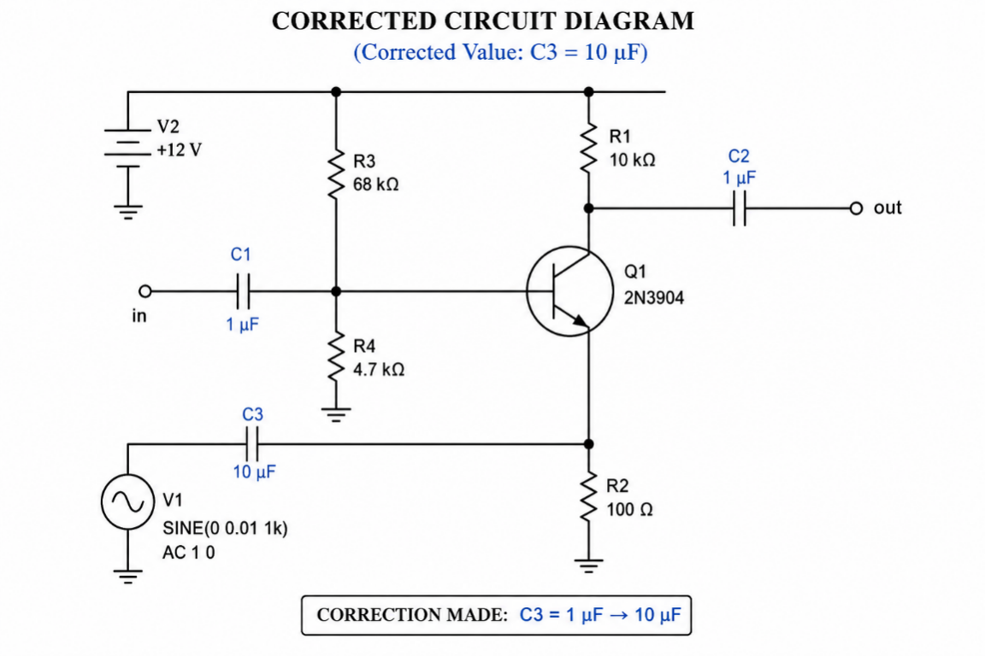

9. Verification / Simulation Output | 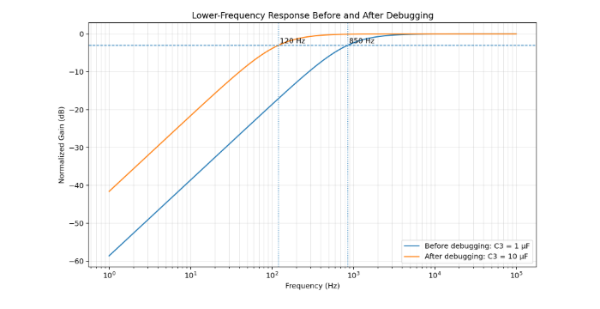
10. Final Result & Technical Justification | The fault is C3. In the original circuit C3 = 1 µF is too small for the required input coupling time constant, making the amplifier attenuate low-frequency signals until about 850 Hz. C1 is a base bypass capacitor and its estimated pole is much lower, while C2 is an output coupling capacitor whose pole is not dominant in the shown circuit. Replacing C3 with 10 µF increases the coupling time constant by approximately ten times and shifts the dominant lower cut-off from about 850 Hz toward the required 120 Hz. Therefore, the corrected circuit meets the specified frequency-response requirement and demonstrates the effect of coupling capacitor selection on BJT amplifier bandwidth.

Marks Distribution
Assessment Criterion | Marks | Marks Awarded | Faculty Remarks
Problem identification & circuit understanding | 4
Fault analysis & technical calculations | 5
Correct identification of error | 3
Effective circuit correction | 3
Verification / output validation | 3
Technical explanation & documentation | 2
Total | 20

