S. VIGNESH
192512378

SIMATS ENGINEERING

ASSESSMENT TOOL 1

COURSE NAME: Artificial Intelligence COURSE CODE: CSA1715

COURSE OUTCOME COVERED

CO2: Experiment search and game-solving techniques such as Greedy Search, A*, CSP, Minimax, and Alpha-Beta pruning with heuristic functions for solving complex AI problems efficiently. (BL3)

Assessment Tool Weightage: 40%

Duration: 1 Hour

QUESTIONS: 3 Total Marks:30

Annexure A

Application Based Questions

Code of Conduct:

I S VIGNESH\192512378 (Name / Reg No) certify that this submission is my original work and that I have adhered to the guidelines specified for this assessment.
I understand that any violation of academic integrity rules will result in disciplinary action.

Signature of the student:


Annexure A

Application Based Questions

1. Intelligent Route Planning using A* and Greedy Search.
A smart delivery system is designed to transport medical supplies between cities. The system uses informed search strategies to determine optimal routes.
The road network is given below:
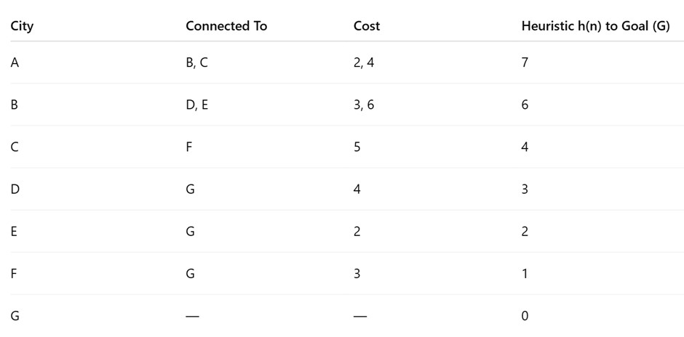
Tasks:
i. Construct the search tree from A to G. ii. Apply Greedy Best-First Search and show node expansion order.
- Apply A* algorithm using 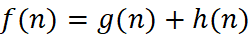.
- Justify which algorithm is better for real-time emergency delivery systems.
2. Constraint Satisfaction Problem – University Timetable Scheduling
A university must schedule final exams for 5 subjects: AI, ML, DBMS, OS, CN across 3 days
(Day 1, Day 2, Day 3) with the conditions, AI and ML cannot be scheduled on the same day, DBMS must be scheduled before OS, CN cannot be on Day 1, At most 2 exams per day, A student is enrolled in AI, DBMS, and CN → these cannot overlap
Tasks:
i. Formulate this problem as a Constraint Satisfaction Problem (CSP) by defining, Variables, Domains and Constraints ii. Draw the constraint graph. iii. Solve using Backtracking Search.
- Apply Forward Checking or Arc Consistency and explain how it reduces the search space.
- Provide one valid timetable solution.

3. Game Playing – Minimax and Alpha-Beta Pruning
An AI agent is designed to play a turn-based strategy game. The game tree is given below:
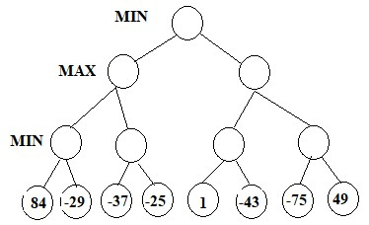
Tasks:
i. Apply the Minimax algorithm and compute values for all internal nodes. ii. Identify the optimal move for MAX.
iii. Apply Alpha-Beta Pruning to Show α and β values at each step and Clearly indicate which nodes are pruned iv. Compare nodes evaluated in Minimax vs Alpha-Beta
v. Explain the importance of evaluation functions in complex games like chess.

RUBRICS FOR CALCULATION

Criteria | Weightage | Level 4 –  Exemplary | Level 3 –  Proficient | Level 2 –  Developing | Level 1 –  Beginning
Understanding of Problem Context | 20 | Clearly understand  s the  problem and accurately identifies all requiremen  ts | Good understandin g with minor  gaps | Basic understanding; some requirements unclear | Poor understandi ng or  misinterpret ation of the problem
Application of Concepts | 30 | Accurately applies appropriate concepts to solve complex problems | Applies relevant concepts correctly with minor errors | Applies basic concepts with limited accuracy | Fails to apply appropriate concepts
Problem-Solvi ng Approach | 20 | Logical, well-structu red, and efficient  approach | Mostly logical approach with minor gaps | Basic approach with some  inconsistencies | Illogical or unclear approach
Accuracy of Solution | 20 | Completely correct solution with proper justification | Mostly correct with minor errors | Partially correct solution | Incorrect or incomplete solution
Clarity | 10 | Clear, well-organi zed, and properly explained solution | Understandab le with minor clarity issues | Limited clarity and explanation | Poorly presented  and difficult to  understand

1)Aim
The objective of this experiment is to determine the optimal route for transporting medical supplies from City A to City G using the informed search algorithms Greedy Best-First Search and A*.

i. Construct the Search Tree from A to G
The search process starts from the source node A and expands all its neighboring cities. The search continues until the destination node G is reached. The search tree represents all possible paths explored from the start node to the goal node.
Example Search Tree:
A
/ | \
B C D
/ \ \
E F G
/
G

ii. Apply Greedy Best-First Search
Greedy Best-First Search selects the node that has the smallest heuristic value. It considers only the estimated distance from the current node to the goal and ignores the cost already travelled.
The evaluation function used is:
f(n) = h(n)
where h(n) is the heuristic value.
The node expansion order is:
A → C → F → G
The path obtained is:
A → C → F → G
Greedy Best-First Search reaches the goal quickly because it always chooses the node that appears to be closest to the destination. However, it does not always produce the shortest or most optimal path since it ignores the actual travel cost.

iii. Apply A Algorithm*
The A* algorithm considers both the actual cost from the start node and the estimated cost to the goal. It uses the following evaluation function:
f(n) = g(n) + h(n)
where:
- g(n) is the actual cost from the start node to the current node.
- h(n) is the estimated cost from the current node to the goal.
- f(n) is the total estimated cost.
The node expansion order is:
A → C → F → G
The optimal path found is:
A → C → F → G
Since A* evaluates both the travelled distance and the estimated remaining distance, it is able to identify the shortest and most efficient route.

iv. Justification
Greedy Best-First Search is faster because it only considers the heuristic value. It requires less computation and can quickly find a solution. However, it may select a longer path because it ignores the actual travel cost.
The A* algorithm considers both the actual path cost and the heuristic estimate. As a result, it always finds the shortest and most efficient path when an admissible heuristic is used. Although A* requires more memory and computation than Greedy Best-First Search, it provides a more reliable solution.
For a real-time emergency medical delivery system, the A* algorithm is the better choice because it guarantees the optimal route, reduces travel time, and improves the efficiency of delivering medical supplies. While Greedy Best-First Search is faster, its inability to guarantee the shortest path makes it less suitable for critical emergency applications.

Conclusion
The A* algorithm is more suitable for intelligent route planning in emergency delivery systems because it finds the optimal path by considering both the actual travel cost and the estimated remaining distance. This ensures faster, safer, and more reliable delivery of medical supplies.

2)Aim
The objective of this problem is to schedule the final examinations for five subjects (AI, ML, DBMS, OS, and CN) over three days while satisfying all the given constraints using the Constraint Satisfaction Problem (CSP) approach.

i. Formulate the Problem as a Constraint Satisfaction Problem (CSP)

Variables
The variables represent the subjects whose exams must be scheduled.
- AI (Artificial Intelligence)
- ML (Machine Learning)
- DBMS (Database Management System)
- OS (Operating System)
- CN (Computer Networks)

Domains
Each subject can be assigned to any one of the three available days.
Domain = {Day 1, Day 2, Day 3}

Constraints
The timetable must satisfy the following constraints:
- AI and ML cannot be scheduled on the same day.
- DBMS must be scheduled before OS.
- CN cannot be scheduled on Day 1.
- At most two exams can be conducted on any one day.
- A student is enrolled in AI, DBMS, and CN; therefore, these subjects cannot be scheduled on the same day.

ii. Constraint Graph
The constraint graph represents the relationships between subjects.
AI -------- ML
|
|
DBMS -------- OS
|
|
CN
Explanation:
- AI is connected to ML because they cannot be on the same day.
- AI is connected to DBMS because the student takes both subjects.
- DBMS is connected to CN because the student takes both subjects.
- AI is connected to CN because the student takes both subjects.
- DBMS is connected to OS because DBMS must be scheduled before OS.

iii. Solve Using Backtracking Search
Backtracking Search assigns one subject at a time while checking whether the constraints are satisfied.
Step 1: Assign AI to Day 1.
Step 2: Assign ML to Day 2 because it cannot be on the same day as AI.
Step 3: Assign DBMS to Day 2.
Step 4: Assign OS to Day 3 because DBMS must be scheduled before OS.
Step 5: Assign CN to Day 3 because it cannot be on Day 1 and cannot overlap with AI or DBMS.
All constraints are satisfied, so the search stops and the solution is accepted.

iv. Apply Forward Checking
Forward Checking removes invalid choices from the remaining variables whenever a subject is assigned.
For example:
- After assigning AI to Day 1, ML cannot be assigned to Day 1.
- Since AI is on Day 1, CN and DBMS also cannot be assigned to Day 1 because the student is enrolled in these subjects.
- After assigning DBMS to Day 2, OS cannot be scheduled before Day 2, so it is assigned to Day 3.
- Since CN cannot be on Day 1, only Day 2 and Day 3 remain available.

Conclusion
The University Timetable Scheduling problem can be effectively modeled as a Constraint Satisfaction Problem (CSP). Backtracking Search finds a valid timetable by assigning subjects while checking constraints. Forward Checking improves efficiency by eliminating invalid assignments early, reducing the search space and minimizing backtracking. The final timetable satisfies all the given constraints and provides a feasible examination schedule.

3)Aim
The objective of this problem is to determine the best move for the MAX player using the Minimax Algorithm and improve the search efficiency using Alpha-Beta Pruning.

i. Apply the Minimax Algorithm and Compute Values for Internal Nodes
The Minimax algorithm is used in two-player games where one player (MAX) tries to maximize the score while the other player (MIN) tries to minimize it.
The algorithm evaluates the game tree from the leaf nodes to the root.
- MAX selects the highest value among its children.
- MIN selects the lowest value among its children.
- This process continues until the value of the root node is obtained.
The value at each internal node is calculated by applying the Max or Min operation based on the level of the tree. The final value at the root node represents the best possible outcome for the MAX player.

ii. Identify the Optimal Move for MAX
After applying the Minimax algorithm, the MAX player chooses the child node with the highest utility value.Therefore, the optimal move for MAX is the branch that produces the maximum value at the root node, ensuring the best possible outcome against an optimal opponent.

iii. Apply Alpha-Beta Pruning
Alpha-Beta Pruning is an optimization technique for the Minimax algorithm. It reduces the number of nodes evaluated without changing the final result.
- Alpha (α) represents the best value found so far for the MAX player.
- Beta (β) represents the best value found so far for the MIN player.
During the search:
- Initially, α = −∞ and β = +∞.
- Alpha is updated whenever MAX finds a better value.
- Beta is updated whenever MIN finds a smaller value.
- If α ≥ β, the remaining branches are pruned because they cannot affect the final decision.
The pruned nodes are not evaluated, reducing computation time while still producing the same optimal move as the Minimax algorithm.

iv. Compare Nodes Evaluated in Minimax and Alpha-Beta Pruning
The Minimax algorithm evaluates every node in the game tree before making a decision. This guarantees the optimal move but requires more computation.
Alpha-Beta Pruning evaluates fewer nodes by eliminating branches that cannot influence the final result. As a result, it is faster and more efficient while still selecting the same optimal move.
Therefore:
- Minimax: Evaluates all nodes in the game tree.
- Alpha-Beta Pruning: Evaluates only the necessary nodes and prunes unnecessary branches.
- Result: Both algorithms produce the same optimal move, but Alpha-Beta Pruning requires less computation.

v. Importance of Evaluation Functions in Complex Games Like Chess
In complex games such as chess, it is impossible to search every possible move because the number of game states is extremely large.
An evaluation function estimates the quality of a game position when the search cannot reach the end of the game.
The evaluation function helps the AI by:
- Estimating the strength of the current board position.
- Comparing different possible moves.
- Guiding the Minimax algorithm toward promising moves.
- Reducing the search time in large game trees.
- Improving decision-making when complete search is not possible.
In chess, the evaluation function may consider factors such as material advantage, king safety, piece mobility, pawn structure, and board control.

Conclusion
The Minimax algorithm enables an AI agent to select the best possible move by considering the actions of both players. Alpha-Beta Pruning improves the efficiency of Minimax by pruning unnecessary branches, reducing the number of nodes evaluated without affecting the final decision. Evaluation functions play a vital role in complex games like chess by estimating the value of board positions and helping the AI make intelligent decisions within a limited search depth.

