SIMATS ENGINEERING ( S.VIGNESH )
ASSESSMENT TOOL 1 192512378.

COURSE NAME: Artificial Intelligence COURSE CODE: CSA1715

COURSE OUTCOME COVERED

CO1: Apply AI basics such as intelligent agents and uninformed search methods to solve problems effectively. (BL3)

Assessment Tool Weightage: 40%

QUESTIONS: 5 Duration : 1 Hour
Total Marks:50

Annexure A

Analytical Problem Solving

Code of Conduct:

I S.VIGNESH (192512378) (Name &Reg) certify that this submission is my original work and that I have adhered to the guidelines specified for this assessment.
I understand that any violation of academic integrity rules will result in disciplinary action.

Signature of the student:

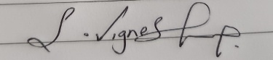

Annexure A

Analytical Problem Solving

- Solve the Water Jug problem: you are given 2 jugs, a 4-gallon one and 3-gallon one. Neither has any measuring maker on it. There is a pump that can be used to fill the jugs with water. How can you get exactly 2 gallons of water into 4-gallon jug? Explicit assumptions: A jug can be filled from the pump, water can be poured out of a jug onto the ground, water can be poured from one jug to another and that there are no other measuring devices available.

- Find out how Mars Rover, analyse and explore the samples on Mars by answering the following questions.
- What are the percept ’s for this agent?
- Characterize the operating environment.
- What are the actions the agent can take?
- How can one evaluate the performance of the agent?
- What sort of agent architecture do you think is most suitable for this agent? Why?

- Explore the search space using search strategies and formulate the problem components for the 8-Queens problem using the following information: Place 8 queens on a chessboard such that none of the queen’s attack any of the others. A configuration of 8 queens on the board as shown in the figure below, but this does not represent a solution as the queen in the first column is on the same diagonal as the queen in the last column.

- A customer wants to travel from the one location to another location using OLA Cab booking mobile application. The customer can select the any of the cab type as mini, micro, sedan, shared, prime and so on based on his comfort to reach the destination. Identify what type of problem-solving agent can be used and write the pseudocode for the above problem.

- A logistics company operates a delivery network where packages must be transported between warehouses at minimum cost. Each route between warehouses has an associated travel cost (fuel + time). The company wants to determine the least-cost path from the starting warehouse S to the destination warehouse G using the Uniform Cost Search (UCS) algorithm.

The delivery network is represented as a weighted graph:
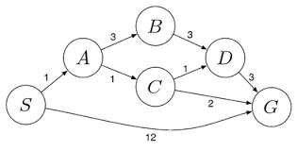
Answers:

 | Weightage | Level 4 (Exemplary) | Level 3 (Proficient) | Level 2 (Developing) | Level 1 (Beginning)
Problem Understanding | 20% | Clearly interprets problem, identifies all parameters and requirements accurately | Understands problem with minor gaps | Partial understanding; misses key elements | Misinterprets or unable to understand problem
Method Selection | 20% | Selects most appropriate method/formula with strong justification | Selects correct method with minor errors | Inappropriate or partially correct method | Unable to select method
Solution Process | 25% | Logical, systematic steps with correct approach throughout | Mostly correct steps with minor mistakes | Disorganized steps; multiple errors | No clear process
Accuracy of Calculation | 20% | All calculations accurate; correct final answer | Minor calculation errors | Frequent errors; incorrect final answer | No valid calculations
Interpretation of Results | 15% | Clearly interprets results with unit engineering relevance | Basic interpretation with minor omissions | Limited or unclear interpretation | No interpretation
Problem Understanding | 20% | Clearly interprets problem, identifies all parameters and requirements accurately | Understands problem with minor gaps | Partial understanding; misses key elements | Misinterprets or unable to understand problem

RUBRICS FOR CALCULATION

ANALYTICAL PROBLEM SOLVING

1. WATER JUG PROBLEM

Problem Understanding:

Two unmarked jugs are available:

• Jug A can hold 4 gallons.
• Jug B can hold 3 gallons.

Initially, both jugs are empty. The objective is to measure exactly 2 gallons of water and keep it in the 4-gallon jug.

A state can be written as:

(x, y)

where:

x = quantity of water in the 4-gallon jug
y = quantity of water in the 3-gallon jug

Initial state:

(0, 0)

Required goal state:

(2, 0)

Method Selection:

This problem can be represented as a state-space search problem. Breadth-First Search is appropriate because every operation has the same cost, and BFS can find a solution using the minimum number of steps.

Solution Process:

Step 1: Fill the 3-gallon jug.

State: (0, 3)

Step 2: Transfer all the water from the 3-gallon jug into the 4-gallon jug.

State: (3, 0)

Step 3: Fill the 3-gallon jug once more.

State: (3, 3)

Step 4: Pour water from the 3-gallon jug into the 4-gallon jug until the 4-gallon jug becomes full.

Since the 4-gallon jug already contains 3 gallons, only 1 gallon is added. Therefore, 2 gallons remain in the 3-gallon jug.

State: (4, 2)

Step 5: Empty the 4-gallon jug.

State: (0, 2)

Step 6: Transfer the remaining 2 gallons from the 3-gallon jug into the 4-gallon jug.

State: (2, 0)

Pseudocode:

BEGIN
SET A ← 0
SET B ← 0

Fill jug B completely
Pour all water from B into A

Fill jug B again
Pour water from B into A until A becomes full
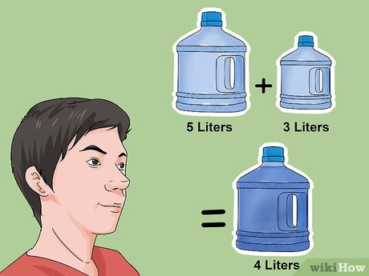
Empty jug A
Transfer the remaining water from B into A

DISPLAY "Jug A contains exactly 2 gallons"
END

Result:

The final state obtained is:

(2, 0)

Hence, exactly 2 gallons of water are measured in the 4-gallon jug without using any measuring instrument.

2. MARS ROVER INTELLIGENT AGENT

Problem Understanding:

A Mars rover is an autonomous intelligent machine that explores the Martian surface. It captures images, studies rocks and soil, collects scientific information and transmits the results to Earth.

Because communication between Earth and Mars takes time, the rover cannot depend on continuous human control. It must sense the environment and make many decisions on its own.

Are the information received by the rover through its sensors.

The main percept include:

• Camera images of rocks, soil, hills and craters
• Distance from nearby obstacles
• Ground slope and surface roughness
• Temperature and atmospheric conditions
• Mineral and chemical properties of samples
• Current position and travelling direction
• Battery charge level
• Condition of wheels and scientific instruments
• Communication availability with Earth

ii. Nature of the Operating Environment:

The rover’s environment can be described as follows:

Partially Observable:
The rover can observe only the area covered by its cameras and sensors. It cannot view the complete Martian surface at once.

Stochastic:
The outcome of an action may not always be predictable. For example, wheels may slip on loose soil.

Sequential:
A present decision affects later actions. Choosing a poor route may waste energy and prevent future exploration.

Dynamic:
Environmental conditions such as light, dust and temperature may change during operation.

Continuous:
Measurements such as speed, distance, temperature and battery level vary continuously.

Unknown:
The rover may not have complete information about the terrain before exploring it.

iii. Actions Performed by the Rover:

The rover can perform actions such as:

• Move forward and backward
• Turn in different directions
• Stop or change speed
• Detect and avoid obstacles
• Capture photographs
• Select rocks and soil for study
• Drill and collect samples
• Analyse the collected material
• Save scientific observations
• Transmit data to Earth
• Enter safe mode when a fault occurs
• Reduce activity when battery power is low

iv. Performance Evaluation:

The rover’s performance may be measured using:

• Number of scientifically useful samples examined
• Accuracy and quality of collected information
• Distance travelled without damage
• Energy consumed during the mission
• Number of obstacles safely avoided
• Amount of data successfully transmitted
• Number of mission objectives completed
• Overall safety of the rover

v. Suitable Agent Architecture:

A hybrid intelligent agent architecture is the most suitable for a Mars rover.

It combines several types of agents:

• Reflex behaviour for immediate obstacle avoidance
• Model-based behaviour for maintaining a map of explored terrain
• Goal-based behaviour for completing mission objectives
• Utility-based behaviour for choosing actions based on safety, energy and scientific value
• Learning behaviour for improving decisions using previous experience

Pseudocode:

FUNCTION Mars Rover Agent()

WHILE mission is active DO

Sensor Data ← Collect Sensor Information()
Update Terrain Model(sensor Data)

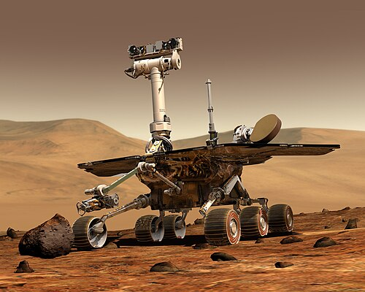
IF a serious system fault is detected THEN
Enter Safe Mode()

ELSE IF an obstacle is detected THEN
Choose And Perform Avoidance Action()

ELSE IF battery level is low THEN
Reduce Power Consumption ()

ELSE
Mission Goal ← Select Most Useful Goal ()
Action Plan ← Create Safe Plan (mission Goal)
Perform Next Action (action Plan)
END IF

Save Collected Information()

IF communication link is available THEN
Send Information To Earth()
END IF

END WHILE

END FUNCTION

Result:

A hybrid architecture is suitable because the rover must respond immediately to danger while also planning long-term scientific activities. It allows the rover to operate safely and independently in an uncertain environment.

3. EIGHT-QUEENS PROBLEM

Problem Understanding:

The Eight-Queens problem requires eight queens to be placed on an 8 × 8 chessboard so that no queen can attack another queen.

Two queens must not be placed:

• In the same row
• In the same column
• On the same diagonal

Problem Formulation:

Initial State:

The chessboard is empty, and no queens have been placed.

State Representation:

A state can be represented using a list in which each value indicates the row occupied by the queen in a particular column.

For example:

[1, 5, 8]

This means:

• The queen in column 1 is placed in row 1.
• The queen in column 2 is placed in row 5.
• The queen in column 3 is placed in row 8.

Actions:

Place one queen in a safe row of the next empty column.

Goal Test:

The goal is reached when all eight queens have been positioned and no pair of queens attacks each other.

Path Cost:

Each placement can be assigned a cost of 1. Since eight queens are placed, the total path cost of a complete arrangement is 8.

Method Selection:

Backtracking search is appropriate for this problem.

The algorithm places queens column by column. Whenever a queen cannot be placed safely in the current column, it returns to the previous column, removes the earlier queen and tries a different row.

This avoids exploring arrangements that are already known to be invalid.

Safety Condition:

Suppose a new queen is placed at:

(row, column)

and a previous queen is located at:

(previous Row, previous Column)

The new position is valid only when:

row ≠ previous Row

and

|row – previous Row| ≠ |column – previous Column|

The first condition prevents queens from sharing a row. The second condition prevents diagonal attacks.

Pseudocode:

FUNCTION Is Position Safe (column, row)

FOR previous Column ← 1 TO column - 1 DO

Previous Row ← queen [previous Column]

IF row = previous Row THEN
RETURN FALSE
END IF

IF ABS (row – previous Row)
= ABS (column – previous Column) THEN
RETURN FALSE
END IF

END FOR

RETURN TRUE
END FUNCTION

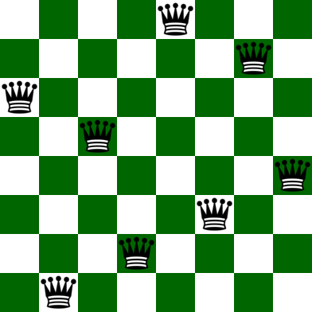
FUNCTION Solve Queens(column)

IF column > 8 THEN
RETURN TRUE
END IF

FOR row ← 1 TO 8 DO

IF Is PositionSafe(column, row) THEN

queen[column] ← row

IF Solve Queens(column + 1) = TRUE THEN
RETURN TRUE
END IF

queen[column] ← 0
END IF

END FOR

RETURN FALSE
END FUNCTION

One Valid Arrangement:

[1, 5, 8, 6, 3, 7, 2, 4]

This means the queens are placed in the corresponding row positions for columns 1 to 8.

Result:

The given arrangement contains no repeated rows or columns, and no two queens share a diagonal. Backtracking is efficient because invalid partial arrangements are rejected immediately instead of generating every possible board configuration.

4. OLA CAB BOOKING PROBLEM-SOLVING AGENT

Problem Understanding:

A customer uses the OLA mobile application to travel from a pickup point to a destination.

The customer may choose different cab categories, such as:

• Micro
• Mini
• Sedan
• Shared
• Prime

The selected option depends on factors such as fare, comfort, driver availability, waiting time and expected journey time.

Type of Agent:

A goal-based problem-solving agent supported by utility-based selection is suitable for this application.

The main goal is:

To move the customer from the pickup point to the required destination.

Since several cabs and routes may satisfy the goal, the utility component compares them and identifies the most suitable option.

Problem Formulation:

Initial State:

The initial information includes:

• Customer’s pickup location
• Destination
• Available drivers
• Cab categories
• Road network
• Current traffic conditions

Actions:

The application can:

• Search for nearby cabs
• Display available cab categories
• Calculate possible routes
• Estimate fare
• Calculate expected waiting time
• Send a booking request to a driver
• Confirm the ride
• Track the cab
• Select an alternative route when traffic changes

Goal Test:

The goal is achieved when the customer reaches the selected destination.

Path Cost:

The total cost may be represented as:

Cost = Fare + Waiting Time + Travel Time

A basic utility function can be written as:

Utility = Comfort - Fare - Waiting Time - Travel Time

A higher utility value indicates a more suitable cab option.

Method Selection:

A* search can be used to determine the best route.

Its evaluation function is:

f(n) = g(n) + h(n)

where:

g(n) = actual cost from the starting point to the current location

h(n) = estimated remaining cost from the current location to the destination

Pseudocode:

FUNCTION Ola Cab Booking (pickup, destination)

Nearby Cabs ← Search Available Cabs(pickup)

IF nearby Cabs is empty THEN
RETURN "No cab is currently available"
END IF

Selected Route ← A Star Route Search (pickup, destination)

FOR each cab in nearby Cabs DO

Estimated Fare ← Calculate Fare (cab, selected Route)
Arrival Time ← Calculate Waiting Time(cab)
Comfort Value ← Find Comfort Value (cab. type)
Journey Time ← Estimate Journey Time (selected Route)

utility ← comfort Value
- estimated Fare
- arrival Time
- journey Time


Save cab and its utility value
END FOR

Arrange cabs from highest to lowest utility

Chosen Cab ← Get Customer Choice ()

Send Booking Request (chosen Cab)

IF the driver accepts THEN
Confirm Ride ()
ELSE
Send request to the next suitable driver
END IF

WHILE customer has not reached destination DO

Monitor Cab Location ()

IF traffic condition changes THEN
Selected Route ← A Star Route Search (
Current Location,
destination
)
END IF

END WHILE

End Trip ()

END FUNCTION

Result:

The goal-based component ensures that the customer reaches the destination. The utility-based component compares cab choices using fare, time and comfort. Therefore, this combined agent provides a practical and efficient solution for cab booking.

5. LEAST-COST PATH USING UNIFORM COST SEARCH

Note:

The original weighted graph is not included in the question text provided. Therefore, the following sample graph is used to demonstrate Uniform Cost Search.

Assumed Route Costs:

S to A = 2
S to B = 5
A to C = 2
A to D = 7
B to D = 1
C to G = 6
D to G = 2

Problem Understanding:

A logistics company needs to transport a package from the starting warehouse S to the destination warehouse G.

Every path between two warehouses has a cost based on fuel usage and travel time. The objective is to identify the route having the smallest total cost.

Problem Formulation:

Initial State:

S

Goal State:

G

Actions:

Move from the current warehouse to any directly connected warehouse.

Step Cost:

The cost written on the edge connecting two warehouses.

Path Cost:

The total path cost is the sum of all route costs.

Method Selection:

Uniform Cost Search is appropriate because all routes do not have the same cost.

UCS always selects the path with the lowest accumulated cost. It guarantees the optimal solution when every edge cost is positive.

Solution Process:

Initial priority queue:

S(0)

Step 1:

Expand S.

Available paths:

S → A = 2
S → B = 5

Queue:

A(2), B(5)

Step 2:

Expand A because it has the lowest cost.

New paths:

S → A → C = 2 + 2 = 4
S → A → D = 2 + 7 = 9

Queue:

C(4), B(5), D(9)

Step 3:

Expand C.

New path:

S → A → C → G = 2 + 2 + 6 = 10

Queue:

B(5), D(9), G(10)

Step 4:

Expand B.

New path to D:

S → B → D = 5 + 1 = 6

The earlier cost to D was 9. Since 6 is smaller, the cost of D is updated.

Queue:

D(6), G(10)

Step 5:

Expand D.

New path to G:

S → B → D → G = 5 + 1 + 2 = 8

The earlier cost to G was 10. Since 8 is lower, the goal cost is updated.

Queue:

G(8)

Step 6:

Remove G from the queue.

Since G is the destination, the search stops.

Pseudocode:

FUNCTION Uniform Cost Search(start, goal)

CREATE an empty priority queue
INSERT start with cost 0

Best Cost[start] ← 0
parent[start] ← NULL

WHILE priority queue is not empty DO

current ← Remove node having minimum cost
current Cost ← Cost of current

IF current = goal THEN
RETURN Construct Path (parent, goal),
Current Cost
END IF

FOR each neighbour of current DO

New Cost ← current Cost
+ Edge Cost (current, neighbour)

IF neighbour is not visited
OR new Cost < best Cost[neighbour] THEN

Best Cost[neighbour] ← new Cost
parent[neighbour] ← current

INSERT neighbour into priority queue
with priority new Cost
END IF

END FOR

END WHILE

RETURN "No path exists"

END FUNCTION

Cost Verification:

Route 1:

S → A → C → G

Cost = 2 + 2 + 6 = 10

Route 2:

S → A → D → G

Cost = 2 + 7 + 2 = 11

Route 3:

S → B → D → G

Cost = 5 + 1 + 2 = 8

Therefore, the minimum-cost route is:

S → B → D → G

Minimum cost:

8 cost units

Result:

Uniform Cost Search selects the path with the smallest accumulated cost rather than the path containing the fewest edges. For the assumed graph, the optimal delivery route is S → B → D → G, with a total cost of 8 units.

