ECA5403 – ELECTROMAGNETIC FIELDS AND WAVES

Student Name: N. Sri Vaishnavi
Register Number: 192512444

ELECTROMAGNETIC FILEDS AND WAVES
Hemavathi .M
192512222
C01-3
EXPERIMENT 3
AIM:
To determine and plot the Force of attraction between two electric Charges and two parallel conductors separated by varying distance between them using MATLAB.
Test case (i) Determination and plotting of force between two electric charges with varying distance
PROGRAM:
clc;
clear;
q1 = input('Enter the charge q1=');
q2 = input('Enter the charge q2=');
epsilon = 8.854e-12;
k = 1/(4*pi*epsilon);
r = linspace(0.1,10,100);
F = k*q1*q2./(r.^2);
disp('Force at r = 1 m is:');
disp(k*q1*q2/(1^2));
plot(r,F,'LineWidth',2);
xlabel('Distance (m)');
ylabel('Force (N)');
title('Force between two electric charges');
OUTPUT:

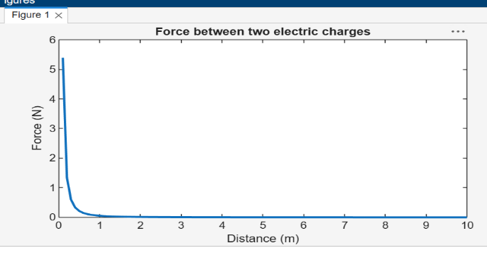

Test case (ii) Determination and plotting of force between two electric charges with different magnitudes
PROGRAM:
clc;
q1 = 5e-6;
q2 = 2e-6;
epsilon = 8.854e-12;
k = 1/(4*pi*epsilon);
r = linspace(0.5,5,100);
F = k*q1*q2./(r.^2);
plot(r,F,'LineWidth',2);
xlabel('Distance (m)');
ylabel('Force (N)');
title('Force between two charges (different magnitudes)');
OUTPUT:

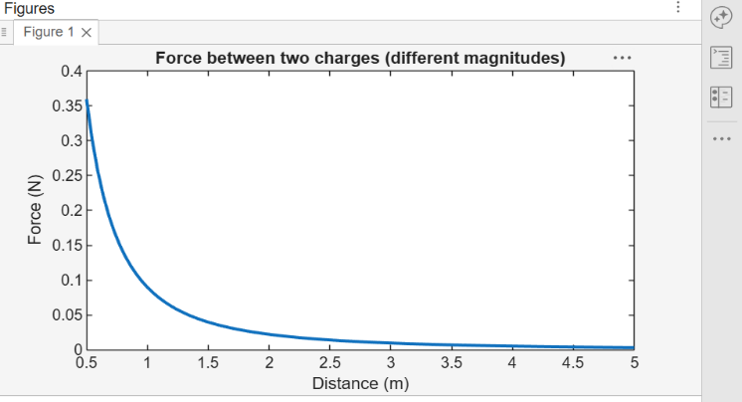

Test case (iii) Determination and plotting of force per unit length between two parallel
conductors with varying distance
PROGRAM:
clc;
mu0 = 4*pi*1e-7;
I1 = 5;
I2 = 10;
d = linspace(0.1,10,100);
F = (mu0*I1*I2)./(2*pi*d);
plot(d,F,'LineWidth',2);
xlabel('Distance (m)');
ylabel('Force per unit length (N/m)');
title('Force between two parallel
conductors');
OUTPUT:
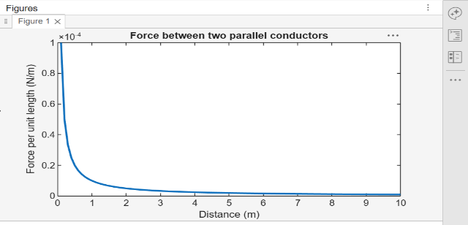

Test case (iv) Determination and plotting of force between two parallel conductors carrying equal currents
PROGRAM:
clc;
mu0 = 4*pi*1e-7;
I1 = 3;
I2 = 3;
d = linspace(0.1,2,100);
F = (mu0*I1*I2)./(2*pi*d);
plot(d,F,'LineWidth',2);
xlabel('Distance (m)');
ylabel('Force per unit length (N/m)');
title('Force between conductors
(equal currents)');

OUTPUT:

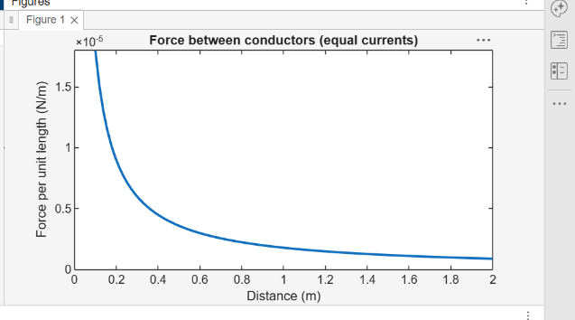

RESULTS:
Thus the program was verified for the force of attraction or repulsion acting along a straight line between two electric charges is directly proportional to the product of the charges and inversely to the square of the distance between them using MATLAB was successfully.
S. No. | Objective | Assessment Criterion | Excellent – 4 | Good – 3 | Satisfactory – 2 | Needs Improvement – 1 | Weighting (%) | Marks given | Marks obtained
1 | Identify physical quantities and force models | Identify physical quantities and force models | Correctly identifies charge/current, separation, medium and force direction for both cases. | Identifies most quantities and models correctly. | Needs guidance in selecting the correct relation or direction. | Uses incorrect force models or quantities.. | 25 | 2.5
2 | Calculate electric and magnetic forces | Calculate electric and magnetic forces | Implements Coulomb-force and parallelcurrent force calculations correctly with units. | Calculations are mostly correct with minor errors.. | Some calculations are correct but require assistance. | Force calculations are invalid or absent | 25 | 2.5
3 | Evaluate force versus separation | Evaluate force versus separation | Correctly varies separation, plots trends and checks theoretical distance dependence | Trend and plots are correct with minoromissio ns. | Limited sweep or incomplete trend interpretation. | Does not establish a valid relationship. | 30 | 3
4 | Explain and report results | Explain and report results | Explains attraction/repulsi on and reports assumptions, units and conclusions clearly. | Conclus ion is correct with minor docume ntation gaps. | Conclusion is incomplete or partly inaccurate. | Conclusion is missing or incorrect. | 20 | 2
Total |  |  |  |  |  |  | 100 | 10

