ECA5403 – ELECTROMAGNETIC FIELDS AND WAVES

INTERNAL EXAM PROJECT

Student Name: N. Sri Vaishnavi
Register Number: 192512444

ECA5403-ELECTROMAGNETIC FILEDS AND WAVES
K.POOJA SREE
192512245
C01-1
EXPERIMENT 1
AIM:
To write a MATLAB program for transformation between Cartesian, Cylindrical and Spherical coordinate systems.
PROGRAM:
clc;
x=input('Enter the value of X=');
y=input('Enter the value of y=');
z=input('Enter the value of z=');
% Cartesian to Cylindrical
rho=sqrt(x^2+y^2);
phi=atan2d(y,x);
disp('Cartesian to cylindrical coordinate system of p(rho,phi,z)=');
disp([rho phi z]);
% Cartesian to Spherical
r=sqrt(x^2+y^2+z^2);
theta=acosd(z/r);
phi=atan2d(y,x);
disp('Cartesian to spherical coordinate system of s(r,theta,phi)=');
disp([r theta phi]);
clc;
rho=input('Enter the value of rho=');
phi=input('Enter the value of phi=');
z=input('Enter the value of z=');
% Cylindrical to Cartesian
x=rho*cosd(phi);
y=rho*sind(phi);
disp('Cylindrical to Cartesian coordinate system of p(x,y,z)=');
disp([x y z]);
% Cylindrical to Spherical
r=sqrt(rho^2+z^2);
theta=acosd(z/r);
disp('Cylindrical to spherical coordinate system of s(r,theta,phi)=');
disp([r theta phi]);
clc;
r=input('Enter the value of r=');
theta=input('Enter the value of theta (deg)=');
phi=input('Enter the value of phi (deg)=');
% Spherical to Cartesian
x=r*sind(theta)*cosd(phi);
y=r*sind(theta)*sind(phi);
z=r*cosd(theta);
disp('Spherical to Cartesian coordinate system of p(x,y,z)=');
disp([x y z]);
% Spherical to Cylindrical
rho=r*sind(theta);
disp('Spherical to cylindrical coordinate system of s(rho,phi,z)=');
disp([rho phi z]);
OUTPUT:

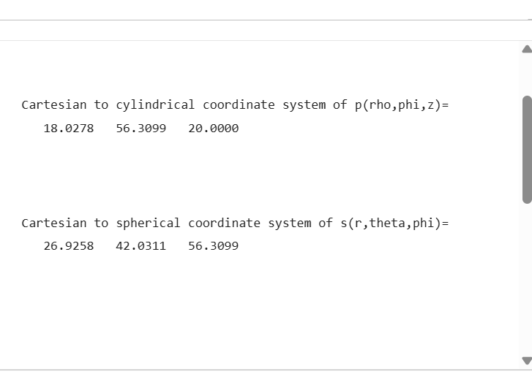
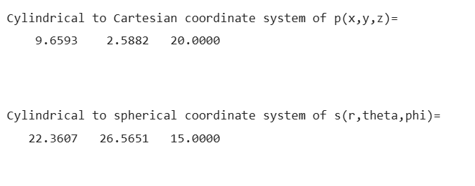
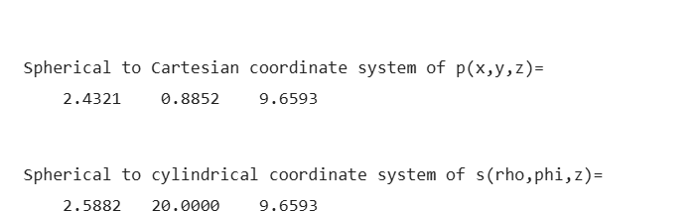
RESULTS:
Thus the transformation between Cartesian, Cylindrical and Spherical coordinate systems have been done using MATLAB software.

TEST CASE (II): TRANSFORMATION OF CYLINDRICAL COORDINATE POINTS INTO CARTESIAN AND SPHERICAL COORDINATE SYSTEM
PROGRAM:
clc;
r=input('Enter the value of r=');
phi=input('Enter the value of phi=');
z=input('Enter the value of z=');
% Cylindrical to Cartesian
x=r*cosd(phi);
y=r*sind(phi);
disp('cylindrical to cartesian coordinate system of p(x,y,z)=');
disp([x y z]);
% Cylindrical to Spherical
R=sqrt(r^2+z^2);
theta=acosd(z/R);
disp('cylindrical to spherical coordinate system of s(r,phi,theta)=');
disp([R phi theta]);
OUTPUT:
Enter the value of r=10
Enter the value of phi=15
Enter the value of z=20

cylindrical to cartesian coordinate system of p(x,y,z)=
9.6593 2.5882 20.0000

cylindrical to spherical coordinate system of s(r,phi,theta)=
22.3607 15.0000 26.5651
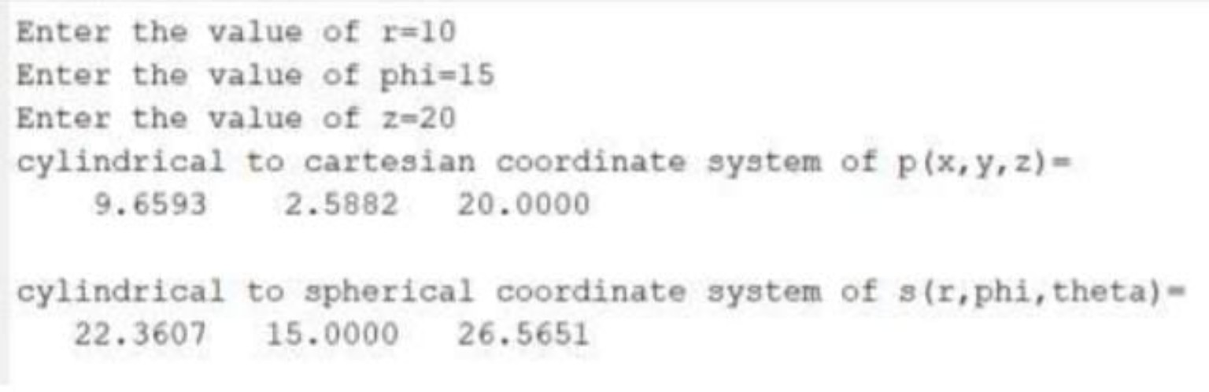

TEST CASE (III): TRANSFORMATION OF SPHERICAL COORDINATE POINTS INTO CYLINDRICAL AND CARTESIAN COORDINATE SYSTEM
PROGRAM:
clc;
r=input('Enter the value of r=');
phi=input('Enter the value of phi=');
theta=input('Enter the value of theta=');
% Spherical to Cartesian
x=r*sind(theta)*cosd(phi);
y=r*sind(theta)*sind(phi);
z=r*cosd(theta);
disp('spherical to cartesian coordinate system of p(x,y,z)=');
disp([x y z]);
% Spherical to Cylindrical
rho=r*sind(theta);
disp('spherical to cylindrical coordinate system of s(rho,phi,z)=');
disp([rho phi z]);
OUTPUT:
Enter the value of r=10
Enter the value of phi=15
Enter the value of theta=20

spherical to cartesian coordinate system of p(x,y,z)=
3.3033 0.8852 9.3969

spherical to cylindrical coordinate system of s(rho,phi,z)=
3.4202 15.0000 9.3969
RESULT:
Thus, the transformations between Cartesian, cylindrical and spherical coordinate systems were performed using MATLAB software.
