Name : S.Parameshwar
Reg No : 192521044
CSA0918-Java Programming
CO4-AT1

A shared listener object is registered on both a “Save” button and a “Save As” menu item that should trigger closely related but not identical logic. Explain how you would use the ActionEvent&#39;s action command string to differentiate the two triggers inside one listener method, rather than writing two separate listener classes.

Aim
To demonstrate how a single ActionListener can handle events from both a Save button and a Save As menu item using the ActionEvent action command string.

Algorithm
- Start the program.
- Create a Save button and a Save As menu item.
- Assign "SAVE" as the action command for the Save button.
- Assign "SAVE_AS" as the action command for the Save As menu item.
- Register the same ActionListener for both components.
- When an event occurs, retrieve the action command using getActionCommand().
- If the command is "SAVE", execute the Save operation.
- If the command is "SAVE_AS", execute the Save As operation.
- Display the appropriate output.
- Stop the program.

Java Program
import javax.swing.*;
import java.awt.*;
import java.awt.event.*;

public class SaveActionExample extends JFrame implements ActionListener {

JButton saveButton;
JMenuItem saveAsItem;

SaveActionExample() {

// Create Save button
saveButton = new JButton("Save");

// Create Save As menu item
saveAsItem = new JMenuItem("Save As");

// Set different action commands
saveButton.setActionCommand("SAVE");
saveAsItem.setActionCommand("SAVE_AS");

// Register the same listener
saveButton.addActionListener(this);
saveAsItem.addActionListener(this);

// Create File menu
JMenu fileMenu = new JMenu("File");
fileMenu.add(saveAsItem);

// Create menu bar
JMenuBar menuBar = new JMenuBar();
menuBar.add(fileMenu);
setJMenuBar(menuBar);

// Add Save button
setLayout(new FlowLayout());
add(saveButton);

// Frame settings
setTitle("Save Action Example");
setSize(400, 200);
setDefaultCloseOperation(JFrame.EXIT_ON_CLOSE);
setVisible(true);
}

// Common listener method
public void actionPerformed(ActionEvent e) {

String command = e.getActionCommand();

if (command.equals("SAVE")) {
System.out.println("Save button clicked.");
System.out.println("Current file is saved.");
}
else if (command.equals("SAVE_AS")) {
System.out.println("Save As menu item clicked.");
System.out.println("Save As operation is performed.");
}
}

public static void main(String[] args) {
new SaveActionExample();
}
}

Sample Input
The user performs the following actions in the GUI:
1. Click Save button
2. Select File → Save As

Sample Output
When Save is clicked:
Save button clicked.
Current file is saved.
When Save As is selected:
Save As menu item clicked.
Save As operation is performed.

Explanation
Both the Save button and Save As menu item use the same ActionListener:
saveButton.addActionListener(this);
saveAsItem.addActionListener(this);
Different action command strings are assigned to distinguish them:
saveButton.setActionCommand("SAVE");
saveAsItem.setActionCommand("SAVE_AS");
Inside the single actionPerformed() method, the command is obtained using:
String command = e.getActionCommand();
The if-else condition then determines which operation should be performed.
Thus, one listener method handles both events, while the action command string differentiates the Save and Save As operations.

Result
Thus, the program successfully uses the ActionEvent action command string to differentiate the Save button and Save As menu item using a single ActionListener, without creating separate listener classes.

Output Screenshot

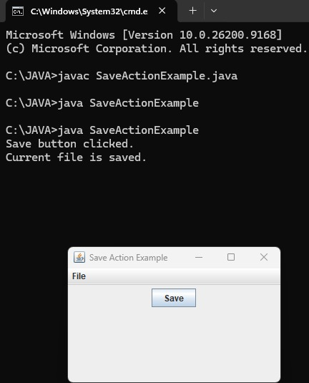

i

