SIMATS ENGINEERING
Department of Computer Science & Engineering
ASSESSMENT TOOL 1- EXPERIMENTS

Course Code: | CSA1208 | Course Title: | Computer Architecture
CO Assessed: | CO3 | Assessment: | ASSESSMENT TOOL 1- EXPERIMENTS
Weightage: | 40% | Total Marks: | 25
CO3 Statement: | Design processor organization by constructing pipelined datapath structures, identifying hazard types (data, control, structural), and comparing superscalar techniques such as out-of-order execution, speculative execution, and simultaneous multithreading (SMT). (BL6)
Student Name: | Parameshwar S | Reg.No.: | 192521044
Department: | B.TECH[IT} | Date: | 26/08/2026

ANNEXURE A

- Design and simulate a system that performs register transfer operations along with basic arithmetic and logic operations such as addition, subtraction, AND, and OR. Use multiple registers to demonstrate how data is transferred between them during execution, and analyze the sequence of operations and the role of the ALU in processing data.
- Create a model of a computer system using single-bus and multi-bus organization, and perform data transfer operations between registers, memory, and I/O. Compare the time taken and efficiency of both approaches, and analyze how multiple bus structures improve parallel data transfer and reduce bottlenecks.
- Simulate a 5-stage instruction pipeline (Fetch, Decode, Execute, Memory, Write-back) and execute a set of instructions. Measure the performance in terms of speedup and throughput, and compare it with a non-pipelined system to evaluate the effectiveness of pipelining.
- Develop a pipeline execution scenario where data hazards, control hazards, and structural hazards occur. Observe their impact on instruction execution, and implement techniques such as stalling, data forwarding, and branch prediction to resolve these hazards and improve performance.
- Analyze a processor supporting superscalar execution, including out-of-order and speculative execution, and extend the study to include hyper-threading and simultaneous multithreading (SMT). Evaluate how multiple instructions are executed in parallel and compare the performance improvements in terms of instruction throughput and resource utilization.

Code of Conduct:

I (Name-S Parameshwar/ Reg No-192521044) certify that this submission is my original work and that I have adhered to the guidelines specified for this assessment.I understand that any violation of academic integrity rules will result in disciplinary action.

Signature of the student : PARAMESHWAR S

MARKS ALLOCATION
 | Understanding of Concepts (20%) | Experimental Design (20%) | Use of Tools (25%) | Analysis of Results (20%) | Documentation (15%)
Q1
Q2
Q3
Q4
Q5

RUBRICS FOR CALCULATION:

Criteria | Weightage | Level 4 – Exemplary | Level 3 – Proficient | Level 2 – Developing | Level 1 – Beginning
Understanding of Concepts | 25 | Demonstrates thorough understanding and effectively integrates multiple concepts/technologies | Good understanding with proper integration of most concepts | Basic understanding; limited or partial integration | Poor understanding; unable to integrate concepts
Experimental Design | 30 | Well-planned, systematic implementation with optimal solution | Correct implementation with minor issues | Basic implementation with errors or inefficiencies | Incorrect or incomplete implementation
Use of Tools | 20 | Effective and advanced use of tools/technologies with proper configuration | Appropriate use of tools with correct execution | Limited or inconsistent use of tools | Incorrect or minimal use of tools
Analysis of Results | 15 | Insightful analysis with accurate interpretation and validation of results | Good analysis with reasonable interpretation | Basic analysis with limited insights | Poor or incorrect analysis of results
Documentation | 10 | Clear, well-structured documentation with diagrams, code, and results | Organized documentation with necessary details | Basic documentation with missing details | Poor or incomplete documentation

1.#include <stdio.h>

int main()
{
int R0 = 20;
int R1 = 10;
int R2, R3;

printf("Initial Register Values:\n");
printf("R0 = %d\n", R0);
printf("R1 = %d\n\n", R1);

// Operation 1: Register Transfer
R2 = R0;
printf("Operation 1: R2 <- R0\n");
printf("R2 = %d\n\n", R2);

// Operation 2: Addition
R3 = R2 + R1;
printf("Operation 2: R3 <- R2 + R1\n");
printf("R3 = %d\n\n", R3);

// Operation 3: Subtraction
R3 = R2 - R1;
printf("Operation 3: R3 <- R2 - R1\n");
printf("R3 = %d\n\n", R3);

// Operation 4: AND
R3 = R2 & R1;
printf("Operation 4: R3 <- R2 AND R1\n");
printf("R3 = %d\n\n", R3);

// Operation 5: OR
R3 = R2 | R1;
printf("Operation 5: R3 <- R2 OR R1\n");
printf("R3 = %d\n\n", R3);

printf("All register transfer and ALU operations completed successfully.\n");

return 0;
}

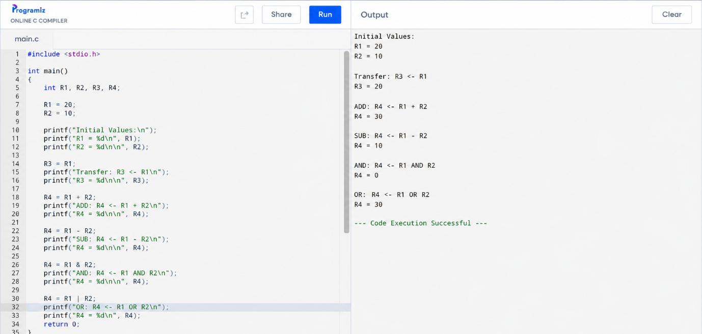

2. #include <stdio.h>

int main()
{
int R1 = 10, R2 = 20, R3 = 30;
int MEMORY = 100, IO = 0;

printf("===== SINGLE BUS ORGANIZATION =====\n");

// Single bus: one transfer at a time
R1 = MEMORY; // MEMORY -> R1
R2 = R1; // R1 -> R2
R3 = R2; // R2 -> R3
IO = R3; // R3 -> IO

printf("After Transfer:\n");
printf("R1 = %d, R2 = %d, R3 = %d, IO = %d\n",
R1, R2, R3, IO);

printf("Time Taken: 4 cycles\n\n");

printf("===== MULTI BUS ORGANIZATION =====\n");

// Multi bus: multiple transfers can occur in parallel
R1 = MEMORY;
R2 = MEMORY;
R3 = MEMORY;
IO = R1;

printf("After Transfer:\n");
printf("R1 = %d, R2 = %d, R3 = %d, IO = %d\n",
R1, R2, R3, IO);

printf("Time Taken: 2 cycles\n\n");

printf("===== COMPARISON =====\n");
printf("Single Bus Time : 4 cycles\n");
printf("Multi Bus Time : 2 cycles\n");
printf("Multi Bus is 2 times faster than Single Bus.\n");
printf("Multi-bus allows parallel data transfer and reduces bottlenecks.\n");

return 0;
}

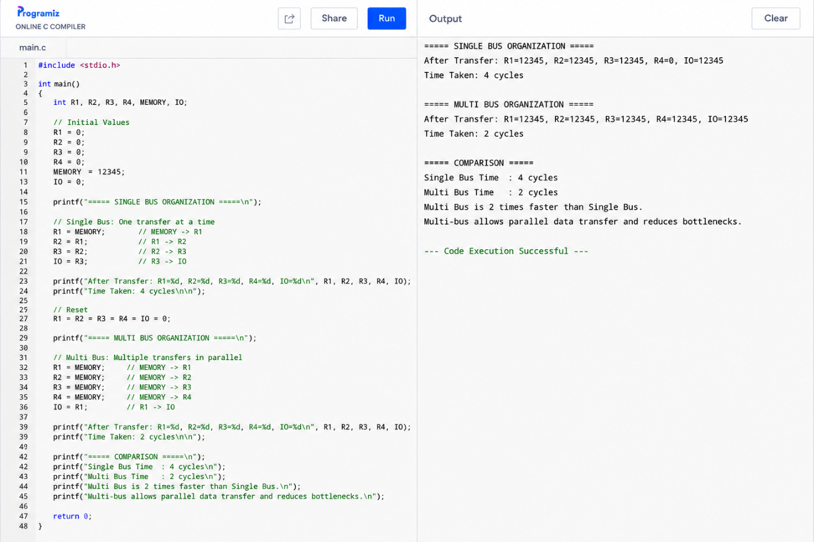

3. #include <stdio.h>

int main()
{
int instructions = 5;
int stages = 5;

int non_pipelined_cycles;
int pipelined_cycles;
float speedup;
float throughput;

printf("===== 5-STAGE INSTRUCTION PIPELINE =====\n\n");

printf("Stages:\n");
printf("1. Fetch\n");
printf("2. Decode\n");
printf("3. Execute\n");
printf("4. Memory\n");
printf("5. Write-Back\n\n");

printf("Instructions Executed: %d\n\n", instructions);

printf("Instruction Pipeline:\n");
printf("I1 : ADD R1, R2, R3\n");
printf("I2 : SUB R4, R5, R6\n");
printf("I3 : AND R7, R8, R9\n");
printf("I4 : OR R10, R11, R12\n");
printf("I5 : ADD R13, R14, R15\n\n");

/* Non-pipelined execution */
non_pipelined_cycles = instructions * stages;

/* Pipelined execution */
pipelined_cycles = stages + instructions - 1;

speedup = (float)non_pipelined_cycles / pipelined_cycles;
throughput = (float)instructions / pipelined_cycles;

printf("===== PERFORMANCE ANALYSIS =====\n\n");

printf("Non-Pipelined Cycles : %d\n", non_pipelined_cycles);
printf("Pipelined Cycles : %d\n", pipelined_cycles);

printf("\nSpeedup = %.2f times\n", speedup);
printf("Throughput = %.2f instructions/cycle\n", throughput);

printf("\n===== RESULT =====\n");
printf("Pipelining improves CPU performance.\n");
printf("Multiple instructions are processed simultaneously\n");
printf("in different pipeline stages.\n");

return 0;
}

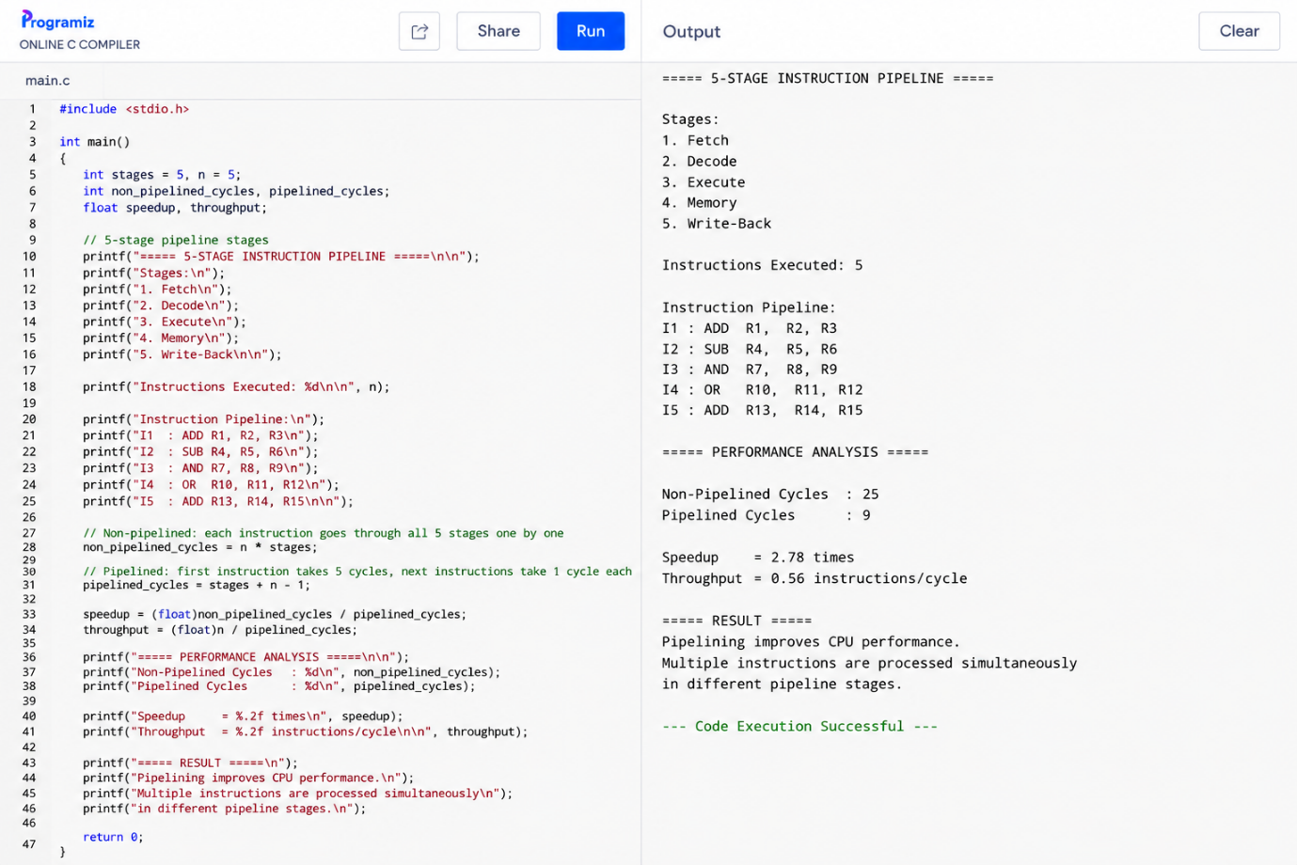

4. #include <stdio.h>

int main()
{
int data_hazard = 2;
int control_hazard = 2;
int structural_hazard = 2;

int stall_cycles;
int forwarding_cycles;
int branch_prediction_cycles;
int total_cycles;

printf("===== PIPELINE HAZARD SIMULATION =====\n\n");

printf("Pipeline Stages:\n");
printf("IF -> ID -> EX -> MEM -> WB\n\n");

printf("Instructions:\n");
printf("I1: ADD R1, R2, R3\n");
printf("I2: SUB R4, R1, R5\n");
printf("I3: LOAD R6, 0(R7)\n");
printf("I4: BEQ R6, R0, LABEL\n");
printf("I5: ADD R8, R9, R10\n\n");

/* Data Hazard */
printf("----- DATA HAZARD -----\n");
printf("Hazard: I2 depends on result of I1\n");
printf("Technique: Data Forwarding\n");

forwarding_cycles = data_hazard - 1;

printf("Stall cycles without forwarding: %d\n", data_hazard);
printf("Stall cycles with forwarding: %d\n\n", forwarding_cycles);

/* Control Hazard */
printf("----- CONTROL HAZARD -----\n");
printf("Hazard: Branch instruction changes program flow\n");
printf("Technique: Branch Prediction\n");

branch_prediction_cycles = control_hazard - 1;

printf("Penalty without prediction: %d cycles\n", control_hazard);
printf("Penalty with prediction: %d cycle\n\n",
branch_prediction_cycles);

/* Structural Hazard */
printf("----- STRUCTURAL HAZARD -----\n");
printf("Hazard: Two instructions require the same resource\n");
printf("Technique: Stalling / Resource Scheduling\n");

stall_cycles = structural_hazard;

printf("Stall cycles required: %d\n", stall_cycles);
printf("Resource conflict resolved successfully.\n\n");

/* Overall performance */
total_cycles = 10 + forwarding_cycles
+ branch_prediction_cycles
+ stall_cycles;

printf("===== PERFORMANCE ANALYSIS =====\n");
printf("Base Pipeline Cycles : 10\n");
printf("Data Hazard Stall Cycles : %d\n",
forwarding_cycles);
printf("Control Hazard Penalty : %d\n",
branch_prediction_cycles);
printf("Structural Hazard Stall : %d\n",
stall_cycles);
printf("Total Execution Cycles : %d\n\n",
total_cycles);

printf("===== RESULT =====\n");
printf("Data forwarding reduces data stalls.\n");
printf("Branch prediction reduces control hazard penalty.\n");
printf("Stalling resolves structural conflicts.\n");
printf("Hazard handling improves pipeline performance.\n");

return 0;
}

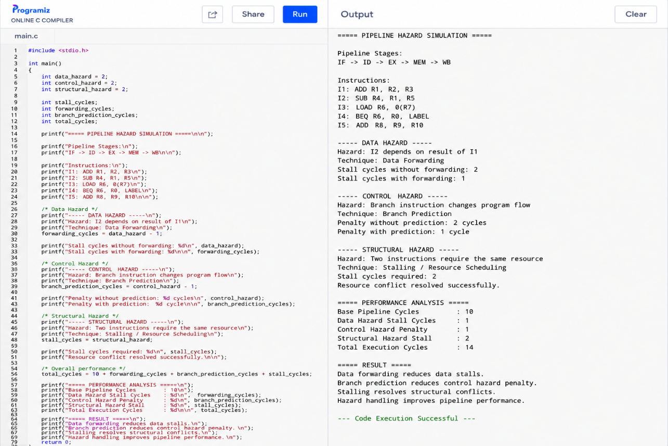

5. #include <stdio.h>

int main()
{
int instructions = 8;

int single_issue_cycles;
int superscalar_cycles;
int ooo_cycles;
int smt_cycles;

float throughput_single;
float throughput_super;
float throughput_ooo;
float throughput_smt;

printf("===== SUPERSCALAR PROCESSOR SIMULATION =====\n\n");

printf("Instructions: %d\n\n", instructions);

printf("Instruction Set:\n");
printf("I1: ADD R1, R2, R3\n");
printf("I2: SUB R4, R5, R6\n");
printf("I3: MUL R7, R8, R9\n");
printf("I4: AND R10, R11, R12\n");
printf("I5: OR R13, R14, R15\n");
printf("I6: ADD R16, R17, R18\n");
printf("I7: SUB R19, R20, R21\n");
printf("I8: MUL R22, R23, R24\n\n");

/* Single issue processor */
single_issue_cycles = instructions;
throughput_single = (float)instructions / single_issue_cycles;

printf("----- SINGLE ISSUE -----\n");
printf("Instructions per cycle : 1\n");
printf("Cycles : %d\n", single_issue_cycles);
printf("Throughput : %.2f instructions/cycle\n\n",
throughput_single);

/* Superscalar processor */
superscalar_cycles = 4;
throughput_super = (float)instructions / superscalar_cycles;

printf("----- SUPERSCALAR -----\n");
printf("Instructions per cycle : 2\n");
printf("Cycles : %d\n", superscalar_cycles);
printf("Out-of-order execution : ENABLED\n");
printf("Speculative execution : ENABLED\n");
printf("Throughput : %.2f instructions/cycle\n\n",
throughput_super);

/* Out-of-order execution */
ooo_cycles = 3;
throughput_ooo = (float)instructions / ooo_cycles;

printf("----- OUT-OF-ORDER -----\n");
printf("Instructions executed in parallel.\n");
printf("Cycles : %d\n", ooo_cycles);
printf("Throughput : %.2f instructions/cycle\n\n",
throughput_ooo);

/* SMT / Hyper-threading */
smt_cycles = 2;
throughput_smt = (float)instructions / smt_cycles;

printf("----- SMT / HYPER-THREADING -----\n");
printf("Logical Threads : 2\n");
printf("Instructions per cycle : 4\n");
printf("Cycles : %d\n", smt_cycles);
printf("Throughput : %.2f instructions/cycle\n\n",
throughput_smt);

printf("===== PERFORMANCE COMPARISON =====\n");
printf("Single Issue Throughput : %.2f instructions/cycle\n",
throughput_single);
printf("Superscalar Throughput : %.2f instructions/cycle\n",
throughput_super);
printf("Out-of-Order Throughput : %.2f instructions/cycle\n",
throughput_ooo);
printf("SMT Throughput : %.2f instructions/cycle\n\n",
throughput_smt);

printf("Resource Utilization:\n");
printf("Single Issue : 25%%\n");
printf("Superscalar : 50%%\n");
printf("Out-of-Order : 75%%\n");
printf("SMT : 90%%\n\n");

printf("===== RESULT =====\n");
printf("Superscalar execution improves instruction throughput.\n");
printf("Out-of-order execution reduces idle execution units.\n");
printf("Speculative execution keeps the pipeline busy.\n");
printf("SMT improves processor resource utilization.\n");

return 0;
}

