SIMATS ENGINEERING
Department of Computer Science & Engineering
ASSESSMENT TOOL 1- CONSTRAINT-BASED PROBLEM SOLVING
Course Code: | CSA12 | Course Title: | Computer Architecture for Multicore Systems
CO Assessed: | CO5 | Assessment: | ASSESSMENT TOOL1- Constraint-Based Problem Solving
Weightage: | 40% | Total Marks: | 25
CO5 Statement: | Construct I/O communication mechanisms by comparing memory-mapped and I/O-mapped techniques, interrupt handling (vectored, hardware, software), DMA controllers, and advanced bus interfaces including PCIe, USB, NVMe, and Thunderbolt.
Student Name: | S.Parameshwar | Reg.No.: | 192521044
Department: | B.TECH[IT} | Date:

ANNEXURE A
Constraint-Based Problem Solving
1.Construct an I/O communication mechanism for a real-time embedded system with the following constraints:
- CPU utilization must be below 15%
- Multiple sensors generate interrupts every 1 ms
- Use vectored interrupt handling
- Select between memory-mapped and I/O-mapped I/O for optimal latency
2.Design an I/O subsystem under these constraints:
- High-speed storage requires throughput > 3 GB/s
- Must use NVMe over PCIe
- CPU should not handle bulk data transfer
- Integrate DMA controller with interrupt notification
3.Construct a multi-device communication architecture with constraints:
- 6 peripherals using USB, 2 high-speed devices using Thunderbolt
- Avoid interrupt starvation
- Use hardware and software interrupts
- Ensure fair bus arbitration
4.Design a data acquisition system with constraints:
- Continuous data stream at 500 MB/s
- Minimal CPU intervention required
- Must compare DMA transfer vs interrupt-driven I/O
- Use memory-mapped I/O for device registers
5.Construct an interrupt handling mechanism with constraints:
- Support nested interrupts
- Maximum interrupt latency < 10 µs
- Use vectored interrupts for high-priority devices
- Use software interrupts for background tasks

Code of Conduct:

I ____________________________________ (Name / Reg No) certify that this submission is my original work and that I have adhered to the guidelines specified for this assessment.
I understand that any violation of academic integrity rules will result in disciplinary action.

Signature of the student:

MARKS ALLOCATION
 | Problem Understanding (25%) | Constraint Analysis (25%) | Solution Development (25%) | Application of Concepts (15%) | Justification (10%)
Q1
Q2
Q3
Q4
Q5

RUBRICS FOR CALCULATION:

Criteria | Weightage | Level 4 – Exemplary | Level 3 – Proficient | Level 2 – Developing | Level 1 – Beginning
Problem Understanding | 25% | Clearly defines the problem and identifies all relevant constraints accurately | Identifies most constraints with minor gaps | Partial understanding; misses key constraints | Fails to identify constraints correctly
Constraint Analysis | 25% | Analyzes constraints effectively and prioritizes them logically | Provides reasonable analysis with some prioritization | Limited analysis; weak prioritization | No meaningful analysis or prioritization
Solution Development | 25% | Develops optimal and feasible solutions satisfying all constraints | Develops workable solutions with minor limitations | Solutions partially satisfy constraints | Solutions do not meet constraints
Application of Concepts | 15% | Effectively applies appropriate concepts, methods, or tools | Applies concepts with minor errors | Limited application; requires guidance | Unable to apply relevant concepts
Justification | 10% | Provides strong justification for decisions with logical reasoning | Provides justification with some clarity | Weak or unclear justification | No justification provided

ANNEXURE A – CONSTRAINT-BASED PROBLEM SOLVING

1. Construct an I/O Communication Mechanism for a Real-Time Embedded System
Given Constraints
- CPU utilization must be below 15%.
- Multiple sensors generate interrupts every 1 ms.
- Vectored interrupt handling must be used.
- Select between memory-mapped I/O and I/O-mapped I/O for minimum latency.
Answer
A real-time embedded system can be designed using a vectored interrupt controller, memory-mapped I/O, short interrupt service routines, and buffered sensor data processing. Since multiple sensors generate interrupts every 1 ms, the system must respond quickly without allowing interrupt processing to consume a large percentage of CPU time.
Proposed Architecture

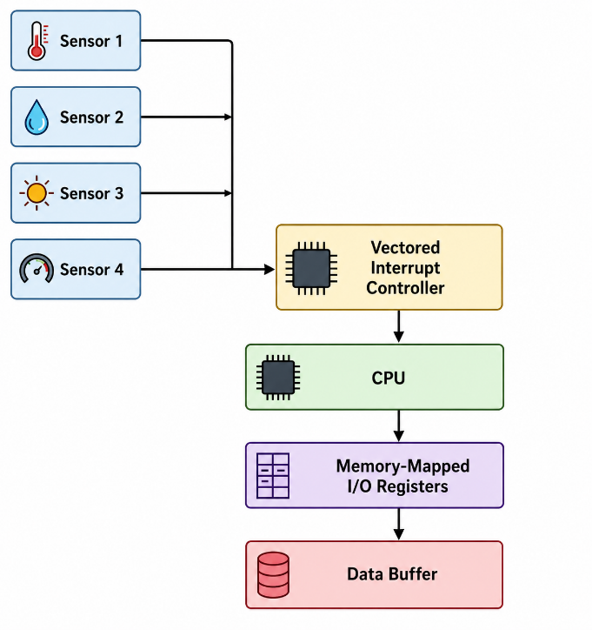

Working
Each sensor is connected to an interrupt input. When a sensor produces new data, it generates an interrupt. The vectored interrupt controller immediately identifies the source and provides the corresponding interrupt vector to the CPU.
The CPU then executes the appropriate ISR. The ISR performs only essential operations such as reading the sensor register, storing the data in a buffer, clearing the interrupt flag, and returning control to the main program.
Long calculations are performed later as background tasks instead of inside the ISR.

Selection of I/O Method
Memory-mapped I/O is selected for this design. In memory-mapped I/O, sensor control and data registers are assigned addresses in the processor's memory address space. The CPU can access these registers using normal load and store instructions.
I/O-mapped I/O can provide a separate address space for devices, but it generally requires dedicated I/O instructions. Memory-mapped I/O provides a simpler programming model and is well suited for fast register access in embedded processors.
CPU Utilization Calculation
Assume four sensors generate interrupts every 1 ms and each ISR requires approximately 8 µs.

$$CPU Utilization=\frac{4×8μs}{1000μs}×100$$
$$=3.2\%$$
Therefore,
$$3.2\%<15\%$$
The CPU remains well within the specified utilization limit.
Result
The proposed mechanism provides fast sensor response, low CPU utilization, predictable interrupt handling, and low I/O access latency. Vectored interrupts prevent the CPU from searching for the interrupt source, while memory-mapped I/O simplifies and speeds up device-register access.

2. Design an I/O Subsystem for High-Speed NVMe Storage
Given Constraints
- Storage throughput must be greater than 3 GB/s.
- The system must use NVMe over PCIe.
- CPU should not perform bulk data transfers.
- A DMA controller must be integrated with interrupt notification.

Answer
A high-performance storage subsystem can be designed using an NVMe SSD connected through a PCIe interface and DMA-based data transfer. NVMe is specifically designed for high-speed solid-state storage and uses PCIe to provide a high-bandwidth connection between the storage controller and the system.

Proposed Architecture

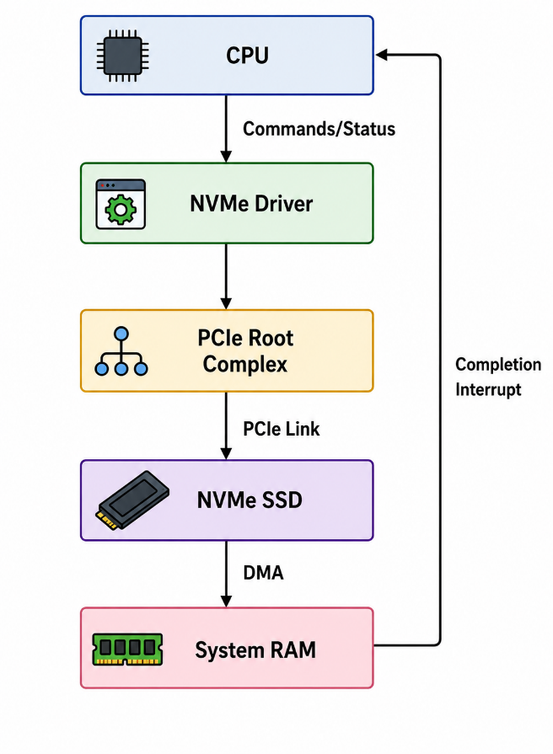

Working
When an application requests data from the SSD, the CPU prepares an NVMe command. The command contains information about the operation and the memory buffers where the data should be placed.
The NVMe controller performs the storage operation and transfers the data directly into system memory using DMA. The CPU does not copy every byte of storage data.
After the requested transfer is completed, the NVMe controller generates a completion interrupt. The CPU handles this interrupt and updates the software state.
DMA Operation
The data path is:
$$NVMe SSD→PCIe→DMA→RAM$$
The CPU is mainly responsible for:
- Creating commands.
- Managing queues.
- Setting up memory buffers.
- Processing completion notifications.
- Handling errors.

Throughput
The PCIe interface must be configured with sufficient bandwidth to support a storage throughput greater than 3 GB/s. A suitable PCIe generation and lane configuration can provide enough bandwidth for such high-speed NVMe operation, subject to the actual SSD and system implementation.
Result
The design satisfies the requirements by using NVMe over PCIe for high-speed communication and DMA for bulk data movement. Interrupt notification informs the CPU only after operations are completed, significantly reducing CPU overhead.

3. Construct a Multi-Device Communication Architecture
Given Constraints
- 6 USB peripherals must be supported.
- 2 high-speed devices must use Thunderbolt.
- Interrupt starvation must be avoided.
- Both hardware and software interrupts must be used.
- Fair bus arbitration must be guaranteed.
Answer
A hierarchical communication architecture can be used to connect the eight devices. The six USB peripherals are managed by a USB host controller, while the two high-speed devices are connected through a Thunderbolt controller.
Proposed Architecture

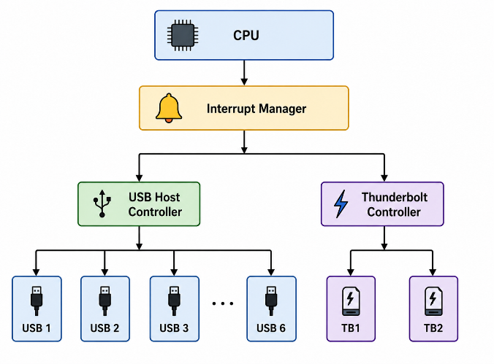
Hardware Interrupts
Hardware interrupts are generated by controllers for important events such as:
- Data transfer completion.
- Device connection.
- Device disconnection.
- Buffer availability.
- Communication errors.
These interrupts are handled quickly by the CPU.

Software Interrupts
Software interrupts are used for non-critical processing after the hardware ISR has completed.
For example:
Hardware Interrupt
↓
Short ISR
↓
Store event information
↓
Software Interrupt
↓
Process data
This prevents lengthy processing from blocking other hardware interrupts.
Avoiding Interrupt Starvation
A priority-based interrupt system is used. Critical hardware events receive higher priority, while normal events receive medium priority.
However, low-priority devices are also given guaranteed processing opportunities. A maximum waiting-time limit can be implemented so that one device cannot occupy the CPU or bus indefinitely.
Fair Bus Arbitration
A weighted round-robin technique can be used for bus arbitration.
Example:
USB1 → USB2 → USB3 → USB4 → USB5 → USB6
↓
Thunderbolt 1
↓
Thunderbolt 2
↓
Repeat
Thunderbolt devices can be given additional bus slots because they support higher-speed transfers, while USB devices still receive regular service.
Result
The architecture supports all six USB peripherals and two Thunderbolt devices. Hardware interrupts provide rapid event notification, software interrupts handle deferred processing, and fair arbitration prevents any device from being permanently delayed.

4. Design a Data Acquisition System with a 500 MB/s Continuous Stream
Given Constraints
- Continuous data rate = 500 MB/s.
- CPU intervention must be minimal.
- DMA and interrupt-driven I/O must be compared.
- Device registers must use memory-mapped I/O.
Answer
For a continuous data stream of 500 MB/s, a DMA-based data acquisition system is the most appropriate solution. Direct CPU-driven data transfer would create excessive overhead because a large amount of data must be moved continuously.
Proposed Architecture

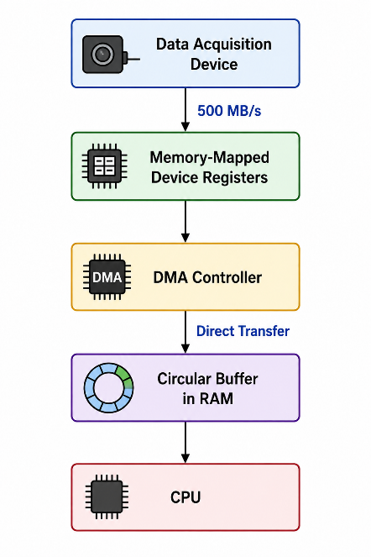

Working
The CPU first configures the DMA controller with:
- Source address.
- Destination address.
- Transfer size.
- Buffer descriptors.
- Transfer mode.
After initialization, the acquisition device continuously supplies data. The DMA controller transfers the data directly into RAM.
A circular buffer can be used so that one portion of memory is filled while the CPU processes another portion.

For example:

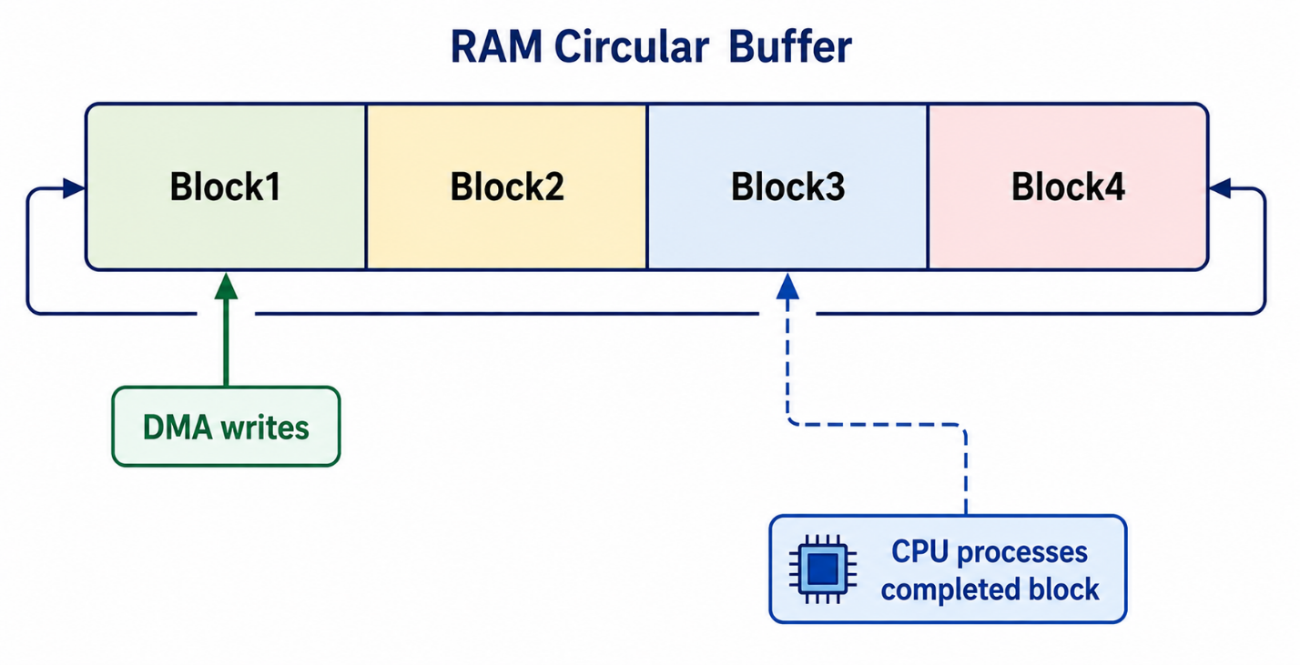

DMA vs Interrupt-Driven I/O
Parameter | DMA Transfer | Interrupt-Driven I/O
CPU involvement | Very low | High
Data movement | DMA hardware | CPU
Suitable for 500 MB/s | Yes | Less suitable
Interrupt frequency | Low | Potentially high
CPU overhead | Low | High
Continuous streaming | Excellent | Difficult
Efficiency | High | Lower
Why DMA is Preferred
At 500 MB/s, interrupting the CPU for every small amount of data would result in a very large number of interrupts. The CPU would spend significant time saving context, executing the ISR, transferring data, and returning to the main task.
DMA transfers large blocks independently and interrupts the CPU only when a block or group of blocks has been completed.
Result
DMA is selected because it provides continuous high-speed data transfer with minimal CPU intervention. Memory-mapped I/O provides direct and convenient access to the acquisition device's control and status registers.

5. Construct an Interrupt Handling Mechanism with Nested Interrupts
Given Constraints
- Nested interrupts must be supported.
- Maximum interrupt latency must be less than 10 µs.
- High-priority devices must use vectored interrupts.
- Background tasks must use software interrupts.
Answer
A priority-based nested interrupt architecture can be designed to satisfy these requirements. The system assigns different priority levels to interrupt sources. A high-priority interrupt can temporarily interrupt a lower-priority ISR.
Proposed Architecture

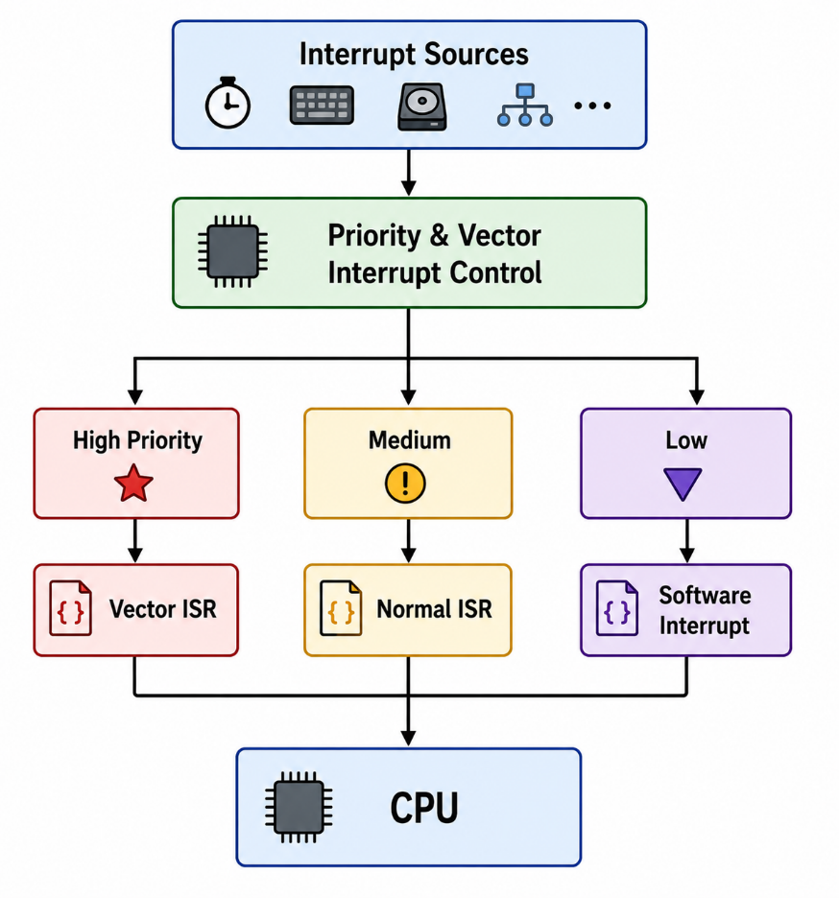

Nested Interrupt Operation
Suppose a low-priority ISR is currently running. If a high-priority device generates an interrupt, the CPU temporarily stops the current ISR.

The sequence is:
Low Priority ISR
│
▼
High Priority Interrupt
│
▼
Save CPU Context
│
▼
Jump to Interrupt Vector
│
▼
Execute High Priority ISR
│
▼
Restore Previous Context
│
▼
Continue Low Priority ISR
This mechanism ensures that critical devices do not have to wait for lengthy low-priority processing.
Vectored Interrupts
High-priority devices are assigned dedicated interrupt vectors.
Example:
Vector 0 → Emergency/critical device
Vector 1 → High-speed communication
Vector 2 → Real-time timer
Vector 3 → Normal peripheral
When an interrupt occurs, the CPU can directly jump to the corresponding ISR instead of searching through all devices.
Software Interrupts
Software interrupts are used for background activities such as:
- Data processing.
- Logging.
- Buffer management.
- Non-critical communication.
- Deferred calculations.
The hardware ISR remains short, while the software interrupt performs the larger processing operation.

Interrupt Latency
The system can be designed with a short critical ISR. An example latency budget is:

Operation | Time
Interrupt detection | 2 µs
Context saving | 2 µs
Vector dispatch | 1 µs
Critical ISR execution | 3 µs
Context restoration | 1 µs
Total | 9 µs

Therefore,
$$Maximum Interrupt Latency=9μs$$
Since:
$$9μs<10μs$$
the latency requirement is satisfied.
Result
The proposed interrupt mechanism supports nested interrupts, priority-based scheduling, vectored handling for critical devices, and software interrupts for background processing. By keeping critical ISRs short and using direct vector dispatch, the maximum estimated latency is maintained below 10 µs.

