SIMATS ENGINEERING
Department of Computer Science & Engineering
ASSESSMENT TOOL 2- PSEUDOCODE WRITING TASK (ALGORITHM DESIGN)

Course Code: | CSA12 | Course Title: | Computer Architecture for Multicore Systems
CO Assessed: | CO5 | Assessment: | ASSESSMENT TOOL2- PSEUDOCODE WRITING TASK (ALGORITHM DESIGN)
Weightage: | 30% | Total Marks: | 25
CO5 Statement: | Construct I/O communication mechanisms by comparing memory-mapped and I/O-mapped techniques, interrupt handling (vectored, hardware, software), DMA controllers, and advanced bus interfaces including PCIe, USB, NVMe, and Thunderbolt.
Student Name: | S.Parameshwar | Reg.No.: | 192521044
Department: | B.TECH[IT[ | Date: | 29/08/2026

ANNEXURE A
Pseudocode Writing Task (Algorithm Design)

- Write pseudocode to design a DMA-based data transfer algorithm that moves data from an I/O device to memory while handling interrupts and minimizing CPU involvement.
- Develop pseudocode for an interrupt handling system that prioritizes vectored interrupts from multiple devices and dispatches appropriate service routines.
- Write pseudocode to select between memory-mapped I/O and I/O-mapped I/O dynamically based on latency and bandwidth requirements.
- Design pseudocode for a bus arbitration algorithm that manages multiple devices communicating over PCIe, USB, and Thunderbolt interfaces.
- Write pseudocode to implement a hybrid I/O communication mechanism that uses polling for low-speed devices and DMA with interrupts for high-speed devices.

Code of Conduct:

I (Name-S.Parameshwar / Reg No-192521044) certify that this submission is my original work and that I have adhered to the guidelines specified for this assessment.
I understand that any violation of academic integrity rules will result in disciplinary action.

Signature of the student : Parameshwar S

MARKS ALLOCATION
 | Problem Understanding (20%) | Algorithm Design (30%) | Use of Control Structures (20%) | Pseudocode Structure (10%) | Completeness (20%)
Q1
Q2
Q3
Q4
Q5

RUBRICS FOR CALCULATION:

Criteria | Weightage | Level 4 – Exemplary | Level 3 – Proficient | Level 2 – Developing | Level 1 – Beginning
Problem Understanding | 20% | Identifies all inputs, outputs, constraints accurately | Minor missing elements | Partial understanding | Incorrect interpretation
Algorithm Design | 30% | Complete, correct, and logically sound solution | Minor logical gaps | Partially correct logic | Incorrect approach
Use of Control Structures | 20% | Efficient and appropriate use of loops, conditions, functions/modules | Minor inefficiencies | Limited or basic usage | Incorrect or missing constructs
Pseudocode Structure | 10% | Well-structured, clear, consistent format, easy to follow | Mostly clear with minor issues | Difficult to follow in parts | Poorly structured and unclear
Completeness | 20% | Handles all cases; optimized approach | Handles most cases; reasonable efficiency | Handles basic cases only | Incomplete or inefficient

1. DMA-Based Data Transfer from I/O Device to Memory
Aim
To design a DMA-based data transfer algorithm that transfers data directly from an I/O device to memory while minimizing CPU involvement and handling completion interrupts.

Pseudocode
ALGORITHM DMA_IO_TO_MEMORY
BEGIN
INITIALIZE CPU
INITIALIZE I/O DEVICE
INITIALIZE DMA CONTROLLER
SET SOURCE ← I/O_DEVICE
SET DESTINATION ← MEMORY
SET DATA_SIZE ← required number of bytes
CONFIGURE DMA CONTROLLER
SET source_address ← I/O_DEVICE_ADDRESS
SET destination_address ← MEMORY_ADDRESS
SET transfer_count ← DATA_SIZE
SET transfer_direction ← IO_TO_MEMORY
ENABLE DMA_INTERRUPT
ENABLE I/O DEVICE
START DMA TRANSFER
WHILE DMA_TRANSFER_NOT_COMPLETED DO
CPU performs other tasks
IF DMA_INTERRUPT_RECEIVED THEN
SAVE CPU STATE
CHECK DMA STATUS
IF TRANSFER_SUCCESSFUL THEN
SET transfer_status ← COMPLETED
CLEAR DMA INTERRUPT
ELSE
SET transfer_status ← ERROR
IDENTIFY ERROR
HANDLE ERROR
END IF
RESTORE CPU STATE
RETURN FROM INTERRUPT
END IF
END WHILE
VERIFY TRANSFERRED DATA
IF data_is_correct THEN
REPORT "DMA Transfer Successful"
ELSE
REPORT "Data Transfer Error"
END IF
END

Working
- CPU initializes the DMA controller.
- Source, destination, transfer size, and direction are configured.
- DMA transfers data directly from the I/O device to memory.
- CPU is free to perform other operations during the transfer.
- After completion, DMA generates an interrupt.
- CPU executes the DMA interrupt service routine.
- Transfer status is checked and the interrupt is cleared.
Advantage: CPU involvement is minimized because the DMA controller performs the actual data transfer.

2. Vectored Interrupt Handling with Priority
Aim
To design an interrupt handling system that prioritizes interrupts from multiple devices and dispatches the correct interrupt service routine (ISR).

Pseudocode
ALGORITHM VECTORED_INTERRUPT_HANDLER
BEGIN
INITIALIZE INTERRUPT CONTROLLER
DEFINE DEVICES:
TIMER
KEYBOARD
NETWORK
DISK
SENSOR
ASSIGN PRIORITY TO EACH DEVICE
ASSIGN INTERRUPT VECTOR TO EACH DEVICE
ENABLE ALL REQUIRED INTERRUPTS
WHILE SYSTEM_IS_RUNNING DO
IF INTERRUPT_REQUEST_RECEIVED THEN
IDENTIFY INTERRUPT_SOURCE

READ INTERRUPT_VECTOR
DETERMINE PRIORITY OF INTERRUPT
IF higher_priority_interrupt_exists THEN
SELECT highest_priority_interrupt
ELSE
SELECT current_interrupt
END IF
SAVE CPU REGISTERS
SAVE PROGRAM_COUNTER
SAVE PROCESSOR_STATUS
DISPATCH INTERRUPT USING VECTOR
SWITCH TO CORRESPONDING ISR
EXECUTE ISR
CLEAR INTERRUPT_FLAG
RESTORE CPU REGISTERS
RESTORE PROGRAM_COUNTER
RESTORE PROCESSOR_STATUS
RETURN FROM INTERRUPT
END IF
END WHILE
END

Example Priority
Priority 1 → Timer
Priority 2 → Network
Priority 3 → Disk
Priority 4 → Sensor
Priority 5 → Keyboard
Example Vector Table
Device | Interrupt Vector | ISR
Timer | 001 | Timer_ISR
Network | 002 | Network_ISR
Disk | 003 | Disk_ISR
Sensor | 004 | Sensor_ISR
Keyboard | 005 | Keyboard_ISR

Working
When multiple devices request interrupts, the interrupt controller identifies their priority. The highest-priority interrupt is serviced first. The interrupt vector directly identifies the corresponding ISR, reducing interrupt dispatch time.
Advantage: Vectored interrupts provide fast and efficient interrupt servicing.

3. Dynamic Selection Between Memory-Mapped I/O and I/O-Mapped I/O
Aim
To dynamically select the appropriate I/O addressing method based on latency and bandwidth requirements.

Pseudocode
ALGORITHM SELECT_IO_MAPPING
INPUT:
latency_requirement
bandwidth_requirement
device_type
BEGIN
READ latency_requirement
READ bandwidth_requirement
READ device_type
IF latency_requirement = HIGH THEN
IF bandwidth_requirement = HIGH THEN
SELECT MEMORY_MAPPED_IO
ELSE
SELECT MEMORY_MAPPED_IO
END IF
ELSE IF bandwidth_requirement = HIGH THEN
SELECT MEMORY_MAPPED_IO
ELSE
SELECT IO_MAPPED_IO
END IF
IF SELECTED_MODE = MEMORY_MAPPED_IO THEN
MAP I/O DEVICE REGISTERS INTO MEMORY ADDRESS SPACE
USE NORMAL LOAD/STORE INSTRUCTIONS
CONFIGURE DEVICE
ELSE IF SELECTED_MODE = IO_MAPPED_IO THEN
ASSIGN SEPARATE I/O ADDRESS SPACE
USE I/O-SPECIFIC INSTRUCTIONS
CONFIGURE DEVICE
END IF
MONITOR I/O PERFORMANCE
MEASURE ACTUAL_LATENCY
MEASURE ACTUAL_BANDWIDTH

IF performance_is_below_requirement THEN
RE-EVALUATE I/O MAPPING
IF requirements_have_changed THEN
SELECT appropriate I/O mode again
END IF
END IF
RETURN SELECTED_MODE
END
Selection Logic
IF latency is HIGH
↓
Choose Memory-Mapped I/O

IF bandwidth is HIGH
↓
Choose Memory-Mapped I/O

IF latency and bandwidth requirements are LOW
↓
I/O-Mapped I/O can be selected
Working
Memory-mapped I/O places device registers in the normal memory address space and allows normal load/store instructions. It is generally convenient when frequent and fast access is required.
I/O-mapped I/O uses a separate I/O address space and dedicated I/O instructions. It can be useful when the architecture supports a separate I/O space and conserving memory address space is important.

4. Bus Arbitration for PCIe, USB, and Thunderbolt
Aim
To design a bus arbitration algorithm that manages communication requests from multiple devices using PCIe, USB, and Thunderbolt interfaces.

Pseudocode
ALGORITHM BUS_ARBITRATION
BEGIN
INITIALIZE PCIe_CONTROLLER
INITIALIZE USB_CONTROLLER
INITIALIZE THUNDERBOLT_CONTROLLER
DEFINE REQUEST_QUEUE
WHILE SYSTEM_IS_RUNNING DO
CHECK PCIe_REQUEST
CHECK USB_REQUEST
CHECK THUNDERBOLT_REQUEST
IF PCIe_REQUEST = TRUE THEN
ADD PCIe_REQUEST TO REQUEST_QUEUE
END IF
IF USB_REQUEST = TRUE THEN
ADD USB_REQUEST TO REQUEST_QUEUE
END IF
IF THUNDERBOLT_REQUEST = TRUE THEN
ADD THUNDERBOLT_REQUEST TO REQUEST_QUEUE
END IF
FOR EACH REQUEST IN REQUEST_QUEUE DO
CALCULATE PRIORITY BASED ON:
DATA_SIZE
LATENCY_REQUIREMENT
DEVICE_PRIORITY
REAL_TIME_REQUIREMENT
END FOR
SELECT HIGHEST_PRIORITY_REQUEST
IF selected_request = PCIe THEN
GRANT PCIe_ACCESS
TRANSFER DATA
RELEASE PCIe_ACCESS
ELSE IF selected_request = USB THEN
GRANT USB_ACCESS
TRANSFER DATA
RELEASE USB_ACCESS
ELSE IF selected_request = THUNDERBOLT THEN
GRANT THUNDERBOLT_ACCESS
TRANSFER DATA
RELEASE THUNDERBOLT_ACCESS
END IF
REMOVE COMPLETED_REQUEST FROM REQUEST_QUEUE
CHECK FOR ERRORS
IF ERROR_DETECTED THEN
HANDLE ERROR
RETRY OR REPORT FAILURE
END IF
END WHILE
END

Priority Example
Real-time request
↓
High-bandwidth request
↓
Low-latency request
↓
Normal request
↓
Background request
Working
- Controllers monitor requests from PCIe, USB, and Thunderbolt devices.
- Requests are placed into a queue.
- Each request is assigned a priority.
- The arbitration logic selects the highest-priority request.
- Access is granted to the selected interface.
- Data transfer takes place.
- After completion, the resource is released.
- The next request is processed.
Note: In real systems, PCIe, USB, and Thunderbolt have different protocol-specific architectures and arbitration mechanisms. The pseudocode represents a high-level system-level arbitration policy, not a replacement for their actual protocol controllers.

- Hybrid I/O Communication Mechanism
Aim
To design a hybrid I/O mechanism that uses polling for low-speed devices and DMA with interrupts for high-speed devices.

Pseudocode
ALGORITHM HYBRID_IO_COMMUNICATION
BEGIN
INITIALIZE ALL I/O DEVICES
FOR EACH DEVICE DO
DETERMINE DEVICE_SPEED
DETERMINE DATA_SIZE
DETERMINE LATENCY_REQUIREMENT
IF DEVICE_SPEED = LOW AND
DATA_SIZE = SMALL THEN
SET MODE ← POLLING
ELSE
SET MODE ← DMA_WITH_INTERRUPT
END IF
END FOR
WHILE SYSTEM_IS_RUNNING DO
FOR EACH DEVICE DO
IF MODE = POLLING THEN
CHECK DEVICE_STATUS
IF DEVICE_READY THEN
READ DATA FROM DEVICE
PROCESS DATA
CLEAR DEVICE_STATUS
END IF
ELSE IF MODE = DMA_WITH_INTERRUPT THEN
CONFIGURE DMA_CONTROLLER
SET SOURCE_ADDRESS
SET DESTINATION_ADDRESS
SET TRANSFER_SIZE
ENABLE DMA_INTERRUPT
START DMA_TRANSFER
CPU CONTINUES OTHER TASKS
IF DMA_INTERRUPT_RECEIVED THEN
SAVE CPU STATE
CHECK DMA_STATUS
IF TRANSFER_SUCCESSFUL THEN
PROCESS TRANSFERRED DATA
ELSE
HANDLE DMA_ERROR
END IF
CLEAR INTERRUPT
RESTORE CPU STATE
END IF
END IF
END FOR
END WHILE
END

Example Device Classification
Device Type | Data Rate | Selected Method
Keyboard | Low | Polling
Simple Sensor | Low | Polling
Mouse | Low/Medium | Polling
Network Interface | High | DMA + Interrupt
SSD/Storage | Very High | DMA + Interrupt
High-speed Camera | High | DMA + Interrupt

Working

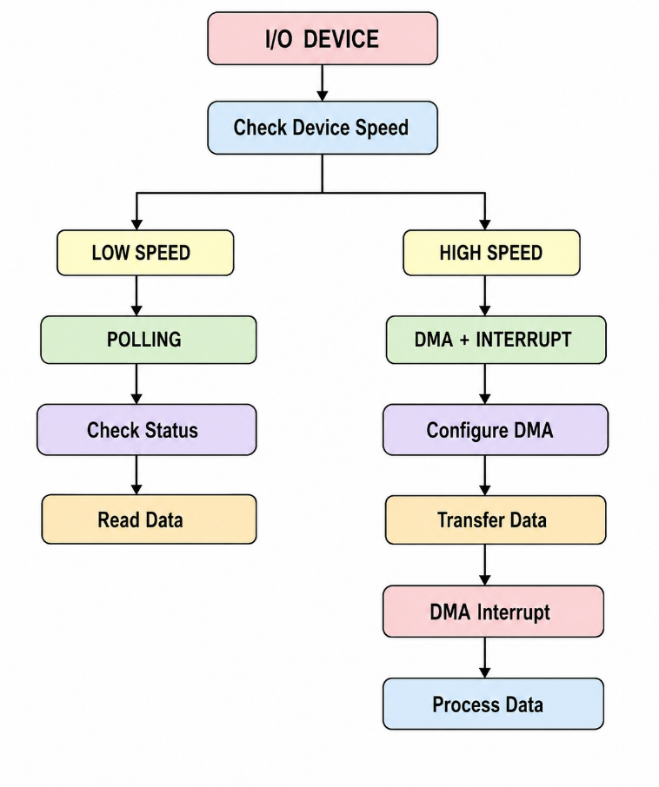

Advantages
- Polling is simple and suitable for low-speed devices.
- DMA reduces CPU involvement for large/high-speed transfers.
- Interrupts notify the CPU only when DMA operations require attention.
- The hybrid approach improves overall CPU utilization and I/O performance.
- Different devices can use the communication method most appropriate for their requirements.

