SIMATS ENGINEERING
Department of Computer Science & Engineering
ASSESSMENT TOOL 1- INDUSTRY PROBLEM SOLVING TASK

Course Code: | CSA12 | Course Title: | Computer Architecture for Multicore Systems
CO Assessed: | CO4 | Assessment: | ASSESSMENT TOOL1- INDUSTRY PROBLEM SOLVING TASK
Weightage: | 30% | Total Marks: | 25
CO4 Statement: | Implement hierarchical memory systems by differentiating cache levels (L1, L2, L3), virtual memory with paging, and advanced memory technologies (DRAM, SRAM, NAND Flash, MRAM, RRAM) based on latency, bandwidth, and throughput characteristics.
Student Name: | Parameshwar S | Reg.No.: | 192521044
Department: | B.TECH[IT] | Date: | 27/08/2026

ANNEXURE A
INDUSTRY PROBLEM SOLVING TASK

- Smartphone Performance Optimization
A mobile manufacturer observes lag while switching between apps. Analyze the role of L1, L2, L3 cache and DRAM and propose a hierarchical memory redesign to reduce latency and improve throughput.
- Cloud Server Memory Bottleneck
A cloud service provider experiences high latency in database queries. Compare cache hierarchy vs virtual memory paging and recommend improvements using appropriate memory technologies.
- Autonomous Vehicle Data Processing
An autonomous vehicle must process sensor data in real time. Evaluate SRAM, DRAM, and MRAM and design a memory hierarchy that maximizes bandwidth and minimizes latency.
- AI Inference Edge Device
An edge AI device needs fast model loading with low power consumption. Compare NAND Flash, DRAM, and RRAM and recommend an optimized hierarchical memory structure.
- High-Performance Gaming Console
A gaming console suffers frame drops during large scene loading. Analyze L3 cache vs DRAM throughput and propose memory hierarchy enhancements.

Code of Conduct:

I (Name-S.Parameshwar / Reg No-192521044) certify that this submission is my original work and that I have adhered to the guidelines specified for this assessment.
I understand that any violation of academic integrity rules will result in disciplinary action.

Signature of the student : PARAMESHWAR S

MARKS ALLOCATION
 | Understanding of Industry Problem (20%) | Application of Engineering Concepts (25%) | Solution Design (25%) | Use of Tools (15%) | Analysis (10%)
Q1
Q2
Q3
Q4
Q5

RUBRICS FOR CALCULATION:

Criteria | Weightage | Level 4 – Exemplary | Level 3 – Proficient | Level 2 – Developing | Level 1 – Beginning
Understanding of Industry Problem | 20% | Comprehensive understanding of real-world problem and constraints | Good understanding with minor gaps in requirements | Basic understanding; some requirements unclear | Poor understanding; misinterprets problem context
Application of Engineering Concepts | 25% | Applies advanced and relevant concepts effectively to solve the problem | Applies appropriate concepts with minor errors | Limited application of concepts | Incorrect or no application of concepts
Solution Design | 25% | Innovative, practical, and feasible solution aligned with industry standards | Logical and feasible solution with minor gaps | Basic solution with limited feasibility | Unclear or impractical solution
Use of Tools | 15% | Effective use of modern tools, technologies, and real data | Appropriate use of tools with correct implementation | Limited or inconsistent use of tools | Minimal or incorrect use of tools
Analysis | 10% | Thorough analysis with validated results and performance evaluation | Good analysis with reasonable validation | Basic analysis with limited validation | Poor or no analysis

1. Smartphone Performance Optimization
Problem Analysis
The mobile manufacturer observes lag while switching between applications. The main reason is not simply insufficient RAM; it is the increasing gap between processor speed and memory access speed.
During app switching, the processor frequently accesses application instructions, UI data, background processes, and recently used memory pages. If required data is not present in the faster cache levels, the processor must access slower memory.

Role of Different Memory Levels

Memory | Main Role | Latency | Capacity | Best Use
L1 Cache | Stores immediately required instructions/data | Very Low | Very Small | Active app execution
L2 Cache | Stores frequently reused data missed by L1 | Low | Small/Medium | Working data
L3 Cache | Shared cache for multiple CPU cores | Moderate | Larger | Cross-core/shared data
DRAM | Main working memory | High compared with cache | Large | Applications/background apps

Proposed Hierarchical Redesign

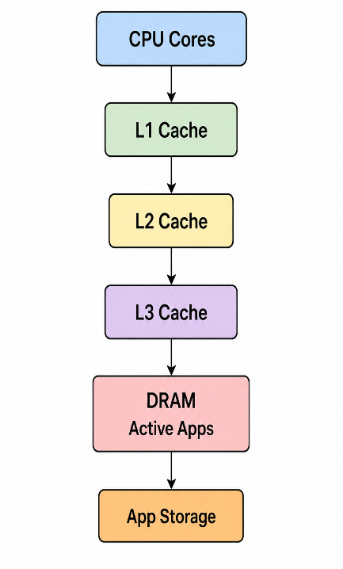

Unique Optimization
Instead of treating every application equally, the operating system can classify applications into:
- Hot apps – currently active or frequently switched to
- Warm apps – recently used applications
- Cold apps – rarely used applications
Frequently accessed data from hot apps should remain available in cache and DRAM, while cold applications can be compressed or moved out of the active working set.
Expected Improvement
The redesigned hierarchy reduces:
- Cache miss penalties
- DRAM accesses
- App-switch latency
- CPU idle time
It also improves throughput because the processor spends more cycles executing instructions rather than waiting for memory.
Result
A cache-aware and workload-aware memory hierarchy can significantly improve smartphone responsiveness during multitasking while maintaining the same physical DRAM capacity.

2. Cloud Server Memory Bottleneck
Problem Analysis
The cloud provider experiences high database-query latency. Database systems repeatedly access indexes, rows, transaction metadata, and frequently used query results.
Two mechanisms must be distinguished:
Cache hierarchy reduces processor-to-memory access latency.
Virtual memory paging manages memory capacity by moving pages between DRAM and secondary storage.
Therefore, paging should not be used as a replacement for cache optimization.

Cache Hierarchy vs Virtual Memory Paging
Feature | Cache Hierarchy | Virtual Memory Paging
Main Purpose | Reduce access latency | Extend usable memory
Managed By | Hardware | OS + hardware
Fastest Storage | SRAM cache | DRAM
Slow Path | DRAM | SSD/storage
Main Problem | Cache miss | Page fault
Database Benefit | Faster repeated CPU accesses | Supports large workloads

Proposed Architecture

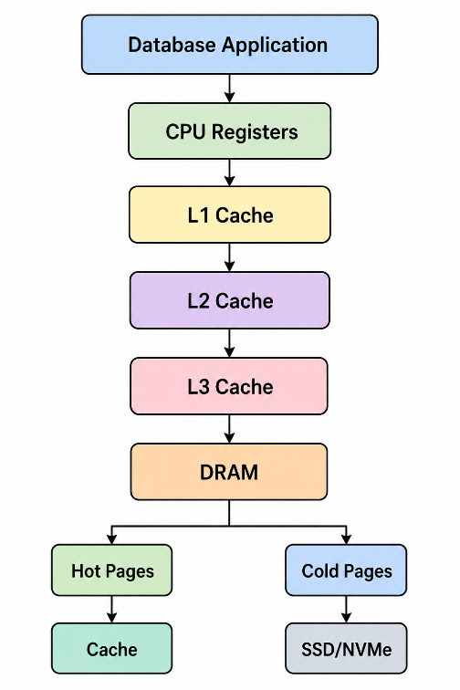

Unique Improvement: Database-Aware Memory Tiering
Instead of allowing frequently accessed database pages to be randomly evicted, the server can classify pages according to access frequency.
Hot data → DRAM
Frequently executed instructions → CPU cache
Warm data → compressed memory
Cold/inactive pages → NVMe SSD
This reduces unnecessary page faults.
Recommended Technologies
- High-speed SRAM for CPU caches
- High-capacity DRAM for database working sets
- NVMe SSD as secondary storage
- Memory compression to increase effective DRAM capacity
Performance Evaluation
If a database repeatedly accesses the same index:
Without optimization:
CPU → Cache Miss → DRAM → Possible Page Fault → SSD

With optimization:
CPU → L1/L2/L3 → DRAM
The second path avoids expensive storage access.
Result
The best solution is not simply increasing DRAM. A cache-aware database memory hierarchy combined with intelligent virtual-memory/page management reduces database-query latency and improves server throughput.

3. Autonomous Vehicle Data Processing
Problem Analysis
An autonomous vehicle continuously receives data from cameras, LiDAR, radar, ultrasonic sensors and other vehicle systems. Unlike a normal application, delayed processing can affect the vehicle's response time.
Therefore, the design objective is:
Minimum latency + maximum bandwidth + predictable access time.

SRAM vs DRAM vs MRAM
Technology | Speed | Volatility | Density | Suitable Role
SRAM | Extremely Fast | Volatile | Low | Real-time processing/cache
DRAM | Fast | Volatile | High | Sensor data buffer
MRAM | Fast | Non-volatile | Medium | Persistent/critical data

Proposed Autonomous Vehicle Memory Hierarchy

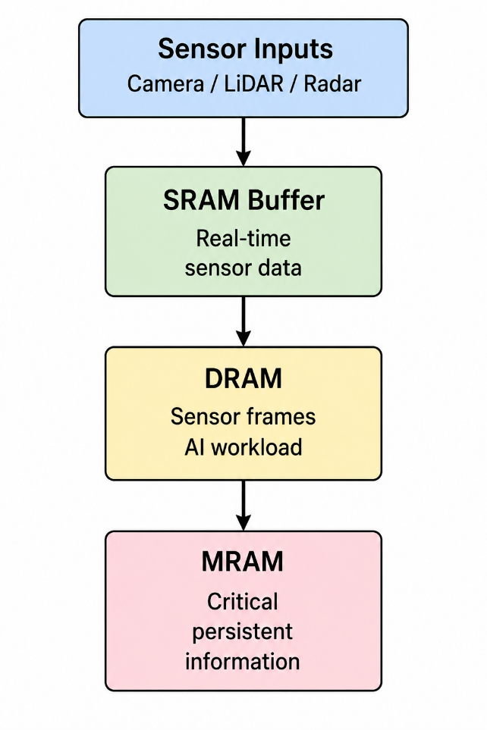

Unique Design: Priority-Based Sensor Memory
Sensor information should not be treated equally.
For example:
Emergency braking data → SRAM
Current camera/LiDAR processing frames → DRAM
Critical configuration/calibration/state data → MRAM
This creates a priority-aware memory system.
Why SRAM for Real-Time Data?
SRAM has very low latency, so it is appropriate for the smallest and most time-critical working sets.
Why DRAM?
The vehicle's AI and sensor-processing algorithms need much more memory than SRAM can economically provide. DRAM therefore acts as the main high-capacity working memory.
Why MRAM?
MRAM provides non-volatile storage characteristics with relatively fast access, making it useful for information that should survive power interruption.
Result
The proposed SRAM–DRAM–MRAM hierarchy separates urgent data, high-volume data and persistent data, maximizing processing bandwidth while minimizing the latency of safety-critical operations.

4. AI Inference Edge Device
Problem Analysis
An edge AI device needs to load machine-learning models quickly while consuming little power.
The challenge is that:
- NAND Flash provides high capacity but slower access.
- DRAM provides fast working memory but is volatile.
- RRAM can provide non-volatile memory characteristics and can be useful for AI-oriented memory architectures.
Memory Comparison
Technology | Speed | Power | Volatile? | Main Application
NAND Flash | Moderate/Slow | Low when idle | No | Model storage
DRAM | Fast | Higher | Yes | Active inference
RRAM | Fast potential access | Low | No | AI model/weight storage

Proposed Hierarchy

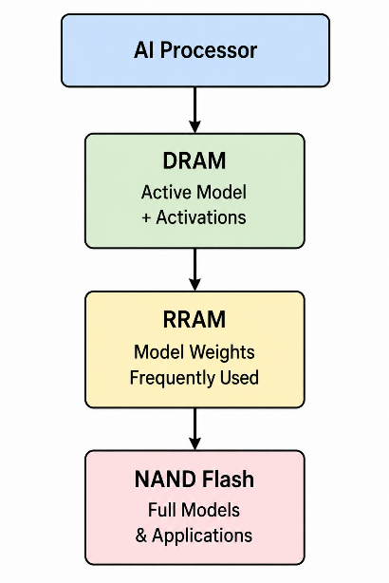

Unique Optimization: Model Tiering
Instead of loading the entire AI model every time:
- Store the complete model in NAND Flash.
- Keep frequently used model components in RRAM.
- Move the currently executing model into DRAM.
- Keep intermediate activations in DRAM.
- Replace only required model sections.
This reduces unnecessary data movement.
Example
NAND Flash
↓
Complete AI Models
↓
RRAM
Frequently used weights
↓
DRAM
Current inference model
↓
AI Accelerator
Benefits
- Faster model startup
- Reduced NAND accesses
- Lower energy consumption
- Better inference throughput
- Efficient use of limited edge-device memory
Result
The NAND → RRAM → DRAM hierarchy combines the capacity of NAND, persistence and AI-oriented potential of RRAM, and high-speed working capability of DRAM to create a power-efficient edge AI architecture.

5. High-Performance Gaming Console
Problem Analysis
The gaming console experiences frame drops while loading large scenes. Modern game scenes contain:
- Textures
- 3D models
- Lighting information
- Animation data
- Physics data
- Audio assets
When these assets cannot reach the processor/GPU quickly enough, the rendering pipeline waits, producing frame-time spikes.

L3 Cache vs DRAM
Feature | L3 Cache | DRAM
Capacity | Smaller | Much Larger
Latency | Lower | Higher
Technology | SRAM | DRAM
Cost per bit | High | Lower
Best Use | Frequently reused data | Large game assets
Main Limitation | Limited capacity | Higher latency

Proposed Gaming Memory Hierarchy

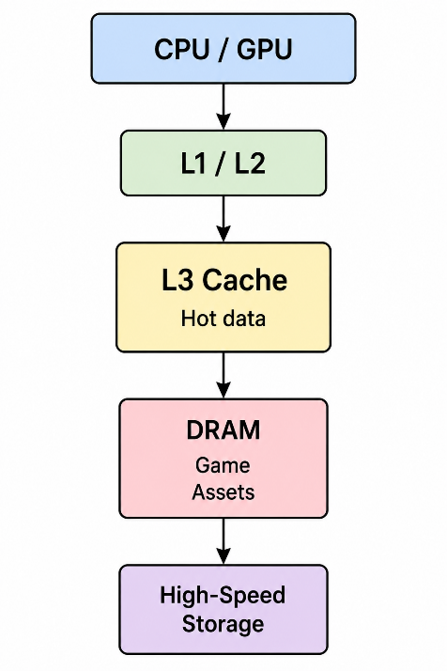

Unique Solution: Predictive Scene Prefetching
The console should predict which game assets will be needed next.
For example:
Player moving toward Area B
↓
Game Engine predicts Area B
↓
Textures + Models + Lighting
prefetched from storage
↓
DRAM
↓
Frequently reused assets → L3
↓
CPU/GPU rendering
Instead of waiting until the player enters the next area, the system loads assets before they are required.
L3 Optimization
The L3 cache should prioritize:
- Frequently reused game-engine instructions
- Physics data
- AI state
- Frequently accessed rendering metadata
Large textures should generally remain in larger memory rather than attempting to place everything in L3.
Performance Goal
The objective is not merely increasing L3 size. The important metric is:
Frame-time consistency.
Poor design:
16 ms → 17 ms → 45 ms → 16 ms
↑
Frame drop

Optimized design:
16 ms → 16 ms → 17 ms → 16 ms
A predictive prefetch system can reduce large memory stalls and improve frame-time stability.
Result
A cache-aware + predictive-prefetch memory hierarchy allows frequently reused data to remain close to the processor while large scene assets are streamed into DRAM ahead of demand, reducing frame drops and improving gaming performance.

Comparison

Industry Problem | Primary Bottleneck | Proposed Key Idea | Main Benefit
Smartphone | App-switch latency | Hot/Warm/Cold app tiering | Faster multitasking
Cloud Server | Database memory latency | Database-aware page tiering | Lower query latency
Autonomous Vehicle | Real-time sensor processing | Priority-based SRAM/DRAM/MRAM | Deterministic response
Edge AI | Model loading + power | NAND/RRAM/DRAM model tiering | Faster, energy-efficient inference
Gaming Console | Large scene loading | Predictive asset prefetching | Fewer frame drops

Conclusion

The major design principle across all five industries is that one memory technology cannot simultaneously provide minimum latency, maximum capacity, low power and high bandwidth. Therefore, an efficient computer architecture uses a hierarchical memory system, placing the most time-critical and frequently accessed information in fast memory while keeping large or less frequently accessed information in higher-capacity memory.
The proposed solutions go beyond simply increasing memory size. They use workload-aware placement, priority-based buffering, intelligent paging, model tiering and predictive prefetching. This makes the architectures practical for modern smartphones, cloud servers, autonomous vehicles, edge AI systems and gaming consoles.

