1. **Write a program to check if a number is positive, negative, or zero.**

**Input: A number n**

**Output: Message indicating whether the number is positive, negative, or zero**

#include <stdio.h>

int main()

{

int num;

scanf("%d", &num);

if (num > 0)

printf("The number is positive.\n");

else if (num < 0)

printf("The number is negative.\n"); else

printf("The number is zero.\n");

return 0;

}

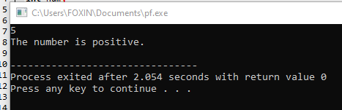

# Write a program to find the largest among three numbers.

**Input:** Three numbers a, b, c

**Process**: Compare the numbers to find the largest using if...else if...else

**Output:** The largest number

#include <stdio.h>

int main()

{

int a, b, c;

scanf("%d %d %d", &a, &b, &c);

if (a >= b && a >= c)

printf("The largest number is: %d\n", a);

else if (b >= a && b >= c)

printf("The largest number is: %d\n", b);

else

printf("The largest number is: %d\n", c);

return 0;

}

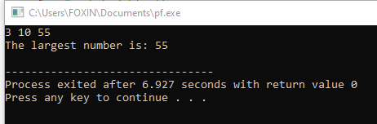

# Write a program to check if a year is a leap year.

**Input:** A year (integer)

**Process:**

A year is a leap year if:

It is divisible by 400, or

It is divisible by 4 and not divisible by 100

**Output:** Whether the year is a leap year or not

#include <stdio.h>

int main()

{

int year;

scanf("%d", &year);

if ((year % 400 == 0) || (year % 4 == 0 && year % 100 != 0))

printf("%d is a leap year.\n", year);

else

printf("%d is not a leap year.\n", year);

return 0;

}

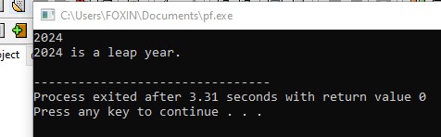

# Write a program to check whether a character is a vowel or consonant.

**Input:** A character **Process:**

* Convert character to lowercase (optional)
* Check if it is one of: 'a', 'e', 'i', 'o', 'u'
* If it’s an alphabet but not a vowel → consonant
* If not an alphabet → invalid input

**Output:** Whether the character is a vowel, consonant, or invalid

#include <stdio.h>

int main() { char ch;

printf("Enter a character: ");

scanf(" %c", &ch);

if ((ch >= 'A' && ch <= 'Z') || (ch >= 'a' && ch <= 'z'))

{

if (ch == 'a' || ch == 'e' || ch == 'i' || ch

== 'o' || ch == 'u' ||

ch == 'A' || ch == 'E' || ch == 'I' ||

ch == 'O' || ch == 'U')

printf("%c is a vowel.\n", ch); else

printf("%c is a consonant.\n",ch);

}

else

{

printf("Invalid input. Please enter an

alphabet.\n");

}

return 0;

}

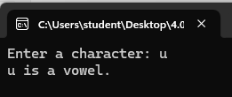

# Write a program to check whether a number is divisible by 5 and 11.

**Input:** A number

**Process**: Check if the number is divisible by both 5 and 11 using the modulus operator %

**Output**: Display whether the number is divisible by both 5 and 11

#include <stdio.h>

int main()

{

int number;

scanf("%d", &number);

if (number % 5 == 0 && number % 11 == 0)

{

printf("%d is divisible by both 5 and 11.\n", number);

}

else

{

printf("%d is NOT divisible by both 5 and 11.\n", number);

}

return 0;

}

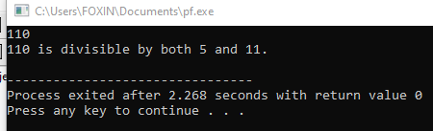

# Write a program to find the absolute value of a number.

**Input**: A number (integer or float)

**Output:** Display the absolute value of the number

#include <stdio.h>

int main()

{

int num, absValue;

scanf("%d", &num);

if (num < 0)

absValue = -num;

else

absValue = num;

printf("The absolute value is: %d\n", absValue);

return 0;

}

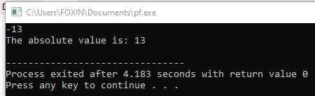

# Write a menu-driven program to perform +, -, *, / operations.

**Input:** Two numbers and choice of operation (+, -, *, /)

**Process**: Perform the selected arithmetic operation **usingOutput**: Display the result of the operation

#include <stdio.h>

int main()

{

float num1, num2, result; int choice;

scanf("%f %f", &num1, &num2);

printf("\nSelect Operation:\n");

printf("1. Addition (+)\n");

printf("2. Subtraction (-)\n");

printf("3. Multiplication (*)\n");

printf("4. Division (/)\n");

printf("Enter your choice (1-4): ");

scanf("%d", &choice);

switch(choice)

{

case 1:

result = num1 + num2;

case 2:

result = num1 - num2;

case 3:

result = num1 * num2;

case 4:

if(num2 != 0)

{

result = num1 / num2; printf("Result = %.2f\n", result);

}

else

{

printf("Error: Division by zero is not allowed.\n");

}

default:

printf("Invalid choice. Please select from 1 to 4.\n");

}

}

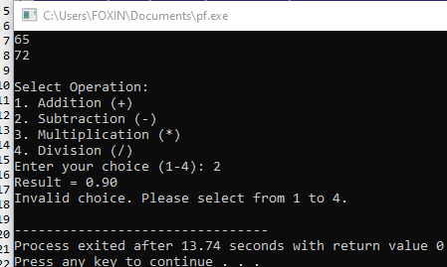

# Write a program to find the number of digits in a number.

**Input:** An integer number

**Output:** Display the count of digits

#include <stdio.h>

int main()

{

int num, count = 0;

scanf("%d", &num); if (num == 0)

count = 1;

else

{

while (num != 0) { num /= 10; count++;

}

}

printf("Number of digits = %d\n", count); return 0;

}

