SAVEETHA SCHOOL OF ENGINEERING
SAVEETHA INSTITUTE OF MEDICAL AND TECHNICAL SCIENCES
COMPUTER SCIENCE AND ENGINEERING PROGRAMME
CSA04 – OPERATING SYSTEMS
Name: Bharath Raj S
Reg no: 192521082

LIST OF PROGRAMS (3,4 &5)
3. Design a CPU scheduling program with C using First Come First Served technique with the
following considerations.
a. All processes are activated at time 0.
b. Assume that no process waits on I/O devices.

Program:

#include <stdio.h>

int main() {
int n, i;
int bt[20], wt[20], tat[20];
float avg_wt = 0, avg_tat = 0;

printf("Enter number of processes: ");
scanf("%d", &n);

for (i = 0; i < n; i++) {
printf("Enter burst time for P%d: ", i + 1);
scanf("%d", &bt[i]);
}

wt[0] = 0;

for (i = 1; i < n; i++)
wt[i] = wt[i - 1] + bt[i - 1];

for (i = 0; i < n; i++) {
tat[i] = wt[i] + bt[i];
avg_wt += wt[i];
avg_tat += tat[i];
}

printf("\nProcess\tBurst\tWaiting\tTurnaround\n");

for (i = 0; i < n; i++)
printf("P%d\t%d\t%d\t%d\n",
i + 1, bt[i], wt[i], tat[i]);

printf("\nAverage Waiting Time = %.2f", avg_wt / n);
printf("\nAverage Turnaround Time = %.2f\n", avg_tat / n);

return 0;
}

Output screenshot:

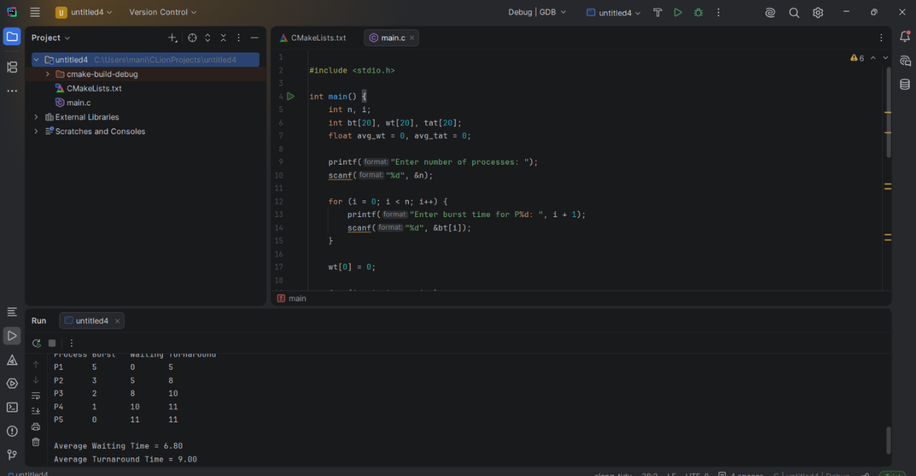

4. Construct a scheduling program with C that selects the waiting process with the smallest execution time to execute next.

Program:

#include <stdio.h>

int main() {
int n, i, j, bt[10], wt[10], tat[10], temp;

printf("Enter number of processes: ");
scanf("%d", &n);

for(i = 0; i < n; i++) {
printf("Enter burst time: ");
scanf("%d", &bt[i]);
}

for(i = 0; i < n-1; i++)
for(j = i+1; j < n; j++)
if(bt[i] > bt[j]) {
temp = bt[i];
bt[i] = bt[j];
bt[j] = temp;
}

wt[0] = 0;

for(i = 1; i < n; i++)
wt[i] = wt[i-1] + bt[i-1];

printf("\nBurst\tWaiting\tTurnaround\n");

for(i = 0; i < n; i++) {
tat[i] = wt[i] + bt[i];
printf("%d\t%d\t%d\n", bt[i], wt[i], tat[i]);
}

return 0;
}

Output screenshot:
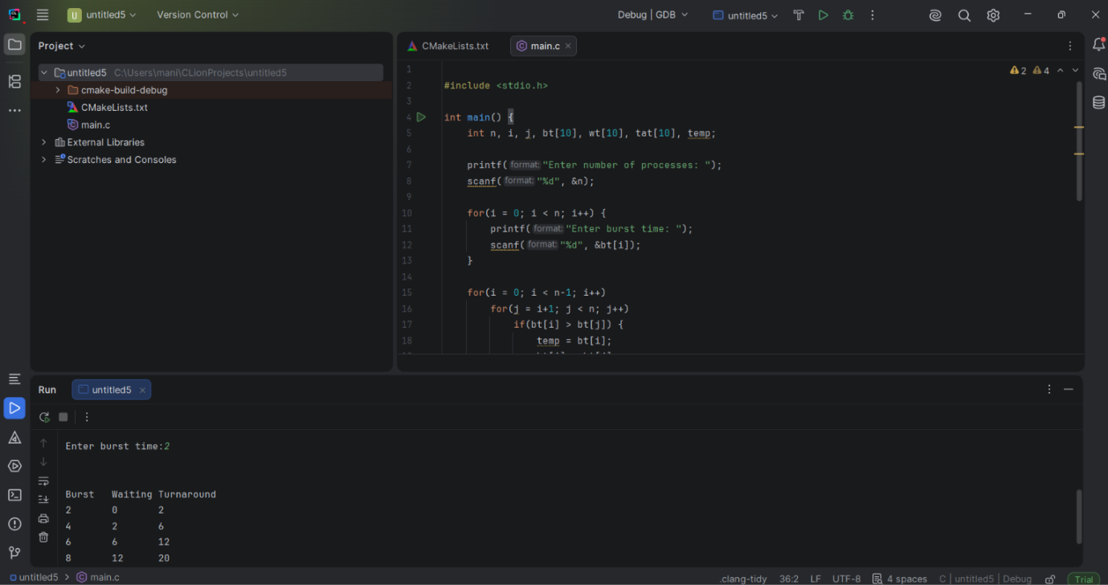

5. Construct a scheduling program with C that selects the waiting process with the highest priority to execute next.

Program:

#include <stdio.h>
int main() {
int n, i, j, temp;
int p[20], bt[20], pr[20];
printf("Enter number of processes: ");
scanf("%d", &n);
for(i = 0; i < n; i++) {
printf("Enter burst time and priority for P%d: ", i + 1);
scanf("%d %d", &bt[i], &pr[i]);
p[i] = i + 1;
}
for(i = 0; i < n - 1; i++) {
for(j = i + 1; j < n; j++) {
if(pr[i] > pr[j]) {
temp = pr[i]; pr[i] = pr[j]; pr[j] = temp;
temp = bt[i]; bt[i] = bt[j]; bt[j] = temp;
temp = p[i]; p[i] = p[j]; p[j] = temp;
}
}
}
printf("\nProcess\tBurst Time\tPriority\n");
for(i = 0; i < n; i++) {
printf("P%d\t%d\t\t%d\n", p[i], bt[i], pr[i]);
}
return 0;
}

Output screenshot:

