SAVEETHA SCHOOL OF ENGINEERING
SAVEETHA INSTITUTE OF MEDICAL AND TECHNICAL SCIENCES
COMPUTER SCIENCE AND ENGINEERING PROGRAMME
CSA04 – OPERATING SYSTEMS
Name: Bharath Raj S
Reg no: 192521082

LIST OF PROGRAMS (6,7 &8)

6. Construct a C program to implement pre-emptive priority scheduling algorithm.

Program:

#include <stdio.h>

int main() {
int n, i, time = 0, completed = 0;
int at[20], bt[20], rt[20], pr[20];
int wt[20] = {0}, tat[20] = {0};
int ct[20] = {0}, highest, finish = 0;
float avgwt = 0, avgtat = 0;

printf("Enter number of processes: ");
scanf("%d", &n);

for(i = 0; i < n; i++) {
printf("Enter arrival time, burst time and priority for P%d: ",
i + 1);
scanf("%d %d %d", &at[i], &bt[i], &pr[i]);
rt[i] = bt[i];
}

while(completed < n) {
highest = -1;

for(i = 0; i < n; i++) {
if(at[i] <= time && rt[i] > 0) {
if(highest == -1 || pr[i] < pr[highest])
highest = i;
}
}

if(highest == -1) {
time++;
continue;
}

rt[highest]--;
time++;

if(rt[highest] == 0) {
completed++;
ct[highest] = time;
tat[highest] = ct[highest] - at[highest];
wt[highest] = tat[highest] - bt[highest];
}
}

printf("\nProcess\tAT\tBT\tPriority\tWT\tTAT\n");

for(i = 0; i < n; i++) {
printf("P%d\t%d\t%d\t%d\t\t%d\t%d\n",
i + 1, at[i], bt[i], pr[i],
wt[i], tat[i]);

avgwt += wt[i];
avgtat += tat[i];
}

printf("\nAverage Waiting Time = %.2f", avgwt / n);
printf("\nAverage Turnaround Time = %.2f\n", avgtat / n);

return 0;
}
Output Screenshot:

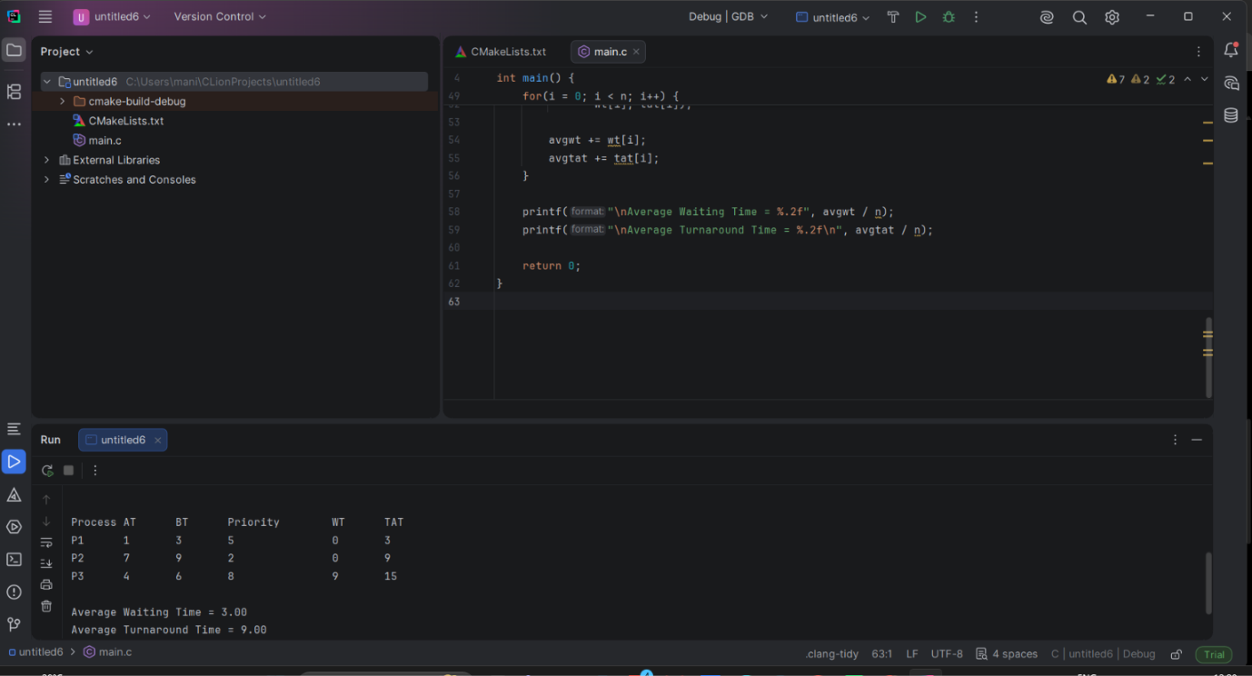

7. Construct a C program to implement non-preemptive SJF algorithm.

Program:

#include <stdio.h>

int main() {
int n, i, j, time = 0, completed = 0;
int at[20], bt[20], wt[20], tat[20], ct[20];
int done[20] = {0}, min, temp;
float avgwt = 0, avgtat = 0;

printf("Enter number of processes: ");
scanf("%d", &n);

for(i = 0; i < n; i++) {
printf("Enter arrival time and burst time for P%d: ", i + 1);
scanf("%d %d", &at[i], &bt[i]);
}

while(completed < n) {
min = -1;

for(i = 0; i < n; i++) {
if(at[i] <= time && !done[i]) {
if(min == -1 || bt[i] < bt[min])
min = i;
}
}

if(min == -1) {
time++;
continue;
}

time += bt[min];
ct[min] = time;
tat[min] = ct[min] - at[min];
wt[min] = tat[min] - bt[min];
done[min] = 1;
completed++;
}

printf("\nProcess\tAT\tBT\tWT\tTAT\n");

for(i = 0; i < n; i++) {
printf("P%d\t%d\t%d\t%d\t%d\n",
i + 1, at[i], bt[i], wt[i], tat[i]);

avgwt += wt[i];
avgtat += tat[i];
}

printf("\nAverage Waiting Time = %.2f", avgwt / n);
printf("\nAverage Turnaround Time = %.2f\n", avgtat / n);

return 0;
}

Output Screenshot:

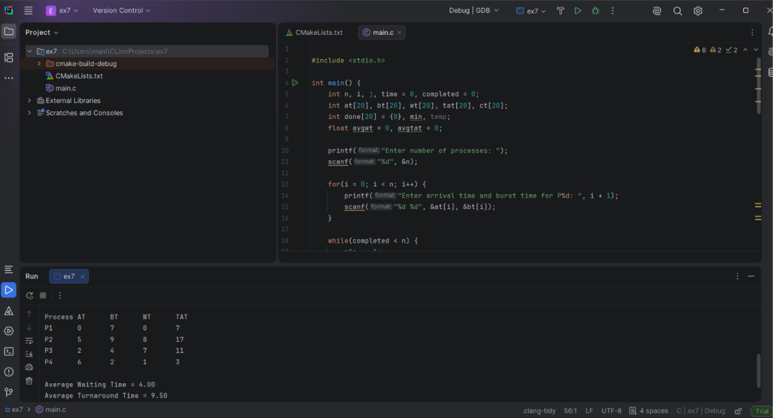

8. Construct a C program to simulate Round Robin scheduling algorithm with C.

Program:

#include <stdio.h>

int main() {
int n, i, tq, time = 0, remain;
int bt[20], rt[20], wt[20], tat[20];
float avgwt = 0, avgtat = 0;

printf("Enter number of processes: ");
scanf("%d", &n);

for(i = 0; i < n; i++) {
printf("Enter burst time for P%d: ", i + 1);
scanf("%d", &bt[i]);
rt[i] = bt[i];
}

printf("Enter time quantum: ");
scanf("%d", &tq);

remain = n;

while(remain > 0) {
for(i = 0; i < n; i++) {
if(rt[i] > 0) {
if(rt[i] > tq) {
time += tq;
rt[i] -= tq;
} else {
time += rt[i];
wt[i] = time - bt[i];
rt[i] = 0;
remain--;
}
}
}
}

printf("\nProcess\tBT\tWT\tTAT\n");

for(i = 0; i < n; i++) {
tat[i] = bt[i] + wt[i];

printf("P%d\t%d\t%d\t%d\n",
i + 1, bt[i], wt[i], tat[i]);

avgwt += wt[i];
avgtat += tat[i];
}

printf("\nAverage Waiting Time = %.2f", avgwt / n);
printf("\nAverage Turnaround Time = %.2f\n", avgtat / n);

return 0;
}
Output Screenshot:

