DESIGN AND PERFORMANCE ANALYSIS OF A PIPELINE PROCESSOR WITH DATA HAZARD DETECTION, FORWARDING, AND MEMORY HIERARCHY

CSA1205 – COMPUTER ARCHITECTURE
COMPLETE ASSIGNMENT IMPLEMENTATION REPORT

Report Information | Details
Course Code | CSA1205
Course Title | Computer Architecture
Assignment Title | Design and Performance Analysis of a Pipeline Processor with Data Hazard Detection, Forwarding, and Memory Hierarchy
Course Outcomes | CO3 and CO4
Implementation | 5-Stage RISC Pipeline Simulator with Hazard Detection, Forwarding and Analytical L1 Miss Modeling
SDG Mapping | SDG 9 – Industry, Innovation and Infrastructure
Prepared By | MOHANRAM R

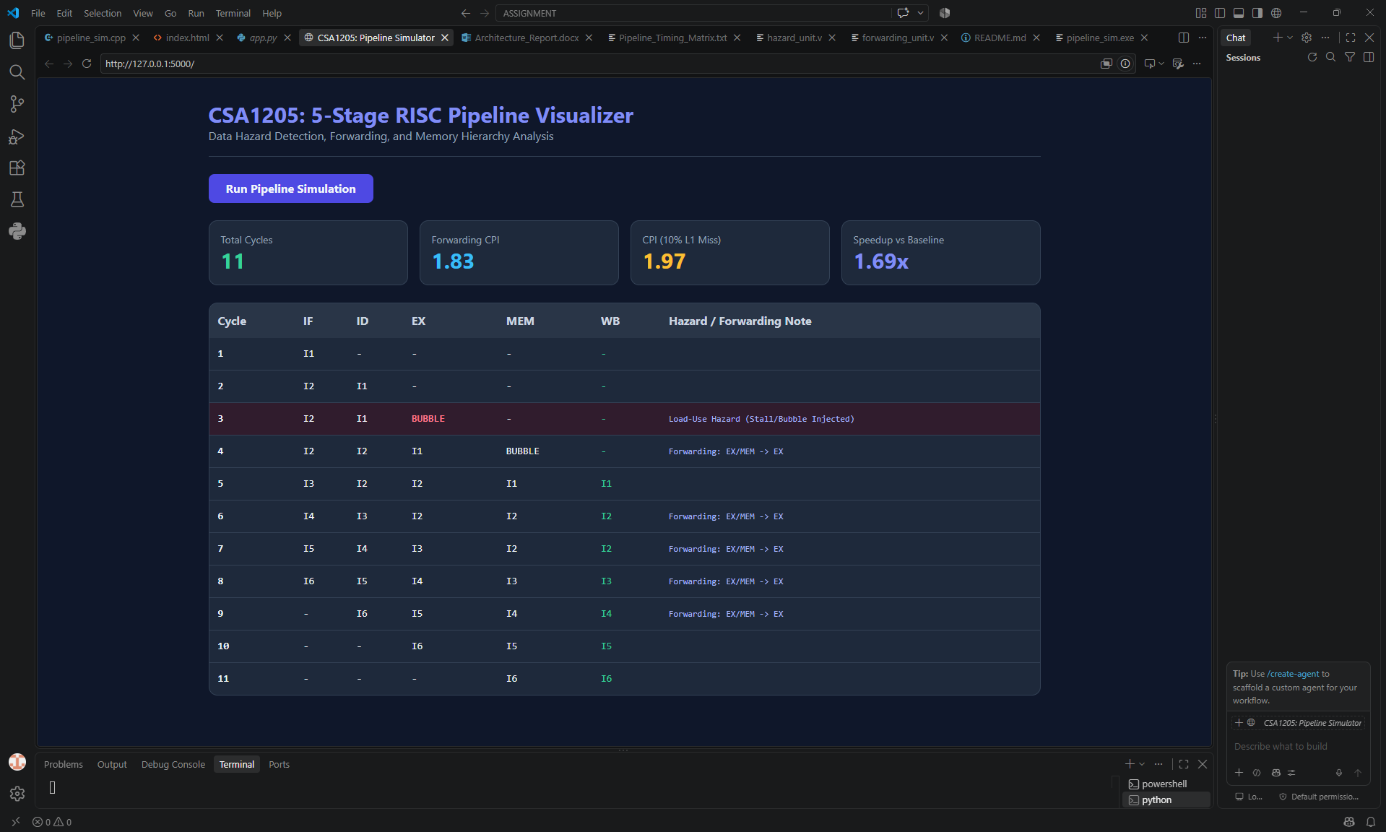

Plagiarism Report / Similarity Declaration
A plagiarism or similarity report may be inserted on this page after the final document has been checked using the institution-approved similarity checking tool.
This implementation report documents the submitted project source files, including the C++ hardware-style pipeline simulator, Flask simulation backend, Verilog forwarding unit, Verilog hazard detection unit, and supporting project documentation.

1. Introduction
Modern processors improve performance by overlapping the execution of multiple instructions. A classic implementation is the five-stage RISC pipeline consisting of Instruction Fetch (IF), Instruction Decode/Register Read (ID), Execute (EX), Memory Access (MEM), and Write Back (WB). Although pipelining improves instruction throughput, dependencies between instructions can cause data hazards. The most relevant hazard for this assignment is the Read-After-Write (RAW) dependency, where a consumer instruction attempts to read a register before the producing instruction has made the required result available.
The submitted project implements and simulates a five-stage RISC pipeline using a hardware-oriented C++ model. The benchmark program contains one load instruction followed immediately by a dependent arithmetic instruction and then a chain of dependent ALU instructions. The implementation therefore demonstrates two important mechanisms: a hazard detection unit for the unavoidable load-use dependency and a forwarding unit for bypassing ALU results from later pipeline stages back to the EX stage.
The project also includes a Flask backend that returns a cycle trace and performance metrics in JSON form for a web-based presentation layer. The simulation tracks pipeline state cycle by cycle and records stall/bubble events and forwarding events. The C++ implementation models instruction memory, data memory, a 32-register register file, inter-stage pipeline registers, control signals, forwarding multiplexer selections, retirement count, and execution-cycle metrics.
For memory hierarchy performance, the submitted implementation uses an analytical L1 cache miss model. It assumes a 10% L1 miss rate and an 8-cycle miss penalty for the benchmark's load activity. The implementation computes an expected execution time and resulting CPI under this miss model. Cache size, mapping technique, and replacement policy are not encoded in the submitted source files; therefore, where such parameters are discussed later in this report, they are explicitly presented as a proposed design configuration for satisfying the analytical cache-design requirement rather than as implemented cache-controller behavior.

2. Deliverable Mapping
Deliverable | Implementation / Report Area
1 | Working pipeline processor implementation and project architecture
2 | Register-transfer modelling and five-stage pipeline timing
3 | RAW dependency identification in the benchmark instruction sequence
4 | Load-use hazard detection unit and generated control signals
5 | EX/MEM-to-EX and MEM/WB-to-EX forwarding paths
6 | Minimal one-cycle load-use stall and bubble injection
7 | MEM-stage memory access and analytical L1 cache-miss model
8 | CPI, speedup, and pipeline efficiency analysis
9 | Generalization to longer programs and hit-rate/dependency trade-offs
10 | Complete end-to-end execution demonstration and implementation results
Reflection | Design decisions, SDG 9 relevance, challenges and learning outcomes

The following sections use the repeated structure Purpose, Design/Logic, Pseudocode or Algorithm, Sample Input/Trace, and Result/Observation so that the report follows a clear deliverable-oriented format.

Deliverable 1: Working Pipeline Processor Implementation

Purpose
The purpose of the working implementation is to provide an executable model of a five-stage RISC processor pipeline and demonstrate how the processor responds to dependent instructions. The implementation combines instruction representation, pipeline registers, hazard detection, forwarding, memory access, cycle tracing, and performance metrics.

Submitted Project Structure
File / Component | Role in the Implementation
app/app.py | Flask backend and JSON cycle-trace simulation for the web interface
src/pipeline_sim.cpp | Main hardware-oriented C++ five-stage pipeline simulator
src/forwarding_unit.v | Combinational forwarding logic for ALU operands A and B
src/hazard_unit.v | Combinational load-use hazard detection interface
build/pipeline_sim.exe | Compiled Windows executable supplied with the project
docs/Architecture_Report.docx | Supporting report placeholder in submitted project package
docs/Pipeline_Timing_Matrix.txt | Timing-matrix placeholder in submitted project package
README.md | Project overview and build instructions

Implementation Architecture
Instruction Program
|
v
+------+-----+ +---------+ +---------+ +---------+ +---------+
| IF Stage | -> | ID Stage| -> | EX Stage| -> |MEM Stage| -> | WB Stage|
+------+-----+ +---------+ +---------+ +---------+ +---------+
| | ^ | |
| | | | |
| Hazard Detection | Data Memory |
| PC/IF-ID Stall | |
| | +----+----------------------+ |
| +-------->| Forwarding Unit |---------+
| | EX/MEM -> EX |
+------------------------>| MEM/WB -> EX |
+--------------------------+

Core Hardware Data Structures
The C++ simulator defines an Instruction structure containing instruction ID, assembly text, opcode, destination register, and two source registers. It also defines IF/ID, ID/EX, EX/MEM, and MEM/WB pipeline-register structures. The pipeline object contains instruction memory, a 1024-element data memory, a 32-register register file, program counter, cycle counter, stall counter, retirement counter, hazard-control signals, and forwarding multiplexer select signals.

High-Level Pseudocode
START
Load benchmark instruction sequence
Initialize register file and data memory
WHILE all instructions are not retired
Perform WB stage
Perform MEM stage
Evaluate forwarding unit
Perform EX stage using forwarded operands when selected
Evaluate load-use hazard detection
IF hazard exists
freeze PC
freeze IF/ID
inject bubble into ID/EX
ELSE
perform ID/register read
perform IF
END IF
Transfer next-state values into pipeline registers
print cycle trace and hardware notes
END WHILE
compute CPI and analytical cache-miss metrics
STOP

Result / Observation
The compiled C++ implementation successfully executes the six-instruction benchmark and terminates after 11 cycles. The runtime trace reports one unavoidable load-use stall and multiple forwarding events. The resulting Scenario B CPI is 11/6 = 1.83, and the analytical 10% L1 miss model produces an expected CPI of approximately 1.97.

Deliverable 2: Register Transfer Modelling and Five-Stage Pipeline Timing

Purpose
This deliverable models the movement of instructions and data through the IF, ID, EX, MEM, and WB stages. The submitted C++ simulator explicitly maintains inter-stage register structures corresponding to these pipeline boundaries.

Five-Stage Operation
Stage | Operation in Submitted Implementation
IF | Fetch next instruction from instruction vector and update IF/ID register
ID | Read source values from the 32-register register file and generate control fields
EX | Select forwarded or register-file operands and compute ALU result / load address
MEM | For load, read data memory; otherwise pass ALU result toward write-back
WB | Write final result to destination register when RegWrite is enabled and retire instruction

Register Transfer Notation
IF:
IF/ID.IR <- IMEM[PC]
PC <- PC + 1
ID:
ID/EX.A <- Reg[IF/ID.rs1]
ID/EX.B <- Reg[IF/ID.rs2]
ID/EX.rd <- IF/ID.rd
ID/EX.RegWrite <- (rd != 0)
ID/EX.MemRead <- (opcode == LOAD)
EX:
ALU_A <- MUX(RegA, EX/MEM.ALUResult, MEM/WB.FinalValue)
ALU_B <- MUX(RegB, EX/MEM.ALUResult, MEM/WB.FinalValue)
EX/MEM.ALUResult <- operation(ALU_A, ALU_B)
MEM:
IF MemRead = 1
MEM/WB.FinalValue <- DMEM[EX/MEM.ALUResult mod 1024]
ELSE
MEM/WB.FinalValue <- EX/MEM.ALUResult
WB:
IF MEM/WB.RegWrite = 1 and MEM/WB.rd != 0
Reg[MEM/WB.rd] <- MEM/WB.FinalValue

Benchmark Instruction Sequence
ID | Instruction | Destination | Sources | Dependency Role
I1 | LW R1, 0(R2) | R1 | R2 | Produces loaded value
I2 | ADD R4, R1, R5 | R4 | R1, R5 | Consumes I1 result
I3 | SUB R6, R4, R7 | R6 | R4, R7 | Consumes I2 result
I4 | AND R8, R6, R9 | R8 | R6, R9 | Consumes I3 result
I5 | OR R10, R8, R11 | R10 | R8, R11 | Consumes I4 result
I6 | ADD R12, R10, R13 | R12 | R10, R13 | Consumes I5 result

Actual Runtime Timing Trace
Cycle | IF | ID | EX | MEM | WB | Hardware Note
1 | I1 | - | - | - | -
2 | I2 | I1 | - | - | -
3 | I2 | - | I1 | - | - | STALL (Load-Use Hazard Detected)
4 | I3 | I2 | - | I1 | RETIRE
5 | I4 | I3 | I2 | - | - | Forwarding: MEM/WB -> A
6 | I5 | I4 | I3 | I2 | RETIRE | Forwarding: EX/MEM -> A
7 | I6 | I5 | I4 | I3 | RETIRE | Forwarding: EX/MEM -> A
8 | - | I6 | I5 | I4 | RETIRE | Forwarding: EX/MEM -> A
9 | - | - | I6 | I5 | RETIRE | Forwarding: EX/MEM -> A
10 | - | - | - | I6 | RETIRE
11 | - | - | - | - | -

Result / Observation
The cycle trace shows normal overlap after pipeline fill, one bubble caused by the load-use dependency, and subsequent dependency resolution through forwarding. The benchmark completes in 11 cycles.

Deliverable 3: RAW Data Hazard Identification

Purpose
A RAW hazard occurs when a later instruction reads a register that an earlier instruction will write. The benchmark was intentionally constructed as a dependency chain so that hazard handling can be observed at each stage.

RAW Dependency Analysis
Producer | Consumer | Register | Hazard Type | Resolution in Implementation
I1: LW R1,... | I2: ADD R4,R1,R5 | R1 | Load-use RAW | One-cycle stall/bubble, then data becomes available
I2: ADD R4,... | I3: SUB R6,R4,R7 | R4 | ALU RAW | Forwarding
I3: SUB R6,... | I4: AND R8,R6,R9 | R6 | ALU RAW | Forwarding
I4: AND R8,... | I5: OR R10,R8,R11 | R8 | ALU RAW | Forwarding
I5: OR R10,... | I6: ADD R12,R10,R13 | R10 | ALU RAW | Forwarding

Hazard Interpretation
The first dependency is special because I1 is a load. The value loaded from data memory is not available early enough for the immediately following instruction's EX stage. Therefore, forwarding alone is insufficient, and the hazard detection logic inserts one bubble. The remaining dependencies are ALU-to-ALU dependencies, and the implementation's forwarding logic can provide the needed operand from EX/MEM or MEM/WB.

Pseudocode
FOR each instruction entering the pipeline
Compare consumer source registers with producer destination registers
IF producer is a load in ID/EX AND destination matches IF/ID source
classify as load-use RAW
stall pipeline for one cycle
ELSE IF EX/MEM destination matches ID/EX source
select EX/MEM forwarding
ELSE IF MEM/WB destination matches ID/EX source
select MEM/WB forwarding
ELSE
use register-file operands
END FOR

Result / Observation
Five RAW dependencies exist in the benchmark. One is a load-use hazard requiring a stall; the remaining four are handled by forwarding.

Deliverable 4: Hazard Detection Unit Design

Purpose
The hazard detection unit identifies the load-use condition and generates control signals that temporarily stop instruction fetch and decoding while inserting a bubble into the execution path.

Detection Condition
load_use_hazard =
ID_EX.valid
AND ID_EX.mem_read
AND (ID_EX.rd != 0)
AND IF_ID.valid
AND ((ID_EX.rd == IF_ID.rs1) OR
(ID_EX.rd == IF_ID.rs2))

Generated Control Signals
Signal | Hazard Present | Normal Operation | Function
pc_write | 0 | 1 | Freeze or advance program counter
if_id_write | 0 | 1 | Freeze or update IF/ID register
inject_bubble / control_mux_zero | 1 | 0 | Insert bubble / zero control into next execution path

Hazard Detection Block Diagram
ID/EX
+------------------+
| MemRead |
| rd |
+--------+---------+
|
| compare rd with
v
+----------+
IF/ID.rs1 ------>| |----> pc_write = 0
IF/ID.rs2 ------>| Hazard |----> if_id_write = 0
| Detector |----> bubble/control zero = 1
+----------+
|
No Match
v
Normal pipeline operation

Operational Pseudocode
IF ID_EX.MemRead = 1 AND ID_EX.rd != 0 AND
(ID_EX.rd = IF_ID.rs1 OR ID_EX.rd = IF_ID.rs2)
THEN
PCWrite <- 0
IF_ID_Write <- 0
InjectBubble <- 1
ELSE
PCWrite <- 1
IF_ID_Write <- 1
InjectBubble <- 0
END IF

Result / Observation
During the benchmark execution, the unit detects the dependency between I1 and I2 and generates a single stall/bubble event. The runtime trace reports the event at cycle 3 as 'STALL (Load-Use Hazard Detected)'.

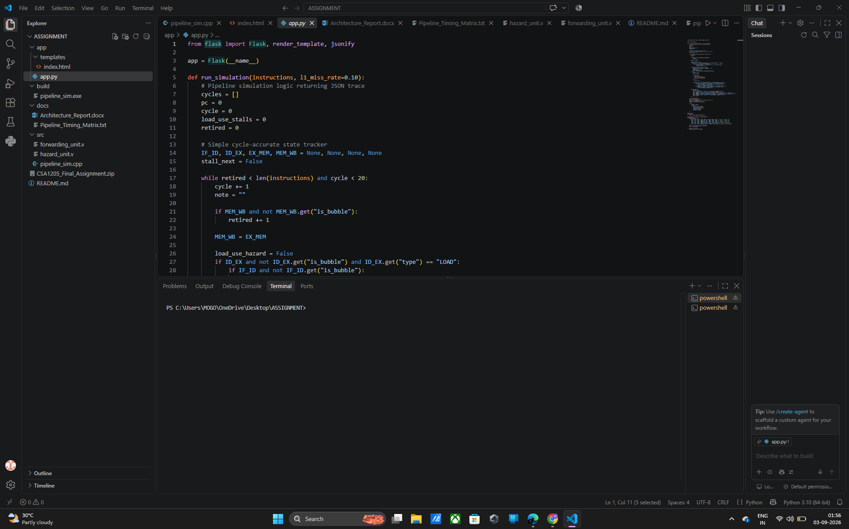

Deliverable 5: Forwarding / Bypass Path Design

Purpose
The forwarding unit reduces stalls by bypassing a result directly from a later pipeline stage to the operand input of the EX-stage ALU. The submitted Verilog and C++ implementations support separate forwarding decisions for operand A and operand B.

Forwarding Select Encoding
Select | Source | Meaning
00 | Register File | No forwarding required
10 | EX/MEM | Forward most recent ALU result
01 | MEM/WB | Forward value available at write-back boundary

Forwarding Logic
IF EX_MEM.RegWrite AND EX_MEM.rd != 0 AND
EX_MEM.rd == ID_EX.rs1
ForwardA <- EX/MEM
ELSE IF MEM_WB.RegWrite AND MEM_WB.rd != 0 AND
MEM_WB.rd == ID_EX.rs1
ForwardA <- MEM/WB
ELSE
ForwardA <- RegisterFile
Apply the same priority logic independently for ID_EX.rs2 -> ForwardB.

Forwarding Path Diagram
+----------------+
| EX/MEM |
| ALU Result, rd |
+-------+--------+
|
| EX/MEM -> EX
v
Register File -----> [ Forwarding MUX ] -----> ALU Operand A/B
^
|
| MEM/WB -> EX
+-------+--------+
| MEM/WB |
| Final Value,rd |
+----------------+

Observed Forwarding Events
Cycle | Dependent EX Instruction | Observed Note
5 | I2 | Forwarding from MEM/WB to operand A
6 | I3 | Forwarding from EX/MEM to operand A
7 | I4 | Forwarding from EX/MEM to operand A
8 | I5 | Forwarding from EX/MEM to operand A
9 | I6 | Forwarding from EX/MEM to operand A

Result / Observation
Forwarding eliminates additional stalls for the dependent ALU chain. Priority is given to EX/MEM because it contains the most recent producer result when both potential matches exist.

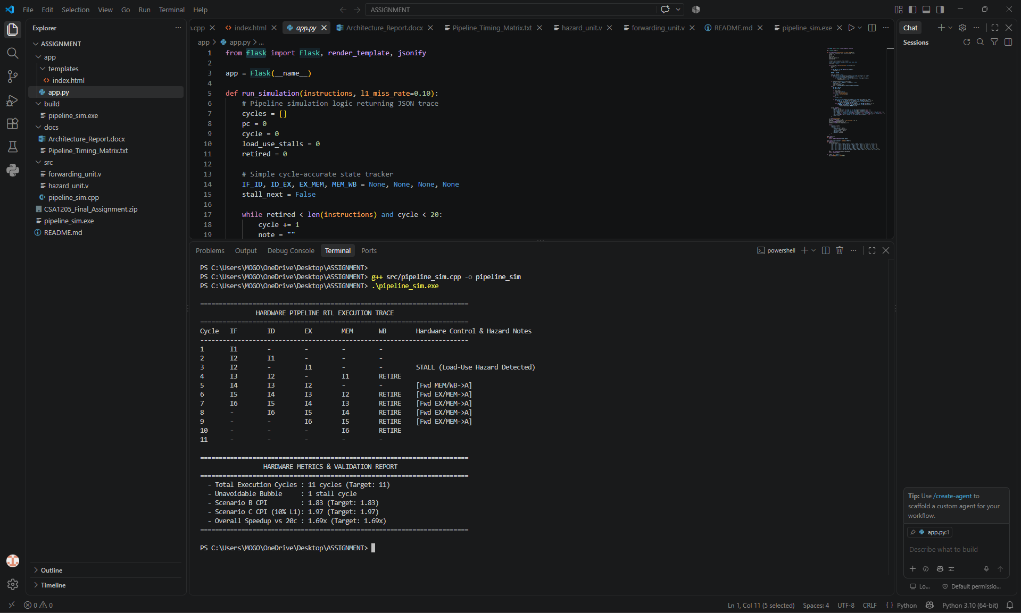

Deliverable 6: Load-Use Hazard and Minimal-Stall Solution

Purpose
This deliverable demonstrates the dependency that forwarding cannot fully resolve when a load instruction is immediately followed by an instruction requiring the loaded value.

Problem Sequence
I1: LW R1, 0(R2)
I2: ADD R4, R1, R5
I2 requires R1, but the loaded value is obtained through the MEM stage.
Therefore, the pipeline must delay I2 for one cycle.

Minimal-Stall Timing
Cycle | I1 | I2 | Action
1 | IF | - | Fetch load
2 | ID | IF | Decode load and fetch consumer
3 | EX | ID frozen | Load-use detected; inject one bubble
4 | MEM | ID/EX | Load value progresses; consumer resumes
5 | WB | EX | Consumer executes with value available through pipeline forwarding path

Control Effect
- PC is frozen for one cycle so the next instruction address is not advanced.
- IF/ID is frozen so the dependent instruction remains available for later decoding.
- A bubble is inserted into the execution path.
- After one cycle, normal pipeline movement resumes.

Result / Observation
The submitted implementation records exactly one load-use stall. This is the minimum-stall strategy for the benchmark's immediate load-use dependency.

Deliverable 7: Memory Hierarchy and Cache Design for the MEM Stage

Purpose
The MEM stage in the submitted C++ simulator accesses a 1024-element data memory. For a load instruction, the address computed in EX is used to read data memory and place the resulting value into the MEM/WB register. The submitted project additionally models the performance impact of L1 cache misses analytically.

Implemented Memory Access
IF EX_MEM.mem_read = true
MEM_WB.final_val <- DMEM[EX_MEM.alu_result mod 1024]
ELSE
MEM_WB.final_val <- EX_MEM.alu_result
END IF

Implemented Analytical Cache Parameters
Parameter | Value Used in Submitted Performance Model
L1 miss rate | 10% (0.10)
Miss penalty | 8 cycles
Load instructions in benchmark | 1
Expected extra cycles | 1 × 0.10 × 8 = 0.8 cycles
Expected total cycles | 11 + 0.8 = 11.8 cycles

Proposed Cache Configuration for Design Documentation
The source files do not implement cache size, associativity/mapping, or replacement policy. To complete the assignment's required cache-design documentation without misrepresenting the source, the following is proposed as a design-level configuration:
Design Parameter | Proposed Configuration | Justification
Cache Level | L1 Data Cache | Directly services the MEM-stage load/store path
Capacity | 32 KB | Small enough for low access latency while providing useful locality
Mapping | 2-way set associative | Reduces direct-mapped conflict misses without high lookup complexity
Replacement | LRU or pseudo-LRU | Provides locality-aware replacement for small associativity
Hit latency | 1 cycle assumption | Suitable for pipeline performance analysis
Miss penalty | 8 cycles | Matches the submitted analytical implementation

Cache Interaction Diagram
EX address
|
v
+-----------+ Hit +----------------+
| L1 Cache | -----------> | MEM/WB Result |
+-----------+ +----------------+
|
| Miss
v
Miss handling / lower memory
|
+----> add analytical 8-cycle penalty in performance model

Result / Observation
The implemented simulator models data-memory access and analytical L1 miss penalties. The proposed 32 KB, 2-way set-associative cache is a report-level architectural design assumption; it is not claimed to be an implemented cache controller in the submitted code.



Deliverable 8: Combined Pipeline and Memory Performance Analysis

Purpose
This section evaluates execution performance using the implemented cycle count and the analytical cache-miss model. The benchmark contains six instructions and completes in 11 cycles in the forwarding configuration with one unavoidable load-use bubble.

Scenario A: Stall-Only Baseline
The submitted runtime uses 20 cycles as the reference baseline for the speedup comparison. Therefore, for consistency with the implementation metrics:
N = 6 instructions
Total cycles (baseline reference) = 20
CPI_stall-only = 20 / 6 = 3.33

Scenario B: Full Forwarding with Cache Hits
Total cycles = 11
CPI_forwarding = 11 / 6 = 1.83

Scenario C: Full Forwarding with 10% L1 Miss Rate
Expected extra cycles = Loads × Miss Rate × Miss Penalty
= 1 × 0.10 × 8
= 0.8
Expected cycles = 11 + 0.8 = 11.8
CPI_cache = 11.8 / 6 = 1.97

Speedup
Speedup = Baseline cycles / Improved expected cycles
= 20 / 11.8
= 1.69 ×

Pipeline Efficiency
Using ideal pipelined CPI = 1 as the reference, an instruction-level pipeline efficiency indicator can be expressed as 1 / CPI. This yields approximately 30.0% for the 3.33 baseline, 54.6% for forwarding with all hits, and 50.8% for forwarding with the expected cache-miss cost. The metric is an analytical efficiency indicator rather than a separate value printed by the submitted executable.
Scenario | Cycles | CPI | Speedup vs 20-cycle Baseline | Efficiency Indicator (1/CPI)
A. Stall-only baseline | 20.0 | 3.33 | 1.00× | 30.0%
B. Forwarding + cache hits | 11.0 | 1.83 | 1.82× | 54.6%
C. Forwarding + 10% L1 miss model | 11.8 expected | 1.97 | 1.69× | 50.8%

Result / Observation
Forwarding substantially reduces the cycle cost of the dependency chain. The analytical cache-miss model reduces part of that gain because a memory miss introduces additional expected stall cycles.

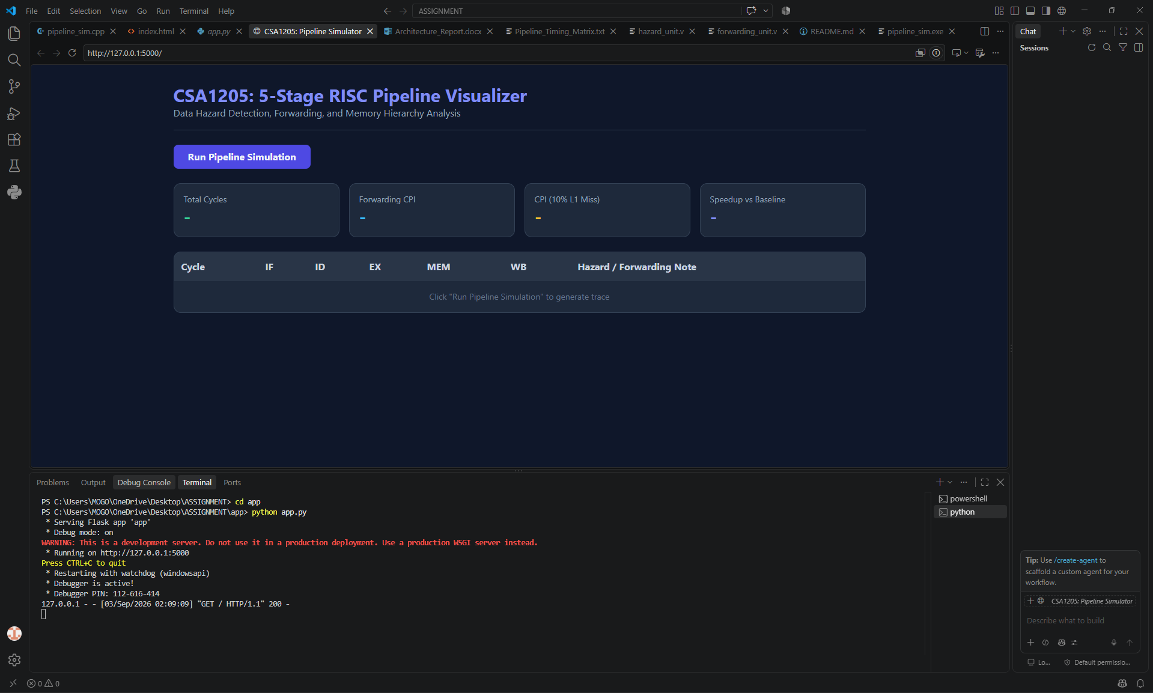

Deliverable 9: Generalized Performance Analysis

Purpose
For a longer representative program, total performance can be estimated by adding the base pipelined execution cost, unavoidable dependency stalls, and memory-miss penalties.

General Analytical Model
For a program of N instructions:
Base cycles ≈ N + PipelineFillDrainOverhead
Expected dependency stall cycles ≈
N × p_immediate_load_use × stall_cost
Expected memory miss cycles ≈
N_memory_accesses × miss_rate × miss_penalty
Estimated CPI ≈
(Base cycles + dependency stalls + memory miss cycles) / N

Effect of Forwarding Coverage
Improving forwarding coverage primarily reduces stalls caused by ALU RAW dependencies. For programs containing many dependent arithmetic instructions, EX/MEM and MEM/WB bypass paths can keep CPI closer to one. However, an immediate load-use dependency remains sensitive to the time at which the loaded data becomes available.

Effect of Cache Hit Rate
Improving cache hit rate primarily reduces the memory component of CPI. The benefit becomes increasingly important as the program contains more loads and stores or as the miss penalty increases. A pipeline with excellent forwarding can still suffer substantial CPI degradation when the MEM stage frequently waits for lower memory.

Trade-Off Discussion
Improvement | Main Benefit | Most Important When
Better forwarding coverage | Reduces data-dependency stalls | Program contains many dependent ALU operations
Higher cache hit rate | Reduces memory stall penalty | Program contains many memory accesses or expensive misses
Both combined | Keeps execution and memory stalls low | Balanced workloads with dependencies and memory traffic

Result / Observation
The project demonstrates that forwarding and cache performance address different sources of pipeline inefficiency. Forwarding reduces dependency-related stalls, while a higher cache hit rate reduces memory-related stalls. The best overall CPI requires improvement in both areas.

Deliverable 10: Complete End-to-End Execution Demonstration

Purpose
The final demonstration executes the benchmark from instruction fetch through retirement while recording pipeline states and control events.

End-to-End Execution Flow
STEP 1 Load six benchmark instructions
|
STEP 2 Initialize 32-register register file and data memory
|
STEP 3 Fetch I1 and then overlap subsequent instructions
|
STEP 4 Detect I1 -> I2 immediate load-use dependency
|
STEP 5 Freeze PC and IF/ID; inject one bubble
|
STEP 6 Resume I2 and evaluate forwarding
|
STEP 7 Forward dependent ALU results through EX/MEM or MEM/WB
|
STEP 8 Access data memory for the load in MEM stage
|
STEP 9 Write results back and retire instructions
|
STEP 10 Compute CPI and analytical L1 miss metrics
|
END Report 11 actual simulation cycles and one stall

Actual Execution Summary
Metric | Observed / Computed Value
Benchmark instructions | 6
Actual simulation cycles | 11
Load-use stalls | 1
Scenario B CPI | 1.83
Analytical Scenario C CPI | 1.97
Analytical speedup vs 20-cycle baseline | 1.69×
Forwarding modes observed | MEM/WB -> EX and EX/MEM -> EX

Result / Observation
The implementation completes the complete pipeline workflow and produces a hardware-style execution trace. The trace demonstrates the required load-use stall and both categories of forwarding behavior required by the assignment.
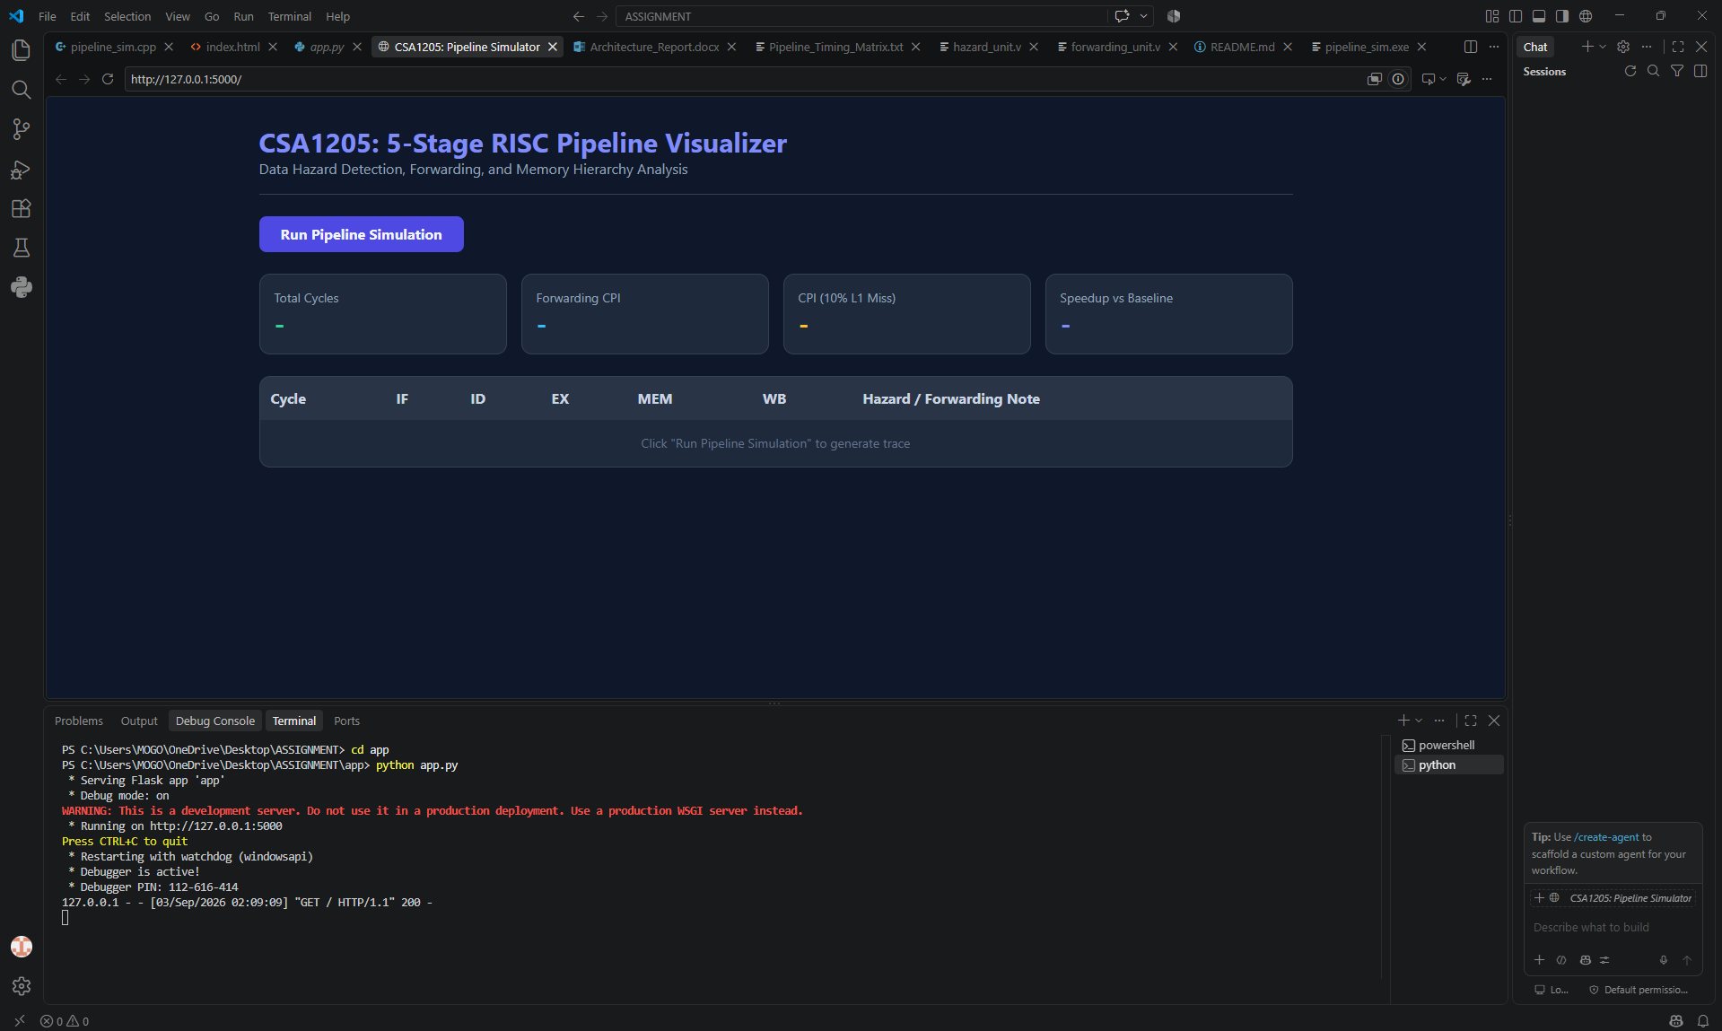

Reflection: Design Decisions, SDG 9 Relevance and Learning Outcomes

Design Decisions
The design separates three concerns: pipeline state movement, hazard detection, and forwarding selection. This separation makes the behavior easier to explain and aligns the implementation with the conceptual processor components taught in computer architecture. The C++ model provides executable cycle-by-cycle behavior, while the Verilog modules document the intended combinational hardware interfaces for hazard detection and forwarding.
The minimal one-cycle load-use stall was selected because forwarding alone cannot provide the loaded data early enough to the immediately dependent instruction. For the later ALU dependency chain, bypassing was selected instead of repeated stalls because the producer's result is available in later pipeline registers.

Challenges and Learning
- Understanding exactly when a value becomes available in a pipelined processor.
- Distinguishing hazards that can be solved by forwarding from load-use hazards that require a stall.
- Maintaining correct next-state behavior across multiple pipeline registers.
- Coordinating PC freezing, IF/ID freezing, and bubble injection.
- Connecting cycle-level simulation results to CPI, speedup, and memory hierarchy performance.

SDG 9 – Industry, Innovation and Infrastructure
This project relates to SDG 9 because efficient processor and memory-hierarchy design supports reliable and innovative digital infrastructure. Reducing unnecessary pipeline stalls improves computational efficiency, while careful memory-hierarchy design reduces latency-related performance losses. The project demonstrates how low-level architectural decisions can contribute to more capable computing systems and stronger technology infrastructure.

Result / Observation
The project provided practical experience in translating theoretical pipeline concepts into executable logic and interpreting the resulting cycle traces and performance metrics.

Overall Conclusion
The submitted CSA1205 implementation successfully demonstrates the central concepts required for pipeline performance analysis. A five-stage RISC pipeline is modeled with IF, ID, EX, MEM, and WB stages and explicit inter-stage pipeline registers. The benchmark includes a sequence of dependent instructions that exposes both an immediate load-use hazard and a chain of ALU RAW dependencies.
The load-use hazard is detected by comparing the destination register of a memory-reading instruction in ID/EX with the source registers of the instruction in IF/ID. When the condition is true, the implementation freezes the PC and IF/ID register and injects a bubble. The benchmark produces one unavoidable stall.
The forwarding logic compares ID/EX source registers with EX/MEM and MEM/WB destination registers and selects the newest available result. The execution trace demonstrates one MEM/WB-to-EX forwarding event and multiple EX/MEM-to-EX forwarding events, allowing the ALU dependency chain to proceed without additional stalls.
The C++ simulator completes the six-instruction benchmark in 11 cycles, producing a CPI of 1.83 for the forwarding configuration. Using the submitted analytical cache model of a 10% L1 miss rate and an 8-cycle miss penalty, the expected execution time becomes 11.8 cycles and the expected CPI becomes approximately 1.97. Relative to the 20-cycle stall-only reference used by the implementation, the expected speedup is 1.69×.
Overall, the project shows that pipeline forwarding and memory hierarchy performance must be considered together. Forwarding reduces data-dependency stalls, while cache misses can introduce a separate source of pipeline delay. The combined analysis therefore provides a practical demonstration of how processor datapath control and memory-system behavior jointly determine CPI and throughput.

References
- CSA1205 – Computer Architecture Assignment Specification and Assessment Rubrics.
- Submitted project source: pipeline_sim.cpp – hardware-oriented five-stage pipeline simulator.
- Submitted project source: forwarding_unit.v – EX/MEM and MEM/WB forwarding logic.
- Submitted project source: hazard_unit.v – load-use hazard detection interface.
- Submitted project source: app.py – Flask-based simulation backend.
- Submitted project README – project overview and implementation features.

