SIMATS ENGINEERING
Department of Computer Science & Engineering
ASSESSMENT TOOL-1 EXPERIMENTS

Course Code: | CSA1205 | Course Title: | Computer Architecture
CO Assessed: | CO3 | Assessment: | ASSESSMENT TOOL 1EXPERIMENTS
Weightage: | 40% | Total Marks: | 25
CO3Statement: | Design processor organization by constructing pipelined datapath structures, identifying hazard types (data, control, structural), and comparing superscalar techniques such as out-of-order execution, speculative execution, and simultaneous multithreading (SMT). (BL6)
Student Name: | R.MOHANRAM | Reg.No.: | 192521117
Department: | B TECH IT | Date: | 10/08/2026

ANNEXURE A

- Design and simulate a system that performs register transfer operations along with basic arithmetic and logic operations such as addition, subtraction, AND, and OR. Use multiple registers to demonstrate how data is transferred between them during execution, and analyze the sequence of operations and the role of the ALU in processing data.
- Create a model of a computer system using single-bus and multi-bus organization, and perform data transfer operations between registers, memory, and I/O. Compare the time taken and efficiency of both approaches, and analyze how multiple bus structures improve parallel data transfer and reduce bottlenecks.
- Simulate a 5-stage instruction pipeline (Fetch, Decode, Execute, Memory, Write-back) and execute a set of instructions. Measure the performance in terms of speedup and throughput, and compare it with a non-pipelined system to evaluate the effectiveness of pipelining.
- Develop a pipeline execution scenario where data hazards, control hazards, and structural hazards occur. Observe their impact on instruction execution, and implement techniques such as stalling, data forwarding, and branch prediction to resolve these hazards and improve performance.
- Analyze a processor supporting superscalar execution, including out-of-order and speculative execution, and extend the study to include hyper-threading and simultaneous multithreading (SMT). Evaluate how multiple instructions are executed in parallel and compare the performance improvements in terms of instruction throughput and resource utilization.

Question 1: Register Transfer Operations and ALU Functionality Analysis

1.1 System Architecture and Register Set Definition

To simulate register transfer microoperations and Arithmetic Logic Unit (ALU) processing, an 8-bit synchronous CPU datapath model is designed using hardware simulation tools (e.g., Logisim Evolution / Verilog HDL). The system core integrates four general-purpose registers (𝑹𝟎, 𝑹𝟏, 𝑹𝟐, 𝑹𝟑), an Accumulator (𝑨𝑪), an Instruction Register (𝑰𝑹), and a Status/Flag Register (𝑭𝑳𝑨𝑮𝑺). System timing is synchronized via a single master clock signal 𝑪𝑳𝑲.

Component Specifications:
- Registers 𝑹𝟎, 𝑹𝟏, 𝑹𝟐, 𝑹𝟑 (8-bit): General-purpose registers configured with parallel load inputs (𝑳𝑫) and tri-state bus enable drivers (𝑬𝑵).
- Accumulator (𝑨𝑪, 8-bit): Dedicated hardware register connected directly to the output of the ALU.
- Flag Register (𝑭𝑳𝑨𝑮𝑺, 4-bit): Latching register storing Zero (𝒁), Carry (𝑪), Sign (𝑺), and Overflow (𝑽) flags.
- Internal Bus Architecture: Dual 8-bit internal buses (𝑩𝒖𝒔_{𝑨} and 𝑩𝒖𝒔_{𝑩}) for simultaneous operand delivery.
- Control Unit (CU): Hardwired finite state machine generating control signals at each clock pulse cycle 𝑻_{𝒏}.

  - Register Transfer Logic and Microoperations
The hardware executes arithmetic and logical transformations by placing source register contents onto 𝑩𝒖𝒔_{𝑨} and 𝑩𝒖𝒔_{𝑩}, configuring the ALU control lines (𝑺_{𝟐}, 𝑺_{𝟏}, 𝑺_{𝟎}), and enabling the destination register load gate on the rising edge of 𝑪𝑳𝑲.

ALU Operations Matrix:
𝑺 = 𝟎𝟎𝟎_{𝟐}:ADD (𝑶𝒖𝒕 = 𝑨 + 𝑩)
𝑺 = 𝟎𝟎𝟏_{𝟐}:SUB (𝑶𝒖𝒕 = 𝑨 + 𝑩̅ + 𝟏)
𝑺 = 𝟎𝟏𝟎_{𝟐}:AND (𝑶𝒖𝒕 = 𝑨 ∧ 𝑩)
𝑺 = 𝟎𝟏𝟏_{𝟐}:OR (𝑶𝒖𝒕 = 𝑨 ∨ 𝑩)
  - Execution Trace Sequence Initial Setup:
- 𝑹𝟎 = 𝟎𝒙𝟐𝟓 (𝟎𝟎𝟏𝟎𝟎𝟏𝟎𝟏_{𝟐} / 𝟑𝟕_{𝟏𝟎})
- 𝑹𝟏 = 𝟎𝒙𝟏𝟗 (𝟎𝟎𝟎𝟏𝟏𝟎𝟎𝟏_{𝟐} / 𝟐𝟓_{𝟏𝟎})
- 𝑹𝟐 = 𝟎𝒙𝟎𝟎, 𝑹𝟑 = 𝟎𝒙𝟎𝟎, 𝑨𝑪 = 𝟎𝒙𝟎𝟎, 𝑭𝑳𝑨𝑮𝑺 = [𝒁 = 𝟎, 𝑪 = 𝟎, 𝑺 = 𝟎, 𝑽 = 𝟎]
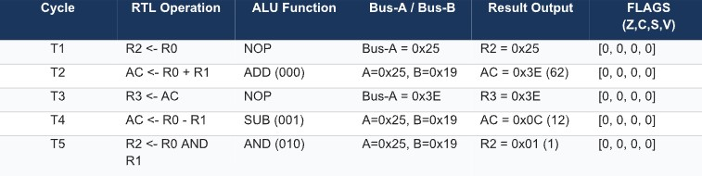
1.4 Step-by-Step Mathematical Verification

- Cycle 𝑻_{𝟏} (𝑹𝟐 ← 𝑹𝟎):
Tri-state buffer for 𝑹𝟎 asserts 𝟎𝒙𝟐𝟓 onto 𝑩𝒖𝒔_{𝑨}. On clock edge 𝑻_{𝟏}, load line 𝑹𝟐_{𝑳𝑫} latches 𝟎𝒙𝟐𝟓 into 𝑹𝟐.
- Cycle 𝑻_{𝟐} (Addition: 𝑨𝑪 ← 𝑹𝟎 + 𝑹𝟏):
𝑹𝟎 = 𝟎𝟎𝟏𝟎𝟎𝟏𝟎𝟏_{𝟐} (𝟑𝟕_{𝟏𝟎})
𝑹𝟏 = 𝟎𝟎𝟎𝟏𝟏𝟎𝟎𝟏_{𝟐} (𝟐𝟓_{𝟏𝟎})
Sum = 𝟎𝟎𝟏𝟏𝟏𝟏𝟏𝟎_{𝟐} (𝟎𝒙𝟑𝑬/𝟔𝟐_{𝟏𝟎})
No carry-out (𝑪 = 𝟎), non-zero result (𝒁 = 𝟎), MSB is 0 (𝑺 = 𝟎), no signed overflow (𝑽 =
𝟎). 𝑨𝑪 updates to 𝟎𝒙𝟑𝑬.
- Cycle 𝑻_{𝟑} (𝑹𝟑 ← 𝑨𝑪):
Contents of 𝑨𝑪 (𝟎𝒙𝟑𝑬) are driven onto 𝑩𝒖𝒔_{𝑨} and latched into 𝑹𝟑.
- Cycle 𝑻_{𝟒} (Subtraction: 𝑨𝑪 ← 𝑹𝟎 − 𝑹𝟏):
Two's complement of 𝑹𝟏: 𝑹̅̅̅𝟏̅ + 𝟏 = 𝟏𝟏𝟏𝟎𝟎𝟏𝟏𝟎_{𝟐} + 𝟏 = 𝟏𝟏𝟏𝟎𝟎𝟏𝟏𝟏_{𝟐} (𝟎𝒙𝑬𝟕). 𝑹𝟎 = 𝟎𝟎𝟏𝟎𝟎𝟏𝟎𝟏_{𝟐}
+(𝑹̅̅̅𝟏̅ + 𝟏) = 𝟏𝟏𝟏𝟎𝟎𝟏𝟏𝟏_{𝟐}
\𝒉𝒍𝒊𝒏𝒆Raw Sum = 𝟏𝟎𝟎𝟎𝟎𝟎𝟏𝟏𝟎𝟎_{𝟐} → Truncated 8-bit: 𝟎𝟎𝟎𝟎𝟏𝟏𝟎𝟎_{𝟐} (𝟎𝒙𝟎𝑪/𝟏𝟐_{𝟏𝟎}) Result matches 𝟑𝟕 − 𝟐𝟓 = 𝟏𝟐.
- Cycle 𝑻_{𝟓} (Bitwise AND: 𝑹𝟐 ← 𝑹𝟎 ∧ 𝑹𝟏):
𝟎𝟎𝟏𝟎𝟎𝟏𝟎𝟏_{𝟐} (𝟎𝒙𝟐𝟓)
∧ 𝟎𝟎𝟎𝟏𝟏𝟎𝟎𝟏_{𝟐} (𝟎𝒙𝟏𝟗)
\𝒉𝒍𝒊𝒏𝒆 = 𝟎𝟎𝟎𝟎𝟎𝟎𝟎𝟏_{𝟐} (𝟎𝒙𝟎𝟏) Destination register 𝑹𝟐 updates to 𝟎𝒙𝟎𝟏.

1.5 Role of the ALU in Processing Data

The ALU is a purely combinational logic block containing full adders, multiplexers, and logic gates. It does not store state independently; rather, its output dynamically updates as operands arrive on 𝑩𝒖𝒔_{𝑨} and 𝑩𝒖𝒔_{𝑩}. Synchronous execution is achieved because register update lines (𝑳𝑫) latch ALU outputs only on precise positive clock transitions, preventing transient propagation glitches from corrupting processor state.

Question 2: Single-Bus vs. Multi-Bus Organization and Transfer Analysis

2.1 System Topology Comparison

- Single-Bus System: A single shared central bus interconnects all registers, the ALU, Memory
Address/Data Registers (MAR/MDR), and I/O ports. At any given clock cycle, only ONE data transfer can occur. Multi-operand ALU operations require intermediate holding latches and multiple serial transfer cycles.
- Multi-Bus System (Three-Bus Topology): Utilizes dedicated source buses (Bus-A, Bus-B) and a
destination bus (Bus-C), alongside independent Memory and I/O buses. Operands are read
concurrently from two source registers, processed by the ALU, and written back to a destination register in a single cycle without bus contention.

  - System Modeling &amp; Scenario Execution
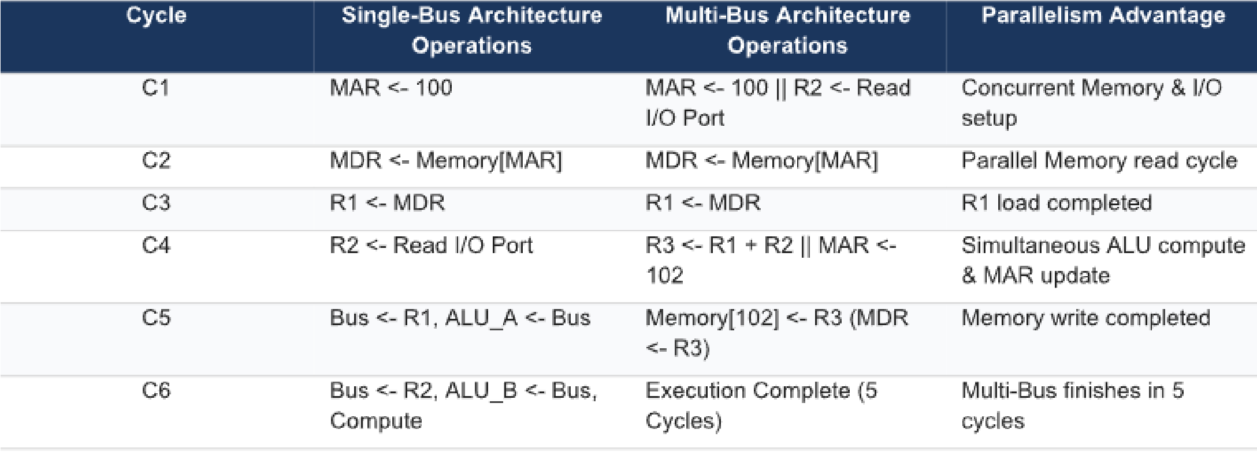

  - Quantitative Time &amp; Efficiency Evaluation

- Single-Bus Time (T_single): N_single = 11 cycles. T_single = 11 * T_clk.
- Multi-Bus Time (T_multi): N_multi = 5 cycles. T_multi = 5 * T_clk.
- Speedup Factor (S): S = T_single / T_multi = 11 / 5 = 2.20x (220% faster execution). • Time Reduction Efficiency (E): Efficiency Gain = ((11 - 5) / 11) * 100% = 54.55% latency reduction.

2.4 Bottleneck Mitigation Analysis

The single-bus structure introduces severe resource contentions. The ALU cannot execute an addition directly from registers because both operands must share the same bus, requiring temporary storage latches (𝑨𝑳𝑼_{𝑨}, 𝑨𝑳𝑼_{𝑩}, 𝑨𝑪) and adding 4 cycles of overhead.
In contrast, the multi-bus architecture completely eliminates bus multiplexing overhead. 𝑩𝒖𝒔_{𝑨} and 𝑩𝒖𝒔_{𝑩} feed operands 𝑹𝟏 and 𝑹𝟐 into the ALU concurrently, while 𝑩𝒖𝒔_{𝑪} carries the result directly to 𝑹𝟑 in cycle 𝑪_{𝟒}. Furthermore, memory address bus paths operate independently of internal register buses, allowing memory write setup (𝑴𝑨𝑹 ← 𝟏𝟎𝟐) to occur simultaneously with computation.

Question 3: 5-Stage Instruction Pipeline Simulation and Performance Evaluation

3.1 5-Stage Pipeline Architecture Overview

The classic 5-stage RISC instruction pipeline divides instruction execution into five overlapping processing phases:

    - Fetch (IF): Fetch instruction from cache/memory using Program Counter (𝑷𝑪); update 𝑷𝑪 ← 𝑷𝑪 + 𝟒.
    - Decode (ID): Decode instruction opcode and read source registers from Register File.
    - Execute (EX): Execute ALU operations or calculate effective branch/memory addresses.
    - Memory (MEM): Access data cache for load/store operations (LW/SW).
    - Write-back (WB): Write computation/memory results back into target registers.

3.2 Simulation Benchmark Workload

An independent 8-instruction RISC sequence is executed on an ideal pipeline (no hazard stalls):
- 𝑰_{𝟏}: ADD R1, R2, R3
- 𝑰_{𝟐}: SUB R4, R5, R6
- 𝑰_{𝟑}: AND R7, R8, R9
- 𝑰_{𝟒}: OR R10, R11, R12
- 𝑰_{𝟓}: XOR R13, R14, R15
- 𝑰_{𝟔}: ADD R16, R17, R18
- 𝑰_{𝟕}: SUB R19, R20, R21
- 𝑰_{𝟖}: OR R22, R23, R24

  - Pipeline Execution Space-Time Matrix

  - Performance Quantification and Mathematical Evaluation

Simulation Parameters:

- Number of instructions (𝑵) = 8
- Pipeline stages (𝒌) = 5
- Clock cycle time (𝝉) = 𝟐 ns (Clock Frequency 𝒇 = 𝟓𝟎𝟎 MHz)

Non-Pipelined System Calculations:
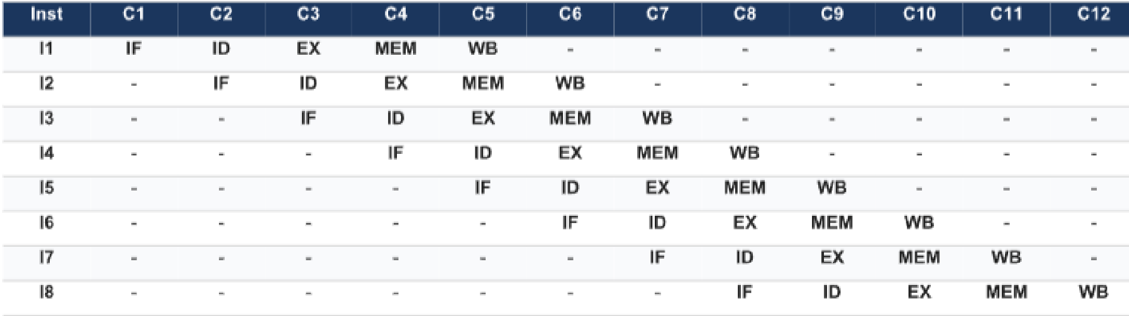
- Execution time per instruction = 𝒌 × 𝝉 = 𝟓 × 𝟐 ns = 𝟏𝟎 ns • Total Non-Pipelined Execution Time (𝑻_{np}):
𝑻_{np} = 𝑵 × 𝒌 × 𝝉 = 𝟖 × 𝟓 × 𝟐 ns = 𝟖𝟎 ns

- Non-Pipelined Throughput (𝑻𝑷_{np}):
𝑵 𝟖
𝑻𝑷_{np} = = = 𝟎. 𝟏 inst/ns = 𝟏𝟎𝟎 MIPS
𝑻_{np} 𝟖𝟎 ns

Pipelined System Calculations:

- Total Clock Cycles (𝑪𝒚𝒄𝒍𝒆𝒔_{pipe}) = 𝒌 + (𝑵 − 𝟏) = 𝟓 + (𝟖 − 𝟏) = 𝟏𝟐 cycles • Total Pipelined Execution Time (𝑻_{p}):
𝑻_{p} = 𝑪𝒚𝒄𝒍𝒆𝒔_{pipe} × 𝝉 = 𝟏𝟐 × 𝟐 ns = 𝟐𝟒 ns
- Pipelined Throughput (𝑻𝑷_{p}):
𝑵 𝟖
𝑻𝑷_{p} = = = 𝟎. 𝟑𝟑𝟑𝟑 inst/ns = 𝟑𝟑𝟑. 𝟑𝟑 MIPS
𝑻_{p} 𝟐𝟒 ns

Performance Gains:

- Speedup Factor (𝑺):
𝑻_{np} 𝟖𝟎 ns
𝑺 = = = 𝟑. 𝟑𝟑𝟑 ×
𝑻_{p} 𝟐𝟒 ns
- Theoretical Maximum Speedup (𝑺_{max}):
𝑺_{max} = 𝒌 = 𝟓. 𝟎 ×
- Pipeline Efficiency (𝑬):
𝑺 𝟑. 𝟑𝟑𝟑
𝑬 = = = 𝟎. 𝟔𝟔𝟔𝟕 (66.67%)
𝒌 𝟓
Note: As 𝑵 → ∞, pipeline speedup approaches the theoretical limit 𝑺 → 𝒌 = 𝟓 ×, and efficiency 𝑬 → 𝟏𝟎𝟎%.

Question 4: Pipeline Hazard Analysis and Mitigation Techniques

4.1 Hazard Classifications

- Structural Hazards: Hardware resource conflicts where two pipeline stages attempt to access the same physical resource concurrently (e.g., single-ported memory accessed simultaneously by IF and MEM).

- Data Hazards: Occur when an instruction depends on the result of a preceding instruction still in flight within the pipeline:
    - Read-After-Write (RAW): True data dependency.
    - Write-After-Read (WAR): Anti-dependency. o Write-After-Write (WAW): Output dependency.

- Control Hazards: Branch and jump instructions that alter the 𝑃𝐶 value, introducing uncertainty during instruction fetch phases.

  - Benchmark Hazard Test Sequence

I1: ADD R1, R2, R3 ; Writes destination R1 in WB stage
I2: SUB R4, R1, R5 ; RAW Hazard on R1 (produced by I1)
I3: LW R6, 0(R4) ; Memory Load to R6; RAW Dependency on R4 (from I2)
I4: AND R7, R6, R8 ; Load-Use Data Hazard on R6 (from I3)
I5: BEQ R7, R0, TARGET ; Control Hazard (Branch dependent on R7 from I4)

  - Mitigation Techniques Mechanics

- Data Forwarding (Bypassing): Hardware paths route calculated outputs directly from pipeline registers (EX/MEM or MEM/WB) back to the EX stage multiplexer inputs, bypassing register file write delays.
- Load-Use Stall Insertion: Because data loaded via LW is not available until the end of the MEM stage, an instruction immediately consuming that loaded register requires a hardware stall bubble in the ID stage.
- Branch Prediction & Target Buffers (BTB): Dynamic 2-bit saturating prediction counters predict branch direction in the IF stage. If correct, zero penalty cycles are incurred; if mispredicted, speculative instructions are flushed, incurring a 2-cycle penalty.

  - Hazard Pipeline Timing Matrix (Mitigated Execution)

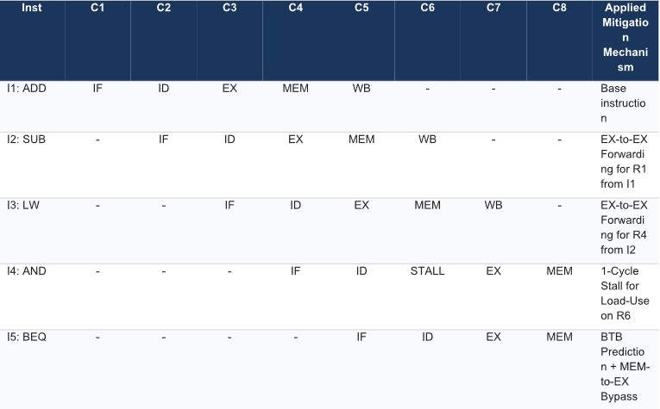

  - Quantitative Performance Impact Analysis

Cycle Comparison:

- Unmitigated System Execution (Stalls only): o 𝑰_{𝟐} stalls 𝟐 cycles waiting for 𝑰_{𝟏} Write-Back. o 𝑰_{𝟒} stalls 𝟐 cycles waiting for 𝑰_{𝟑} Write-Back. o 𝑰_{𝟓} stalls 𝟐 cycles for branch resolution.
𝟓 o Total Cycles = 𝟏𝟑 Clock Cycles (𝑰𝑷𝑪 = = 𝟎. 𝟑𝟖)
𝟏𝟑
- Mitigated System Execution (Forwarding + BTB): o 𝑰_{𝟐} stalls 𝟎 cycles (Forwarded).
    - 𝑰_{𝟒} stalls 𝟏 cycle (Load-Use constraint).
    - 𝑰_{𝟓} stalls 𝟎 cycles (Correct Branch Prediction).
𝟓 o Total Cycles = 𝟗 Clock Cycles (𝑰𝑷𝑪 = = 𝟎. 𝟓𝟔)
𝟗

Performance Gain:

𝟏𝟑 − 𝟗
Cycle Reduction Efficiency = ( ) × 𝟏𝟎𝟎% = 𝟑𝟎. 𝟕𝟕% reduction in execution latency
𝟏𝟑
𝟎. 𝟓𝟔 − 𝟎. 𝟑𝟖
Throughput Improvement = ( ) × 𝟏𝟎𝟎% = 𝟒𝟕. 𝟑𝟕% IPC gain
𝟎. 𝟑𝟖

Question 5: Superscalar, Out-of-Order Execution, Speculation, and SMT Architecture

5.1 Superscalar Processing Principles

Superscalar architectures exploit Instruction-Level Parallelism (ILP) by deploying multiple parallel execution pipelines (multiple ALUs, FPUs, Load/Store Units) capable of fetching, decoding, issuing, and executing 𝑵 instructions per clock cycle.

5.2 Out-of-Order Execution (OoO) and Speculation Paradigm

To overcome pipeline stalls from data dependencies and memory cache misses, high-performance processors utilize dynamic Out-of-Order (OoO) execution pipelines:

[In-Order Fetch/Decode]
│
▼
[Register Renaming (RAT)] <-- Eliminates WAR/WAW False Dependencies
│
▼
[Reservation Stations (RS)] <-- Operands Wait Asynchronously
│
▼
[Out-of-Order Execution] <-- Dispatched as soon as Operands Ready
│
▼
[Reorder Buffer (ROB)] <-- Buffers Results Temporarily
│
▼
[In-Order Commit / WB] <-- State Committed Safely & In-Order

- Register Alias Table (RAT / Renaming): Maps architectural registers (𝑹𝟎--𝑹𝟑𝟏) to a larger physical register file pool, eliminating false dependencies: Write-After-Read (WAR) and WriteAfter-Write (WAW).

- Reservation Stations (RS): Issue queues where instructions wait asynchronously. An instruction dispatches to an execution unit as soon as its required input operands become available, regardless of original program order.

- Reorder Buffer (ROB) & Precise Exceptions: Results are computed Out-of-Order but stored temporarily in the ROB. Instructions commit state changes to architectural registers strictly In-Order, preserving precise exception handling and rollback capability upon branch misprediction.

- Speculative Execution: Branch prediction units allow instructions following a branch to be fetched and executed speculatively. If the branch resolves correctly, ROB commits the speculative results; if mispredicted, speculative pipeline state is flushed without affecting memory or architectural registers.

5.3 Simultaneous Multithreading (SMT) and Hyper-Threading

While superscalar architectures focus on Instruction-Level Parallelism (ILP) within a single thread, Simultaneous Multithreading (SMT) combines ILP with Thread-Level Parallelism (TLP).

In an SMT architecture (such as Intel Hyper-Threading):
- Duplicated Hardware Resources: Architectural state components are replicated per logical thread (Program Counters, Register Files, Control Logic, Interrupt Controllers).
- Shared Hardware Resources: Core execution hardware is shared (Execution Units/ALUs, Reservation Stations, L1/L2 Caches, Translation Lookaside Buffers).

SMT enables instructions from multiple independent software threads to enter execution pipelines concurrently in the same clock cycle, converting unused pipeline capacity into productive throughput.

  - Architectural Paradigm Comparison

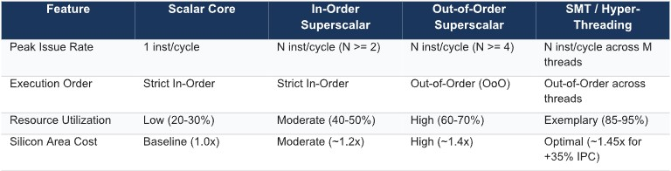

  - Quantitative Throughput and Resource Utilization Analysis

Hardware Benchmark Context:

Quad-issue core containing 4 execution ALUs/Functional Units.
Cycle Slot Occupancy Illustration:

Scalar In-Order Core:
[ Cycle 1 ] [ Inst 1 ] [ Idle ] [ Idle ] [ Idle ] --> 25% Unit Utilization
[ Cycle 2 ] [ STALL ] [ STALL ] [ STALL ] [ STALL ] --> Cache Miss Stall

Superscalar Out-of-Order Core (Single Thread):
[ Cycle 1 ] [ Inst 1 ] [ Inst 2 ] [ Inst 3 ] [ Idle ] --> 75% Unit Utilization
[ Cycle 2 ] [ Inst 4 ] [ STALL ] [ STALL ] [ STALL ] --> Dependency Stall

Superscalar SMT Core (Dual Thread: Thread A + Thread B):
[ Cycle 1 ] [ ThA_I1 ] [ ThA_I2 ] [ ThB_I1 ] [ ThB_I2 ] --> 100% Unit Utilization
[ Cycle 2 ] [ ThA_ST ] [ ThB_I3 ] [ ThB_I4 ] [ ThB_I5 ] --> 75% Utilization (Thread B fills Thread A stall)

Performance Comparison Metrics:

- Single-Threaded In-Order Core:
  - Average Instructions Per Cycle (IPC) = 𝟏. 𝟐
𝟏.𝟐 o Functional Unit Utilization = × 𝟏𝟎𝟎% = 𝟑𝟎%
𝟒
- Single-Threaded Out-of-Order Core:
  - Bypasses data stalls using RS and ROB queues.
  - Average IPC = 𝟐. 𝟔
𝟐.𝟔 o Functional Unit Utilization = × 𝟏𝟎𝟎% = 𝟔𝟓%
𝟒
- Dual-Thread SMT Core:
  - When Thread A incurs a cache miss or long-latency operation, Thread B immediately fills the vacant execution slots in the exact same clock cycle. o Combined System IPC = 𝟑. 𝟔
𝟑.𝟔 o Functional Unit Utilization = × 𝟏𝟎𝟎% = 𝟗𝟎%
𝟒
Conclusion:

SMT eliminates both horizontal waste (unused execution slots in a cycle) and vertical waste (cycles lost entirely to memory latency stalls), maximizing processor instruction throughput and resource utilization.

Code of Conduct:

I R.MOHANRAM / 192521117 (Name / Reg No) certify that this submission is my original work and that I have adhered to the guidelines specified for this assessment.I understand that any violation of academic integrity rules will result in disciplinary action.

Signature of the student: R.Mohanram

MARKS ALLOCATION
 | Understanding of Concepts(20%) | Experimental Design(20%) | Use of  Tools(25%) | Analysis of Results(20%) | Documentation(15 %)
Q1
Q2
Q3
Q4
Q5

RUBRICS FOR CALCULATION:

Criteria | Weightage | Level 4 – Exemplary | Level 3 –  Proficient | Level 2 –  Developing | Level 1 –  Beginning
Understanding of Concepts | 25 | Demonstrates thorough understanding and  effectively integrates multiple concepts/technologies | Good understanding with proper  integration of most concepts | Basic understanding;  limited or partial integration | Poor understanding; unable to  integrate concepts
Experimental Design | 30 | Well-planned, systematic implementation with optimal solution | Correct implementation with minor issues | Basic implementation with errors or inefficiencies | Incorrect or incomplete implementation
Use of Tools | 20 | Effective and advanced use of tools/technologies with proper configuration | Appropriate use of tools with correct execution | Limited or inconsistent use of  tools | Incorrect or minimal use of tools
Analysis of Results | 15 | Insightful analysis with accurate interpretation and validation of results | Good analysis with reasonable interpretation | Basic analysis with limited insights | Poor or incorrect analysis of results
Documentation | 10 | Clear, well-structured documentation with  diagrams, code, and results | Organized documentation with necessary details | Basic documentation  with missing details | Poor or incomplete documentation

