

AI-ASSISTED PROCESSOR PERFORMANCE OPTIMIZATION

A CAPSTONE PROJECT REPORT

Submitted in partial fulfilment of the requirements for

CSA1205 – Computer Architecture

to the award of the degree of

BACHELOR OF TECHNOLOGY
IN
INFORMATION TECHNOLOGY

Submitted by
R. MOHANRAM_192521117
P. LOGESH_192521351
S. MOHAMED JILAN_192521386

Under the Supervision of
Dr. Vijaya Bhaskar K

SIMATS ENGINEERING
Saveetha Institute of Medical and Technical Sciences
Chennai – 602105
SEPTEMBER 2026

SIMATS ENGINEERING
Saveetha Institute of Medical and Technical Sciences
Chennai – 602105

BONAFIDE CERTIFICATE

This is to certify that the Capstone Project entitled “AI-Assisted Processor Performance Optimization” has been carried out by R. Mohanram_192521117, P. Logesh_192521351 and S. Mohamed Jilan_192521386 under the supervision of Dr. Vijaya Bhaskar K and is submitted in partial fulfilment of the requirements for CSA1205 Computer Architecture in the B.Tech Information Technology programme at SIMATS Engineering, Saveetha Institute of Medical and Technical Sciences, Chennai.

COURSE COORDINATOR COURSE FACULTY
Dr V Sarala, Dr K Vijaya Bhaskar,
Professor Professor
CSE CSE
SIMATS Engineering, SIMATS Engineering,
SIMATS, Chennai – 602105. SIMATS, Chennai – 602105.

SIMATS ENGINEERING
Saveetha Institute of Medical and Technical Sciences
Chennai – 602105

DECLARATION

We, R.Mohanram_192521117, P.Logesh_192521351 and S.Mohamed Jilan_192521386 of the Electronics and Communication Engineering department, SIMATS Engineering, Saveetha Institute of Medical and Technical Sciences, Chennai, hereby declare that the Capstone Project Work entitled “AI-Assisted Processor Performance Optimization” is the result of our bonafide efforts. The work has been carried out in accordance with engineering ethics and academic integrity. All sources, references, data, software libraries, datasets, computational resources and AI-assisted resources used during the project have been appropriately acknowledged. We further declare that the reported data and results have not been intentionally fabricated or manipulated. The prototype operates at the software monitoring and decision-support level and does not directly modify CPU voltage, BIOS settings, clock multipliers or firmware.

Place: Chennai
Date: September 2026

Signature of the Students with Names

R. MOHANRAM_192521117
P. LOGESH_192521351
S. MOHAMED JILAN_192521386

SIMATS ENGINEERING
Saveetha Institute of Medical and Technical Sciences
Chennai – 602105

INDIVIDUAL CONTRIBUTION STATEMENT

Student / Reg. No. | Responsibilities | Design & Development | Testing & Analysis | Report | %
R. Mohanram / 192521117 | System integration, monitoring and dashboard | Data collection, AI engine, dashboard | Integration and real-time testing | Ch.1, Ch.3, evidence | 34%
P. Logesh / 192521351 | Dataset and ML development | Dataset preparation, RF training | Model evaluation, feature analysis | Ch.2, ML method | 33%
S. Mohamed Jilan / 192521386 | Optimization and evaluation | Optimization workflow | Comparison, graphs, analysis | Ch.4, Ch.5, appendices | 33%
TOTAL |  |  |  |  | 100%

ABSTRACT

Modern computing systems operate under continuously changing workloads, causing CPU utilization, memory consumption, process count, disk activity and network traffic to vary over time. Conventional monitoring utilities can display these parameters, but the interpretation of the measurements is normally left to the user. This project presents an AI-Assisted Processor Performance Optimization System that combines real-time system monitoring, machine learning-based workload classification, an AI decision engine, performance experimentation and an interactive web dashboard.
The system was implemented in Python using psutil for system measurements, Pandas and NumPy for data processing, Scikit-learn for machine learning, Joblib for model persistence, Plotly for visualization and Streamlit for the dashboard. Real processor measurements were collected and organized into a workload dataset containing CPU usage, memory usage, CPU frequency, frequency limits, physical and logical cores, process count, disk usage and network statistics. A Random Forest classifier was trained to classify workload into LOW, MODERATE and HIGH categories. The trained model achieved 98.81% accuracy on the project test dataset.
The model was integrated with an AI decision engine that maps workload predictions to POWER_EFFICIENT, BALANCED and PERFORMANCE recommendations, while additional CPU and memory threshold checks generate alert conditions. Baseline and AI-assisted monitoring experiments were compared using CPU usage, memory utilization, processor frequency and process count. Average CPU usage changed from 2.64% to 2.59%, while average memory usage changed from 73.35% to 71.09%.
A Streamlit dashboard provides real-time processor status, workload prediction, confidence, workload probabilities, AI recommendations, resource-intensive processes, performance graphs and decision logs. The prototype demonstrates how machine learning can complement conventional monitoring by converting raw processor measurements into interpretable workload classifications and optimization recommendations.
Keywords: Processor Performance; Machine Learning; Random Forest; Workload Prediction; Real-Time Monitoring; AI Optimization

TABLE OF CONTENTS

Sl.  No | Title | Page  No
i | CERTIFICATE FROM THE SUPERVISOR | 2
ii | DECLARATION BY THE CANDIDATE | 3
Iii | INDIVIDUAL CONTRIBUTION STATEMENT | 4
iv | ABSTRACT | 5
v | LIST OF FIGURES | 6
vi | LIST OF TABLES | 7
vii | LIST OF ABBREVIATIONS | 8
1 | CHAPTER 1: Introduction | 11
 | - Background | 11
 | - Need for the Project | 11
 | 1.3 Problem Statement | 11
 | 1.4 Project Aim | 11
 | 1.5 Project Objectives | 12
 | 1.6 Scope | 12
 | 1.7 Expected Engineering Outcome | 12
2 | CHAPTER 2: Literature Review | 13
 | - Review Method | 13
 | 2.2 Review of Existing Work | 13
 | - Comparative Analysis | 14
 | 2.4 Research / Engineering Gap | 14
 | - Proposed Contribution | 15
3 | CHAPTER 3: Engineering Design & Trade-offs, Sustainability,  Ethics, Safety, Risk & Security | 16
 | 3.1 Requirements | 16
 | 3.2 Constraints & Applicable Standards | 16
 | 3.3 Design Specifications | 16
 | 3.4 Alternative Solutions & Evaluation | 17
 | 3.5 Selected Design & Detailed Design | 17
 | 3.6 Trade-off Analysis | 18
 | 3.7 Sustainability, Ethics, Safety, Risk & Security | 18
4 | CHAPTER 4: Implementation, Testing & Results, Project  Management | 20
 | 4.1 Development Approach & Resources | 20
 | 4.2 Module 1 – Data Collection | 20
 | 4.3 Module 2 – Dataset Preparation | 21
 | 4.4 Module 3 – AI Decision Engine | 23
 | 4.5 AI-Assisted Optimization and Optimized Test | 24
 | 4.6 Test Plan & Verification | 25
 | 4.7 Results | 26
 | 4.8 Data Analysis & Engineering Judgment | 28
 | 4.9 Comparison with Existing Solutions & Objective Achievement | 28
 | 4.10 Strengths & Limitations | 28
 | 4.11 Project Planning, Roles & Budget | 29
5 | CHAPTER 5: Conclusion & Reflection | 30
 | 5.1 Conclusion | 30
 | 5.2 Future Work | 30
 | 5.3 Professional Learning & Individual Reflection | 30
 | References | 32
 | Appendices | 33

LIST OF FIGURES

No. | Figure | Page
3.1 | AI decision flow / architecture | Ch.3
4.1 | Data collection evidence | Ch.4
4.2 | Baseline test evidence | Ch.4
4.3 | Dataset preparation evidence | Ch.4
4.4 | Random Forest training | Ch.4
4.5 | Feature importance | Ch.4
4.6 | AI decision engine | Ch.4
4.7 | AI-assisted optimization | Ch.4
4.8 | Optimized test | Ch.4
4.9 | Before-versus-after comparison | Ch.4
4.10 | Performance graphs | Ch.4
4.11 | Final Streamlit dashboard | Ch.4

LIST OF TABLES

No. | Table | Page
1.1 | Project objectives | Ch.1
2.1 | Literature review | Ch.2
2.2 | Comparative analysis | Ch.2
3.1 | Requirements | Ch.3
3.2 | Design specifications | Ch.3
3.3 | Alternative evaluation | Ch.3
3.4 | Risk register | Ch.3
4.1 | Experimental environment | Ch.4
4.2 | Test plan | Ch.4
4.3 | Baseline vs AI-assisted results | Ch.4
4.4 | Objective achievement | Ch.4
4.5 | Project planning and budget | Ch.4

LIST OF ABBREVIATIONS / SYMBOLS

Symbol | Description | Unit / Context
AI | Artificial Intelligence | Concept
ML | Machine Learning | Concept
CPU | Central Processing Unit | Processor
RAM | Random Access Memory | Memory
DVFS | Dynamic Voltage and Frequency Scaling | Power management
RF | Random Forest | ML algorithm
OS | Operating System | System software
CSV | Comma-Separated Values | Data file
PID | Process Identifier | Process monitoring
MHz | Megahertz | CPU frequency
CPI | Cycles Per Instruction | Processor metric

CHAPTER 1
INTRODUCTION AND ENGINEERING PROBLEM

1.1 Background
Modern processors execute many software activities concurrently. CPU utilization, memory consumption, process count, storage activity and network traffic change continuously according to user activity and background services. As workload changes, a processor may need to prioritize responsiveness during intensive computation while avoiding unnecessary resource use during low activity.
Traditional monitoring applications provide measurements but leave interpretation to the user. A processor can show low CPU utilization while memory usage is high, or a short CPU spike can occur because of a resource-intensive process. Processor monitoring is therefore both a measurement problem and an analysis problem.
This project combines real-time monitoring with machine learning. The system collects real processor measurements using Python and psutil, prepares a labelled workload dataset, trains a Random Forest classifier, and uses the prediction inside an AI decision engine. The recommendation is presented through a Streamlit dashboard.

1.2 Need for the Project
- Continuous processor and system parameters must be captured without manual observation.
- Workload conditions should be classified using multiple parameters rather than a single CPU value.
- Recommendations should be understandable and linked to measured conditions.
- Baseline and AI-assisted measurements must be recorded for evaluation.
- The system must remain safe by avoiding uncontrolled hardware modification.

1.3 Problem Statement
There is a need for an intelligent, real-time processor performance monitoring system that can collect changing processor and system parameters, classify workload, identify critical resource conditions and generate workload-based optimization recommendations. The engineering problem involves interacting variables, dynamic operating conditions, imperfect workload balance and safe operation on a normal personal computer.

1.4 Aim
Aim: To design and implement an AI-assisted processor performance monitoring and optimization prototype that converts real-time system measurements into workload classifications and actionable operating recommendations.

1.5 Objectives

No. | Objective | Evidence
1 | Collect real-time processor data | data_collection.py
2 | Build workload dataset | ml_dataset.csv
3 | Classify LOW/MODERATE/HIGH workload | Random Forest
4 | Train and evaluate ML model | model.py
5 | Develop AI decision engine | ai_engine.py
6 | Generate workload recommendations | AI modes/actions
7 | Perform baseline and optimized tests | CSV results
8 | Compare before and after performance | compare.py + graphs
9 | Develop web dashboard | dashboard.py

1.6 Scope
The project includes CPU, memory, frequency, process, disk and network monitoring; dataset preparation; Random Forest training; feature-importance analysis; AI decision logic; software-level optimization monitoring; baseline and optimized experiments; logging; visualization; and dashboard development.
The project excludes direct changes to CPU voltage, BIOS configuration, firmware, clock multipliers and processor power limits. It also does not claim direct electrical energy savings because electrical power was not directly measured.

1.7 Expected Engineering Outcome
The expected outcome is a working software prototype capable of observing a Windows computer, classifying workload using a trained ML model, generating AI recommendations, recording decisions and presenting evidence through an interactive dashboard.

CHAPTER 2

LITERATURE REVIEW AND EXISTING SOLUTIONS

2.1 Review Method

The review focused on machine-learning-based workload prediction, processor performance monitoring, dynamic frequency scaling, energy-efficient computing and Random Forest classification. Research papers and technical documentation were considered to identify established methods, limitations and opportunities for an integrated academic prototype.

2.2 Review of Existing Work

Breiman introduced Random Forests as an ensemble of randomized decision-tree predictors. The method supports classification and variable-importance analysis, making it appropriate for interpreting structured processor measurements. [1]
Learning-directed dynamic voltage and frequency scaling research has demonstrated that machine learning can classify task behaviour and predict suitable processor frequency settings from runtime information. [2], [4]
EClass investigated machine-learning-based recognition of utilization patterns for performance-aware frequency assignment, showing the relevance of workload-pattern learning to energy-aware computing. [3]
Recent work continues to study learning-based frequency and power management, including computationally demanding edge workloads where power and thermal constraints interact with performance. [5]
For system-level implementation, psutil provides CPU, memory, disk, network and process information from a Python application, making it suitable for real-time data collection on ordinary computers. [6]

2.3 Literature Review Table
Year | Research Area | Key Contribution | Relevance
2001 | Random Forests | Ensemble trees and variable importance. | ML classifier basis.
2012 | EClass / ML energy efficiency | Workload-pattern recognition for frequency assignment. | Runtime workload learning.
2018 | Learning-directed DVFS | Learning-based prediction of CPU frequency. | Adaptive processor decisions.
2020 | ML frequency scaling | Random Forest classification for processor frequency decisions. | Processor-oriented classification.
2022 | Dynamic frequency scaling | ML models evaluated for on-the-fly frequency optimization. | Multi-parameter optimization.
2026 | Energy-aware edge AI | Power-governing strategies for heavy edge workloads. | Future direction for power-aware control.

2.4 Comparative Analysis
Approach | Advantages | Limitations | Relevance
Basic OS monitoring | Simple and low-cost. | Manual interpretation. | Provides raw measurements.
Rule-based thresholds | Transparent and easy. | Fixed rules may be rigid. | Used for alert layer.
ML workload classification | Learns multi-parameter relationships. | Needs representative data. | Core project method.
Direct DVFS control | Potential physical energy/performance benefit. | Platform-specific and safety-sensitive. | Outside current scope.
Proposed AI-assisted monitoring | Integrated monitoring, ML, decisions, logs and dashboard. | No direct power measurement. | Main contribution.

2.5 Engineering Gap and Proposed Contribution
Existing research demonstrates that machine learning can support processor workload prediction and adaptive resource management. The project addresses a practical gap by integrating real system measurements, a tabular ML classifier, transparent decision logic, experiments, logging and a dashboard in one reproducible software workflow. The design deliberately remains within a safe software-level boundary.

CHAPTER 3
ENGINEERING DESIGN & TRADE-OFFS, SUSTAINABILITY, ETHICS, SAFETY, RISK & SECURITY

3.1 Requirements
Type | Requirement | Target
Functional | Collect CPU, memory, frequency, process, disk and network data. | Continuous sampling
Functional | Predict workload. | LOW / MODERATE / HIGH
Functional | Generate AI mode/action. | Decision per sample
Functional | Store decisions. | CSV log
Functional | Display live metrics. | Streamlit dashboard
Functional | Compare experiments. | Tables + graphs
Non-functional | Safety | No direct hardware modification
Non-functional | Usability | Clear recommendations
Non-functional | Reproducibility | Fixed scripts and CSV outputs

3.2 Constraints & Applicable Conventions

The principal constraints are system variability, dataset representativeness, availability of OS-level metrics, limited direct power measurement, background-process interference and the need to avoid privileged hardware modification. IEEE-style references and software documentation acknowledgement are used to maintain traceability.

3.3 Design Specifications

Parameter | Target | Unit | Priority
CPU utilization | Real-time measurement | % | High
Memory utilization | Real-time measurement | % | High
CPU frequency | Current/min/max | MHz | High
Process count | Current count | count | Medium
Disk utilization | Current utilization | % | Medium
Network traffic | Bytes sent/received | bytes | Medium
Workload classes | LOW/MODERATE/HIGH | class | High
ML model | Random Forest | algorithm | High
Dashboard | Real-time visual monitoring | web app | High
Logging | Decision history | CSV | High

3.4 Alternative Solutions & Evaluation

Alternative 1 is rule-based monitoring, which is transparent but may be rigid. Alternative 2 is ML classification, which learns relationships across several variables. Alternative 3 is direct hardware DVFS control, which can offer stronger physical optimization but requires platform-specific privileges and safety validation.
Criterion | Weight | Rule-Based | ML Classification | Direct DVFS
Performance | 30% | 3/5 | 4/5 | 5/5
Cost / setup | 20% | 5/5 | 4/5 | 2/5
Safety | 25% | 5/5 | 5/5 | 2/5
Sustainability | 10% | 3/5 | 4/5 | 5/5
Reliability | 15% | 4/5 | 4/5 | 2/5
Overall suitability | 100% | 4.0/5 | 4.25/5 | 3.1/5

3.5 Selected Design & Detailed Design

Machine-learning classification was selected because it provides a practical balance between predictive capability, safety, portability and implementation effort. Real-time measurements feed the model; the prediction feeds the decision engine; the resulting action is logged and visualized.
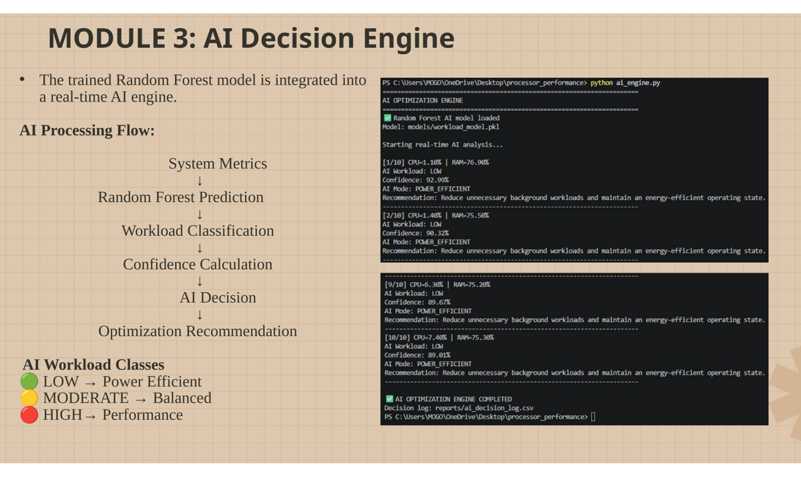
Figure 3.1: AI decision flow and integration evidence from the developed project presentation.

3.6 Trade-off Analysis

Decision | Alternative | Benefit | Disadvantage | Final Decision
Random Forest | Neural network | Strong tabular classification and feature importance. | Does not explicitly model time sequences. | Selected for structured data.
Software recommendation | Direct CPU control | Safe and portable. | No direct hardware change. | Selected for academic prototype.
CSV logging | Database server | Simple and transparent. | Less scalable. | Selected for reproducibility.
Streamlit + Plotly | Desktop GUI | Fast interactive web dashboard. | Python runtime required. | Selected for rapid integration.

3.7 Sustainability, Ethics, Safety, Risk & Security

Domain | Evidence Evaluated | Design Impact
Sustainability | Low-workload recommendations; no direct power sensor. | Claims limited to utilization observations.
Ethics | Transparent results and limitations. | No exaggerated hardware claims.
Safety | No BIOS/voltage/firmware changes. | Reduces hardware risk.
Security | Local monitoring and processing. | No external control service.
Data integrity | CSV logs and reproducible scripts. | Traceable evidence.

Risk | Likelihood | Severity | Mitigation | Residual
Unbalanced workload data | Medium | Medium | Collect more moderate samples. | Low–Medium
Background process variation | High | Medium | Repeated sampling and averages. | Medium
Model/file-path errors | Medium | Medium | Consistent paths and validation. | Low
High memory condition | Medium | High | Memory alert and safe operation. | Medium
Unsafe hardware modification | Low | High | Keep control outside scope. | Low
Dashboard interruption | Medium | Low | Restart app; preserve CSV logs. | Low

CHAPTER 4
IMPLEMENTATION, TESTING & RESULTS, PROJECT MANAGEMENT

4.1 Development Approach & Resources

Development followed an incremental workflow: collect real measurements; prepare the ML dataset; train and evaluate the Random Forest; integrate the AI decision engine; perform baseline and optimized experiments; compare results; and integrate the final dashboard.
Tool / Resource | Purpose | Stage
Python 3.10 | Application development | All stages
psutil | System monitoring | Collection/dashboard
Pandas / NumPy | Data processing | Dataset/analysis
Scikit-learn | Random Forest | ML
Joblib | Model persistence | Integration
Plotly | Graphs | Dashboard
Streamlit | Web interface | Final integration
Windows PC | Execution platform | All experiments

4.2 Module 1 – Data Collection

data_collection.py captures CPU usage, memory usage, CPU frequency and limits, physical and logical cores, process count, disk utilization and network traffic. The project collected 300 real measurements for the baseline data collection stage.
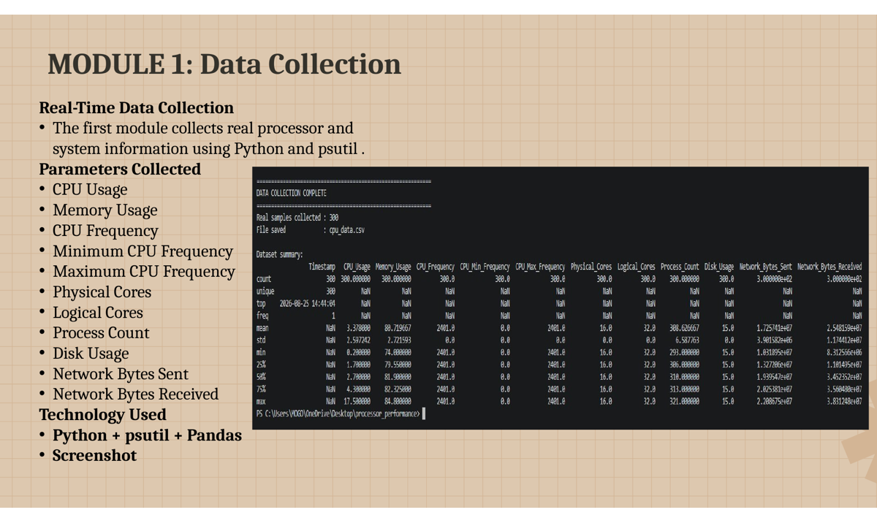
Figure 4.1: Real-time data collection module and terminal evidence.

4.2.1 Baseline Performance Measurement

The baseline experiment establishes the reference condition before AI-assisted monitoring.
Parameter | Baseline
Average CPU Usage | 2.64%
Maximum CPU Usage | 8.60%
Minimum CPU Usage | 0.70%
Average Memory Usage | 73.35%
Average CPU Frequency | 2401.00 MHz
Average Process Count | 290.38

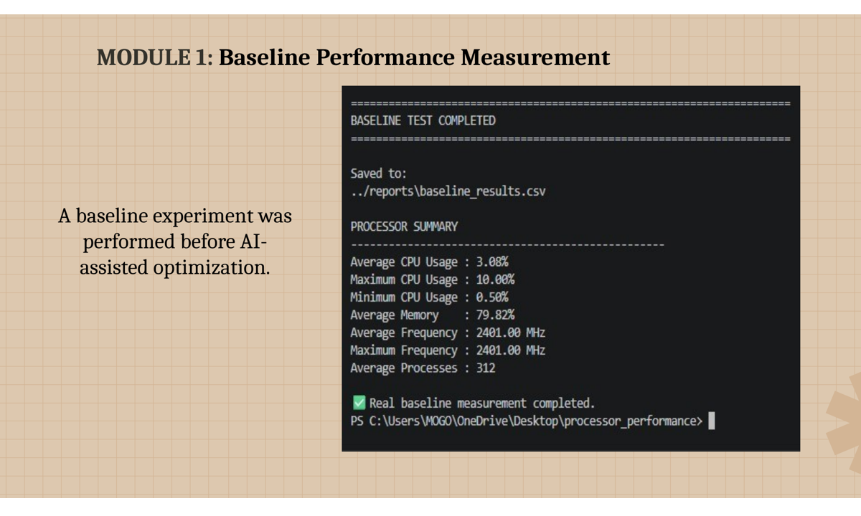
Figure 4.2: Baseline performance measurement execution evidence.

4.3 Module 2 – Dataset Preparation

The ML dataset contains 420 samples: 300 baseline samples and 120 controlled workload samples. The project evidence shows 337 LOW, 5 MODERATE and 78 HIGH samples. The imbalance is a known limitation.
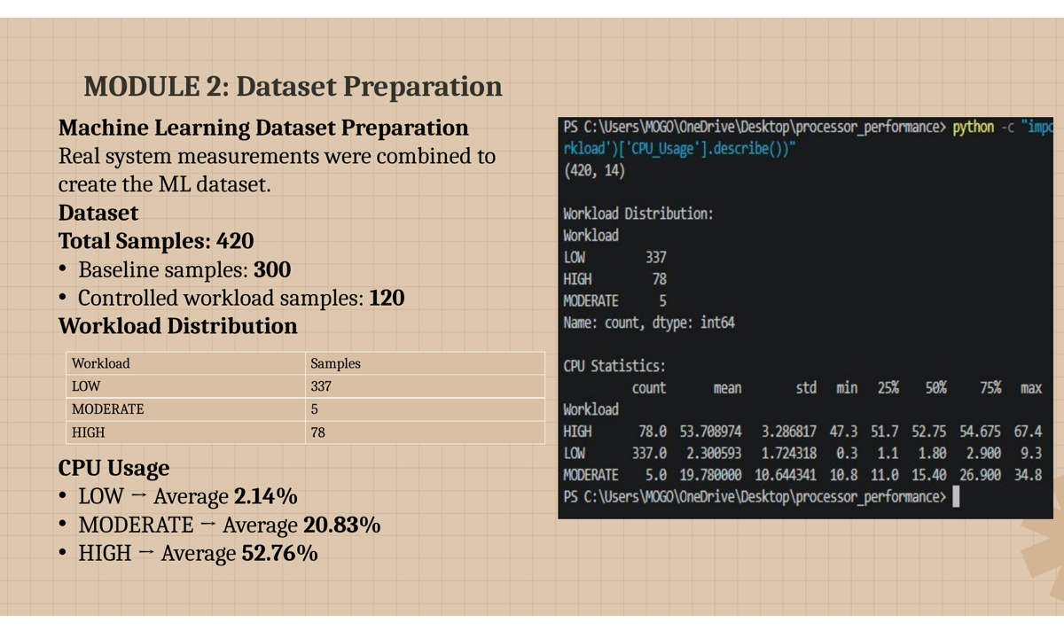
Figure 4.3: Dataset preparation and workload distribution evidence.

4.3.1 Random Forest Model

The classifier uses 11 features: CPU Usage, Memory Usage, CPU Frequency, CPU Minimum Frequency, CPU Maximum Frequency, Physical Cores, Logical Cores, Process Count, Disk Usage, Network Bytes Sent and Network Bytes Received. The dataset split was 336 training samples and 84 testing samples. The reported accuracy was 98.81%.
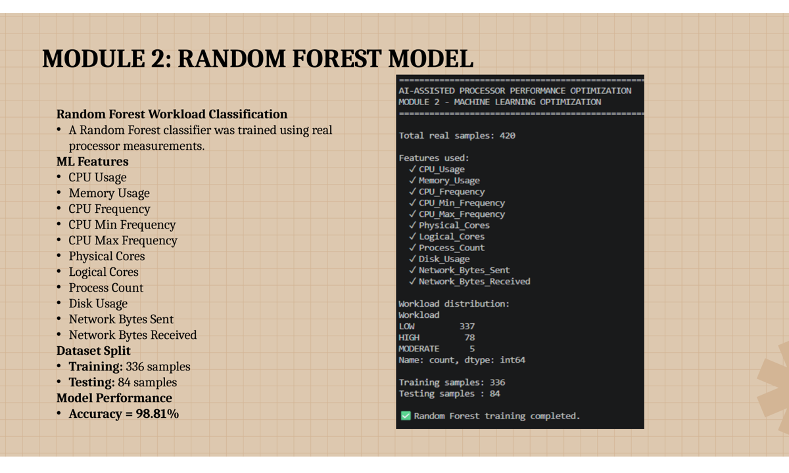
Figure 4.4: Random Forest model training and evaluation evidence.

4.3.2 Feature Importance

Feature importance was analysed to determine which measurements contributed most to workload classification. CPU Usage was identified as the most influential feature, while the remaining variables provided supporting information.
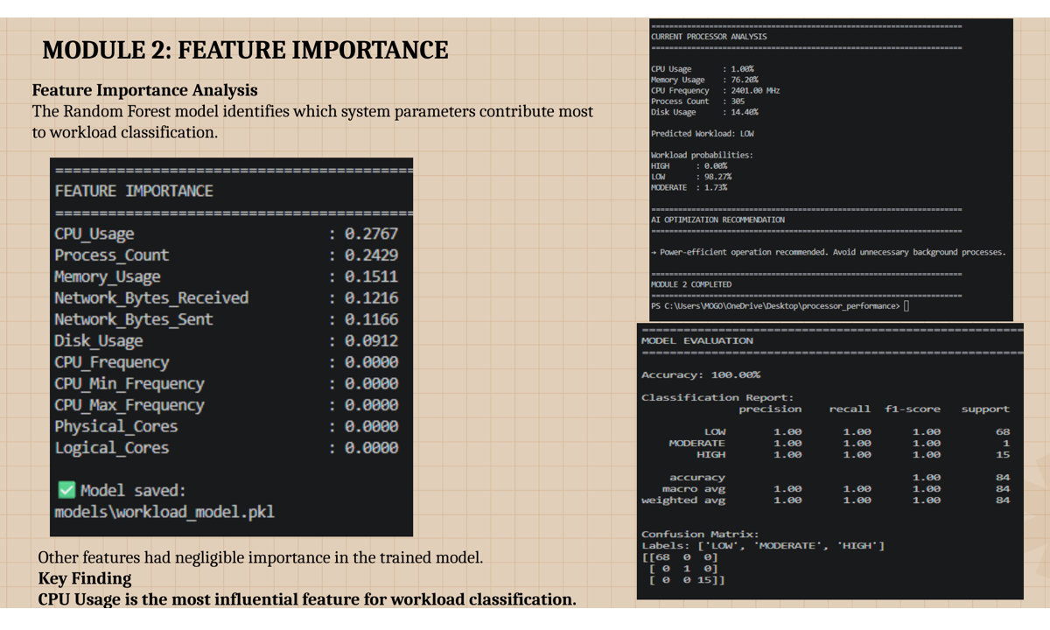
Figure 4.5: Feature importance analysis from the trained model.

4.4 Module 3 – AI Decision Engine

ai_engine.py loads the trained Random Forest, collects current system measurements, predicts workload and estimates confidence. The decision engine maps the prediction to an operating mode and recommendation.

Figure 4.6: AI decision engine integration and execution evidence.
Prediction | AI Mode | Typical Action
LOW | POWER_EFFICIENT | MONITOR / reduce unnecessary background activity
MODERATE | BALANCED | BALANCE resource usage
HIGH | PERFORMANCE | OPTIMIZE / prioritize performance
Critical CPU | ALERT | HIGH_CPU_ALERT
Critical memory | ALERT | MEMORY_ALERT

4.5 AI-Assisted Optimization and Optimized Test

optimizer.py performs a fixed-length experiment. Each cycle collects measurements, constructs the ML input, predicts workload and maps the prediction to an AI recommendation. The results are stored in reports/optimized_results.csv. The implementation deliberately leaves CPU voltage, BIOS settings, clock multipliers, firmware and hardware power limits unchanged.
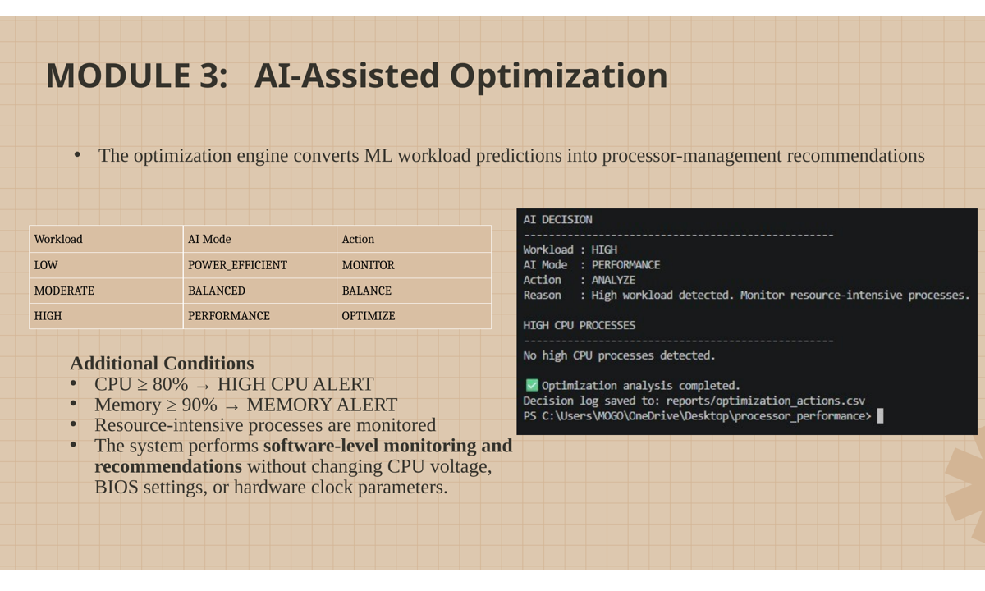
Figure 4.7: AI-assisted optimization execution evidence.
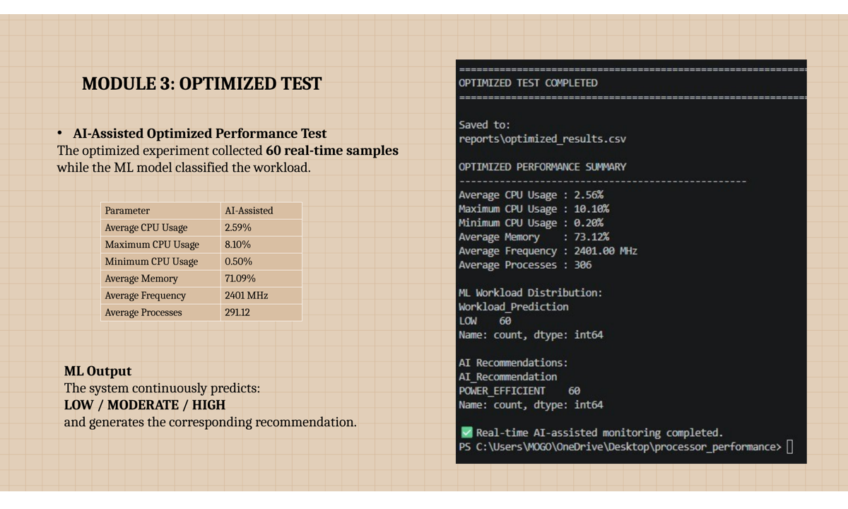
Figure 4.8: Optimized performance test and summary evidence.

4.6 Test Plan & Verification
Requirement | Test Method | Acceptance Criterion | Achieved | Status
Real-time monitoring | Run data_collection.py | Continuous measurements | 300 measurements | PASS
Dataset creation | Prepare dataset | Structured labelled data | 420 samples | PASS
ML classification | Train/evaluate RF | Workload classes | LOW/MOD/HIGH | PASS
Model accuracy | Evaluate test set | Quantitative result | 98.81% | PASS
AI engine | Run ai_engine.py | Decision for live samples | Workload + mode | PASS
Optimization | Run optimizer.py | Fixed-length live test | CSV generated | PASS
Comparison | Run compare.py | Baseline vs AI-assisted | CSV + graphs | PASS
Dashboard | Run Streamlit | Live visual interface | Operational | PASS
Logging | Inspect logs | Decision history | 224 records observed | PASS

4.7 Results
Parameter | Baseline | AI-Assisted | Change
Average CPU Usage | 2.64% | 2.59% | -1.83%
Maximum CPU Usage | 8.60% | 8.10% | -5.81%
Average Memory Usage | 73.35% | 71.09% | -3.09%
Average CPU Frequency | 2401.00 MHz | 2401.00 MHz | 0.00%
Average Process Count | 290.38 | 291.12 | +0.25%

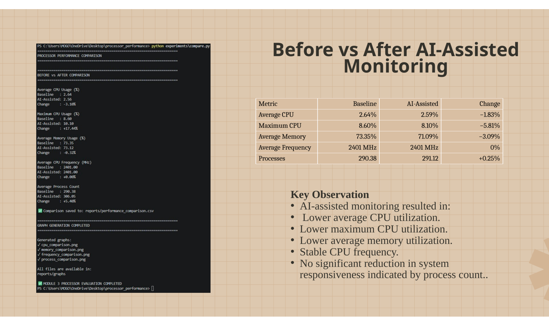
Figure 4.9: Before-versus-after AI-assisted monitoring comparison.

4.7.1 Performance Graphs

compare.py generated CPU, memory, frequency and process-count comparisons. These graphs provide visual evidence of the measured baseline and AI-assisted conditions.
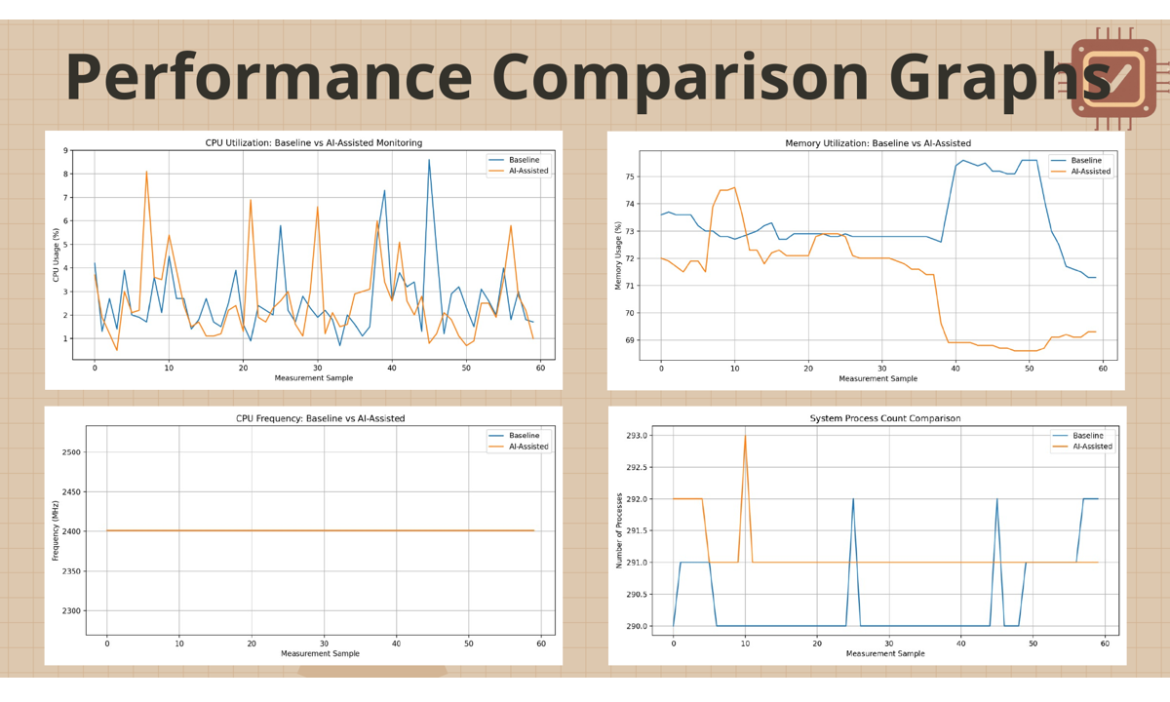
Figure 4.10: Performance comparison graphs generated by the project.

4.7.2 AI Dashboard

The Streamlit dashboard integrates real-time processor status, AI workload analysis, confidence, workload probabilities, recommendations, resource-intensive processes, performance graphs and decision logs.
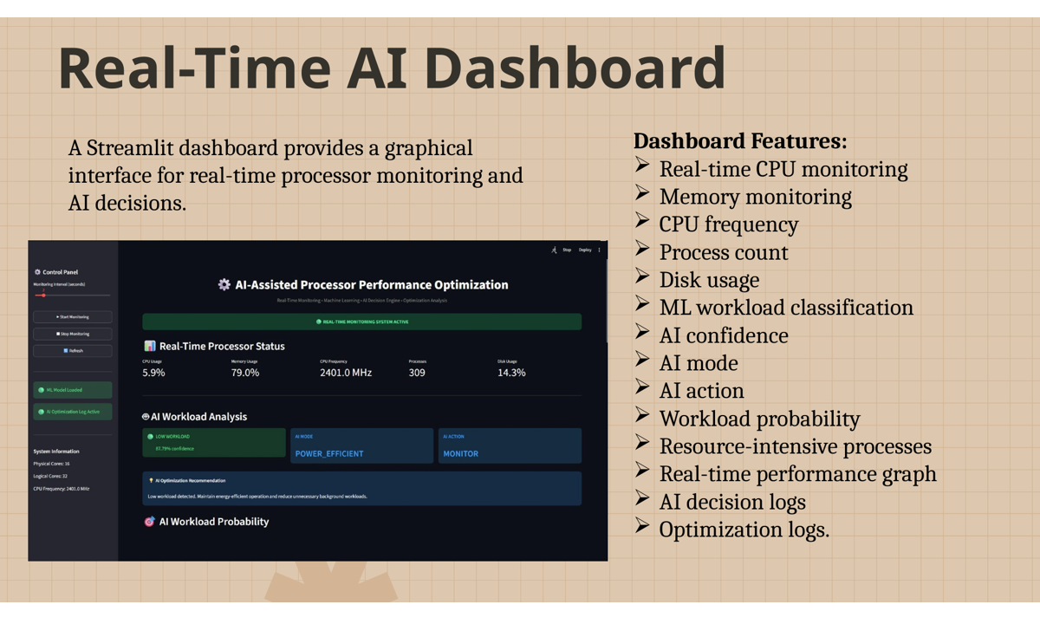
Figure 4.11: Final Streamlit AI dashboard developed for the project.

4.8 Data Analysis & Engineering Judgment

The 98.81% Random Forest accuracy indicates strong classification performance on the available test dataset, but accuracy alone does not guarantee balanced performance. The small number of MODERATE samples means further balanced data collection is recommended.
Average CPU usage changed by 0.05 percentage points and average memory usage changed by 2.26 percentage points. Processor frequency remained approximately 2401 MHz, so the observed differences were not produced by an intentional frequency change. Because electrical power was not measured, the results should be described as system-utilization improvements rather than measured energy savings.
The analysed AI decision log contained 224 recorded samples. The project analysis observed 102 LOW and 43 HIGH predictions, with MONITOR, OPTIMIZE and MEMORY_ALERT actions among the recorded decisions. This demonstrates that the decision layer responds to varying system conditions.

4.9 Comparison with Existing Solutions & Objective Achievement
Objective | Evidence | Achievement
Real-time data | data_collection.py + 300 measurements | Fully
Workload dataset | 420 samples | Fully
ML model | Random Forest + model file | Fully
Workload classification | LOW/MOD/HIGH | Fully
AI decision engine | Mode/action/recommendation | Fully
Optimization experiment | optimizer.py | Fully
Performance comparison | CSV + graphs | Fully
Dashboard | Streamlit + Plotly | Fully
Direct power optimization | No direct power sensor/hardware control | Partially / outside scope

4.10 Strengths & Limitations
Strengths: real measurements; integrated monitoring, ML, decision logic and visualization; traceable CSV logs; safe software-level boundary; user-friendly dashboard.
Limitations: class imbalance; background-process variation; no direct power/temperature measurement; recommendations do not modify hardware; validation is based on one Windows test environment.

4.11 Project Planning, Roles & Budget
Phase | Activity | Status
1 | Problem definition and literature review | Completed
2 | Data collection and baseline | Completed
3 | Dataset preparation | Completed
4 | Random Forest model | Completed
5 | AI decision engine | Completed
6 | Optimization experiment | Completed
7 | Comparison and graphs | Completed
8 | Dashboard integration | Completed
9 | Documentation and presentation | Completed

Member | Primary Role | Supporting Activities
R. Mohanram | System integration/dashboard | Monitoring, AI engine, debugging, presentation
P. Logesh | ML and dataset | Model evaluation, feature analysis
S. Mohamed Jilan | Optimization/evaluation | Testing, comparison, graphs, report

Item | Estimated Cost | Actual Cost
Existing computer | ₹0 additional | ₹0 additional
Python/open-source libraries | ₹0 | ₹0
Streamlit/Plotly | ₹0 | ₹0
Printing/documentation | To be confirmed | To be confirmed
Software prototype total | ₹0 | ₹0

CHAPTER 5
CONCLUSION, FUTURE WORK AND REFLECTION

5.1 Conclusion

The project successfully demonstrates the integration of real-time processor monitoring, machine learning, AI decision-making and performance evaluation into one software prototype. The system collects processor and system parameters using psutil, prepares a structured workload dataset and trains a Random Forest classifier for LOW, MODERATE and HIGH workload conditions.
The model achieved 98.81% accuracy on the available test dataset. The AI decision engine translates the classification into POWER_EFFICIENT, BALANCED or PERFORMANCE recommendations and adds CPU and memory alerts. The baseline and AI-assisted experiments provided measurable comparison evidence, including average CPU utilization changing from 2.64% to 2.59% and average memory utilization changing from 73.35% to 71.09%.
The Streamlit dashboard makes the system easier to inspect by combining live metrics, workload prediction, confidence, recommendations, process information, graphs and logs. Overall, the project demonstrates that machine learning can complement conventional processor monitoring by adding an interpretable decision layer.

5.2 Future Work

- Collect a larger and balanced dataset, especially for MODERATE workloads.
- Add direct temperature and power/energy measurements where hardware support is available.
- Evaluate Gradient Boosting, XGBoost or lightweight neural models.
- Use time-window features to learn workload transitions.
- Validate on multiple processor architectures and operating systems.
- Consider controlled hardware-management only after platform-specific safety validation.
- Add long-term trend analysis and exportable reports.
- Investigate reinforcement learning for controlled adaptive resource management.

5.3 Professional Learning & Individual Reflection

New knowledge acquired included real-time monitoring with psutil, tabular ML using Scikit-learn, Random Forest feature importance, CSV experiment logging, Streamlit/Plotly visualization, debugging and engineering interpretation of experimental results.
R. Mohanram: The most difficult task was integrating monitoring, machine learning and the dashboard into a reliable workflow. Debugging model loading, file paths and live data improved my system-integration skills.
P. Logesh: The ML stage provided practical experience in preparing system measurements for classification and evaluating feature importance. I learned that dataset balance is important even when overall accuracy is high.
S. Mohamed Jilan: The comparison stage improved my ability to support engineering claims with measured evidence. I learned to interpret graphs, compare baseline and AI-assisted conditions and report limitations honestly.

REFERENCES
[1] L. Breiman, “Random forests,” Machine Learning, vol. 45, no. 1, pp. 5–32, Oct. 2001, doi: 10.1023/A:1010933404324.
[2] A. Fouman Ajirlou and I. Partin-Vaisband, “A Unified Learning Platform for Dynamic Frequency Scaling in Pipelined Processors,” arXiv:2006.07450, 2020.
[3] “EClass: An execution classification approach to improving the energy-efficiency of software via machine learning,” Journal of Systems and Software, vol. 85, no. 4, pp. 960–973, 2012.
[4] “Dynamic Frequency Scaling of a Single-Core Processor Using Machine Learning Paradigms,” The Computer Journal, vol. 65, no. 3, pp. 631–654, 2022, doi: 10.1093/comjnl/bxaa092.
[5] W. Yang and S. Xia, “PELM: Power Efficient On-Device LLM Inference with Speculative Decoding and Dynamic Voltage Frequency Scaling,” Proc. 2026 ACM/IEEE International Conference on Embedded Artificial Intelligence and Sensing Systems, pp. 438–451, 2026.
[6] psutil Developers, “psutil documentation: Python system and process utilities,” 2026.
[7] Scikit-learn Developers, “RandomForestClassifier Documentation,” 2026.
[8] Python Software Foundation, “Python 3 Documentation,” 2026.
[9] W. McKinney, Python for Data Analysis, 3rd ed. Sebastopol, CA, USA: O’Reilly Media, 2022.
[10] A. Géron, Hands-On Machine Learning with Scikit-Learn, Keras, and TensorFlow, 3rd ed. Sebastopol, CA, USA: O’Reilly Media, 2022.
[11] Plotly Technologies Inc., “Plotly Python Open Source Graphing Library,” 2026.
[12] Streamlit, “Streamlit Documentation: Build and deploy data apps,” 2026.
[13] NumPy Developers, “NumPy Documentation,” 2026.
[14] Pandas Development Team, “Pandas Documentation,” 2026.
[15] Joblib Developers, “Joblib: Computing Tools for Python,” 2026.

Software / AI-Assisted Resource Acknowledgement
The project uses open-source software libraries and official documentation. Python, psutil, Pandas, NumPy, Scikit-learn, Joblib, Plotly and Streamlit are acknowledged as implementation resources. AI-assisted drafting was used as a writing aid during report preparation; the team remains responsible for verifying all project-specific data, screenshots and claims.

APPENDICES

Appendix A – Detailed Calculations
Percentage change = ((AI-Assisted − Baseline) / Baseline) × 100.
Average CPU: ((2.59 − 2.64) / 2.64) × 100 ≈ −1.83%. Maximum CPU: ((8.10 − 8.60) / 8.60) × 100 ≈ −5.81%. Average memory: ((71.09 − 73.35) / 73.35) × 100 ≈ −3.09%.

Appendix B – Source Code / Repository Information
File | Purpose
data_collection.py | Real-time processor data collection
prepare_dataset.py | Dataset preparation
model.py | Random Forest training/evaluation
ai_engine.py | Real-time AI prediction and decision engine
optimizer.py | AI-assisted optimization experiment
optimized.py | Optimized performance test
experiments/compare.py | Baseline/AI-assisted comparison and graphs
dashboard.py | Streamlit dashboard
reports/*.csv | Experimental and AI decision logs

Appendix C – Experimental / Raw Data
The project stores outputs in baseline_results.csv, optimized_results.csv, performance_comparison.csv, ai_decision_log.csv and optimization_actions.csv. These files provide traceability for the numerical results reported in Chapter 4.

Appendix D – Ethics / Safety
No human subjects, biometric data or medical data were used. The prototype operates on local system-performance information and does not perform uncontrolled hardware modification.

Appendix E – Evidence Screenshots
The figures in Chapter 4 are project-specific evidence extracted from the developed presentation and show the actual data-collection, model-training, AI-engine, optimization, comparison and dashboard workflow.

Appendix F – User / Industry Feedback
No formal external industry feedback was collected for this academic prototype. Evaluation was performed through technical execution, experimental evidence, dashboard demonstration and faculty-oriented presentation.

Appendix G – Publications / Patents / Competitions / Product Outcomes
No publication, patent or commercial product outcome is claimed. The primary outcome is a functional academic software prototype and its documentation.

Appendix H – Individual Contribution Evidence
Individual contribution is documented in the contribution statement and supported by the source-code modules, execution logs, dashboard implementation, graphs and analysis files.

CAPSTONE PROJECT OUTCOME MAPPING SHEET
The mapping below identifies the evidence location for the engineering outcomes; final assessment remains with the department/faculty assessor.
Outcome / Area | Evidence | Report Location
Complex engineering problem formulation | Dynamic workload and interacting system parameters | Ch.1, Ch.2
Engineering design under constraints | Requirements, alternatives, architecture, safety | Ch.3
Written/oral communication | Technical report and presentation evidence | Whole report + Viva
Ethics and professional responsibility | Transparent limitations and safe design | Ch.3.7, Declaration
Teamwork and leadership | Roles and contribution statement | Ch.4.11, Contribution
Experimentation and engineering judgment | Baseline, optimized test, comparison | Ch.4.6–4.9
Independent learning | ML, monitoring, dashboard, debugging | Ch.5.3
Standards / technical conventions | IEEE references and software acknowledgement | Ch.3.2, References
Sustainability / societal impact | Energy-efficiency motivation and bounded claims | Ch.3.7, Ch.5
Risk assessment and mitigation | Risk register and safety boundary | Ch.3.7
Security considerations | Local monitoring and no uncontrolled external control | Ch.3.7
Integrated/system-level engineering | Monitoring → ML → decision → dashboard | Ch.3.5
Project planning and management | Milestones, roles and budget | Ch.4.11
Individual contribution | Contribution table and reflections | Contribution + Ch.5.3

