SIMATS ENGINEERING
ASSESSMENT TOOL 2: Industry Problem Solving Task

COURSE NAME: | Cloud Computing and Big Data Analytics | COURSE CODE: | CSA15

COURSE OUTCOME COVERED
CO4: Analyze big data characteristics and challenges across domains including security and application aspects. (BL4)
Assessment Tool Weightage: 20%

Dave's Taxonomy: Articulation (Level 4)  Question Count: 5 | Total Marks: 40

Code of Conduct
I __R.MOHANRAM/192521118__ (Name / Reg No) certify that this submission is my original work and that I have adhered to the guidelines specified for this assessment.
I understand that any violation of academic integrity rules will result in disciplinary action.
Signature of the student: __mohanram__

Assessment Tasks
Industry Problem Solving Task
- An e-commerce company receives clickstream, transaction, and review data from millions of users daily. Propose a big data analytics pipeline and explain how the 5Vs influence architecture design.

E-Commerce Big Data Analytics Pipeline
An e-commerce company receives clickstream data, transaction data, and customer reviews from millions of users every day. Such a system requires a distributed big data architecture capable of collecting, storing, processing, and analyzing high-volume and high-speed data.
Proposed Big Data Pipeline
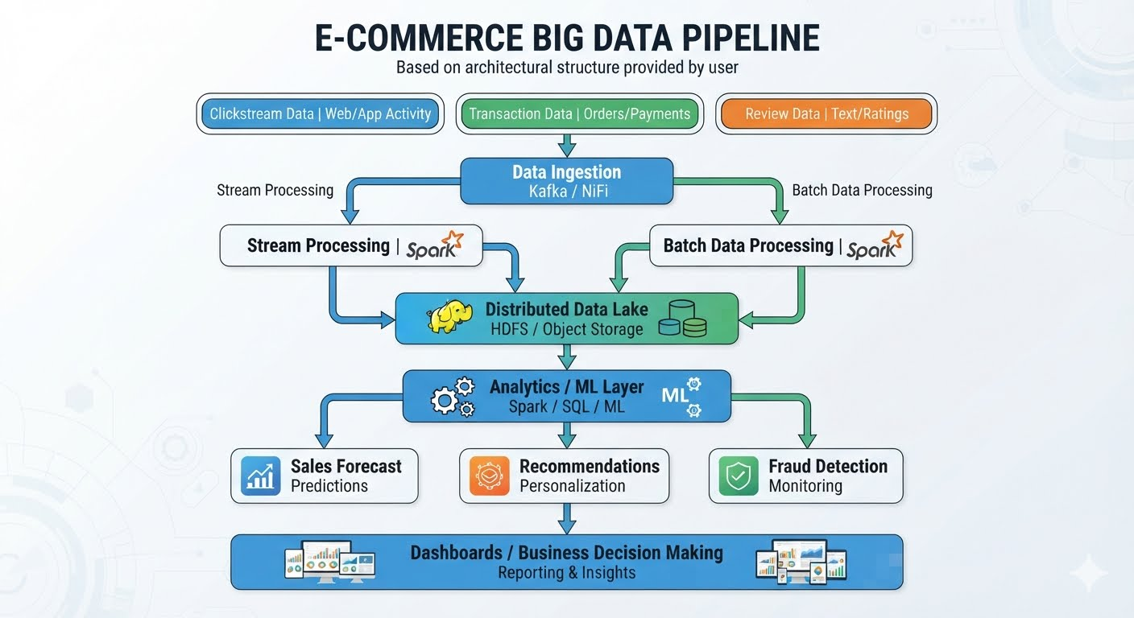
2. Data Sources
Clickstream Data
Generated when customers interact with the website or mobile application.
Examples:
Page views
Product searches
Clicks
Time spent
Cart additions
Product views
This data is usually high-volume and high-velocity.
Transaction Data
Includes:
Orders
Payments
Returns
Discounts
Purchase amounts
This data is generally structured and requires strong consistency and security.
Review Data
Includes:
Text reviews
Star ratings
Images
Customer feedback
Reviews introduce semi-structured and unstructured data into the platform.

3. Data Ingestion Layer
An ingestion layer collects data from all sources.
Technologies such as Apache Kafka can be used for high-speed event ingestion, while tools such as Apache NiFi can help integrate data from multiple sources.
Website/App ─┐
Transactions ├──→ Ingestion Layer ──→ Big Data Platform
Reviews ─────┘
The ingestion layer should support:
High throughput
Fault tolerance
Real-time streaming
Multiple data sources

4. Storage Layer
A distributed data lake using HDFS or cloud object storage can store the incoming data.
A suitable organization could be:
data-lake/
│
├── clickstream/
├── transactions/
├── reviews/
└── processed-data/
Raw data can be retained while cleaned and transformed datasets are stored separately.
This approach supports both batch and streaming analytics.

5. Processing Layer
Stream Processing
Real-time processing can be used for:
Fraud detection
Live recommendation updates
Real-time product popularity
Cart-abandonment analysis
Example:
Click Event
↓
Kafka
↓
Spark Streaming
↓
Real-time Analysis
Batch Processing
Batch processing is useful for:
Daily sales reports
Customer segmentation
Historical trend analysis
Monthly revenue analysis
Technologies such as Apache Spark can process large datasets in parallel.

6. Analytics Layer
The processed data can be analyzed using SQL, machine learning, and statistical techniques.
Applications
Recommendation system
Browsing History
+
Purchase History
+
Reviews
↓
Recommendation Model
↓
Personalized Products
Fraud detection
Transactions
↓
Analytics/ML
↓
Suspicious Pattern
↓
Fraud Alert
Demand prediction
Historical Sales
+
Clickstream
+
Seasonal Trends
↓
Prediction Model
↓
Future Demand

7. How the 5Vs Influence Architecture Design
The 5Vs—Volume, Velocity, Variety, Veracity, and Value—directly influence the architecture.
5V | E-Commerce Example | Architecture Impact
Volume | Millions of clicks and transactions | Distributed storage and parallel processing
Velocity | Continuous clicks and transactions | Streaming ingestion and real-time processing
Variety | Tables, JSON, reviews, images, logs | Data lake and flexible schemas
Veracity | Duplicate/inaccurate reviews or incomplete data | Data cleansing, validation and governance
Value | Recommendations, fraud detection, sales insights | Analytics, ML and visualization layer

8. Volume
The company receives data from millions of users every day, creating very large datasets.
Architectural requirement
A single server may become a bottleneck.
Therefore:
Large Data
↓
Distributed Storage
↓
Multiple Processing Nodes
The architecture should support horizontal scaling by adding nodes as data grows.

9. Velocity
Clickstream events and transactions arrive continuously and sometimes need immediate analysis.
Architectural requirement
The system needs a streaming pipeline:
User Activity
↓
Kafka
↓
Stream Processing
↓
Real-Time Insights
This is important for applications such as fraud detection and real-time recommendations.

10. Variety
The company handles multiple data formats:
Transaction → Structured
Clickstream → Semi-structured
Reviews → Unstructured / Semi-structured
Images → Unstructured
Architectural requirement
A flexible data lake is suitable because it can retain different data types before transformation.

11. Veracity
Not all collected data is perfectly reliable.
Examples:
Duplicate transactions
Missing customer fields
Fake/spam reviews
Incorrect product information
Incomplete clickstream records
Architectural requirement
The pipeline should include:
Raw Data
↓
Validation
↓
Cleaning
↓
Deduplication
↓
Trusted Dataset
Data quality monitoring and governance are therefore important.

12. Value
The ultimate purpose of collecting huge amounts of data is to generate useful business outcomes.
The company can derive:
Personalized recommendations
Fraud detection
Demand forecasting
Customer segmentation
Dynamic marketing
Inventory optimization
Thus, the architecture must not only store data but also provide analytics and machine-learning capabilities.

13. Security Considerations
Because transaction data and customer information are sensitive, security should be included throughout the pipeline.
Authentication and Authorization
Use IAM/RBAC to ensure only authorized users and services can access data.
Encryption
Encrypt data at rest.
Encrypt data in transit using TLS.
Data Privacy
Sensitive customer information should be masked or anonymized where appropriate.
Monitoring and Auditing
Maintain logs of data access and administrative activities.

14. Final Recommended Architecture
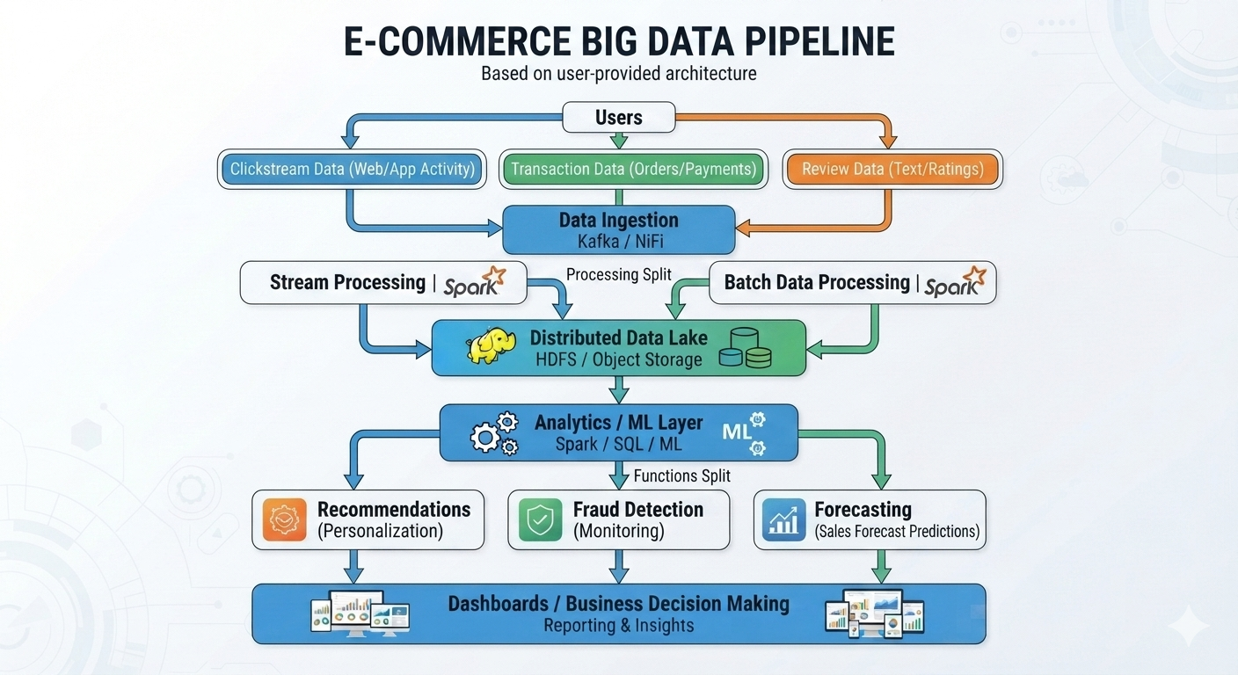Conclusion
For an e-commerce company handling millions of daily events, a distributed, cloud-based big data pipeline is required. Data should be ingested through scalable streaming systems, stored in distributed object storage or HDFS, processed using batch and stream analytics, and analyzed using SQL and machine learning.
The 5Vs determine the architecture: Volume requires distributed scaling, Velocity requires real-time processing, Variety requires flexible storage, Veracity requires data-quality controls, and Value requires analytics and ML. This architecture enables the company to turn massive customer and transaction data into useful insights for recommendation, fraud detection, forecasting, and business decision-making.

- A healthcare organization collects structured patient records, semi-structured insurance claims, and unstructured medical images. Design an approach to manage and secure this data ecosystem.

Secure Big Data Ecosystem for a Healthcare Organization
A healthcare organization handles different forms of sensitive information: structured patient records, semi-structured insurance claims, and unstructured medical images. The recommended solution is a secure healthcare data lake architecture with separate storage, processing, governance, and security controls.
1. Proposed Architecture
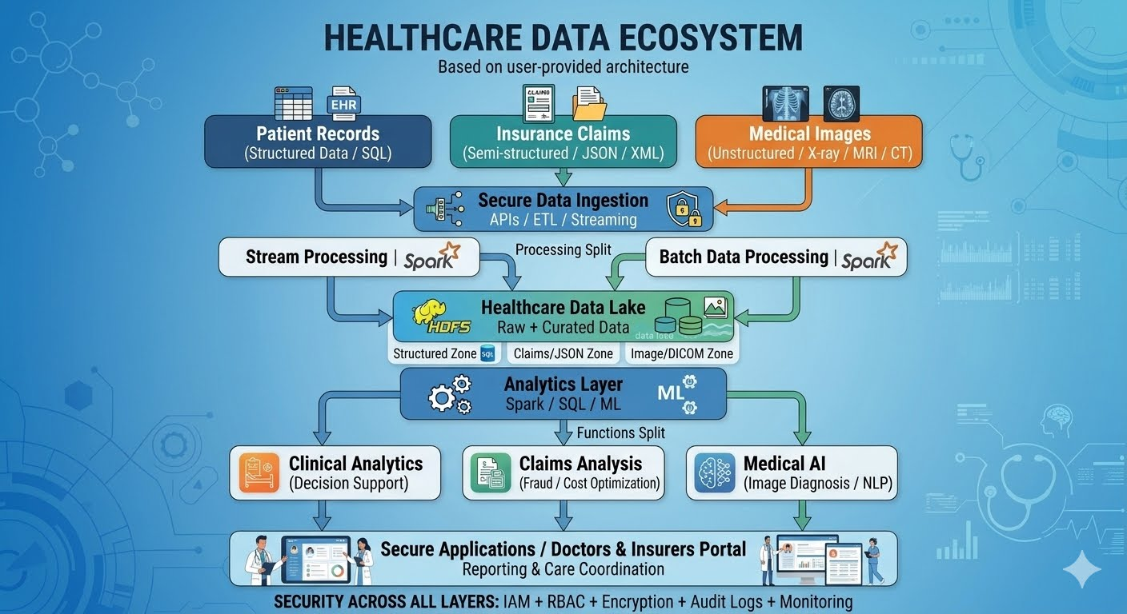
2. Data Classification and Storage
A. Structured Patient Records
Examples:
Patient ID
Name
Age
Diagnosis
Medication
Lab results
These can be stored in a relational or managed database because they have a defined schema.
Patient_ID | Diagnosis | Blood_Group | Result
101 | Diabetes | O+ | Normal
B. Semi-Structured Insurance Claims
Claims may arrive as JSON, XML, or similar records.
Example:
{
"claim_id": "CL1001",
"patient_id": "101",
"amount": 25000,
"status": "Approved"
}
These are well suited to a data lake/object storage or document-oriented systems because their fields can vary between records.
C. Unstructured Medical Images
Examples:
X-ray
CT scans
MRI scans
Ultrasound images
Medical images can be stored as image objects, commonly using DICOM-compatible workflows.
medical-images/
├── patient-101/
│ ├── xray.dcm
│ └── ct.dcm
└── patient-102/
└── mri.dcm
Object storage is suitable for large image collections because it scales independently from the compute layer.

3. Secure Data Ingestion
Data can come from:
Hospital information systems
Electronic health records
Insurance companies
Medical devices
Imaging systems
A secure ingestion layer should validate and transfer the data before it enters the analytics environment.
Hospital System
|
Insurance System ----> Secure Ingestion ----> Data Lake
|
Imaging System
Use:
APIs
ETL/ELT pipelines
Secure file transfer
Streaming where real-time processing is required
Data should be validated and checked for malformed or duplicate records before entering curated datasets.

4. Data Lake Organization
A useful design is to separate raw, processed, and trusted information.
Healthcare Data Lake
│
├── Raw Zone
│ ├── Patient Data
│ ├── Claims
│ └── Medical Images
│
├── Curated Zone
│ ├── Cleaned Patient Data
│ ├── Validated Claims
│ └── Indexed Images
│
└── Analytics Zone
├── Clinical Datasets
├── Claims Analytics
└── ML Datasets
This separation makes data processing, auditing, and access control easier.

5. Security Design
Healthcare information is highly sensitive, so security should be implemented at every layer.
A. Identity and Access Management
Use IAM and role-based access control (RBAC).
Different users receive different permissions:
User | Access
Doctor | Assigned patient clinical data
Radiologist | Relevant medical images
Insurance Staff | Authorized claims data
Data Scientist | Approved/anonymized datasets
Administrator | Infrastructure management
The principle of least privilege should be applied.

B. Authentication
Use strong authentication such as:
Multi-factor authentication
Federated identity
Role-based authorization
For example:
User
↓
MFA
↓
Identity Provider
↓
Role Verification
↓
Authorized Healthcare Data

6. Encryption
Data in Transit
Use TLS/HTTPS when transferring:
Patient records
Insurance claims
Medical images
Hospital → TLS → Cloud
Data at Rest
Encrypt:
Databases
Object storage
Backup copies
Medical images
Use a managed Key Management Service (KMS) or equivalent key-management system.
Keys should be securely controlled and rotated according to organizational policy.

7. Data Privacy
Personally identifiable information and protected health information should be protected through:
Data Masking
Hide unnecessary fields from users who do not need them.
Pseudonymization
Replace direct identifiers with pseudonymous IDs for analytics.
Anonymization
Remove identifying information when creating datasets for appropriate research or analytics use.
For example:
Clinical Database
↓
Remove / transform identifiers
↓
De-identified Analytics Dataset
↓
Research / ML
This reduces unnecessary exposure of patient identity.

8. Audit Logging and Monitoring
Every sensitive access should be auditable.
The system should record:
Who accessed data
Which patient record was accessed
What operation was performed
When it occurred
Whether access succeeded or failed
Example:
Doctor A
↓
Viewed Patient 101
↓
Audit Log
↓
Timestamp + User + Resource + Action
Monitoring can detect unusual activity such as:
Repeated failed logins
Large-scale data downloads
Access outside normal working patterns
Unauthorized attempts to view records

9. Backup and Disaster Recovery
Healthcare data must remain recoverable.
Use:
Automated backups
Database snapshots
Object-storage versioning
Replication across appropriate locations
Disaster recovery procedures
Example:
Primary Data
↓
Backup
↓
Replicated Storage
↓
Recovery Environment
Medical images and patient records should have carefully defined RPO and RTO based on clinical requirements.

10. Data Governance
A healthcare data ecosystem should have clear rules for:
Data ownership
Retention periods
Classification
Access approval
Data quality
Data deletion
Regulatory compliance
A metadata/catalog system can help identify:
Dataset → Owner → Sensitivity → Location → Retention → Allowed Users

11. Processing and Analytics
After securing and cleaning the data, the organization can use distributed analytics.
Clinical Analytics
Patient Records + Lab Results
↓
Big Data Analytics
↓
Clinical Insights
Claims Analytics
Claims
↓
Pattern Analysis
↓
Fraud / Cost Detection
Medical Imaging
MRI / CT / X-ray
↓
Image Processing / AI
↓
Assistance for Clinical Interpretation
Sensitive analytics should operate only on appropriately authorized data.

12. Expected Benefits
Scalability
The organization can store growing numbers of patient records, claims, and images without redesigning the entire platform.
Security
IAM, encryption, monitoring, and auditing protect sensitive healthcare data.
Better Data Integration
Different formats can be managed within a unified data ecosystem.
Analytics
Clinical, operational, and insurance datasets can be analyzed together while maintaining appropriate access controls.
Availability
Redundancy and backups reduce the impact of infrastructure failures.

13. Recommended End-to-End Flow
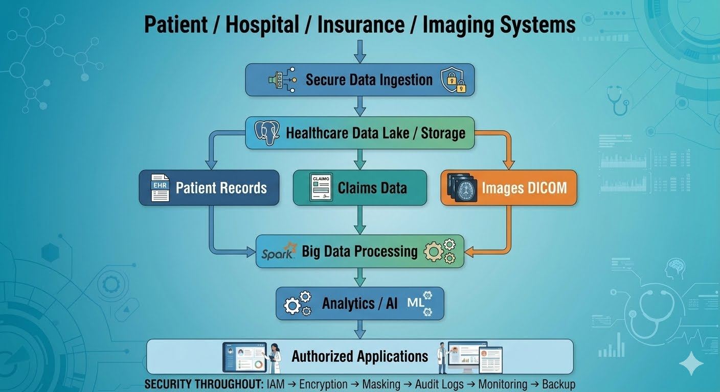
SECURITY THROUGHOUT:
IAM → Encryption → Masking → Audit Logs → Monitoring → Backup
Conclusion
The healthcare organization should use a secure, distributed data-lake architecture that handles structured patient records, semi-structured insurance claims, and unstructured medical images according to their data characteristics. Structured records can use managed databases, while claims and large medical-image collections can be handled efficiently through scalable object storage and data-lake technologies.
Security must be implemented end-to-end using RBAC/IAM, MFA, encryption, data masking or pseudonymization, audit logging, monitoring, backups, and governance controls. This approach provides a scalable foundation for healthcare analytics while protecting sensitive patient information and supporting regulatory and organizational requirements.

- A telecom company wants to detect churn patterns using high-volume customer interaction data. Identify the big data challenges and recommend suitable analytics and integration strategies.

Telecom Customer Churn Prediction Using Big Data Analytics
A telecom company generates very large amounts of customer interaction data from call records, SMS usage, mobile data, recharge history, complaints, customer-service interactions, and network usage. The company wants to identify customers who are likely to leave the service, known as customer churn.
A big-data-based churn analytics platform can combine these sources, process them at scale, and use machine-learning models to identify high-risk customers.

1. Major Big Data Challenges
A. High Volume of Data
A telecom operator can generate millions of records from:
Call Detail Records (CDRs)
Internet usage
SMS activity
Recharge transactions
Customer complaints
App/web interactions
Network events
A conventional single-server database may become difficult to scale.
Solution
Use distributed cloud storage/object storage or HDFS and distributed processing such as Apache Spark.
Millions of Records
↓
Distributed Storage
↓
Parallel Processing

B. High Velocity
Telecom data is generated continuously.
For example:
Call → Data session → Network event → Recharge → Complaint
Some churn signals need to be identified quickly.
Solution
Use streaming technologies such as Apache Kafka for ingestion and Spark Structured Streaming or equivalent stream-processing systems for near-real-time analysis.
Network Events
↓
Kafka
↓
Stream Processing
↓
Churn Risk Update

C. Data Variety
The company handles different types of data:
Data | Type
Customer/account records | Structured
Call records | Structured
JSON application events | Semi-structured
Customer complaints | Text/unstructured
Social-media feedback | Unstructured
Network logs | Semi-structured
Challenge
Different formats and schemas must be combined.
Solution
Use a data lake with schema-on-read capabilities and an integration layer.

D. Data Quality and Veracity
Telecom datasets may contain:
Missing customer information
Duplicate records
Incorrect timestamps
Inconsistent customer IDs
Failed or incomplete transactions
Poor-quality data can produce incorrect churn predictions.
Solution
Include a data-quality pipeline:
Raw Data
↓
Validation
↓
Cleaning
↓
Deduplication
↓
Standardization
↓
Trusted Dataset

E. Data Integration
Information may be stored in different systems:
CRM
Billing
Network
Recharge
Customer Support
Mobile App
Combining these systems into one customer view is a major challenge.
Solution
Use API/ETL or streaming integration tools to create a unified customer profile.

2. Recommended Big Data Architecture
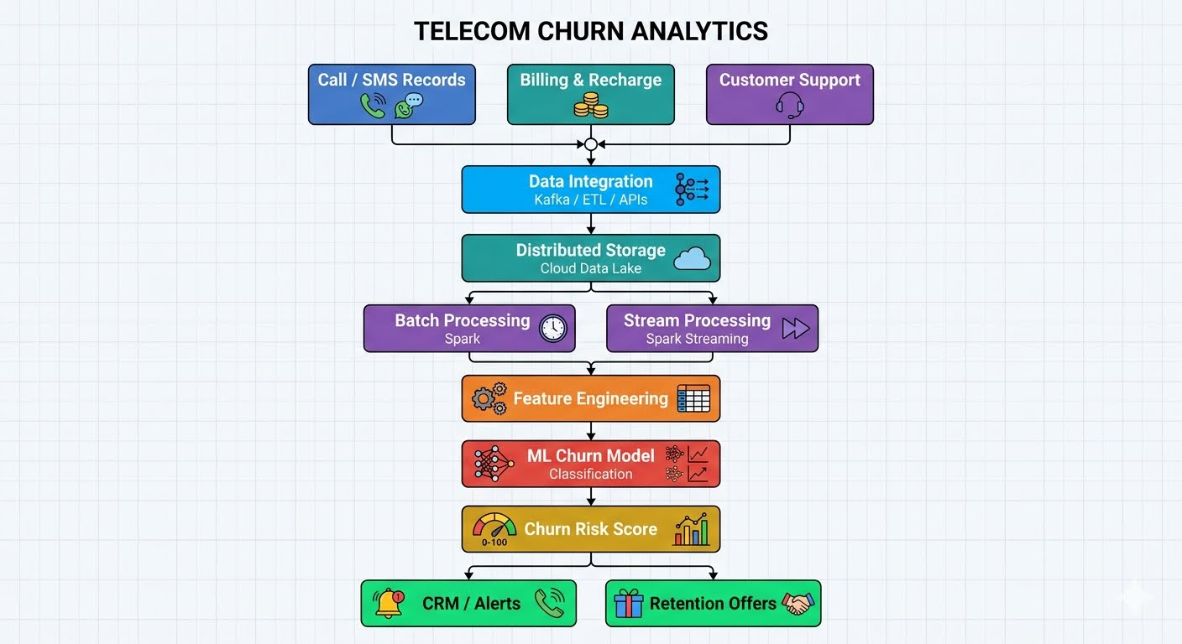
3. Data Integration Strategy
The first requirement is to combine information from multiple sources.
Source Systems
CRM
Billing
Network
Recharge
Customer Support
Mobile App
↓
Integration Layer
↓
Unified Customer Dataset
Integration Technologies
Apache Kafka can be used for continuous event ingestion.
Apache NiFi / ETL tools / APIs can be used to collect and transform data from databases and applications.
This allows the organization to create a unified profile such as:
Customer 101
---------------------------
Monthly usage : 120 GB
Calls : 340
Recharge frequency : Low
Complaints : 4
Network issues : High
Customer tenure : 8 months
These features can be used by the churn model.

4. Analytics Strategy
A. Descriptive Analytics
First, analyze historical churn patterns.
Questions include:
Which age groups churn most?
Which plans have high churn?
Does low usage correlate with churn?
Does poor network experience increase churn?
Example:
Historical Customer Data
↓
Aggregation
↓
Churn Pattern Report

B. Predictive Analytics
The main objective is to predict which customers are likely to churn.
Machine-learning models such as:
Logistic Regression
Decision Trees
Random Forest
Gradient-boosting models
can be trained using historical labeled data.
Example:
Customer Features
↓
ML Churn Model
↓
Probability of Churn
↓
High / Medium / Low Risk
Example:
Customer 101 → 0.82 → High Risk
Customer 102 → 0.25 → Low Risk
Customer 103 → 0.67 → Medium Risk

5. Feature Engineering
Useful churn features include:
Usage Features
Monthly data usage
Number of calls
SMS frequency
Average call duration
Financial Features
Recharge frequency
Monthly spending
Payment failures
Service Features
Number of complaints
Network-quality issues
Customer-service interactions
Behavioral Features
Declining usage over time
Reduced app activity
Plan changes
The data-processing platform can calculate these features automatically.

6. Real-Time Churn Detection
For high-value customers, the company may want near-real-time detection.
Example:
Customer's usage suddenly drops
↓
Network problems detected
↓
Complaint submitted
↓
Streaming Analytics
↓
Churn Risk Increased
↓
CRM Alert
The telecom company could then send an appropriate retention offer.

7. Handling Unstructured Customer Feedback
Customer complaints and reviews may contain text.
Natural Language Processing (NLP) can identify:
Negative sentiment
Network complaints
Billing complaints
Service dissatisfaction
Example:
"Network is very poor in my area"
↓
Sentiment Analysis
↓
Negative Feedback
↓
Churn Risk Feature
This can improve the predictive model beyond numerical usage data.

8. Model Evaluation
The model should not be evaluated only by accuracy because churn datasets can be imbalanced.
Useful measures include:
Precision
Recall
F1-score
ROC-AUC
For retention campaigns, recall can be important because missing a genuinely high-risk customer may mean losing that customer.

9. Security and Privacy Challenges
Telecom data contains sensitive customer information.
The platform should use:
Access Control
RBAC/IAM should restrict who can access customer information.
Encryption
Encrypt data in transit and at rest.
Data Masking
Hide unnecessary personal identifiers in analytics datasets.
Audit Logging
Record who accessed or modified sensitive information.
Data Governance
Define retention, access, and sharing policies.

10. Recommended Analytics Pipeline
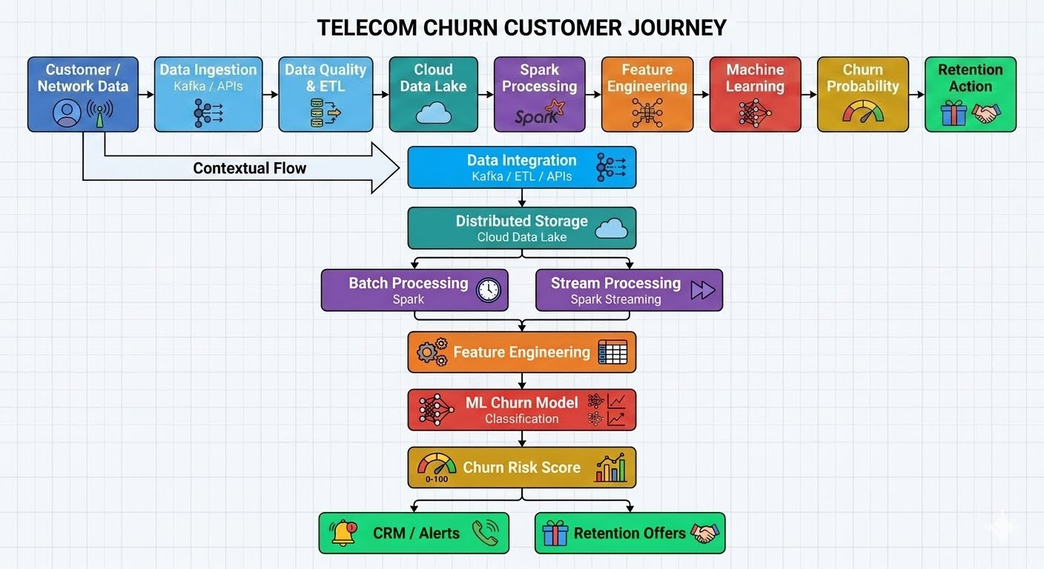
11. Benefits to the Telecom Company
Reduced Customer Loss
High-risk customers can be identified before they leave.
Personalized Offers
Retention offers can be targeted rather than sent to every customer.
Improved Customer Experience
Network and complaint patterns can be identified.
Operational Efficiency
Customer-service teams can prioritize high-risk cases.
Revenue Protection
Reducing churn helps protect recurring subscription revenue.

12. Challenge–Solution Summary
Big Data Challenge | Recommended Strategy
High volume | Distributed storage and Spark
High velocity | Kafka + stream processing
Data variety | Data lake + schema management
Poor data quality | Cleansing and validation
Data integration | Kafka, APIs, ETL
Large-scale ML | Distributed model training/processing
Sensitive customer data | Encryption + IAM + masking
Real-time churn detection | Streaming analytics
Conclusion
The telecom company should implement a distributed churn analytics platform that integrates CRM, billing, network, recharge, and customer-interaction data into a cloud data lake. Kafka and API/ETL tools can handle data ingestion, while Spark can provide scalable batch and streaming analytics. Machine-learning models can then use engineered customer features to predict churn probability.
The combination of distributed storage, real-time integration, predictive analytics, NLP for customer feedback, and strong security controls allows the telecom company to identify churn patterns early and take targeted retention actions, turning large-scale customer data into measurable business value.

- A smart city project generates sensor streams from traffic, air quality, and surveillance systems. Explain how distributed file systems and data integration tools can support large-scale analysis.

Smart City Sensor Data Management and Large-Scale Analysis
A smart city continuously generates data from traffic sensors, air-quality sensors, surveillance cameras, parking systems, and other IoT devices. Since the data is produced at high volume and velocity, a distributed storage and integration architecture is required.
1. Proposed Architecture
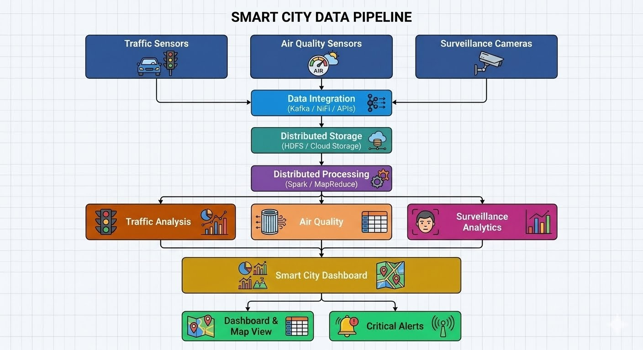
2. Role of Distributed File Systems
A Distributed File System (DFS) stores large datasets across multiple machines instead of depending on a single server.
A common example is HDFS. In a cloud environment, distributed object storage can provide a similar large-scale storage foundation.
How it works
Suppose the city generates a very large surveillance video file.
Large File
↓
Split into Blocks
↓
+--------+--------+--------+
| Node 1 | Node 2 | Node 3 |
| Block A| Block B| Block C|
+--------+--------+--------+
The blocks can be distributed across multiple storage nodes.
Benefits
1. Scalability
More storage nodes can be added as sensor data increases.
2. Fault tolerance
Data can be replicated so that failure of one node does not result in data loss.
3. High-throughput processing
Multiple nodes can read different blocks simultaneously.
4. Large-file support
Suitable for large surveillance videos, sensor histories, and log datasets.

3. Role of Data Integration Tools
Smart-city data comes from many different systems and formats.
Traffic → JSON / sensor records
Air Quality → CSV / IoT messages
Cameras → Video / metadata
Data integration tools collect, transform, and move this information into a common analytics platform.
Examples include:
Apache Kafka – high-throughput event and stream ingestion
Apache NiFi – data-flow management and integration
APIs and ETL/ELT tools – connecting applications and databases
Integration Flow
Traffic Sensors ─┐
Air Sensors ─────┼──→ Kafka / NiFi ──→ Data Lake
Cameras ─────────┘

4. Real-Time Sensor Integration
For traffic monitoring, data may need to be processed immediately.
For example:
Traffic Sensor
↓
Kafka
↓
Stream Processing
↓
Traffic Congestion Detected
↓
Alert / Signal Control
Kafka can buffer and distribute incoming events, while a stream-processing engine such as Spark Structured Streaming can analyze them.

5. Batch Data Integration
Not every workload requires real-time processing.
Historical air-quality data can be processed periodically:
Sensor Data
↓
Distributed Storage
↓
Daily/Hourly Batch Processing
↓
Pollution Trend Analysis
This can help city administrators identify:
Pollution trends
Peak traffic periods
Long-term environmental changes

6. Combining Distributed Storage and Integration
The two technologies perform different but complementary roles.
Component | Main Role
Sensors | Generate data
Kafka/NiFi | Collect and integrate data
Distributed File System | Store large datasets
Spark/MapReduce | Process data in parallel
Analytics | Generate insights
Dashboard | Present results
The relationship is:
Data Sources
↓
Integration
↓
Distributed Storage
↓
Distributed Processing
↓
Analytics

7. Example: Traffic Analysis
Suppose thousands of traffic sensors continuously report vehicle counts.
Step 1: Data Generation
Sensor 1 → 100 vehicles
Sensor 2 → 150 vehicles
Sensor 3 → 210 vehicles
Step 2: Data Integration
Kafka collects the events.
Sensors
↓
Kafka Topics
↓
Traffic Data Stream
Step 3: Distributed Storage
Historical data is stored in HDFS or cloud storage.
Traffic Data
↓
Distributed Storage
↓
Multiple Nodes
Step 4: Processing
Spark processes the data in parallel.
Historical + Current Traffic Data
↓
Distributed Processing
↓
Congestion Prediction
Step 5: Result
The city dashboard can display:
Current Traffic: HIGH
Location: Junction A
Recommended Action: Increase green-light duration

8. Example: Air-Quality Analysis
Air-quality sensors can continuously report:
PM2.5
PM10
CO
NO₂
Temperature
Humidity
The integration pipeline collects these readings and stores them at scale.
Air Sensors
↓
Kafka
↓
Data Lake
↓
Spark Analytics
↓
Pollution Trends
↓
City Dashboard
The city can identify pollution hotspots and compare air quality across different time periods.

9. Surveillance Data
Surveillance systems produce particularly large volumes of video and image data.
Distributed/cloud storage can store the raw media, while metadata can be analyzed separately.
Camera
↓
Video + Metadata
↓
Storage
├── Video → Object/Distributed Storage
└── Metadata → Analytics Platform
Instead of transferring every raw video stream to a central processing system, edge processing can first extract useful events such as:
Vehicle detection
Crowd detection
Incident detection
Only relevant information can then be sent to the central analytics platform.

10. Security Considerations
Smart-city datasets may contain sensitive information, especially surveillance data.
The platform should use:
Authentication and authorization
Role-based access control
Encryption in transit and at rest
Audit logs
Data retention policies
Network security and segmentation
For example:
Camera Data
↓
Encrypted Transfer
↓
Secure Storage
↓
Authorized Analytics Only

11. Challenges and Solutions
Challenge | Solution
Huge sensor data volume | Distributed storage
Continuous data streams | Kafka/stream processing
Different data formats | NiFi/ETL/API integration
Hardware failure | Data replication
High processing requirements | Spark/parallel processing
Sensitive surveillance data | Encryption + IAM
Real-time decisions | Streaming analytics

12. Final Architecture
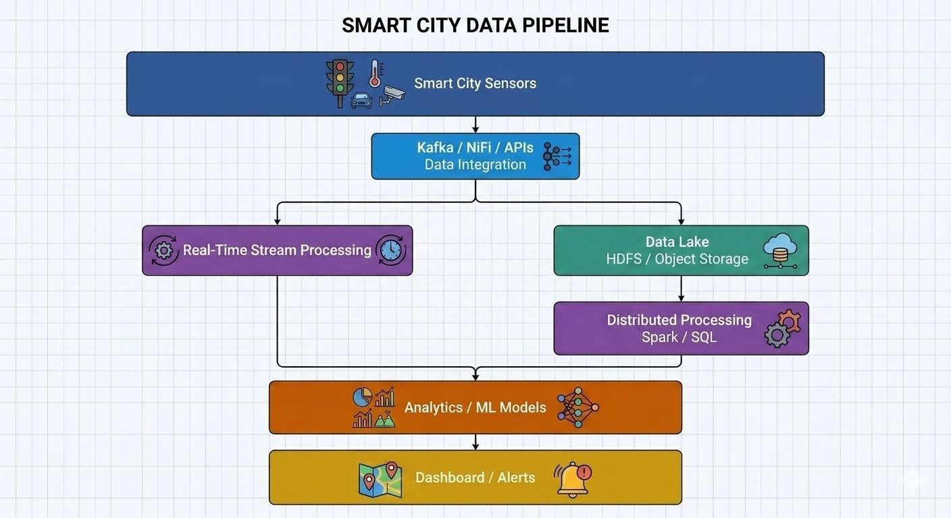Conclusion
A smart-city platform can use data integration tools such as Kafka and NiFi to collect and standardize continuous streams from traffic, air-quality, and surveillance systems. A distributed file system such as HDFS, or cloud object storage used as a data lake, provides scalable and fault-tolerant storage for the resulting large datasets.
Distributed processing frameworks such as Apache Spark can then process the data in parallel for real-time and historical analysis. Together, these technologies enable the city to handle high volume, high velocity, and diverse sensor data while supporting applications such as traffic optimization, pollution monitoring, and surveillance analytics.

- A financial analytics firm must comply with strict privacy requirements while processing high-velocity transaction data. Design a secure big data solution and justify the controls chosen.

CO4 – Industry Problem Solving Task
Case 5: Secure Big Data Solution for Financial Analytics
A financial analytics firm processes high-velocity transaction data while having to meet strict privacy and security requirements. The solution should therefore combine real-time data ingestion, distributed storage and processing, strong access control, encryption, privacy protection, and continuous monitoring.
1. Proposed Secure Architecture
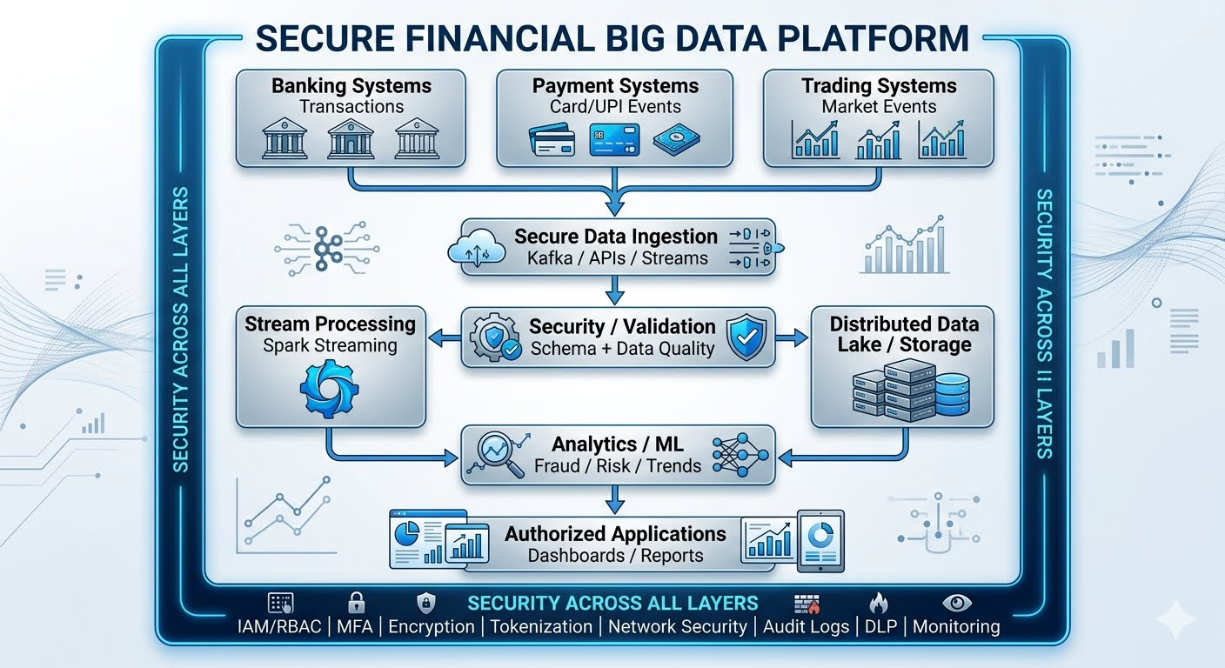
2. High-Velocity Data Ingestion
Financial transactions can arrive continuously at very high rates.
Examples:
Card transactions
Online transfers
UPI/payment events
ATM transactions
Trading events
A distributed streaming platform such as Apache Kafka can act as the ingestion layer.
Transaction
↓
Kafka Topic
↓
Stream Processing
↓
Fraud / Risk Analysis
Why Kafka/streaming?
It provides:
High-throughput ingestion
Distributed processing
Fault tolerance
Message buffering
Multiple consumers for different analytics applications

3. Data Validation and Quality
Before analytics, incoming transactions should be checked.
Example:
Raw Transaction
↓
Schema Validation
↓
Duplicate Check
↓
Data Quality Check
↓
Trusted Transaction Stream
This prevents malformed or duplicate records from entering analytical models.

4. Secure Distributed Storage
Historical transactions should be stored in a secure cloud data lake or distributed storage platform.
Example structure:
financial-data/
│
├── raw/
│ ├── transactions/
│ └── payment-events/
│
├── curated/
│ ├── validated-transactions/
│ └── customer-data/
│
└── analytics/
├── fraud-features/
└── risk-model-data/
Distributed storage allows the organization to scale as transaction volumes increase.

5. Encryption
Encryption is one of the most important controls for protecting financial information.
A. Encryption in Transit
Use TLS for communication between:
Transaction systems
Kafka
Processing clusters
Databases
Analytics applications
Transaction System
|
TLS
|
▼
Data Platform
This prevents unauthorized interception.
B. Encryption at Rest
Encrypt:
Transaction databases
Data-lake objects
Backups
Logs containing sensitive information
Use a cloud KMS/HSM-based key management system for secure key control.
Why?
Even if someone gains access to the underlying storage, encrypted information is much harder to misuse.

6. Identity and Access Management
Use IAM + RBAC to ensure that employees and applications can access only the information required for their responsibilities.
Example:
Role | Access
Fraud Analyst | Transaction analytics
Risk Analyst | Risk datasets
Data Scientist | Approved/pseudonymized datasets
Administrator | Infrastructure management
Auditor | Read-only audit records
Least privilege
A data scientist should not automatically receive access to raw customer account numbers simply because they need transaction data for a model.

7. Multi-Factor Authentication
Administrative and privileged accounts should use MFA.
User
↓
Username + Password
↓
MFA Verification
↓
Identity Provider
↓
Authorized Resource
This reduces the risk of account compromise when passwords are stolen.

8. Privacy Protection
Financial analytics often requires transaction information but does not always require direct customer identifiers.
Therefore, use:
Tokenization
Replace sensitive identifiers with tokens.
Account Number
↓
Tokenization
↓
TXN-8F21-A7
Masking
Display only part of a sensitive value:
Original: 5245 8932 1234 5678
Masked: XXXX XXXX XXXX 5678
Pseudonymization
Replace customer identities with generated identifiers when performing analytics.
This reduces exposure of personally identifiable information.

9. Data Loss Prevention
A DLP strategy can identify and restrict unauthorized movement of sensitive information.
For example, prevent raw customer account data from being:
Uploaded to unauthorized systems
Downloaded by unauthorized users
Sent outside approved environments
This is particularly important for privacy-focused financial analytics.

10. Stream Processing and Real-Time Analytics
Financial firms often need immediate detection of suspicious transactions.
For example:
Transaction
↓
Kafka
↓
Stream Processing
↓
Fraud Detection Model
↓
Risk Score
↓
Alert / Review
Example:
Transaction Amount = High
+
Unusual Location
+
Unusual Device
↓
High Risk Score
↓
Fraud Alert
This allows suspicious activity to be identified without waiting for a daily batch report.

11. Network Security
The platform should be segmented into separate network zones.
Internet / External Systems
|
Firewall
|
API Gateway
|
+-----+------+
| |
Ingestion Application
| |
+-----+------+
|
Analytics Zone
|
Secure Storage
Additional controls can include:
Private subnets
Firewalls/security groups
Network segmentation
Private service endpoints
Zero-trust access principles
This reduces the attack surface.

12. Logging and Auditing
All important activity should generate audit records.
Examples:
Login attempts
API calls
Data access
Changes to permissions
Data exports
Configuration changes
Example:
User: Analyst01
Action: Viewed transaction dataset
Resource: transactions/2026/08
Time: 10:35:42
Result: Allowed
Audit logs should themselves be protected from unauthorized modification.

13. Monitoring and Alerts
A centralized monitoring platform should watch:
Transaction-processing latency
Kafka lag
Processing failures
Authentication failures
Unusual data access
CPU/memory usage
Network traffic
Security events
Example:
Unusual Data Download
↓
Monitoring System
↓
Security Alert
↓
SOC / Administrator
↓
Investigation
This enables proactive detection rather than waiting for a breach or system failure.

14. Backup and Disaster Recovery
Financial transaction data must be recoverable.
Use:
Automated backups
Point-in-time recovery
Storage versioning where appropriate
Replication
Disaster recovery environments
Example:
Primary Data
↓
Encrypted Backup
↓
Secondary Region
↓
Disaster Recovery
Recovery objectives should be defined according to the criticality of financial systems.

15. Data Retention and Governance
Not every dataset should be retained indefinitely.
The firm should define:
What data is collected
Why it is collected
Who can access it
How long it should be retained
When it should be securely deleted
Where it can be stored or processed
A metadata/catalog system can maintain information such as:
Dataset
↓
Sensitivity Level
↓
Owner
↓
Retention Period
↓
Authorized Roles
This supports privacy and regulatory governance.

16. Example: Real-Time Fraud Detection
Consider an online payment of ₹2,00,000.
Customer Payment
↓
Kafka
↓
Stream Processing
↓
Fraud Model
|
+── Normal → Process
|
└── Suspicious → Alert
The system may evaluate:
Transaction amount
Customer's normal transaction pattern
Device information
Location
Transaction frequency
The analytics system can assign a risk score while the customer's sensitive identifiers remain protected through tokenization or pseudonymization wherever direct identity is unnecessary.

17. Security Control Justification
Control | Why It Is Needed
TLS encryption | Protects data while moving between systems
Encryption at rest | Protects stored financial information
IAM/RBAC | Prevents unauthorized access
MFA | Protects privileged accounts
Tokenization/masking | Reduces exposure of sensitive identifiers
Network segmentation | Limits attack movement
Audit logging | Provides accountability and investigation evidence
Monitoring/SIEM | Detects suspicious behavior
DLP | Prevents unauthorized data movement
Backup/DR | Protects availability and recoverability
Data governance | Supports privacy and retention requirements

18. Recommended End-to-End Solution
High-Velocity Transactions
↓
Kafka / APIs
↓
Data Validation + Quality
↓
+-----------------------+
| Stream Processing |
| Fraud / Risk Analysis |
+----------+------------+
|
+----------------------+
| |
▼ ▼
Real-Time Alerts Secure Data Lake
|
▼
Batch Analytics
|
▼
Reports / ML Models

SECURITY:
IAM + MFA + TLS + Encryption
Tokenization + RBAC + DLP
Audit Logs + Monitoring + DR
Conclusion
The financial analytics firm should use a secure distributed streaming architecture based on Kafka or equivalent ingestion technology, distributed cloud storage, and stream/batch analytics. High-velocity transactions can be analyzed in near real time for fraud and risk detection, while historical data can support deeper analytics and machine-learning workloads.
The strongest privacy design combines encryption, IAM/RBAC, MFA, tokenization, data masking, network segmentation, DLP, auditing, monitoring, and controlled retention. These controls are justified because financial transaction data is highly sensitive and must remain confidential, accurate, available, and accessible only to authorized users.

Industry Problem Solving Rubric
Criteria | Weightage | Level 4 - Exemplary | Level 3 - Proficient | Level 2 - Developing | Level 1 - Beginning
Understanding of Industry Context | 20% | Demonstrates strong understanding of real-world problem context | Good understanding | Basic understanding | Weak understanding
Application of Big Data Concepts | 25% | Applies highly relevant big data ideas and tools | Mostly appropriate application | Partial application | Weak application
Solution Design | 25% | Solution is practical, scalable, and well reasoned | Reasonable solution | Basic solution with gaps | Unclear solution
Security / Risk Awareness | 15% | Strong awareness of security and operational risks | Reasonable awareness | Limited awareness | Poor awareness
Clarity and Professionalism | 15% | Well-structured and professional response | Generally clear | Moderately clear | Poorly presented

