SIMATS ENGINEERING
ASSESSMENT TOOL 3: Reverse Engineering Task

COURSE NAME: | Cloud Computing and Big Data Analytics | COURSE CODE: | CSA15

COURSE OUTCOME COVERED
CO4: Analyze big data characteristics and challenges across domains including security and application aspects. (BL4)
Assessment Tool Weightage: 10%

Dave's Taxonomy: Articulation (Level 4)  Question Count: 5 | Total Marks: 30

Code of Conduct
I __R.MOHANRAM/192521117__ (Name / Reg No) certify that this submission is my original work and that I have adhered to the guidelines specified for this assessment.
I understand that any violation of academic integrity rules will result in disciplinary action.
Signature of the student: __mohanram__

Assessment Tasks
Reverse Engineering Task
For each task, study the described big data solution, infer how it was built, identify the underlying components, and explain what design decisions were likely made.
- A recommendation engine processes user clicks, search queries, and purchases from multiple devices. Reverse engineer the probable data types, ingestion flow, and analytics stages.

Recommendation Engine for Multi-Device User Activity
A recommendation engine that processes user clicks, search queries, and purchases from multiple devices is likely built as a distributed big-data pipeline. By examining the inputs and expected output, we can infer the probable data types, ingestion architecture, processing stages, and design decisions.

1. Probable Data Types
The recommendation system handles different types of data.
Data Source | Probable Data Type | Example
User clicks | Semi-structured event data | user_id, product_id, timestamp, device
Search queries | Text / semi-structured | "wireless headphones"
Purchases | Structured transaction data | Order ID, amount, product ID
Device information | Semi-structured | Mobile, laptop, tablet
User profile | Structured | Age, location, preferences
Example click event
{
"user_id": "U101",
"product_id": "P205",
"event": "click",
"device": "mobile",
"timestamp": "2026-08-19T10:30:00"
}
Example purchase record
Order_ID | User_ID | Product_ID | Amount | Timestamp
O1001 | U101 | P205 | 2500 | 10:35
Therefore, the system has a mixture of structured, semi-structured, and text data.

2. Probable Data Ingestion Flow
Since users interact continuously across multiple devices, the system is likely to use both event streaming and batch ingestion.

Mobile App ─────┐
Web Browser ────┼──→ API / Event Collector
Tablet ─────────┘ |
▼
Kafka / Stream
Ingestion Layer
|
+------------+------------+
| |
▼ ▼
Real-Time Data Raw Data
Processing Storage
Why streaming?
Clicks and searches are generated continuously, so a streaming platform such as Apache Kafka can ingest events with low delay.
Why batch ingestion?
Historical purchase records and older user activity can be periodically loaded into the data lake or warehouse for training and long-term analysis.

3. Identity Resolution Across Devices
Because the same user may use a mobile, laptop, and tablet, the system needs to determine that different events belong to the same person.
A probable design is:
Mobile User ID ──┐
Web User ID ─────┼──→ Identity Resolution ──→ Unified User ID
Tablet User ID ──┘
For authenticated users, the system may use a stable internal customer identifier.
For anonymous users, temporary identifiers such as session or device IDs may be used until an appropriate identity linkage is available.
Result
Unified User U101
-------------------------
Mobile clicks
Web searches
Tablet activity
Purchases
This is essential because recommendations become more accurate when behavior from multiple devices can be associated appropriately.

4. Storage Layer
A probable design uses a data lake or distributed cloud storage for raw events.

Data Lake
|
+-----------+-----------+
| | |
Clicks Searches Purchases
| | |
+-----------+-----------+
|
Processed Data
The raw data can be retained for future model training, while cleaned datasets are stored separately.

5. Data Cleaning and Preparation
Before recommendation analysis, the system likely performs:
Duplicate removal
Missing-value handling
Timestamp normalization
User/device ID mapping
Invalid-event filtering
Sessionization
Example:
Raw Events
↓
Validation
↓
Cleaning
↓
Identity Resolution
↓
User Activity Dataset

6. Analytics Stages
The recommendation engine probably contains several analytics stages.
Stage 1: Descriptive Analytics
The system first determines what users are doing.
For example:
User U101
↓
Viewed headphones
↓
Searched "Bluetooth headset"
↓
Clicked 4 products
↓
Purchased one headphone
This produces behavioral features.

Stage 2: Feature Engineering
The system converts raw activity into useful model features.
Examples:
Number of product views
Search frequency
Purchase frequency
Recently viewed categories
Average order value
Time since last purchase
Device usage
Product/category preferences
Example:
User U101
----------------------------
Headphone views = 8
Searches = 5
Purchases = 2
Recent category = Electronics
Average order value = ₹2,500

Stage 3: Recommendation Model
Several approaches could be used.
Collaborative Filtering
Recommends products based on behavior of similar users.
Similar Users
↓
Similar Purchases
↓
Recommended Products
Content-Based Recommendation
Uses product characteristics and the user's interests.
User liked:
Headphones + Audio
↓
Recommend:
Speakers + Earbuds
Hybrid Recommendation
Combines user behavior and product characteristics.

7. Real-Time Recommendation Flow
The architecture may also support immediate updates.
For example:
User Searches:
"Gaming Laptop"
↓
Event Stream
↓
Real-Time Processing
↓
Update User Profile
↓
Recommendation Engine
↓
Show Gaming Laptops
This means the recommendation engine does not have to wait for a daily batch process to react to new behavior.

8. Probable System Architecture
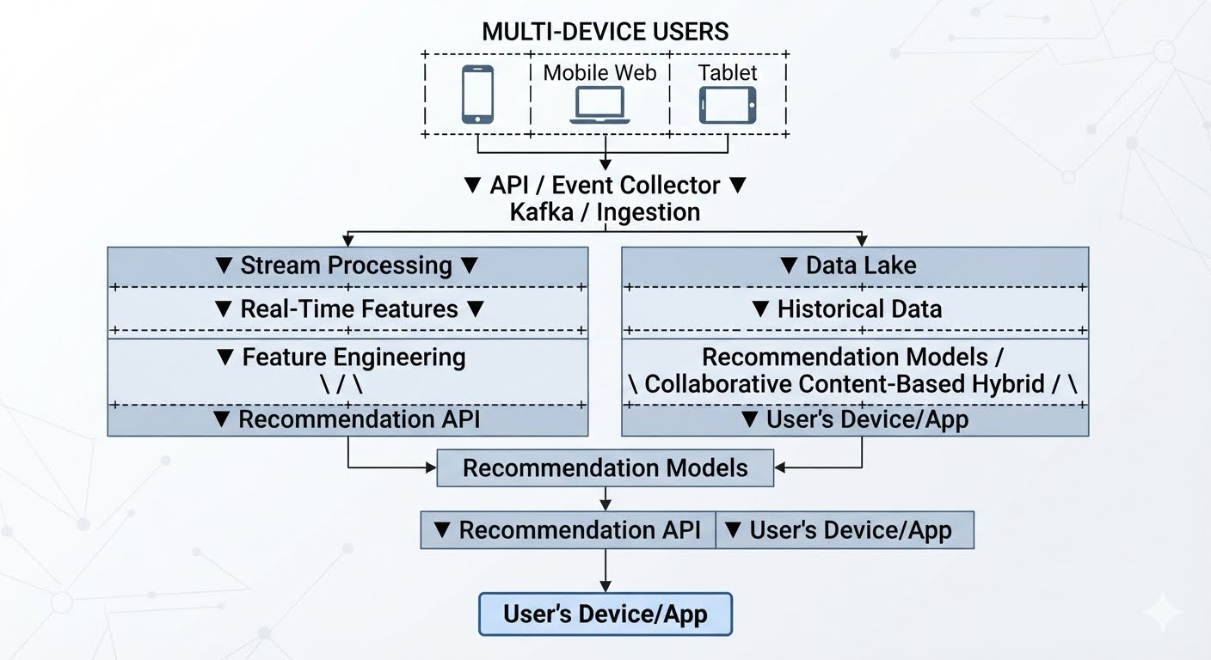
9. Likely Design Decisions
By reverse engineering the solution, the following design decisions are likely:
1. Distributed ingestion
Because millions of clicks and searches may arrive simultaneously.
2. Streaming + batch architecture
Streaming is used for fresh recommendations, while batch processing is used for historical model training.
3. Flexible storage
A data lake is appropriate because the system handles multiple data formats.
4. Unified user identity
A common internal user ID is required to combine activity from multiple devices.
5. Scalable processing
Distributed processing frameworks such as Spark can process large historical datasets in parallel.
6. Separate model-serving layer
The recommendation model should be exposed through an API so web and mobile applications can request recommendations efficiently.

10. Security and Privacy Considerations
Because the system collects detailed user behavior, it should include:
Authentication and authorization
Encryption in transit and at rest
Access controls for behavioral data
Pseudonymization of user identifiers where appropriate
Audit logs
Data-retention policies
The recommendation system should avoid exposing raw customer information to components that only require anonymized or aggregated features.

11. Reverse-Engineering Summary
Observed Requirement | Probable Component
Continuous clicks/searches | Kafka / event streaming
Multiple data formats | Data lake
Multi-device activity | Identity resolution
Large historical datasets | Distributed storage
Real-time recommendations | Stream processing
Historical model training | Spark/batch processing
Personalized suggestions | ML recommendation model
Application access | Recommendation API

Conclusion
The recommendation engine is likely a distributed, event-driven big-data system. User clicks, searches, and purchases are collected from multiple devices through APIs or event collectors and ingested using a scalable streaming platform. Raw and historical data is stored in a distributed data lake, while stream and batch processing create behavioral features.
A recommendation model—such as collaborative filtering, content-based filtering, or a hybrid model—then generates personalized suggestions. The key architectural decisions are scalable ingestion, unified identity across devices, distributed storage, real-time and batch analytics, and an API-based model-serving layer. This design allows the system to handle large volumes of user activity while providing timely and personalized recommendations.

- A ride-sharing company displays live traffic heatmaps and demand forecasts. Reverse engineer the likely distributed storage and processing backbone behind the system.

Ride-Sharing Traffic Heatmaps and Demand Forecasting
A ride-sharing platform that provides live traffic heatmaps and demand forecasts must process a continuous stream of GPS locations, trip information, traffic conditions, and historical ride data. By examining the application's behavior, we can infer the likely distributed storage and processing architecture behind it.
1. Probable Data Sources
The system likely receives data from:
Driver GPS locations
Rider pickup/drop locations
Completed and cancelled trips
Vehicle speed and movement
Road traffic conditions
Historical trip records
Weather and event information
Example GPS event:
{
"vehicle_id": "V1025",
"latitude": 13.0827,
"longitude": 80.2707,
"speed": 18,
"timestamp": "2026-08-19T11:30:00"
}
The data is generated continuously, making velocity an important characteristic.

2. Probable Data Ingestion Backbone
Because thousands or millions of location events may arrive continuously, the system likely uses a distributed event-ingestion platform such as Apache Kafka or an equivalent managed streaming service.
Drivers / Riders / GPS
|
▼
Event Collection
|
▼
Kafka / Streaming
|
+-----+------+
| |
▼ ▼
Real-Time Historical
Processing Storage
Why streaming?
A traffic heatmap must change quickly when vehicles slow down or congestion develops. Therefore, the system cannot depend only on daily batch processing.

3. Probable Distributed Storage
The platform likely uses multiple storage layers because live traffic and historical forecasting have different requirements.
A. Data Lake / Object Storage
Raw historical GPS and trip data can be stored in distributed cloud object storage or a data lake.
ride-data/
│
├── gps/
├── trips/
├── traffic/
├── weather/
└── historical/
This layer provides large-scale, durable, and economical storage.
B. Distributed Database / Serving Store
For fast access to current traffic information, the system may use a distributed database or key-value/geospatial store.
Current Traffic
↓
Distributed Serving Database
↓
Heatmap API
This avoids scanning the entire historical data lake whenever a user opens the map.

4. Real-Time Processing Backbone
The live heatmap requires stream processing.
A likely technology is Apache Spark Structured Streaming, Apache Flink, or a managed equivalent.
GPS Events
↓
Kafka
↓
Stream Processing
↓
Aggregate by Location/Grid
↓
Traffic Density
↓
Heatmap Store
↓
Mobile App
For example, a city can be divided into geographic grid cells.
+----+----+----+
| A1 | A2 | A3 |
+----+----+----+
| B1 | B2 | B3 |
+----+----+----+
| C1 | C2 | C3 |
+----+----+----+
The streaming engine calculates:
Number of vehicles
Average speed
Trip density
Congestion level
for each cell.

5. Live Traffic Heatmap Generation
The probable workflow is:
Vehicle GPS
↓
Streaming Ingestion
↓
Location Mapping
↓
Speed / Density Calculation
↓
Traffic Classification
↓
Heatmap Data
↓
API
↓
Mobile Application
Example:
Grid B2
Vehicles = 850
Average Speed = 12 km/h
Traffic = Heavy
The application converts this processed data into a visual heatmap.

6. Historical Storage for Demand Forecasting
Demand forecasting requires historical information.
The platform may store:
Number of rides
Pickup locations
Drop locations
Time of day
Day of week
Weather
Holidays/events
Historical traffic
This could be stored in a distributed data lake or warehouse.
Years of Trip Data
↓
Distributed Storage
↓
Batch Processing
↓
Feature Engineering
↓
Forecasting Model

7. Batch Processing Backbone
Historical data can be processed periodically using distributed systems such as Apache Spark.
Example:
Historical Trips
↓
Spark Batch Processing
↓
Hourly/Daily Demand Patterns
↓
ML Training Dataset
This is different from the real-time heatmap pipeline.

8. Demand Forecasting
The system likely uses machine-learning or statistical models to predict demand.
Useful features include:
Historical rides
Current demand
Time of day
Day of week
Weather
Events
Location
Traffic conditions
Example:
Historical Data
+
Weather
+
Time
+
Traffic
↓
Forecasting Model
↓
Predicted Demand
Example result:
Area: Chennai Central
Time: 6:00 PM

Current demand: 820 rides/hour
Predicted demand: 1,150 rides/hour
The company can use this to position drivers before demand increases.

9. Probable End-to-End Architecture
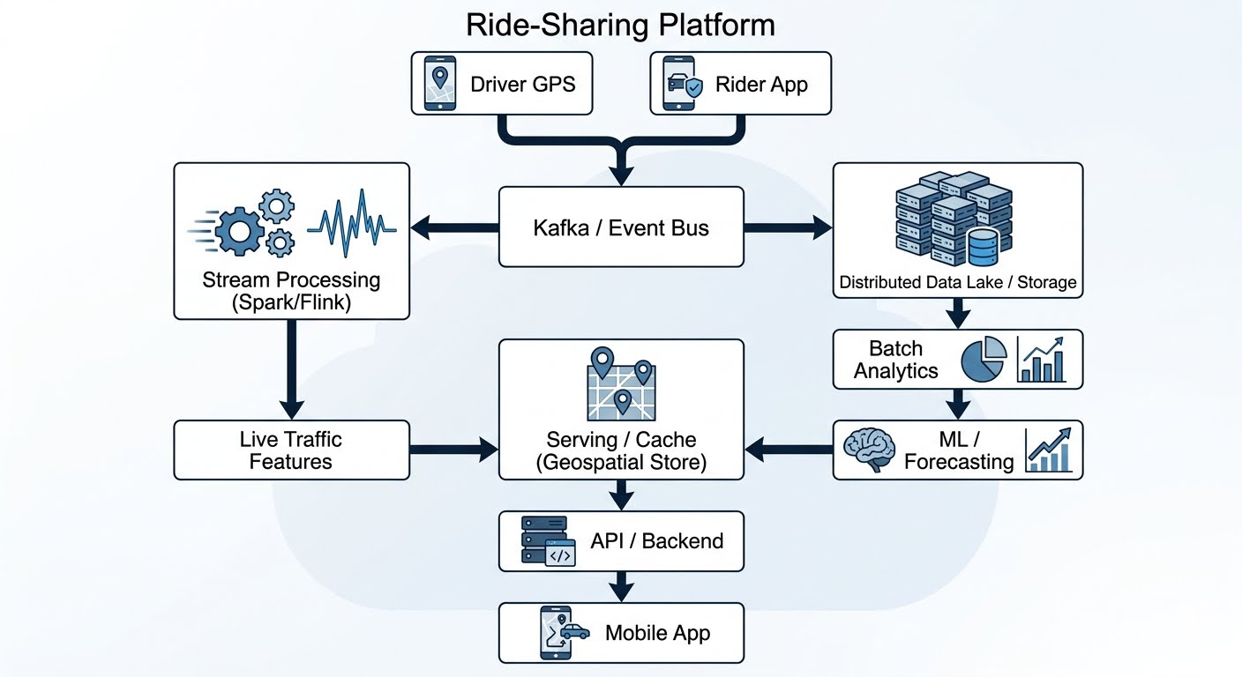
10. Why Distributed Storage Is Needed
Scalability
A ride-sharing company can generate enormous amounts of GPS and trip data. Distributed storage allows additional nodes or capacity to be added as the dataset grows.
Fault Tolerance
Data can be replicated across nodes so that failure of one machine does not destroy the dataset.
Parallel Processing
Large historical datasets can be processed simultaneously across multiple machines.

11. Why Distributed Processing Is Needed
A single server may not be able to process:
Millions of GPS events
+
Millions of trip records
+
Historical datasets
quickly enough.
Distributed processing divides the workload:
Large Dataset
↓
+----+----+----+----+
|Node|Node|Node|Node|
+----+----+----+----+
↓
Parallel Processing
↓
Combined Result
This makes real-time processing and large-scale model training practical.

12. Probable Caching Layer
Since many users may request the same map information, the application may use a distributed cache.
Mobile App
↓
API
↓
Cache
↓
Traffic Data Store
Frequently requested traffic information can be served from cache instead of repeatedly querying the main database.
This reduces:
Response time
Database load
Processing overhead

13. Design Decisions Inferred
Observed Requirement | Likely Design Decision
Live traffic map | Stream processing
Continuous GPS data | Kafka/event streaming
Huge historical data | Data lake/object storage
Fast map queries | Distributed serving store/cache
Demand prediction | Batch + ML processing
Geographic analysis | Geospatial indexing/grid aggregation
Fault tolerance | Data replication
Large-scale processing | Spark/Flink distributed cluster

14. Reverse-Engineered Processing Flow
GPS / Trip Events
↓
Distributed Ingestion
↓
+---------------------------+
| |
▼ ▼
Real-Time Stream Historical Data
Processing Lake
| |
▼ ▼
Live Traffic Batch Processing
Heatmap |
▼
ML Forecasting
| |
+------------+--------------+
|
▼
Serving Layer / Cache
|
▼
Mobile Application
Conclusion
The ride-sharing platform is most likely backed by a distributed event-driven architecture. Continuous GPS and trip events are ingested through a streaming platform such as Kafka. A distributed stream-processing engine calculates current traffic density and speed to generate the live heatmap, while a data lake stores large volumes of historical trip data.
Distributed batch processing and machine-learning models then use this historical data, together with factors such as time, weather, and traffic, to generate demand forecasts. A fast serving database and cache provide the processed results to mobile users with low latency.
Thus, the underlying design is likely a combination of distributed ingestion + real-time processing + distributed storage + batch analytics/ML + low-latency serving, which allows the platform to provide both live traffic information and predictive demand intelligence.

- A fraud detection dashboard flags suspicious card transactions in near real time. Reverse engineer the probable big data security, streaming, and alerting mechanisms used.

Near Real-Time Fraud Detection Dashboard
A fraud detection dashboard that flags suspicious card transactions in near real time is likely built on a distributed streaming architecture with strong security, real-time analytics, risk scoring, and automated alerting.
By examining the observed behavior, we can reverse engineer the probable components and design decisions.

1. Probable Data Sources
The system likely receives transaction and contextual data from several sources:
Card transactions
ATM transactions
Online payments
Merchant information
Customer/account profiles
Device information
Location information
Previous transaction history
Fraud investigation results
Example transaction event:
{
"transaction_id": "TX10051",
"customer_id": "C102",
"merchant_id": "M500",
"amount": 85000,
"currency": "INR",
"location": "Chennai",
"device": "D45",
"timestamp": "2026-08-19T18:42:10"
}
Because transactions arrive continuously, high velocity is a major architectural requirement.

2. Probable Streaming Architecture
The system likely uses a distributed event-streaming platform such as Apache Kafka or a managed equivalent.
Card / ATM / Payment Systems
|
▼
+---------------+
| Event Gateway |
+-------+-------+
|
▼
Kafka / Event Bus
|
+-----+-----+
| |
▼ ▼
Real-Time Secure Raw
Processing Data Storage
Why streaming?
A batch system that analyzes transactions only every hour or day would be too slow for fraud detection.
The dashboard needs to identify suspicious activity within seconds or near real time.

3. Stream Processing Layer
A stream-processing engine such as Apache Flink, Spark Structured Streaming, or a managed equivalent is likely used.
Transaction
↓
Kafka
↓
Stream Processor
↓
Feature Calculation
↓
Fraud Detection
↓
Risk Score
The processing engine can calculate features such as:
Transaction amount
Transaction frequency
Recent spending pattern
Geographic distance from previous transaction
Device change
Merchant risk
Unusual transaction timing

4. Real-Time Fraud Detection
The system probably combines rules and machine-learning models.
Rule-Based Detection
Example:
IF transaction_amount > threshold
AND transaction_location is unusual
AND recent transaction exists in another distant location
THEN increase risk score
Machine-Learning Detection
A model can learn patterns from historical fraudulent and legitimate transactions.
Transaction Features
↓
ML Fraud Model
↓
Fraud Probability
↓
Risk Score
For example:
Transaction TX10051
Risk Score = 0.94
Classification = HIGH RISK

5. Feature Engineering
The streaming system likely creates features from both the current transaction and historical behavior.
Transaction-Level Features
Amount
Merchant
Time
Location
Payment method
Customer-Level Features
Average spending
Typical transaction locations
Normal transaction frequency
Previous fraud events
Behavioral Features
Current transaction
+
Recent transaction history
+
Customer profile
↓
Fraud Features
This allows the system to detect anomalies rather than relying only on fixed thresholds.

6. Probable Security Architecture
Because the system handles extremely sensitive financial information, security is likely built into every layer.
SECURITY CONTROLS

Transaction Sources
↓
TLS / Encryption
↓
Secure API Gateway
↓
Authentication
↓
Authorization / IAM
↓
Streaming Platform
↓
Encrypted Storage
↓
Authorized Analytics

7. Authentication and Authorization
Only authorized services and employees should access transaction data.
Use:
IAM/RBAC
Strong authentication
MFA for privileged users
Service identities
Least-privilege permissions
Example:
Role | Access
Fraud Analyst | Fraud alerts and approved transaction details
Security Analyst | Security events and investigation data
Data Scientist | Approved/pseudonymized datasets
Administrator | Infrastructure and configuration
A dashboard user should not automatically have access to every raw card record.

8. Encryption
Data in Transit
Transactions should be protected with TLS while traveling between systems.
Payment System
|
TLS
↓
Streaming Platform
Data at Rest
Encrypt:
Transaction storage
Historical datasets
Fraud features
Audit logs
Backups
A cloud KMS/HSM or equivalent key-management service can control encryption keys.

9. Tokenization and Data Masking
The dashboard does not necessarily need to display complete card numbers.
Instead:
Original:
5234 5678 9012 3456

Dashboard:
XXXX XXXX XXXX 3456
Sensitive identifiers can also be tokenized.
This reduces the amount of sensitive data exposed to analysts and dashboard applications.

10. Alerting Mechanism
After calculating the risk score, the system likely applies thresholds.
Risk Score
|
+---- Low ----> Store / Monitor
|
+---- Medium -> Investigation Queue
|
+---- High ---> Immediate Alert
For high-risk transactions, the system can send alerts through:
Security dashboard
Email
SMS
Mobile notification
Incident-management platform

11. Dashboard Workflow
The dashboard likely receives processed alerts rather than querying raw transactions continuously.
Transaction
↓
Stream Processor
↓
Fraud Model
↓
Risk Score
↓
Alert/Event Topic
↓
Dashboard
Example dashboard:
---------------------------------------------------
FRAUD DETECTION DASHBOARD
---------------------------------------------------

Transaction Amount Risk Status
TX10051 ₹85,000 94% HIGH
TX10052 ₹2,500 8% NORMAL
TX10053 ₹42,000 81% REVIEW
---------------------------------------------------

12. Automated Response
For high-risk events, the architecture may trigger an automated response.
High-Risk Transaction
↓
Alert
↓
Fraud System
|
+----> Notify Analyst
|
+----> Request Additional Authentication
|
+----> Temporarily Hold Transaction
The exact action would depend on the organization's fraud policy; high-risk scoring does not automatically prove that a transaction is fraudulent.

13. Historical Storage
The system probably maintains a historical dataset for:
Model training
Fraud investigations
Trend analysis
Regulatory/audit requirements
Kafka
|
+------> Real-Time Analytics
|
+------> Secure Data Lake
|
▼
Historical Analysis
|
▼
ML Model Training
This creates a feedback loop:
Historical Fraud Data
↓
Model Training
↓
Improved Fraud Model
↓
Real-Time Detection

14. Monitoring and Auditing
A financial fraud platform needs continuous monitoring of both the business pipeline and security controls.
Monitor:
Transaction-processing latency
Kafka/event backlog
Processing failures
Fraud model errors
Failed authentication attempts
Unusual administrator access
Data export activity
System availability
Audit Logging
Record:
Who → accessed what → when → action → result
Example:
User: Analyst05
Action: Viewed TX10051
Time: 18:43:12
Result: Allowed
This supports investigation and accountability.

15. Probable End-to-End Architecture
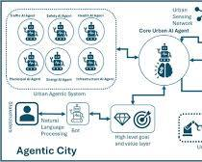
SECURITY:
TLS + IAM/RBAC + MFA + Tokenization
Encryption + Audit Logs + Monitoring

16. Reverse-Engineered Design Decisions
Observed Behavior | Likely Component/Decision
Transactions analyzed immediately | Stream processing
Huge transaction volume | Distributed Kafka/event bus
Historical fraud analysis | Data lake/distributed storage
Fraud probability | ML model
Fixed suspicious patterns | Rule engine
Sensitive card information | Encryption + tokenization
Analyst dashboard | Alert/serving layer
Immediate notification | Event-based alerting
Regulatory investigation | Immutable/controlled audit logs
Continuous operation | Distributed and fault-tolerant architecture

17. Security and Streaming Relationship
The key design is not simply streaming + security separately. Security must be integrated into the streaming pipeline.
Encrypted Transaction
↓
Authenticated Ingestion
↓
Authorized Processing
↓
Privacy-Protected Features
↓
Fraud Analysis
↓
Controlled Alert
↓
Audited Dashboard
This prevents unauthorized users or systems from intercepting or accessing sensitive transaction information while it is being processed.

Conclusion
The fraud detection dashboard is most likely backed by a distributed real-time streaming architecture. Transaction events are securely ingested through an event-streaming platform such as Kafka, then processed using a stream-processing engine such as Flink or Spark. A combination of fraud rules and machine-learning models generates real-time risk scores.
Strong security controls—including TLS, encryption at rest, IAM/RBAC, MFA, tokenization, masking, network protection, and audit logging—protect sensitive financial information. A dedicated alerting layer sends high-risk events to the fraud dashboard and, where appropriate, triggers additional verification or investigation workflows.
The combination of streaming + distributed analytics + security + automated alerting explains how the dashboard can identify suspicious card activity rapidly while protecting sensitive financial data.

- A social media platform stores videos, text comments, hashtags, and user engagement metrics. Reverse engineer how structured and unstructured data are probably managed together.

Managing Structured and Unstructured Social Media Data
A social media platform handles videos, text comments, hashtags, and user engagement metrics. These data types have different structures and processing requirements, so the platform most likely uses a hybrid big data architecture combining object storage, databases, data lakes, streaming systems, and distributed analytics.

1. Probable Data Classification
The first step in reverse engineering is identifying how each type of data is likely represented.
Data | Type | Example | Likely Storage
User profile | Structured | User ID, age, location | Relational/NoSQL DB
Engagement metrics | Structured | Likes, shares, views | NoSQL/analytics DB
Hashtags | Semi-structured/structured | #cloud, #music | NoSQL/search index
Comments | Unstructured/semi-structured | Free-form text | Data lake/document store
Videos | Unstructured | MP4/video streams | Object storage
Video metadata | Structured/semi-structured | ID, duration, timestamp | Database/object metadata
Thus, the platform cannot efficiently place everything into a traditional relational table.

2. Probable Overall Architecture 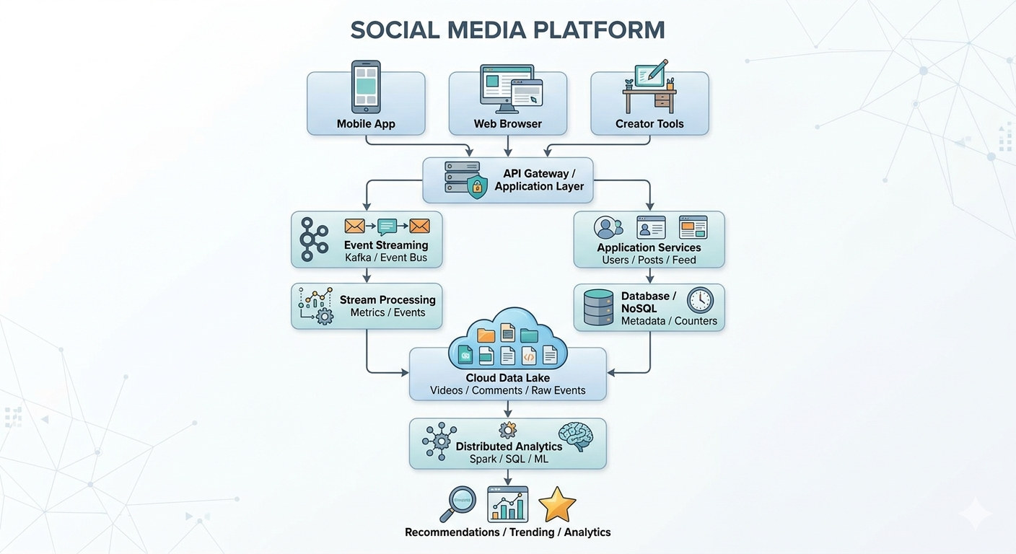
3. Video Data Management
Videos are large unstructured objects and may consume enormous amounts of storage.
They are therefore likely stored in cloud object storage rather than directly inside a relational database.
Example:
social-media-videos/
│
├── user-101/
│ ├── video001.mp4
│ └── video002.mp4
│
└── user-205/
└── video003.mp4
Examples of suitable storage include:
Amazon S3
Azure Blob Storage
Google Cloud Storage
Why object storage?
Handles very large files
Scales independently
High durability
API-based access
Supports lifecycle and archival policies
Integrates well with CDN and video-processing services

4. Video Metadata Management
Although the actual video is unstructured, its metadata is structured or semi-structured.
Example:
{
"video_id": "V1001",
"user_id": "U101",
"duration": 42,
"upload_time": "2026-08-19T18:20:00",
"storage_key": "user-101/video001.mp4"
}
The database may store the metadata while the video itself remains in object storage.
Video Metadata ──→ Database
|
└──────────→ Object Storage
Actual Video
This separation is an important probable design decision.

5. Text Comment Management
Comments contain free-form text and are therefore largely unstructured data, although they may be wrapped in structured records.
Example:
{
"comment_id": "C501",
"user_id": "U101",
"video_id": "V1001",
"text": "Amazing video!",
"timestamp": "2026-08-19T18:25:00"
}
The comment text can be stored in:
A document/NoSQL database for application serving
A data lake for large-scale analytics
Why both?
The live application needs fast retrieval, while analytics may need to process billions of historical comments.

6. Hashtag Management
Hashtags such as:
#football
#music
#technology
#cloudcomputing
can be treated as structured or semi-structured attributes.
The platform may maintain a mapping:
Hashtag → Post/Video IDs
For example:
#music
↓
V1001
V1020
V1084
V2012
A search index or distributed NoSQL store can provide fast hashtag queries.

7. Engagement Metrics
Engagement data is generally structured.
Examples:
Number of views
Likes
Shares
Comments
Followers
Watch time
A record could be:
Video_ID | Views | Likes | Shares | Comments
V1001 | 25000 | 3200 | 540 | 480
Because these metrics change frequently, the platform may use:
NoSQL databases
Distributed counters
Streaming analytics
Caching

8. Event Streaming
Every user interaction generates an event.
For example:
User watches video
User likes video
User comments
User shares video
User follows creator
These events can be sent to a distributed streaming platform such as Kafka.
User Events
↓
Kafka / Event Bus
↓
Stream Processing
↓
+------------------+
| Views |
| Likes |
| Shares |
| Watch Time |
+------------------+
This allows engagement metrics to be updated rapidly.

9. Real-Time Processing
A stream-processing system such as Apache Flink or Spark Structured Streaming can process events continuously.
Example:
Like Event
↓
Kafka
↓
Stream Processor
↓
Increment Like Count
↓
Update Engagement Store
For trending content:
Views + Likes + Shares
↓
Real-Time Analytics
↓
Trending Score
↓
Trending Page

10. Data Lake for Large-Scale Analytics
The platform likely keeps raw or historical data in a data lake.
Data Lake
│
├── Videos / Video Metadata
├── Comments
├── Hashtags
├── User Events
├── Engagement History
└── Processing Results
The data lake allows analytics teams to study multiple data types together.

11. Distributed Processing
A platform with millions of videos and billions of interactions cannot rely on a single processing server.
A distributed processing framework such as Apache Spark could process the datasets in parallel.
Large Dataset
↓
+------+------+------+
| Node1| Node2| Node3|
+------+------+------+
↓
Parallel Processing
↓
Combined Results
Possible analytics include:
Trending-topic detection
Recommendation systems
Sentiment analysis
Creator analytics
Content-performance analysis
Audience segmentation

12. Combining Structured and Unstructured Data
This is the key part of the reverse-engineering task.
Suppose a video has:
Video ID: V1001
Views: 50,000
Likes: 4,000
Hashtag: #football
Comments:
"Great goal!"
"Amazing match!"
The platform can combine:
Structured:
Views, Likes, User ID, Timestamp

+

Semi-structured:
Hashtags, JSON metadata

+

Unstructured:
Video and comment text
into a single analytics workflow.
Structured Data
+
Semi-structured Data
+
Unstructured Data
↓
Data Lake
↓
Distributed Processing
↓
Unified Analytics

13. Example: Finding Trending Videos
The platform could calculate a trending score using several data sources.
Video Views
+
Likes
+
Shares
+
Comment Activity
+
Watch Time
↓
Trending Analytics
↓
Trending Score
Comment text could also be analyzed with NLP.
For example:
Comments
↓
Sentiment Analysis
↓
Positive / Neutral / Negative
↓
Combined with Engagement Metrics
This gives more useful information than simply counting views.

14. Example: Recommendation System
The platform can combine structured engagement data and unstructured content.
User History
+
Watch Time
+
Liked Videos
+
Hashtags
+
Comment Interests
↓
Recommendation Model
↓
Personalized Feed
Video content itself can also be processed to extract metadata such as objects, categories, or other content features.

15. Probable Storage Separation
A likely design is:
+-------------------------+
| Object Storage |
| Videos / Raw Media |
+-------------------------+

+-------------------------+
| NoSQL / Database |
| Users / Metadata / |
| Counters / Hashtags |
+-------------------------+

+-------------------------+
| Data Lake |
| Raw Events / Comments / |
| Historical Analytics |
+-------------------------+
This separation avoids forcing one storage system to handle every workload.

16. Security and Privacy
Social-media data contains personal information and user-generated content, so the architecture should include:
Access Control
Use IAM/RBAC to restrict administrative and analytics access.
Encryption
Encrypt data at rest.
Use HTTPS/TLS in transit.
Privacy
Protect personal identifiers and apply appropriate retention policies.
Content Security
Uploaded files can be scanned and validated before being made available to users.
Audit Logging
Log access to sensitive datasets and administrative operations.

17. Reverse-Engineered Architecture
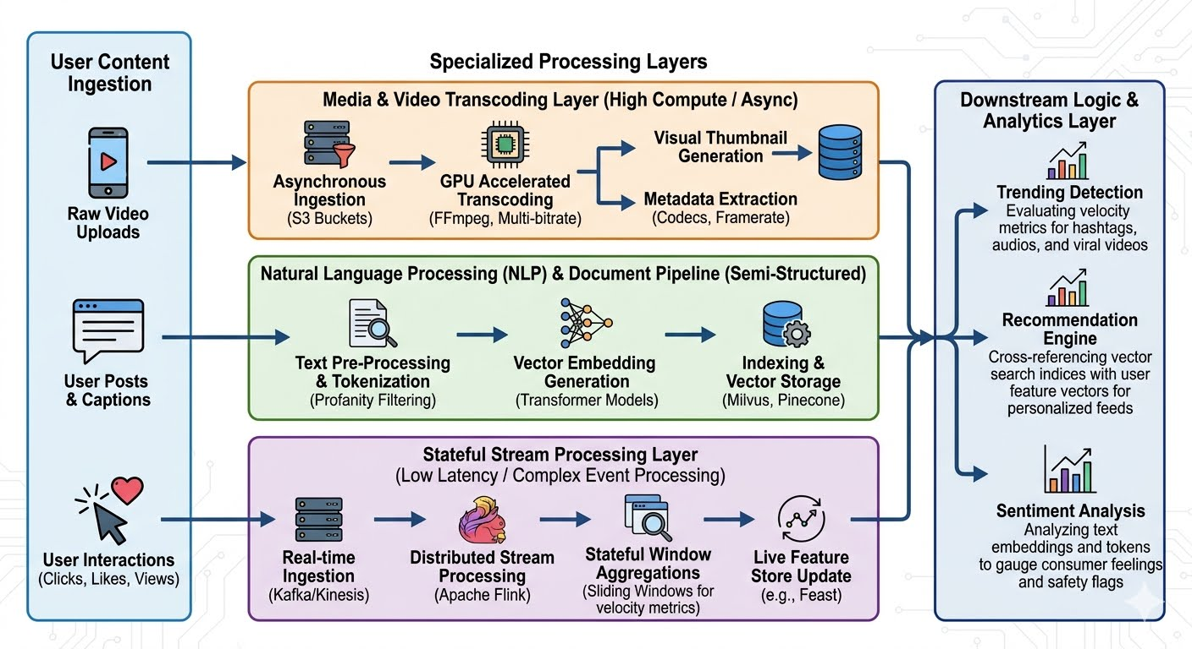
18. Probable Design Decisions
Observed Requirement | Likely Design Decision
Very large videos | Object storage
Fast video metadata queries | NoSQL/database
Huge interaction volume | Kafka/event streaming
Live engagement counts | Stream processing
Historical analytics | Data lake
Mixed data formats | Flexible data-lake architecture
Large-scale analytics | Spark/distributed processing
Trending detection | Real-time + batch analytics
Personalized feed | ML/recommendation pipeline
Searchable hashtags | Search index/NoSQL
Conclusion
The social-media platform likely manages its data using a polyglot architecture, where each data type is stored and processed according to its characteristics. Large videos are stored in scalable object storage, while structured metadata, engagement counters, and hashtags are handled through databases or NoSQL systems. Comments and raw interaction events can be retained in a data lake for large-scale analytics.
A streaming platform such as Kafka can capture likes, views, shares, and comments in real time, while distributed processing frameworks such as Spark or Flink analyze these events. This allows the platform to combine structured, semi-structured, and unstructured data for applications such as trending detection, sentiment analysis, creator analytics, and personalized recommendations.

- A manufacturing IoT platform collects machine logs and maintenance events from many plants. Reverse engineer the likely integration tools, storage strategy, and analytics path.

Manufacturing IoT Platform – Machine Logs and Maintenance Events
A manufacturing IoT platform collects machine logs and maintenance events from many plants. From this requirement, we can infer that the platform is likely designed as a distributed IoT data pipeline using stream ingestion, scalable storage, batch/stream processing, and predictive analytics.

1. Probable Data Sources
The platform likely receives data from many types of industrial systems:
Machine sensors
PLC/SCADA systems
Industrial gateways
Machine logs
Maintenance systems
Enterprise asset-management systems
Operator reports
Example machine event:
{
"plant_id": "PL01",
"machine_id": "M102",
"temperature": 82.5,
"vibration": 6.4,
"status": "RUNNING",
"timestamp": "2026-08-19T21:30:00"
}
Maintenance event:
{
"machine_id": "M102",
"event": "Bearing Replacement",
"date": "2026-08-19",
"technician": "T14"
}
The system therefore has both high-velocity sensor/log data and more structured maintenance information.

2. Probable Integration Architecture
Because data originates from many plants, an IoT gateway and integration layer is likely used.
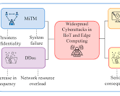
Why an integration layer?
Industrial plants may use different protocols, formats, and equipment vendors. The integration layer standardizes data before central analytics.
Likely technologies include:
MQTT for lightweight IoT messaging
Kafka for high-throughput event streaming
Apache NiFi or ETL tools for data movement and transformation
REST APIs for enterprise maintenance systems

3. Edge Gateway Role
Before data reaches the cloud, an edge gateway can perform:
Protocol conversion
Data filtering
Local aggregation
Temporary buffering
Basic anomaly detection
Example:
Machine Sensor
↓
Edge Gateway
↓
Filter / Aggregate
↓
Cloud
For instance, instead of sending every raw sensor reading, the gateway may calculate a one-minute average or immediately flag an abnormal vibration level.
This reduces bandwidth and can allow some local decisions even during temporary cloud connectivity problems.

4. Probable Data Ingestion Tools
MQTT
Useful for lightweight machine-to-gateway or IoT messaging.
Machine
↓
MQTT
↓
IoT Gateway
Kafka
Useful when the central platform needs to handle very large streams of machine events.
Plant Events
↓
Kafka Topics
↓
Multiple Processing Applications
For example, separate consumers may process the same stream for monitoring, predictive maintenance, and compliance logging.
NiFi / ETL
Useful for integrating maintenance databases and other enterprise systems.
Maintenance DB
↓
ETL / NiFi
↓
Cloud Data Platform

5. Probable Storage Strategy
The platform will likely use different storage systems according to workload.
A. Data Lake / Object Storage
Raw machine logs and historical sensor data can be stored in cloud object storage.
manufacturing-data/
│
├── raw/
│ ├── plant-01/
│ ├── plant-02/
│ └── plant-03/
│
├── maintenance/
│
└── curated/
This provides scalable storage for large volumes of historical IoT data.

B. Time-Series Storage
Machine measurements such as:
Temperature
Pressure
Vibration
Speed
Current
are naturally time-based.
A time-series database or specialized analytics store may therefore be used for fast queries on recent measurements.
Timestamp Machine Temperature
21:00:01 M102 75.2
21:00:02 M102 75.8
21:00:03 M102 76.1
This is useful for monitoring current machine conditions.

C. Relational/Enterprise Database
Maintenance information may be maintained in a structured database:
Machine_ID | Maintenance_Date | Type
M102 | 19-Aug-2026 | Bearing
M205 | 18-Aug-2026 | Motor
The analytics system can join these records with machine sensor history.

6. Why Multiple Storage Types?
The reverse-engineered design is likely polyglot storage rather than one database for everything.
Manufacturing Data
|
+-----------------+----------------+
| | |
▼ ▼ ▼
Object/Data Time-Series Relational
Lake Store Database
| | |
▼ ▼ ▼
Historical Logs Sensor Trends Maintenance Data
Each storage technology is selected according to the access pattern.

7. Stream Processing Path
The platform likely needs real-time monitoring of machine conditions.
Machine Sensors
↓
IoT Gateway
↓
Kafka / Event Stream
↓
Stream Processor
↓
Anomaly Detection
↓
Alert / Dashboard
A stream-processing system such as Apache Flink or Spark Structured Streaming can calculate:
Moving averages
Threshold violations
Vibration anomalies
Temperature changes
Machine downtime events

8. Example of Real-Time Anomaly Detection
Suppose a machine normally operates at 60–70°C.
Temperature Stream
↓
72°C
↓
78°C
↓
85°C
↓
Stream Analytics
↓
Abnormal Trend
↓
Maintenance Alert
The system can notify operators before a machine reaches a critical failure condition.

9. Historical Analytics and Predictive Maintenance
Historical sensor data can be used to train machine-learning models.
Historical Sensor Logs
+
Maintenance History
+
Failure Records
↓
Distributed Processing
↓
Feature Engineering
↓
Machine Learning
↓
Failure Probability
Example output:
Machine: M102
Failure Risk: 87%
Likely Issue: Bearing degradation
Recommended Action: Inspect within 24 hours
This is the likely analytics path for predictive maintenance.

10. Integration of Machine Logs and Maintenance Events
The key insight is that machine logs alone are not enough.
The system must associate sensor behavior with known maintenance and failure events.
Sensor History
+
Maintenance History
+
Failure Records
↓
Unified Machine Timeline
↓
Analytics / ML
For example:
Machine M102
---------------------------------
10 Aug → Vibration begins rising
14 Aug → Temperature increases
18 Aug → Bearing replaced
19 Aug → Normal operation
The model can learn relationships between sensor patterns and maintenance events.

11. Batch Processing
Historical data from all plants can be processed periodically.
Plant 1 Data ─┐
Plant 2 Data ─┼→ Data Lake
Plant 3 Data ─┘ ↓
Spark Batch
↓
Historical Analysis
↓
Predictive Models
Batch analytics can identify:
Frequently failing machines
Plants with high downtime
Maintenance cost trends
Common failure modes
Spare-parts requirements

12. Multi-Plant Data Architecture
A central platform can organize data by plant and machine.
Central Cloud Platform
|
+------------+------------+
| | |
Plant 01 Plant 02 Plant 03
| | |
Machines Machines Machines
\ | /
\ | /
+----------+----------+
|
Data Analytics
This supports both:
Plant-level analytics
Organization-wide benchmarking

13. Monitoring and Alerting
The platform should monitor both the machines and the data pipeline.
Machine Monitoring
Temperature
Vibration
Pressure
Power consumption
Machine state
Data Pipeline Monitoring
Kafka lag
Missing events
Ingestion failures
Processing latency
Storage capacity
Example:
Sensor Failure
↓
Monitoring System
↓
Data Gap Detected
↓
Alert Operations Team

14. Security Considerations
Manufacturing systems may contain operationally sensitive information.
The platform should use:
Authentication and Authorization
Control which plant operators, engineers, and analysts can access specific datasets.
Encryption
Protect data both in transit and at rest.
Network Segmentation
Separate plant/OT networks from general enterprise or cloud networks.
Audit Logging
Record who accessed or modified operational data.
Device Security
Authenticate IoT devices and gateways so unauthorized devices cannot inject false telemetry.

15. Reverse-Engineered End-to-End Architecture
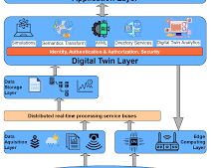
16. Probable Design Decisions
Observed Requirement | Likely Component
Data from many plants | Distributed ingestion
Industrial device communication | MQTT / IoT gateways
Very high event rate | Kafka/event streaming
Large historical logs | Object storage/data lake
Time-based sensor queries | Time-series database
Maintenance records | Relational/enterprise database
Real-time anomaly detection | Flink/Spark Streaming
Historical analysis | Spark batch processing
Failure prediction | Machine-learning models
Cross-plant analytics | Centralized cloud data platform

Conclusion
The manufacturing IoT platform is most likely built around a multi-layer distributed architecture. Edge or IoT gateways collect and normalize machine data, while technologies such as MQTT, Kafka, and integration tools move data into a centralized cloud platform.
Large historical machine logs are best stored in a data lake/object-storage layer, recent time-series measurements can be maintained in a specialized time-series store, and maintenance records can remain in structured enterprise databases. Stream processing enables real-time anomaly detection, while batch processing and machine learning combine historical sensor data with maintenance records to support predictive maintenance.
The resulting architecture provides scalable ingestion, durable storage, real-time monitoring, cross-plant analytics, and predictive maintenance capabilities while keeping operational data secure.

Reverse Engineering Task Rubric
Criteria | Weightage | Level 4 - Exemplary | Level 3 - Proficient | Level 2 - Developing | Level 1 - Beginning
Inference Accuracy | 25% | Infers system components and flow with high accuracy | Mostly accurate inference | Basic inference | Weak inference
Understanding of Architecture | 25% | Shows clear understanding of underlying big data architecture | Good understanding | Partial understanding | Poor understanding
Use of Technical Evidence | 20% | Uses strong reasoning and technical evidence | Reasonable evidence | Limited evidence | No meaningful evidence
Depth of Analysis | 15% | Analysis is deep and insightful | Reasonably deep | Basic depth | Superficial analysis
Clarity | 15% | Clear and organized explanation | Generally clear | Somewhat unclear | Poorly presented

