SIMATS ENGINEERING
ASSESSMENT TOOL 3: Application Based Questions
COURSE NAME: Cloud Computing and Big Data Analytics
COURSE OUTCOME COVERED
COURSE CODE: CSA15
CO2: Analyze virtualization architectures to identify performance and security issues in cloud computing environments. (BL3)
Dave's Taxonomy: Manipulation (Level 2) Question Count: 5
Code of Conduct
Total Marks: 25
I __R.MOHANRAM___ (Name / Reg No) certify that this submission is my original work and that I have adhered to the guidelines specified for this assessment. I understand that any violation of academic integrity rules will result in disciplinary action. Signature of the student: __mohanram___

Assessment Tasks
Application Based Questions
1. A company experiences unpredictable traffic spikes during seasonal sales. Explain how cloud auto-scaling and load balancing can handle this demand efficiently. How does this approach reduce downtime and improve user experience? What role do monitoring tools play in this setup? Relate your answer to a real-world e-commerce scenario.

Handling Traffic Spikes with Auto-Scaling & Load Balancing

Scalable Cloud Architecture for E-commerce

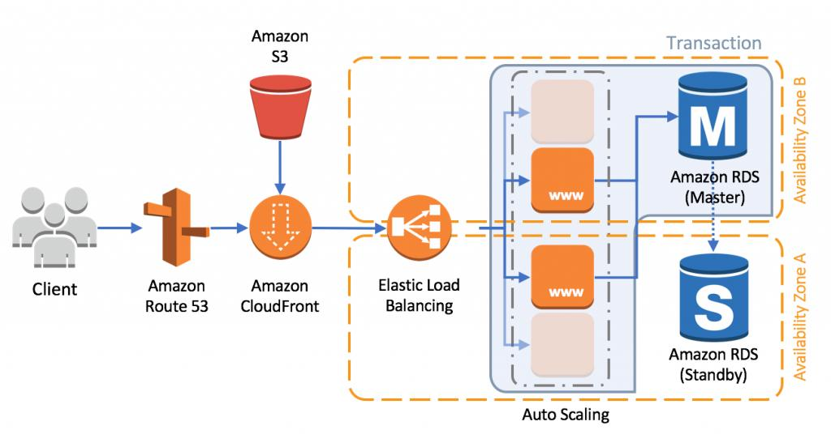
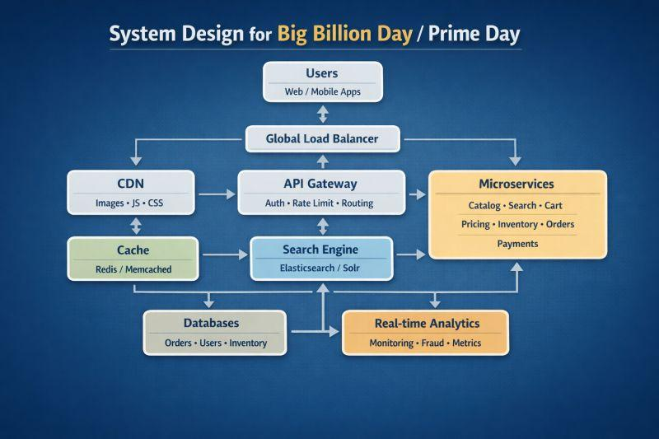

1. How Auto-Scaling Handles Demand

What is Auto-Scaling?
Auto-scaling automatically adds or removes computing resources (VMs/containers) based on demand.

How It Works
- During traffic spikes:
  - New instances are launched automatically
- During low traffic:
  - Unused instances are terminated
Example triggers:
- CPU usage > 70%
- High request rate
- Queue length increases

Benefits
- Prevents system overload
- Optimizes cost (pay only for what you use)

2. Role of Load Balancing

What is Load Balancing?
A load balancer distributes incoming traffic across multiple servers.

Key Functions
- Routes requests to healthy servers only
- Prevents any single server from being overwhelmed
- Performs health checks
Types:
- Layer 4 (network level)
- Layer 7 (application level – smarter routing)

Benefits
- Improved performance
- High availability
- Fault tolerance

3. Reducing Downtime & Improving User Experience

Without Scaling
- Servers crash under heavy load
- Slow page loads
- Failed transactions

With Auto-Scaling + Load Balancing
- Traffic distributed evenly
- New servers added instantly
- Failed servers replaced automatically
Result:
- Minimal downtime
- Faster response times
- Smooth checkout experience

4. Role of Monitoring Tools

What Monitoring Does
- Tracks:
  - CPU, memory, latency
  - Error rates
  - Traffic patterns

Automation Trigger
- Monitoring tools send signals to:
  - Auto-scaling systems
  - Alerting systems

Alerts
- Notify admins of:
  - Performance degradation
  - Failures
Examples:
- Cloud-native monitoring dashboards
- Logs and real-time metrics

5. Real-World E-commerce Scenario
Consider a platform like **Amazon during a major sale event such as **Black Friday:

Situation:
- Millions of users visit simultaneously
- Sudden surge in product searches and checkouts

Solution in Action:
- Auto-scaling launches hundreds of extra servers
- Load balancer distributes users across servers globally
- CDN caching serves static content quickly
- Monitoring tools detect spikes and trigger scaling

Outcome:
- Website remains responsive
- No crashes despite heavy load
- Users enjoy seamless shopping

Summary
Component | Role
Auto-Scaling | Adjusts resources dynamically
Load Balancer | Distributes traffic efficiently
Monitoring Tools | Detects and triggers scaling
CDN | Reduces latency

Final Insight
Combining auto-scaling, load balancing, and monitoring enables cloud systems to:
- Handle unpredictable traffic spikes
- Maintain high availability
- Deliver fast, reliable user experiences
This architecture is essential for modern e-commerce platforms, ensuring zero downtime and customer satisfaction during peak demand.

2. An organization wants to store large volumes of backup data securely in the cloud. Discuss how cloud storage solutions ensure durability and data redundancy. How can encryption and access control protect sensitive backup data? Explain the cost advantages compared to traditional storage systems. Provide an example of a disaster recovery use case.

Secure Cloud Storage for Large-Scale Backups

Cloud Storage Architecture (Durability & Redundancy)
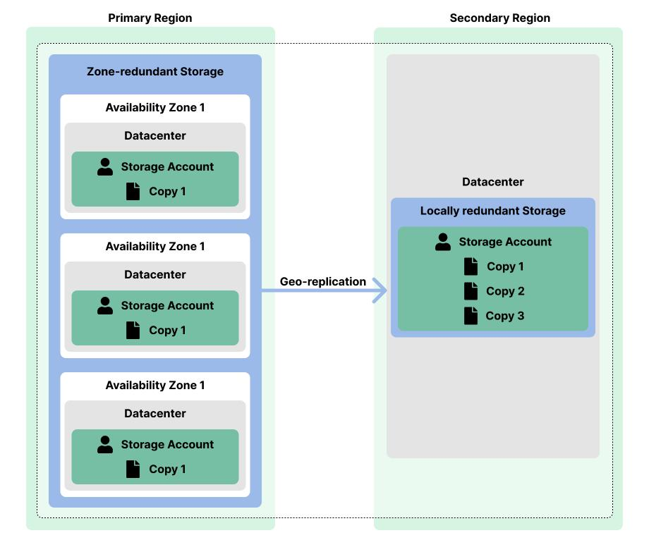
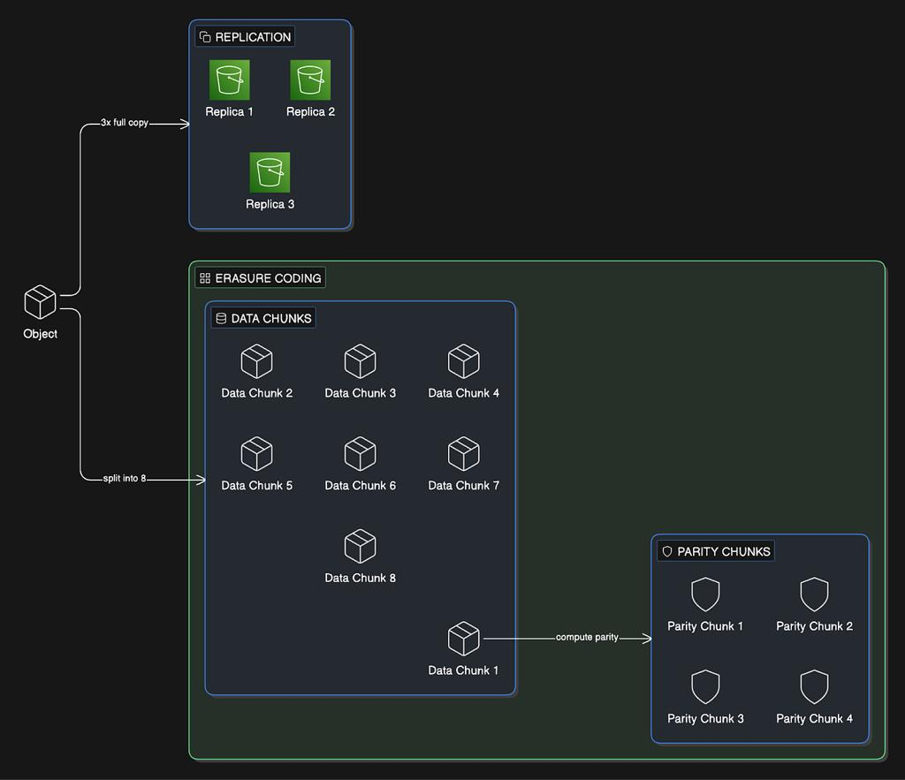
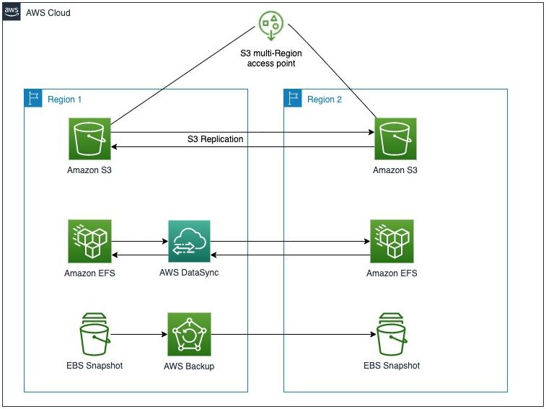

1. Durability & Data Redundancy

Multi-Copy Replication
- Cloud providers store multiple copies of data across:
  - Different disks
  - Multiple servers
  - Multiple availability zones
  - Even if hardware fails, data remains intact

Erasure Coding
- Data is split into fragments + parity blocks
- Stored across different locations
- Can reconstruct data even if parts are lost

Multi-Region Replication
- Backup data copied to another geographic region
- Protects against:
  - Natural disasters
  - Regional outages

Result
- Extremely high durability (e.g., “11 nines” reliability)
- Near-zero risk of permanent data loss

2. Encryption & Access Control

Encryption Mechanisms

1. Data at Rest
- Stored data is encrypted using strong algorithms (e.g., AES-256)

2. Data in Transit
- Secured using TLS/SSL during upload/download
3. Key Management
- Managed via secure key systems (KMS or HSM)
- Regular key rotation

Access Control

Identity & Access Management (IAM)
- Role-based access (RBAC)
- Least privilege principle

Multi-Factor Authentication (MFA)
- Adds extra verification layer

Access Policies
- Define who can:
  - Read
  - Write
  - Delete backups
Prevents unauthorized access and accidental deletion

3. Cost Advantages vs Traditional Storage

Traditional Storage Challenges
- High upfront hardware cost
- Maintenance (cooling, power, staff)
- Limited scalability

Cloud Storage Benefits

Pay-as-You-Go Model
- Pay only for storage used

Storage Tiers
- Hot (frequent access)
- Cold (infrequent access)
- Archive (long-term backup)

No Maintenance Cost
- No hardware management

Elastic Scalability
- Scale instantly without buying new hardware

Cost Efficiency
- Ideal for backups (rarely accessed but large volume)
- Significant savings over time

4. Disaster Recovery Use Case

Scenario: Data Center Failure

Recovery Workflow
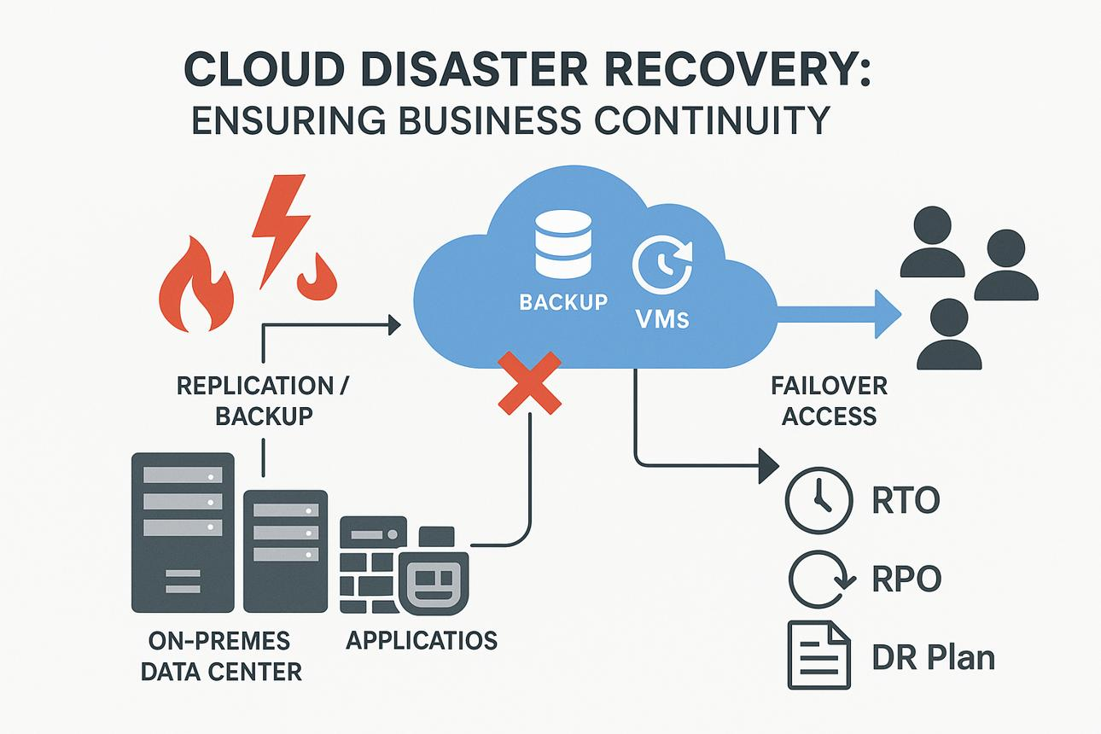

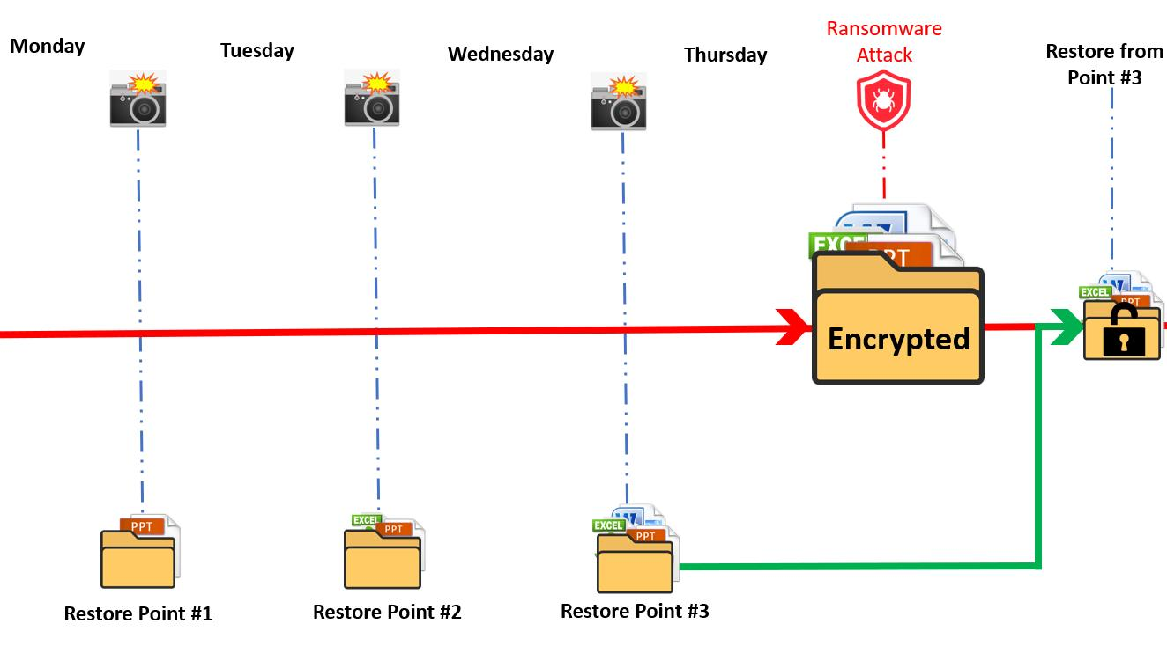

Situation:
- Organization’s on-prem data center fails (e.g., fire or cyberattack)

Solution:
- Backup data already stored in cloud
- Launch new infrastructure in cloud
- Restore data from backup storage
- Resume operations

Outcome:
- Minimal downtime
- No permanent data loss
- Business continuity maintained

Summary
Feature | Cloud Advantage
Durability | Multi-copy + erasure coding
Redundancy | Multi-zone & multi-region
Security | Encryption + IAM
Cost | Pay-as-you-go + no hardware
Recovery | Fast restore from backups

Final Insight
Cloud storage ensures high durability, strong security, and cost efficiency for backup data through:
- Redundant storage across multiple locations
- Advanced encryption and strict access control
- Flexible, low-cost storage tiers
This makes it the preferred solution for modern backup and disaster recovery strategies, ensuring data is always safe, recoverable, and affordable.

3. A mobile app company plans to deploy its application globally. Explain how content delivery networks (CDNs) improve performance and reduce latency. How do edge servers enhance user experience across regions? Discuss how cloud providers support global availability. Relate this to a real-time streaming or gaming application.

Global App Performance with CDN & Edge Servers

CDN Architecture Overview
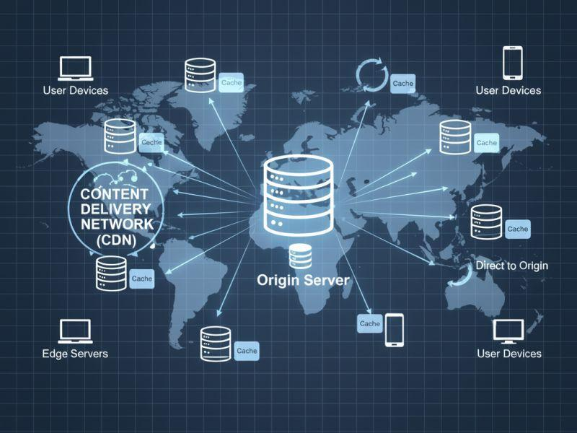
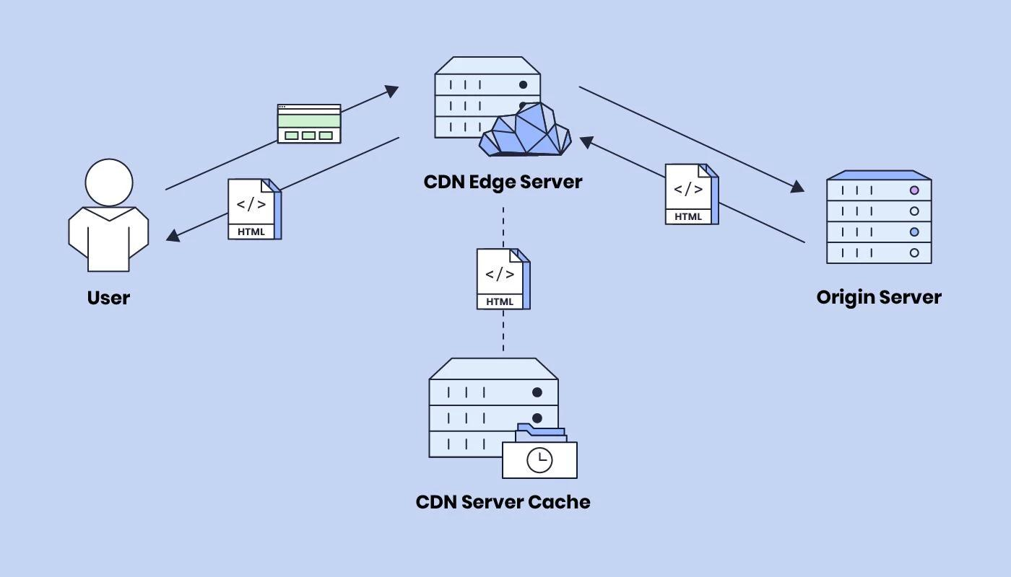
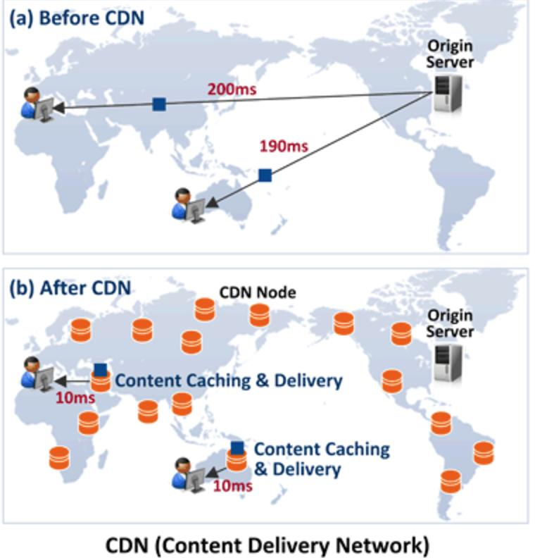

1. How CDNs Improve Performance & Reduce Latency

What is a CDN?
A Content Delivery Network (CDN) is a distributed network of servers placed across the globe to deliver content faster.

How It Works
- User requests content (video, image, API response)
- Request is routed to the nearest CDN server
- Cached content is delivered instantly
Instead of fetching data from a distant origin server, CDN serves it locally

Latency Reduction
- Shorter physical distance → faster response
- Reduced network congestion
- Faster load times
Especially important for:
- Mobile apps
- Streaming platforms
- Online games

2. Role of Edge Servers

What are Edge Servers?
Edge servers are CDN nodes located close to users geographically.

Key Functions
- Cache frequently accessed content
- Process requests locally
- Reduce round-trip time to origin servers

Benefits for User Experience
- Faster app loading
- Smooth video playback (less buffering)
- Reduced lag in gaming
Example:
- A user in India accesses data from a nearby edge server instead of a server in the US

3. How Cloud Providers Support Global Availability

Global Infrastructure
Cloud providers deploy:
- Multiple regions (geographic areas)
- Multiple availability zones within each region

Integrated CDN Services
- Built-in CDN services cache content globally
- Automatically route users to nearest location

Additional Features
- Load balancing across regions
- Auto-scaling to handle demand
- Multi-region deployment for fault tolerance
Ensures:
- High availability
- Low latency worldwide

4. Real-World Scenario: Streaming / Gaming

Example: Netflix (Streaming)
- Videos cached on CDN edge servers globally
- Users stream from nearest server
- Reduces buffering and startup delay

Example: PUBG Corporation (Gaming)
- Game servers + edge nodes reduce latency
- Real-time actions processed closer to players
- Ensures smooth gameplay with minimal lag

Outcome
- Instant content delivery
- Seamless real-time interaction
- Consistent performance worldwide

Summary
Component | Role
CDN | Distributes content globally
Edge Servers | Serve content closer to users
Cloud Regions | Provide global infrastructure
Load Balancing | Routes traffic efficiently

Final Insight
CDNs and edge servers are essential for global application deployment because they:
- Minimize latency
- Improve load times
- Enhance real-time performance
Combined with cloud providers’ global infrastructure, they ensure fast, reliable, and scalable user experiences—critical for modern streaming and gaming applications.

4. A financial institution requires strict compliance and data security in cloud usage. Explain how cloud providers support regulatory compliance and auditing. What role do logging, monitoring, and encryption play in security? How can the company ensure data sovereignty requirements are met? Give an example involving sensitive financial transactions.

Secure & Compliant Cloud for Financial Institutions

Compliance & Security Architecture
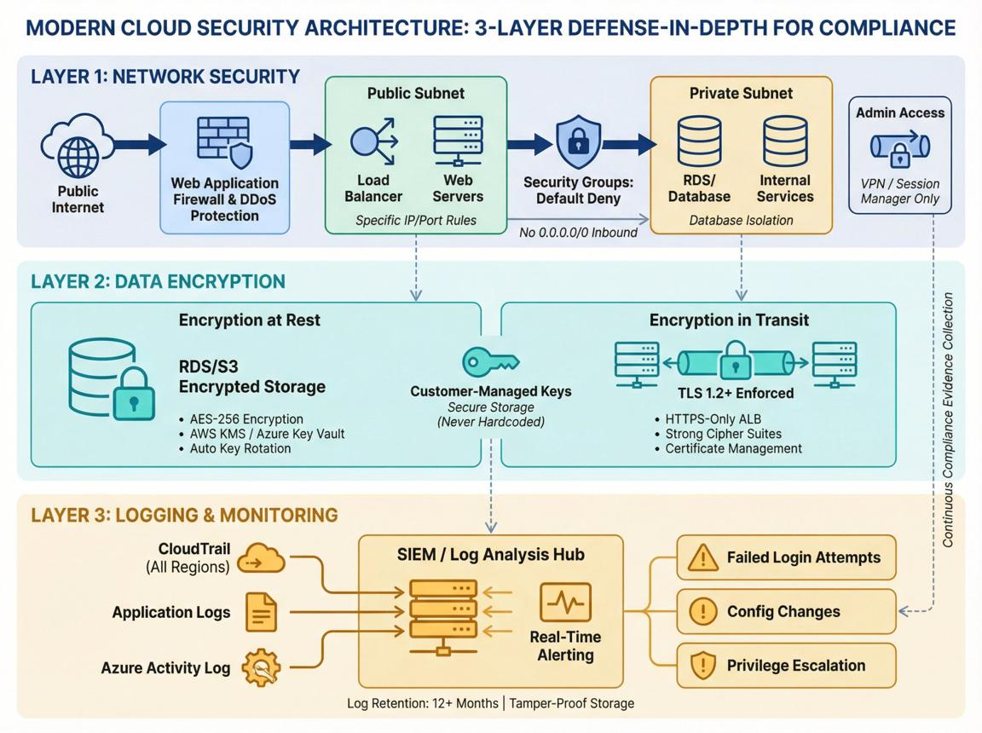
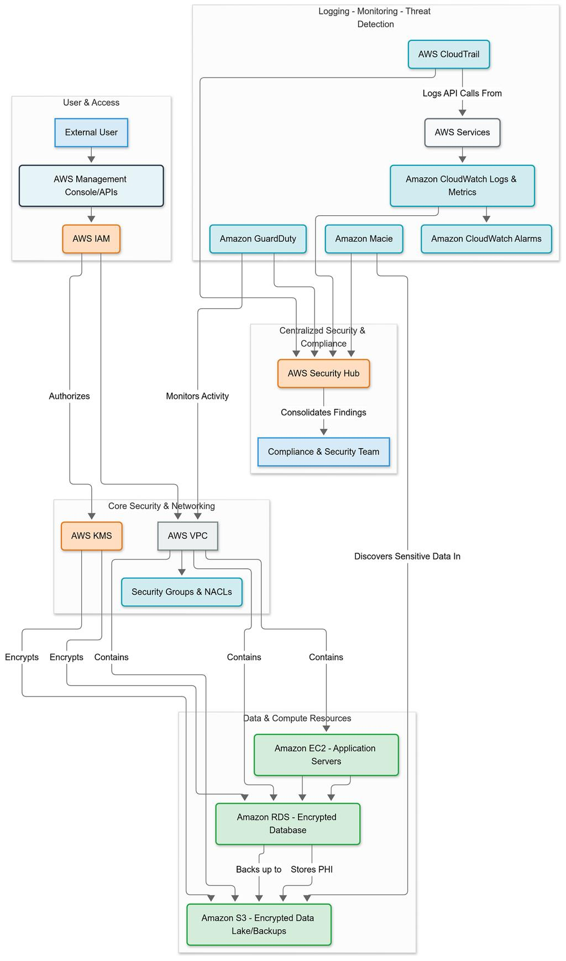
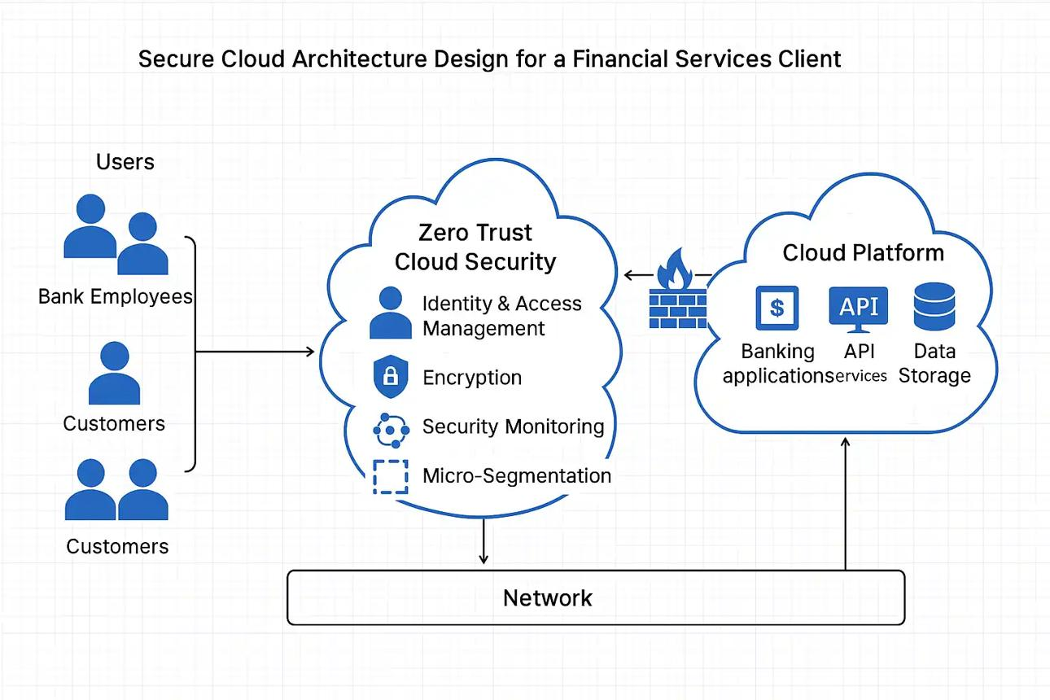

1. How Cloud Providers Support Regulatory Compliance
Financial institutions must comply with strict standards such as:
- PCI-DSS (payment security)
- GDPR (data protection)
- ISO 27001 (information security)

Cloud Provider Support
- Built-in Compliance Certifications
  - Providers undergo regular third-party audits
- Shared Responsibility Model
  - Provider secures infrastructure
  - Customer secures data & access
- Compliance Tools
  - Policy enforcement
  - Automated compliance checks
Helps organizations meet legal and industry requirements efficiently

2. Role of Logging, Monitoring & Auditing

Logging
- Records:
  - User activities
  - API calls
  - System changes
Enables audit trails for investigations

Monitoring
- Tracks:
  - System performance
  - Security events
- Detects anomalies (e.g., unusual login attempts)

Auditing
- Regular review of logs and configurations
- Ensures compliance with regulations
Combined effect:
- Transparency
- Accountability
- Faster incident response

3. Role of Encryption in Security

Data Protection Layers

1. Data at Rest
- Encrypt stored financial data (e.g., account details)

2. Data in Transit
- Use TLS/SSL for secure communication

3. Key Management
- Use secure key services (KMS/HSM)
- Rotate keys regularly
Prevents:
- Data breaches
- Unauthorized access

4. Ensuring Data Sovereignty

What is Data Sovereignty?
Data must be stored and processed within specific geographic boundaries as per regulations.

Implementation Strategies
- Region Selection
  - Store data in approved country/region
- Geo-Fencing
  - Restrict data movement across borders
- Dedicated Cloud Regions
  - Government/financial-specific zones
- Access Controls
  - Limit access to authorized jurisdictions
Ensures compliance with national laws

5. Real-World Example: Financial Transactions

Scenario:
A bank processes online payments and fund transfers.

Security Implementation:
- Transaction data encrypted end-to-end
- All activities logged (who accessed what, when)
- Monitoring detects suspicious transactions (fraud detection)
- Data stored only in country-specific cloud region

Example Event:
- Unusual large transfer detected
- Monitoring triggers alert
- Logs reviewed for audit
- Transaction temporarily blocked
Ensures:
- Fraud prevention
- Regulatory compliance
- Customer trust

Summary
Component | Role
Compliance Tools | Meet legal standards
Logging | Maintain audit trails
Monitoring | Detect threats
Encryption | Protect sensitive data
Data Sovereignty | Ensure legal data location

Final Insight
Cloud providers enable financial institutions to achieve high security and regulatory compliance through:
- Built-in compliance frameworks
- Strong logging and auditing capabilities
- End-to-end encryption
- Strict data residency controls
When properly configured, the cloud can be as secure or more secure than traditional systems, while still offering scalability and efficiency.

5. A development team wants to adopt containerization for application deployment. Explain how containers differ from virtual machines in terms of performance and resource usage. How does orchestration (like Kubernetes) simplify deployment and scaling? Discuss portability benefits across different cloud environments. Provide an example of a microservices-based application.

Containers vs Virtual Machines (VMs)

Architecture Comparison
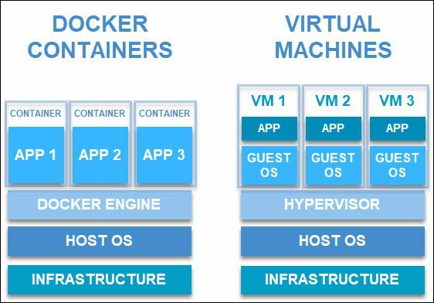
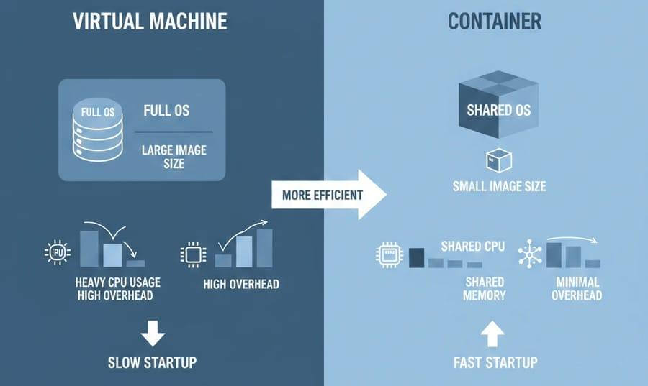
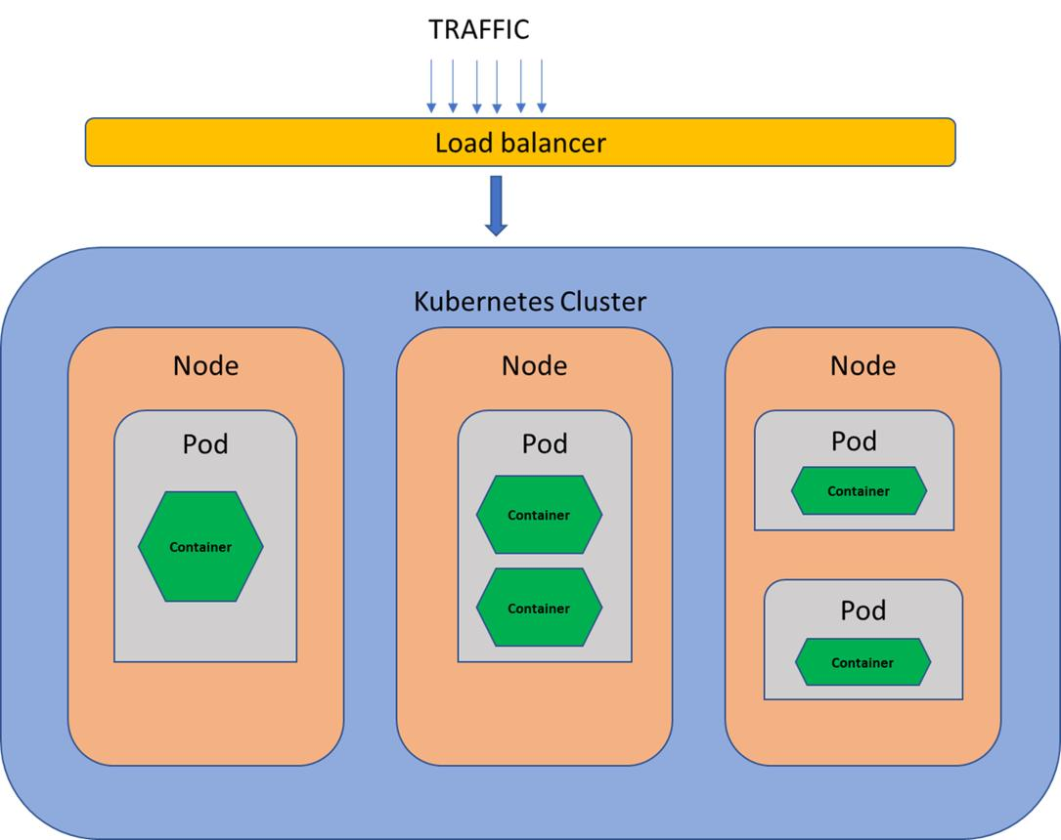

1. Performance & Resource Usage

Virtual Machines (VMs)
- Each VM runs:
  - Full guest OS
  - Applications + dependencies
- Uses a hypervisor layer
Impact:
- Higher memory & CPU usage
- Slower startup (minutes)
- Strong isolation

Containers
- Share the host OS kernel
- Package only:
  - Application + dependencies
Impact:
- Lightweight (low resource usage)
- Fast startup (seconds)
- High density (more apps per server)

Key Differences
Feature | Virtual Machines | Containers
OS | Separate OS per VM | Shared OS
Startup Time | Slow | Fast
Resource Usage | High | Low
Performance | Moderate | Near-native
Isolation | Strong | Moderate

2. Role of Orchestration (Kubernetes)

What is Kubernetes?
Kubernetes is a platform for automating container deployment and management.

Key Capabilities

Automated Deployment
- Deploy containers using declarative configs (YAML)

Auto-Scaling
- Scale pods based on demand (CPU, traffic)

Self-Healing
- Restart failed containers automatically

Service Discovery & Load Balancing
- Automatically route traffic to containers

Result
- Simplifies managing large-scale applications
- Reduces manual intervention

3. Portability Across Clouds

Container Portability
- Containers include all dependencies
- Run consistently on:
  - Any cloud
  - On-premises
  - Developer laptops

Multi-Cloud Flexibility
- Same container image works on:
  - AWS
  - Azure
  - Google Cloud
Eliminates “it works on my machine” problem

4. Example: Microservices-Based Application

E-commerce Platform

Microservices Structure
- User Service
- Product Catalog
- Payment Service
- Order Service
- Notification Service

How Containers Help
- Each service runs in its own container
- Independently deployable
- Scales separately based on demand

With Kubernetes
- Automatically scales payment service during peak checkout
- Restarts failed services
- Balances traffic across instances

Summary
Aspect | Benefit
Containers | Lightweight, fast, efficient
Kubernetes | Automation, scaling, reliability
Portability | Run anywhere consistently
Microservices | Modular, scalable architecture

Final Insight
Containers + orchestration enable:
- High performance with low resource usage
- Automated scaling and resilience
- Seamless portability across environments
This makes them ideal for modern cloud-native applications, especially microservices architectures that require flexibility and scalability.

Application Based Questions Rubric
Criteria | Weightage | Level 4 -  Exemplary | Level 3 -  Proficient | Level 2 -  Developing | Level 1 -  Beginning
Relevance to  Application | 25% | Response  directly  addresses the given use case with strong  relevance | Mostly  relevant  response | Partially  relevant | Weak  relevance
Use of Cloud Concepts | 25% | Applies  appropriate  concepts  accurately | Mostly  accurate  application | Basic  application  only | Incorrect  concept usage
Practical  Insight | 20% | Shows strong real-world  understanding | Shows  reasonable  practical  understanding | Limited  practical  insight | No practical  insight
Completeness | 15% | Response  covers all  required  aspects | Covers most  aspects | Covers only  basic aspects | Incomplete  response
Clarity | 15% | Clear and  concise answer | Generally clear | Some  confusion in  expression | Poor clarity

