SIMATS ENGINEERING

ASSESSMENT TOOL 1: Analytical Problem Solving

COURSE NAME: Cloud Computing and
Big Data Analytics
COURSE CODE: CSA15

COURSE OUTCOME COVERED
CO2: Analyze virtualization architectures to identify performance and security issues in cloud computing environments. (BL3)

Dave's Taxonomy: Manipulation (Level 2) Question Count: 5

Total Marks: 50

Code of Conduct
I R.MOHANRAM/192521117 (Name / Reg No) certify that this submission is my original work and that I have adhered to the guidelines specified for this assessment.
I understand that any violation of academic integrity rules will result in disciplinary action. Signature of the student: mohanram

Assessment Tasks Analytical Problem Solving
- Compare Type-1 and Type-2 hypervisors for a cloud datacenter hosting mission-critical applications. Analyze performance, security, and manageability, then justify the better choice.

Comparison of Type-1 and Type-2 Hypervisors
A hypervisor is software that enables virtualization by allowing multiple virtual machines (VMs) to run on a single physical system. Hypervisors are broadly classified into Type-1 (bare-metal) and Type-2 (hosted).

Type-1 Hypervisor (Bare-Metal)
- Installed directly on physical hardware.
- Does not require a host operating system.
- Examples: VMware ESXi, Microsoft Hyper-V.
Type-2 Hypervisor (Hosted)
- Installed on top of an existing operating system.
- Depends on the host OS for resource management.
- Examples: Oracle VirtualBox, VMware Workstation.

Performance Analysis
- Type-1: Offers high performance because it interacts directly with hardware, reducing overhead.
- Type-2: Has lower performance due to the additional host OS layer, which increases latency.

Security Analysis
- Type-1: More secure since it has a smaller attack surface and fewer software layers.
- Type-2: Less secure because vulnerabilities in the host OS can affect all virtual machines.

Manageability Analysis
- Type-1: Provides centralized control, better scalability, and is suitable for large cloud datacenters.
- Type-2: Easier to use for development and testing but not suitable for large-scale deployment.

Conclusion (Justification)
For a cloud datacenter hosting mission-critical applications, the Type-1 hypervisor is the better choice because it:
- Delivers superior performance
- Ensures stronger security
- Supports efficient and scalable management
Thus, Type-1 hypervisors are widely used in enterprise cloud environments.
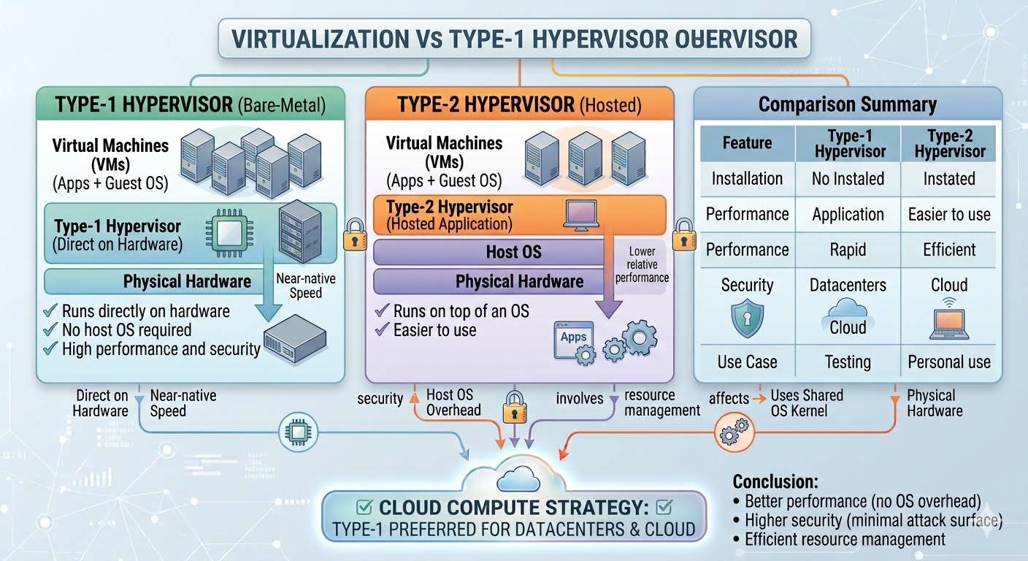

- A cloud provider must isolate workloads belonging to finance, healthcare, and student portals on the same hardware. Analyze how virtualization architecture supports isolation and identify two major attack surfaces.

🔷 Virtualization Architecture for Isolation
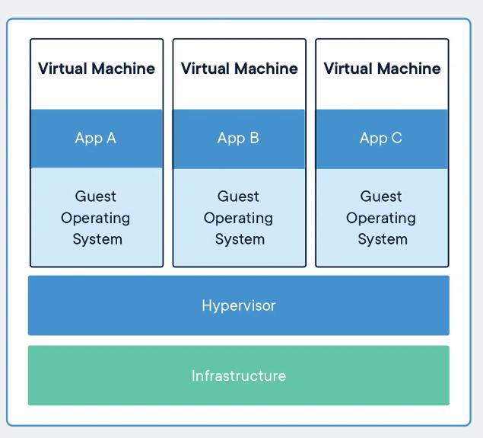
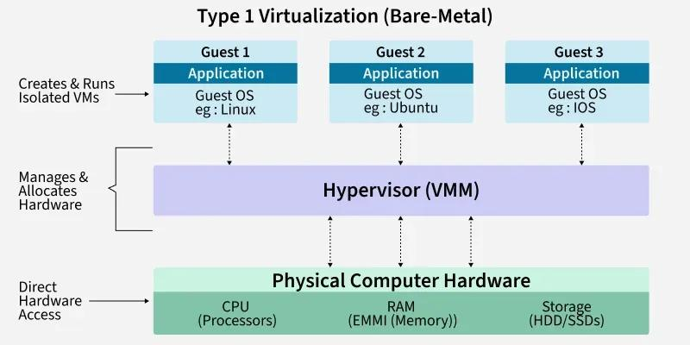

Layered Structure
- Physical Hardware
  - CPU, memory, storage, network
- Hypervisor (Virtual Machine Monitor - VMM)
  - Core component that abstracts hardware
  - Two types:
    - Type 1 (bare-metal)
    - Type 2 (hosted)
- Virtual Machines (VMs)
  - Each VM has:
    - Guest OS
    - Applications (finance, healthcare, student portals)

How Isolation is Achieved
1. Memory Isolation
- Each VM gets its own virtual memory space
- Hypervisor maps virtual → physical memory
- Prevents one VM from accessing another’s data
2. CPU Isolation
- CPU scheduling ensures each VM runs independently
- Privileged instructions are controlled by hypervisor
3. Storage Isolation
- Virtual disks are separated
- File systems are sandboxed
4. Network Isolation
- Virtual switches, VLANs, and software-defined networking
- Prevents unauthorized traffic between workloads
5. Privilege Separation
- Guest OS runs in non-privileged mode
- Hypervisor runs in highest privilege level

Major Attack Surfaces
Even with isolation, some vulnerabilities exist:

1. Hypervisor Attack Surface (VM Escape)

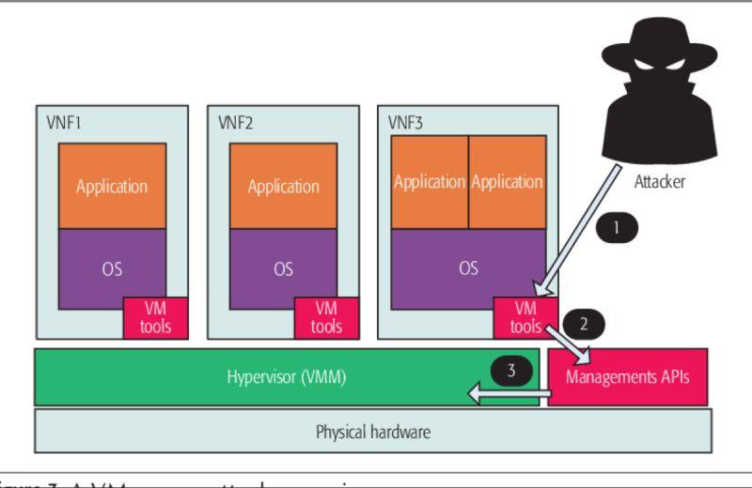

- Definition: When an attacker escapes from a VM to the hypervisor or other VMs
- Impact:
  - Cross-tenant data breach (e.g., finance data exposed to student portal)
- Causes:
  - Bugs in hypervisor
  - Improper isolation enforcement

2. Shared Resource Side-Channel Attacks

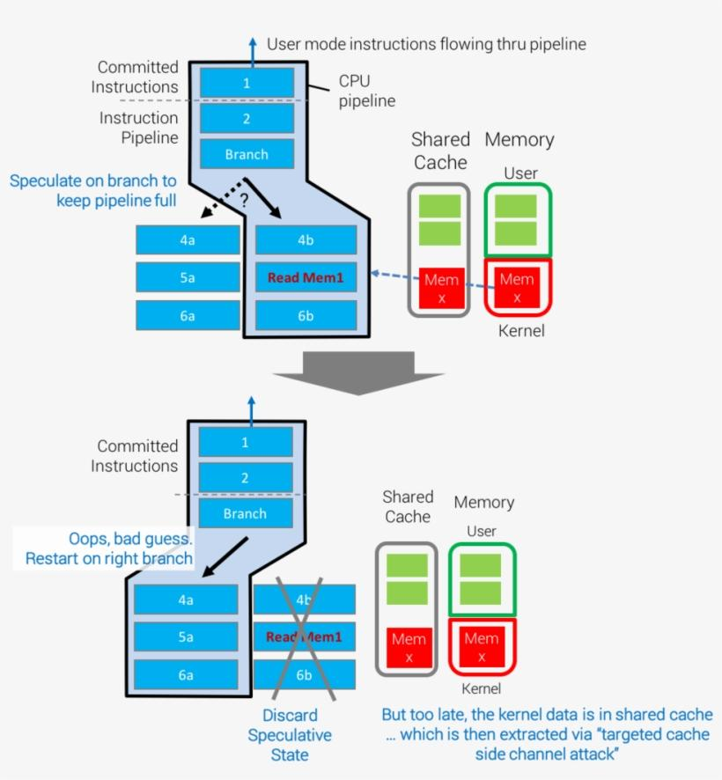

- Definition: Exploiting shared hardware (CPU cache, memory bus)
- Examples:
  - Cache timing attacks
  - Spectre/Meltdown-style leaks
- Impact:
  - Sensitive data leakage across VMs without direct access

Summary
- Virtualization uses a hypervisor-based layered model to isolate workloads.
- Isolation is enforced via:
  - Memory, CPU, storage, and network separation
- However, two key risks remain:
  - VM escape (hypervisor compromise)
  - Side-channel attacks (shared hardware leakage)

- Study the following VM host utilization snapshot and recommend corrective actions: CPU 92%, memory 88%, storage I/O latency 35 ms, average VM boot time 170 s. Explain the likely bottlenecks.
VM Host Utilization Analysis
Overall Architecture & Resource Stress Points
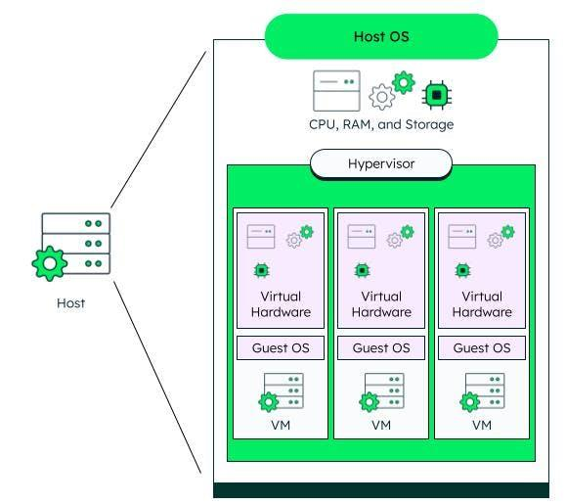

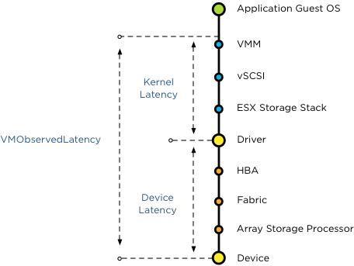

Observed Metrics
- CPU Usage: 92% (Critical)
- Memory Usage: 88% (Near saturation)
- Storage I/O Latency: 35 ms (High; ideal <10 ms)
- VM Boot Time: 170 seconds (Slow)

Likely Bottlenecks (Analysis)
1. CPU Bottleneck
- At 92% utilization, CPU is heavily overcommitted.
- Effects:
  - VM scheduling delays
  - Increased ready time (VMs waiting for CPU)
  - Slower application response
Root cause:
- Too many VMs per host
- CPU overcommit ratio too high

2. Memory Pressure
- At 88% usage, system is close to exhaustion.
- Hypervisor may trigger:
  - Ballooning
  - Swapping (very slow)
Effects:
- Performance degradation
- Increased disk I/O due to swapping

3. Storage I/O Bottleneck (Critical)
- 35 ms latency is very high (normal: 1–10 ms)
Effects:
- Slow VM boot (170 seconds confirms this)
- Application lag
- Backup/snapshot delays
Root causes:
- Disk contention (too many VMs sharing storage)
- Slow storage backend (HDD instead of SSD/NVMe)
- Insufficient IOPS capacity

4. VM Boot Delay
- Boot time (170s) strongly linked to:
  - High disk latency
  - Memory pressure
  - CPU contention

Recommended Corrective Actions
CPU Optimization
- Reduce VM density per host
- Apply CPU affinity / reservations
- Scale out: add more physical hosts
- Enable workload balancing (e.g., live migration)

Memory Optimization
- Add more RAM to host
- Reduce memory overcommit
- Tune ballooning/swapping thresholds
- Right-size VMs (remove unused memory allocation)

Storage Improvements (Highest Priority)
- Move to SSD/NVMe storage
- Increase IOPS capacity
- Use storage tiering
- Separate workloads (finance, healthcare, student portals) across different datastores
- Enable caching (read/write cache)

VM Boot Performance
- Use golden images / templates
- Enable linked clones
- Optimize OS startup services
- Use faster storage (main fix)

Summary Diagram of Bottlenecks
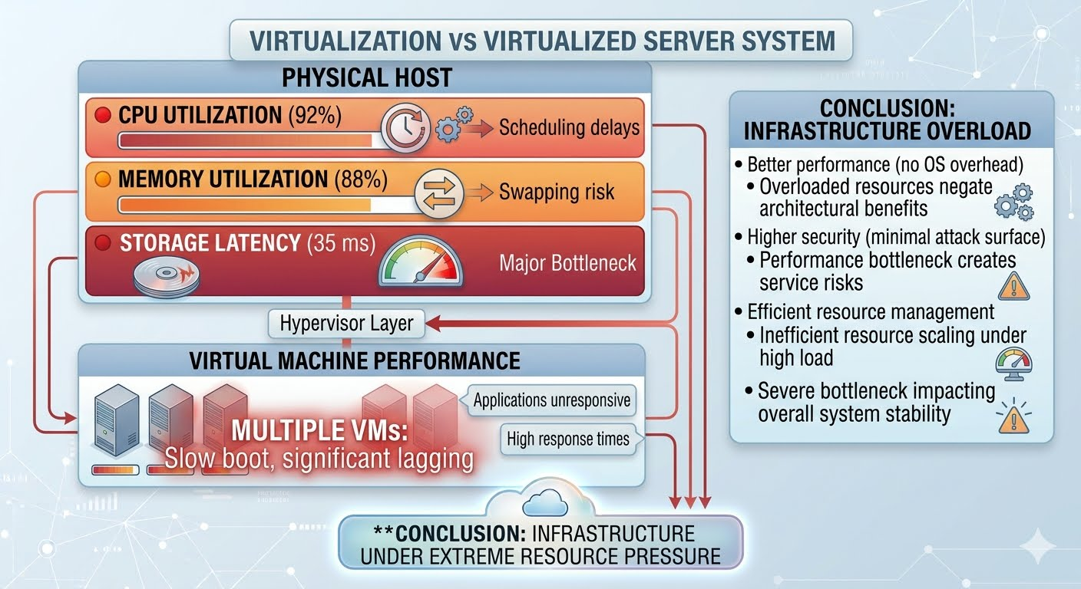
Final Insight
Primary bottleneck: Storage I/O latency
Secondary issues: CPU overcommit + memory pressure
Fix storage first → biggest performance gain
Then rebalance CPU & memory workloads

- Analyze how Software Defined Datacenter architecture improves agility compared with a traditional datacenter. Support your answer with compute, storage, and network virtualization considerations.

Software-Defined Datacenter (SDDC) vs Traditional Datacenter
Traditional vs SDDC Architecture
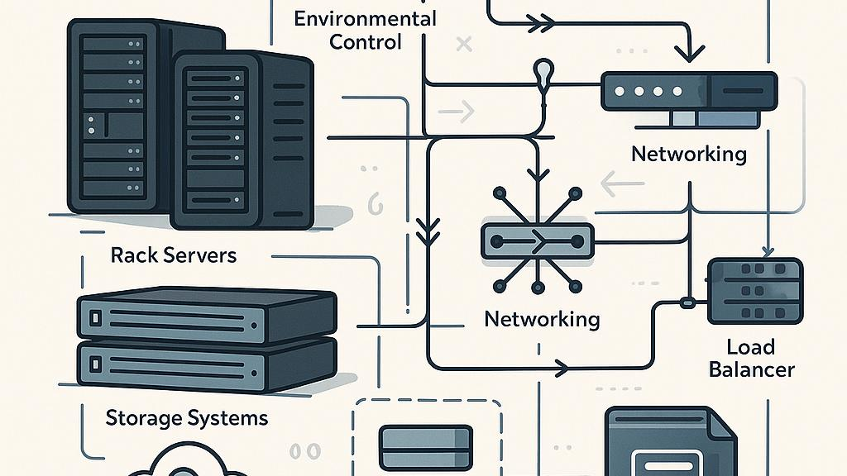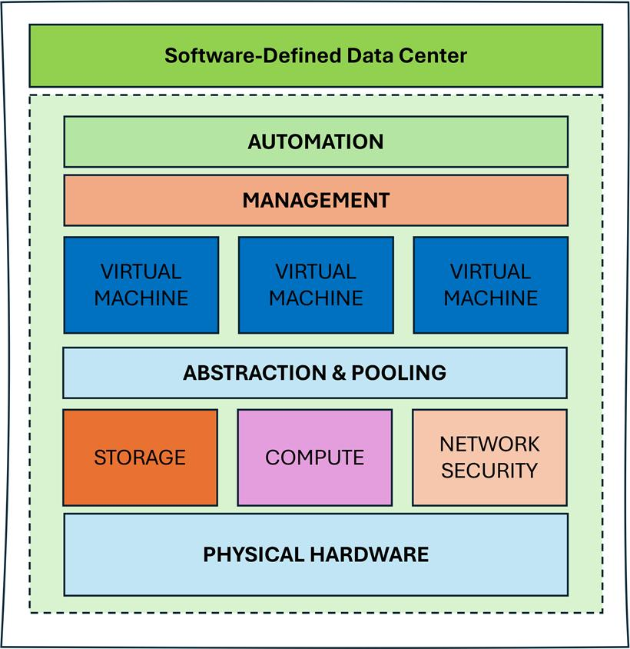

What Changes with SDDC?
A Software-Defined Data center (SDDC) abstracts compute, storage, and networking from hardware and manages them via software, APIs, and automation.
Traditional DC = Hardware-centric, manual
SDDC = Software-driven, automated, programmable

How SDDC Improves Agility
1. Compute Virtualization
Traditional:
- Physical servers manually provisioned
- Long setup times (days/weeks)
SDDC:
- Virtual Machines (VMs) or containers provisioned instantly
- Workloads can be migrated (live migration)
Agility Gains:
- Rapid scaling (scale up/down in minutes)
- Dynamic workload placement
- Better resource utilization

2. Storage Virtualization
Traditional:
- Dedicated storage arrays (static allocation)
- Manual provisioning (LUNs, RAID configs)
SDDC:
- Storage pooled and abstracted (software-defined storage)
- Policy-based allocation (e.g., performance tiers)
Agility Gains:
- On-demand storage provisioning
- Automated scaling & replication
- Faster backup and recovery

3. Network Virtualization
Traditional:
- Hardware-based networking (switches, routers)
- Manual configuration (VLANs, ACLs)
SDDC:
- Software-defined networking (SDN)
- Virtual networks, micro-segmentation
Agility Gains:
- Instant network provisioning
- Automated security policies
- Easy workload mobility across networks

End-to-End Automation

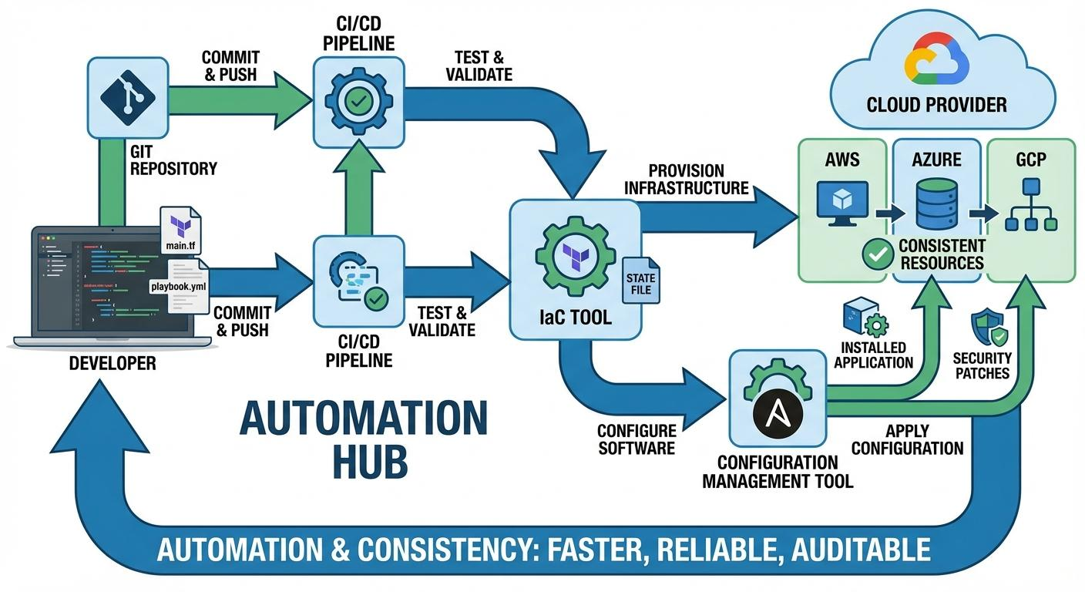

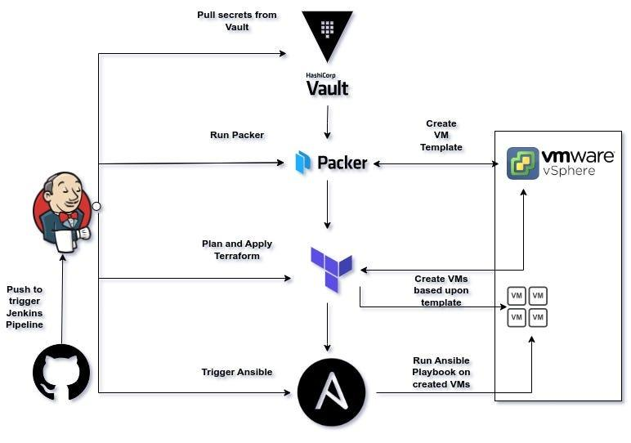
SDDC enables:
- Infrastructure as Code (IaC)
- Self-service provisioning
- API-driven orchestration
Result:
- Deploy entire environments in minutes instead of weeks

Key Agility Comparison
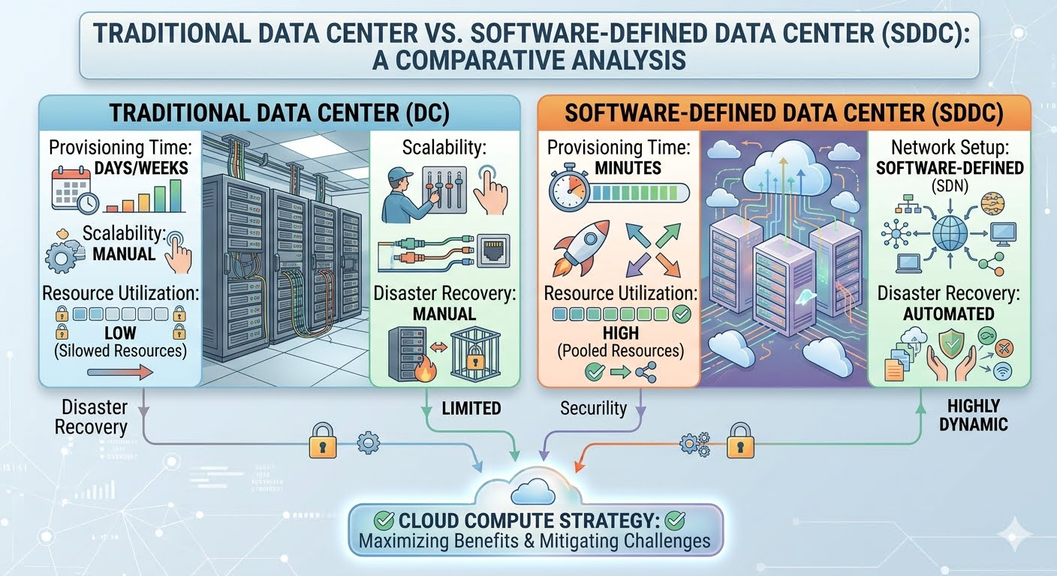
Final Insight
Compute virtualization → instant workload deployment
Storage virtualization → flexible, policy-driven storage
Network virtualization → programmable, secure connectivity
Together, these make SDDC:
- Faster
- More flexible
- Highly automated
Conclusion:
SDDC dramatically improves agility by transforming infrastructure from static hardware systems into dynamic, software-controlled services, enabling rapid provisioning, scaling, and innovation.

5. A multi-cloud federation project fails due to identity mismatches between providers. Analyze the issue and propose a secure identity and privacy design using federation concepts.

Multi-Cloud Federation Failure: Identity Mismatch Analysis & Secure Design
Where the Problem Happens
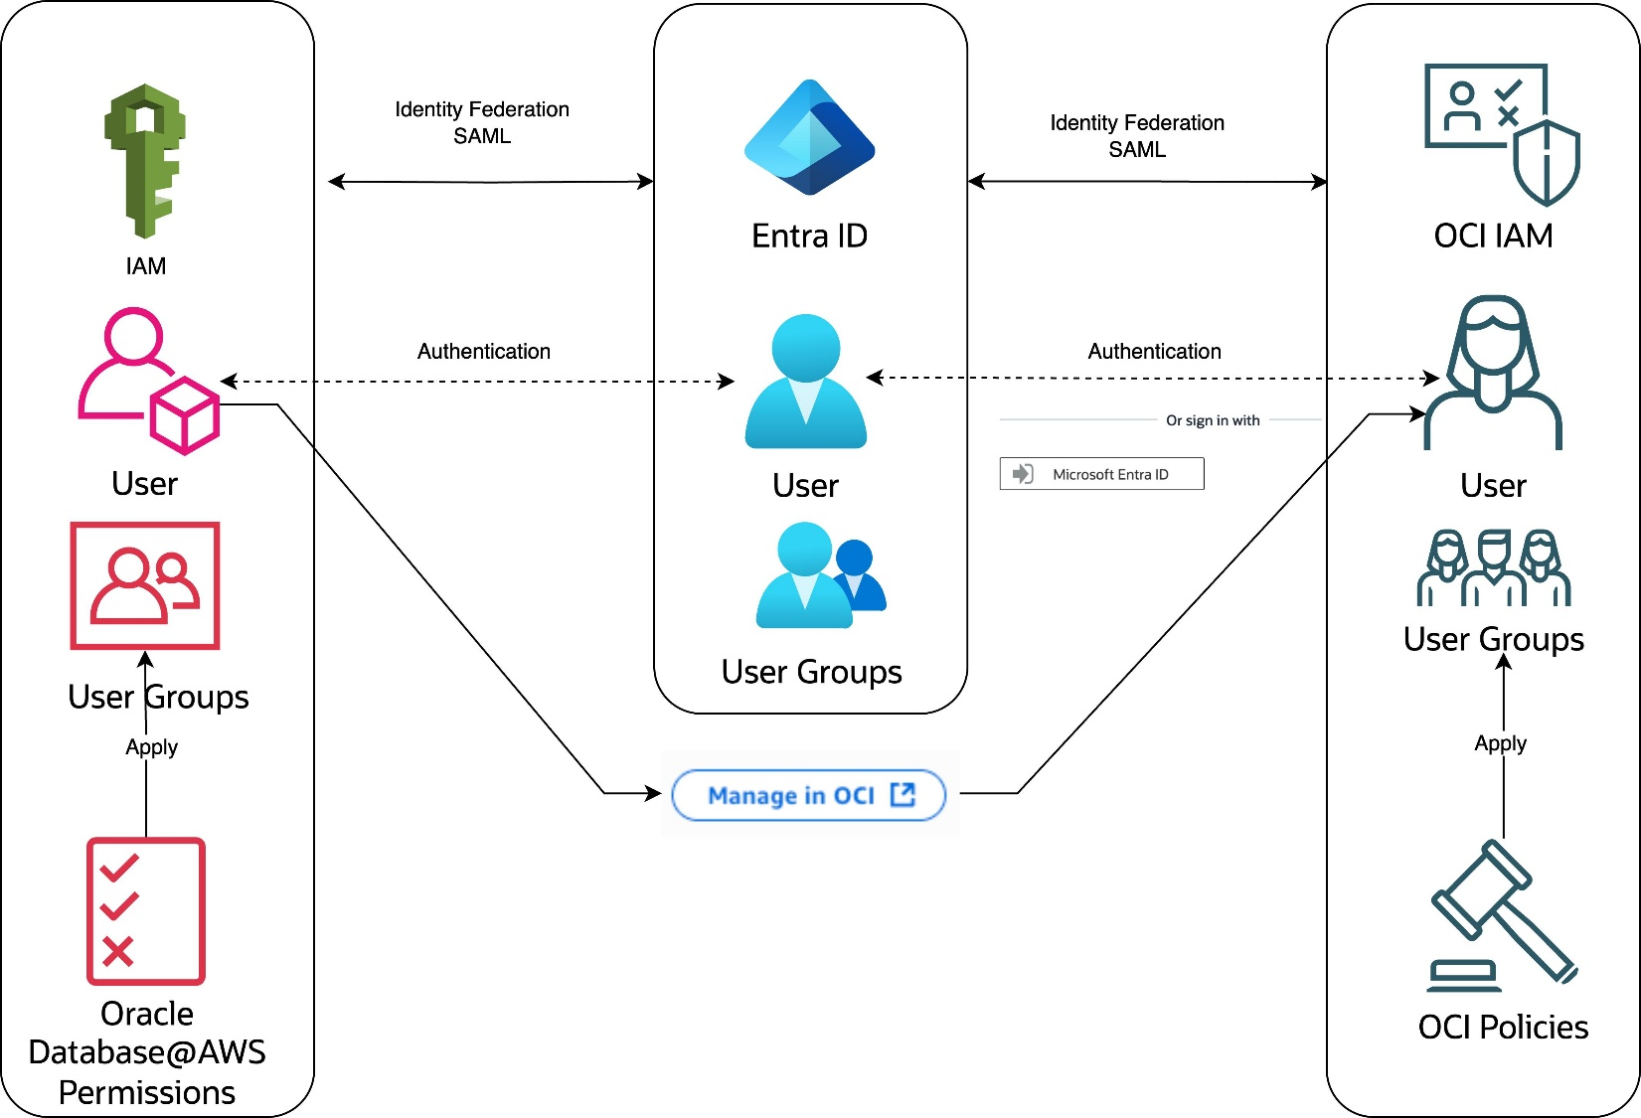

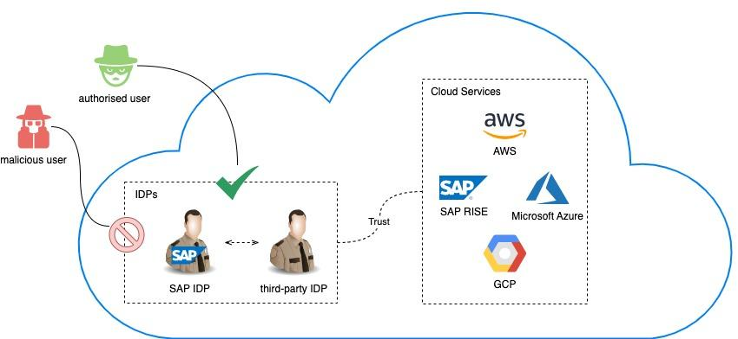

Root Cause Analysis: Why Identity Mismatches Occur
In a multi-cloud federation, different providers (AWS, Azure, GCP, etc.) maintain separate identity systems. Failures typically arise due to:
1. Inconsistent Identity Formats
- One provider uses email (user@org.com)
- Another uses UUIDs or usernames
No universal identity mapping → authentication breaks

2. Lack of a Common Identity Provider (IdP)
- Each cloud has its own authentication mechanism
- No centralized trust anchor
Leads to:
- Duplicate identities
- Broken Single Sign-On (SSO)

3. Attribute Mapping Issues
- Roles/claims differ across providers
  - Example: admin vs superuser
- Missing or misinterpreted attributes

4. Token/Protocol Incompatibility
- One uses SAML, another uses OAuth2/OpenID Connect (OIDC)
- Token validation rules differ

5 .Privacy & Compliance Gaps
- Over-sharing identity attributes
- No clear data minimization policy

Secure Identity & Privacy Design (Federation-Based)
1. Central Identity Provider (IdP)
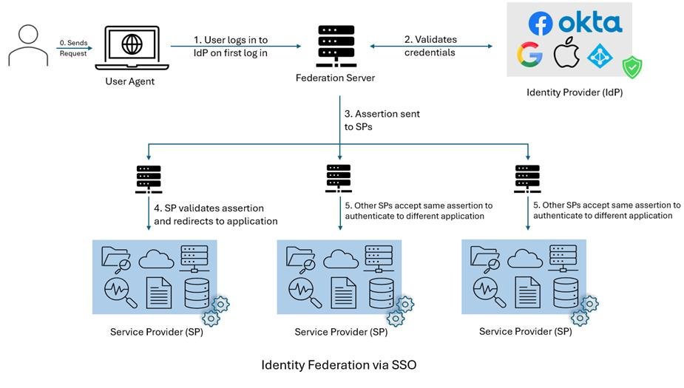

Use a trusted IdP such as:
- Azure AD / Okta / Keycloak
Benefits:
- Single source of truth
- Enables SSO across clouds

2. Federation Protocol Standardization
Adopt common protocols:
- SAML 2.0 → enterprise SSO
- OpenID Connect (OIDC) → modern apps
- OAuth 2.0 → authorization
All providers must trust the same protocol & tokens

3. Unified Identity Schema
- Use a global unique identifier (GUID) per user
- Standardize attributes:
  - user_id
  - email
  - role
  - department
Implement attribute mapping rules across clouds

4. Role-Based Access Control (RBAC)
- Define roles centrally at IdP
- Map roles consistently:
  - admin → admin
  - viewer → read-only
Avoid role ambiguity

5. Privacy-by-Design Principles
- Data minimization: Share only required attributes
- Token scoping: Limit permissions
- Encryption:
  - Tokens signed (JWT)
  - Data encrypted in transit (TLS)
Comply with regulations (GDPR, HIPAA)

6. Trust Relationships
- Establish federation trust:
  - IdP ↔ Cloud Providers (Service Providers)
Use:
- Digital certificates
- Token validation policies

7. Identity Lifecycle Management
- Automated:
  - Provisioning (create users)
  - Deprovisioning (remove access instantly)
Prevents orphan accounts

Secure Federation Flow
User → IdP (Authenticate)
→ Token Issued (SAML/OIDC)
→ Cloud Provider (Trusts IdP)
→ Access Granted based on Role

Summary of Fix
Issue | Solution
Identity mismatch | Global unique identity
Multiple auth systems | Central IdP
Attribute inconsistency | Standard schema
Protocol differences | Use SAML/OIDC
Privacy risks | Minimize & encrypt data

Final Insight
The failure occurred because identity was fragmented across clouds.
A federated identity model with a central IdP, standardized protocols, and privacy controls ensures:
- Seamless access (SSO)
- Strong security
- Regulatory compliance

Analytical Problem Solving Rubric

Criteria | Weightage | Level 4 - Exemplary | Level 3 – Proficient | Level 2 - Developing | Level 1 - Beginning
Problem Interpretation | 20% | Interprets all technical requirements  accurately | Interprets most requirements correctly | Partial interpretation | Misinterprets the problem
Analytical Reasoning | 25% | Strong reasoning with clear  cause-effect analysis | Good reasoning with minor gaps | Basic analysis only | Weak or no analysis
Method Selection | 20% | Chooses highly appropriate virtualization and  security concepts | Chooses mostly suitable concepts | Partially suitable concepts | Inappropriate approach
Solution Quality | 20% | Provides feasible and technically sound solution | Reasonable solution with minor issues | Basic solution with limitations | Unclear or invalid solution
Presentation of Analysis | 15% | Well-structured and technically  precise | Generally clear | Somewhat unclear | Difficult to follow

Total Marks Awarded:

