FEDERATED LEARNING-BASED
PRIVACY-PRESERVING BIG DATA ANALYTICS ON CLOUD
A CAPSTONE PROJECT REPORT
Submitted in partial fulfilment of the requirements for

CSA1516 - CLOUD COMPUTING AND BIG DATA ANALYTICS
for the award of the degree of
BACHELOR OF TECHNOLOGY
IN
INFORMATION TECHNOLOGY

Submitted by
R MOHANRAM-192521117
JOTHIPRAKASH M-192573009

Under the Supervision of
Dr. SANTHIYA LAKSHMI K

SIMATS ENGINEERING
Saveetha Institute of Medical and Technical Sciences
Chennai-602105
SEPTEMBER 2026
SIMATS ENGINEERING
Saveetha Institute of Medical and Technical Sciences
Chennai-602105
BONAFIDE CERTIFICATE
This is to certify that the Capstone Project entitled “Federated Learning-Based Privacy-Preserving Big Data Analytics on Cloud” has been carried out by R MOHANRAM-192521117and JOTHIPRAKASH M-192573009 under the supervision of Dr. Santhiya Lakshmi K and is submitted in partial fulfilment of the requirements for the current semester of the B.Tech Information Technology at SIMATS Engineering, Saveetha Institute of Medical and Technical Sciences, Chennai.
The project work, testing records and technical outcomes presented in this report are based on the implemented Python, PyTorch, Flower, Microsoft Azure Blob Storage and Streamlit system.

COURSE COORDINATOR COURSE FACULTY
Dr. A Gnana Soundari, Dr. K Santhiya Lakshmi,
Professor Professor
CSE / Machine Learning CSE
SIMATS Engineering, SIMATS Engineering,
SIMATS, Chennai – 602105. SIMATS, Chennai – 602105.

SIMATS ENGINEERING
Saveetha Institute of Medical and Technical Sciences
Chennai-602105

DECLARATION
We, R MOHANRAM-192521117 and JOTHIPRAKASH-192573009, hereby declare that the Capstone Project Work entitled “Federated Learning-Based Privacy-Preserving Big Data Analytics on Cloud” is the result of our own bonafide efforts. To the best of our knowledge, the work presented herein is original, accurate and carried out in accordance with engineering ethics and academic integrity. All sources, references, software, datasets, cloud resources, open-source libraries and AI-assisted resources used during the project have been acknowledged. We declare that the data, results, analysis and findings presented in this report have not been fabricated, falsified or manipulated. The reported performance values are derived from the implemented project outputs and execution logs. We further confirm that the privacy statements in this report describe the implemented federated workflow only. The system keeps raw client data local and communicates model parameters/updates; advanced mechanisms such as differential privacy and cryptographic secure aggregation are identified as future enhancements rather than claimed implemented features.
Place: Chennai
Date: September 2026
Signature of the Students with Names
R MOHANRAM-192521117
JOTHIPRAKASH M-192573009

SIMATS ENGINEERING
Saveetha Institute of Medical and Technical Sciences
Chennai-602105

INDIVIDUAL CONTRIBUTION STATEMENT
Student / Register No. | Specific Responsibilities | Design & Development | Testing & Analysis | Report Contribution | Approx. Contribution (%)
R MOHANRAM-192521117 | Federated server/client integration; Azure integration; dashboard; model validation | Designed and implemented core FL, Azure and dashboard workflow | Executed federated rounds, Azure prediction, analytics and integrity verification | Methodology, implementation, results, report consolidation | 50%
JOTHIPRAKASH M-192573009 | Dataset preparation; local client workflow; testing support; documentation | Supported client-side implementation and analytics | Assisted in client testing, output checking and result documentation | Literature review, documentation and presentation support | 50%
Total |  |  |  |  | 100%

ABSTRACT
The rapid growth of distributed and data-intensive applications creates an engineering requirement for collaborative machine learning without unnecessary centralization of raw client data. This project develops a Federated Learning-Based Privacy-Preserving Big Data Analytics on Cloud system that combines local model training, Federated Averaging (FedAvg), cloud storage and interactive analytics. Two clients are configured with 30 input features. Client 1 uses 227 training samples and Client 2 uses 228 training samples, giving 455 training samples in total; the combined test set contains 228 samples. Each client performs local training using a PyTorch feed-forward neural network and communicates model information to a Flower federated server. The server aggregates the participating models using FedAvg for three communication rounds. The recorded federated evaluation accuracy increases from 92.97% in Round 1 to 93.41% in Round 3, an improvement of 0.44 percentage points. The resulting global model contains 4,097 parameters and has a file size of 19,537 bytes. The model and project outputs are stored in Microsoft Azure Blob Storage. The stored model is downloaded for an independent evaluation and produces 201 correct predictions out of 228 test samples, corresponding to 88.16% accuracy. SHA-256 comparison confirms that the locally stored global model and the Azure-downloaded model are identical. A Streamlit dashboard provides federated accuracy visualization, dataset analytics, Azure status, model-integrity verification and live 30-feature prediction. The project demonstrates an end-to-end federated learning workflow that preserves the locality of raw client datasets while using cloud storage for model and analytics artifacts.
Keywords: Federated Learning, Privacy Preservation, FedAvg, Big Data Analytics, Azure Blob Storage, Streamlit

TABLE OF CONTENTS
Sl.  No | Title | Page  No
i | CERTIFICATE FROM THE SUPERVISOR | 2
ii | DECLARATION BY THE CANDIDATE | 3
Iii | INDIVIDUAL CONTRIBUTION STATEMENT | 4
iv | ABSTRACT | 5
v | LIST OF FIGURES | 8
vi | LIST OF TABLES | 9
vii | LIST OF ABBREVIATIONS | 10
1 | CHAPTER 1: Introduction | 11
 | 1.1 Background | 11
 | 1.2 Need for the Project | 11
 | 1.3 Problem Statement | 11
 | 1.4 Project Aim | 12
 | 1.5 Project Objectives | 12
 | 1.6 Scope | 12
 | 1.7 Expected Engineering Outcome | 12
2 | CHAPTER 2: Literature Review | 13
 | 2.1 Review Method | 13
 | 2.2 Review of Existing Work | 13
 | 2.3 Comparative Analysis | 14
 | 2.4 Research / Engineering Gap | 15
 | 2.5 Proposed Contribution | 15
3 | CHAPTER 3: Engineering Design & Trade-offs, Sustainability,  Ethics, Safety, Risk & Security | 16
 | 3.1 Requirements | 16
 | 3.2 Constraints & Applicable Standards | 17
 | 3.3 Design Specifications | 17
 | 3.4 Alternative Solutions & Evaluation | 18
 | 3.5 Selected Design & Detailed Design | 19
 | 3.6 Trade-off Analysis | 20
 | 3.7 Sustainability, Ethics, Safety, Risk & Security | 21
4 | CHAPTER 4: Implementation, Testing & Results, Project  Management | 23
 | 4.1 Development Approach & Resources | 23
 | 4.2 Hardware / Software / Modern Tools | 23
 | 4.3 Test Plan & Verification | 24
 | 4.4 Results | 25
 | 4.5 Data Analysis & Engineering Judgment | 28
 | 4.6 Comparison with Existing Solutions & Achievement of Objectives | 28
 | 4.7 Strengths & Limitations | 29
 | 4.8 Project Planning, Roles & Budget | 29
5 | CHAPTER 5: Conclusion & Reflection | 31
 | 5.1 Conclusion | 31
 | 5.2 Future Work | 31
 | 5.3 Professional Learning & Individual Reflection | 31
 | References | 33
 | Appendices | 34

LIST OF FIGURES
Figure No. | Figure Name | Page No.
Figure 3.1 | Proposed system architecture | 19
Figure 4.1 | Federated learning accuracy across rounds | 25
Figure 4.2 | Client-wise dataset size | 26
Figure 4.3 | Global class distribution | 26
Figure 4.4 | Independent Azure global-model evaluation | 27
Figure 4.5 | Azure model verification workflow | 27
Figure 4.6 | Streamlit dashboard functional layout | 34

LIST OF TABLES
Table No. | Table Name | Page No.
Table 1.1 | Project objectives | 12
Table 2.1 | Literature review matrix | 13
Table 2.2 | Comparison of existing approaches | 14
Table 3.1 | Stakeholder and functional requirements | 16
Table 3.2 | Non-functional requirements | 17
Table 3.3 | Applicable standards and engineering constraints | 17
Table 3.4 | Design specifications | 18
Table 3.5 | Alternative solution evaluation | 20
Table 3.6 | Trade-off analysis | 20
Table 3.7 | Risk register | 21
Table 4.1 | Development resources | 23
Table 4.2 | Test plan and acceptance criteria | 23
Table 4.3 | Federated accuracy results | 23
Table 4.4 | Azure prediction results | 25
Table 4.5 | Objective achievement matrix | 28
Table 4.6 | Project milestones and roles | 29
Table 4.7 | Estimated project cost | 30

LIST OF ABBREVIATIONS / SYMBOLS
Symbol | Description | Unit
FL | Federated Learning | 5
FedAvg | Federated Averaging | 5
ML | Machine Learning | 3
DL | Deep Learning | 2
AI | Artificial Intelligence | 2
API | Application Programming Interface | 1
JSON | JavaScript Object Notation | 1
SHA-256 | Secure Hash Algorithm - 256 bit | 4
CPU | Central Processing Unit | 2
VM | Virtual Machine | 1
NSG | Network Security Group | 1
PTH | PyTorch model state file | 2
UI | User Interface | 3
F1 | F1-score | 5

CHAPTER 1

INTRODUCTION AND ENGINEERING PROBLEM

1.1 Background
Federated learning is a distributed machine-learning paradigm in which participating clients retain their local datasets and collaborate through model updates. This architecture is relevant to engineering systems where data is generated across devices, departments, sites or organizations and where centralizing all raw data is undesirable. Instead of collecting the complete client datasets at one location, each participating client performs local computation and sends model information to an aggregation service. The global model is then updated and redistributed for further learning.
The proposed capstone applies this principle to a practical cloud-enabled workflow. The project uses two federated clients, a Flower-based server, a PyTorch feed-forward neural network, Microsoft Azure Blob Storage and a Streamlit dashboard. The cloud component does not replace local training; rather, it provides persistent storage for the global model, federated results, analytics and prediction results.

1.2 Need for the Project
Centralized machine-learning workflows can become difficult to manage when raw data is distributed and subject to privacy, ownership, network or governance constraints. Large transfers of training data also introduce bandwidth and storage requirements. An engineering solution should therefore balance model quality, privacy, communication efficiency, cloud persistence and operational visibility.
- Preserve the locality of raw client datasets during the federated workflow.
- Enable multiple clients to contribute to a shared model.
- Reduce the need to centralize raw training datasets.
- Provide persistent cloud storage for model and analytics artifacts.
- Provide verifiable and understandable outputs through a dashboard.

1.3 Problem Statement
The engineering problem is to design and implement a distributed machine-learning system in which two geographically or logically separate clients can perform local model training while a federated server aggregates their model updates without receiving their raw training datasets. The system must additionally provide dataset analytics, cloud-based artifact storage, global-model retrieval, post-storage evaluation and an accessible dashboard.

1.4 Project Aim
To design, implement and validate a federated learning system that combines privacy-preserving local training, FedAvg aggregation, Big Data analytics, Azure cloud storage and an interactive Streamlit dashboard.

1.5 Project Objectives
- Design a two-client federated learning architecture.
- Implement local data preparation and preprocessing.
- Implement a PyTorch classification model using 30 input features.
- Coordinate local training through Flower and aggregate updates using FedAvg.
- Run three communication rounds and record round-wise accuracy.
- Generate client and global Big Data analytics.
- Store results, analytics, the global model and prediction results in Azure Blob Storage.
- Download and independently evaluate the stored global model.
- Verify model integrity using SHA-256.
- Provide a Streamlit dashboard and live 30-feature prediction interface.

1.6 Scope
The scope includes the software implementation of a two-client federated learning prototype, dataset preprocessing, PyTorch model training, Flower orchestration, FedAvg aggregation, analytics generation, Azure Blob Storage integration, independent global-model evaluation, model integrity verification and Streamlit visualization. The scope excludes production-grade cryptographic secure aggregation, differential privacy, a large multi-organization deployment and regulated clinical use.

1.7 Expected Engineering Outcome
The expected outcome is a working software prototype that completes federated communication rounds, produces a global PyTorch model, stores and retrieves project artifacts through Azure, measures model performance and presents the complete workflow through a dashboard. The final implementation satisfies these objectives and provides a reproducible sequence of commands for demonstration.

CHAPTER 2

LITERATURE REVIEW AND EXISTING SOLUTIONS

2.1 Review Method
The literature review focused on recent peer-reviewed work related to federated learning, Big Data analytics, privacy preservation, cloud integration, client selection, aggregation, security and heterogeneous distributed environments. The review matrix was designed to connect each paper to an engineering concept used in the proposed system and to identify a practical limitation that motivates the project contribution.

2.2 Review of Existing Work
Source / Year / Paper Title | Authors | Module / Concept Used | Drawback / Limitation
Elsevier, 2026 - Federated Learning for Big Data: A Survey on Opportunities, Applications, and Future Directions | T. R. Gadekallu, Q.-V. Pham, T. Huynh-The, H. Feng, K. Fang, S. Pandya, M. Liyanage, W. Wang, T. T. Nguyen | Big Data Analytics, FL Architecture, Cloud/Big Data Integration | Scalability, communication, privacy and heterogeneity remain engineering challenges.
MDPI Computers, 2026 - Federated Learning: A Survey of Core Challenges, Current Methods, and Opportunities | M. Baduwal, P. Paudel, V. Chaudhary | Client Selection, Aggregation, Optimization, Privacy | Heterogeneity, computation overhead, communication bottlenecks and practical privacy challenges.
MDPI Electronics, 2026 - A Fairness Perspective on Client Selection and Aggregation Methods for Non-IID Mitigation in Federated Learning: A Survey | M. Alsofyani, I. Alturaiki, H. Mathkour | Client Selection, Non-IID Data, Aggregation | Non-IID data can cause client drift, slower convergence and uneven participation influence.
MDPI Electronics, 2026 - Heterogeneity-Aware Poisoning Attacks and Mitigation in Federated Learning: A Comprehensive Survey and Taxonomy | A. Djemaa, D. Djenouri, P. Legg | Security, Model Aggregation, Attack Detection | Client heterogeneity complicates poisoning detection and mitigation.
MDPI Electronics, 2026 - Blockchain-Enabled Federated Learning: A Survey on System Design, Key Challenges, and Future Directions | L. Zhu, B. Zhao, R. Peng | Privacy, Security, Trust, Decentralized FL | Additional blockchain mechanisms may increase system and resource complexity.
IEEE TNNLS, 2025 - Threats and Defenses in the Federated Learning Life Cycle: A Comprehensive Survey and Challenges | Y. Li, Z. Guo, N. Yang, H. Chen, D. Yuan, W. Ding | Privacy & Security, Secure Aggregation, FL Threats | Privacy leakage, malicious updates and attacks remain relevant across the FL lifecycle.
Elsevier, 2026 - Intent-Based Agentic AI Framework for Privacy-Preserving Cross-Cloud Federated Learning and Green Big Data Analytics in Edge-Cloud Networks | S. Guo, L. Yang, Z. Wang | Cross-Cloud FL, Big Data Analytics, Cloud Integration | Cross-cloud coordination, communication overhead and heterogeneous resources increase complexity.

2.3 Comparative Analysis
Existing Approach | Advantages | Limitations | Relevance to Proposed Work
Centralized ML | Simple centralized training; easy data access | Raw-data transfer and centralized exposure | Motivates local-data federated architecture
Basic Federated Learning | Keeps raw data local; collaborative model training | Communication and heterogeneous data challenges | Forms the core of this project
Secure/advanced FL | Adds stronger privacy/security mechanisms | Higher implementation complexity and resource needs | Identified as future enhancement
Cloud-based FL | Persistent cloud storage and scalable access | Cloud configuration, security and network dependency | Implemented using Azure Blob Storage
Big Data analytics layer | Improves visibility into distributed data | Requires reliable aggregation and analytics pipelines | Implemented with client/global statistics and visualizations

2.4 Research / Engineering Gap
The reviewed literature demonstrates strong progress in federated optimization, privacy, security and cloud-enabled analytics, but practical academic prototypes still benefit from integrated engineering workflows that connect local clients, a working federated server, cloud persistence, model verification and a dashboard. The project addresses this implementation gap by combining these functions in a single reproducible pipeline.

2.5 Proposed Contribution
The contribution of the project is an end-to-end, demonstrable federated learning prototype with two clients, 30 features, three FedAvg communication rounds, Big Data analytics, Azure Blob Storage and post-storage model verification. The contribution is primarily an integrated engineering implementation rather than a new federated optimization algorithm.

CHAPTER 3

ENGINEERING DESIGN & TRADE-OFFS, SUSTAINABILITY, ETHICS, SAFETY, RISK & SECURITY

3.1 Requirements

3.1.1 Stakeholder / User Requirements
Stakeholder | Requirement
Student / Developer | System must be executable locally and on an Azure Linux VM environment.
Project Evaluator | System must provide visible evidence of federated rounds, analytics, model and prediction outputs.
End User / Demonstrator | Dashboard should show system status and allow live prediction using 30 features.
Cloud Administrator | Azure artifacts should be organized in predictable blob paths and downloadable.

3.1.2 Functional Requirements
Requirement | Type | Measurable Target
Local client data preparation | Functional | Two clients with 30 features each
Local model training | Functional | Successful PyTorch training on each client
Federated aggregation | Functional | Three Flower communication rounds using FedAvg
Result storage | Functional | Upload results and analytics to Azure Blob Storage
Model retrieval | Functional | Download global model successfully
Independent evaluation | Functional | Evaluate downloaded model on 228-sample combined test set
Dashboard | Functional | Display metrics, charts, model status and live prediction

3.1.3 Non-Functional Requirements
Requirement | Target
Reliability | No client/server crash during completed three-round run
Integrity | Azure model SHA-256 matches local model
Usability | Dashboard displays key results without code interaction
Maintainability | Separate Python modules for client, server, analytics, Azure and dashboard
Performance | Federated run completes within practical demonstration time on CPU/Linux VM

3.2 Constraints & Applicable Standards
Constraint / Standard | Requirement | How Applied
Python 3.x | Supported runtime | Python 3.10 on local Windows and Python 3.12.3 on Azure VM during validation
Flower 1.30.0 | Federated framework | Flower client/server APIs and FedAvg strategy
PyTorch | Model execution | Neural network, training, serialization and prediction
Azure Blob Storage | Cloud persistence | Container federated-results with fixed blob paths
IEEE reference style | Academic citation consistency | References formatted as numbered IEEE-style entries
SHA-256 integrity verification | Artifact validation | Local and downloaded model hashes compared
The system does not claim compliance with a specific privacy regulation, clinical standard or cryptographic standard because the prototype is not deployed in a regulated production environment. Security and privacy considerations are addressed at the workflow and artifact-integrity level, with stronger techniques listed as future work.

3.3 Design Specifications
Parameter | Target / Requirement | Unit | Priority
Number of clients | 2 | clients | High
Input features | 30 | features | High
Training samples | 455 total | samples | High
Test samples | 228 total | samples | High
Federated rounds | 3 | rounds | High
Local epochs | 5 | epochs | Medium
Model size | 19,537 | bytes | Medium
Model parameters | 4,097 | parameters | High
Azure container | federated-results | container | High
Prediction threshold | 0.5 | probability | Medium

3.4 Alternative Solutions & Evaluation
Alternative 1: Centralized machine learning. All client data is copied to one server for training. This is straightforward to implement, but it does not satisfy the project requirement that raw client data remain local.
Alternative 2: Federated learning with local server storage only. This preserves local data and enables model aggregation, but it does not provide cloud persistence or a cloud-oriented demonstration layer.
Alternative 3: Federated learning with Azure Blob Storage and dashboard. This adds cloud persistence, independent model retrieval, verification and visualization while keeping the core training process decentralized.
Criterion | Weight | Centralized ML | Local-only FL | Azure-integrated FL
Privacy/data locality | 5 | 2 | 5 | 5
Implementation complexity | 4 | 5 | 4 | 3
Cloud integration | 4 | 3 | 1 | 5
Demonstration value | 4 | 3 | 3 | 5
Artifact persistence | 3 | 4 | 2 | 5
Scalability potential | 4 | 4 | 4 | 4
The selected design balances the most important project requirements. Centralized ML has the lowest implementation friction but conflicts with the privacy objective. Local-only FL meets the privacy requirement but does not demonstrate cloud integration. The Azure-integrated federated design therefore provides the best overall fit for the capstone requirements.

3.5 Selected Design & Detailed Design
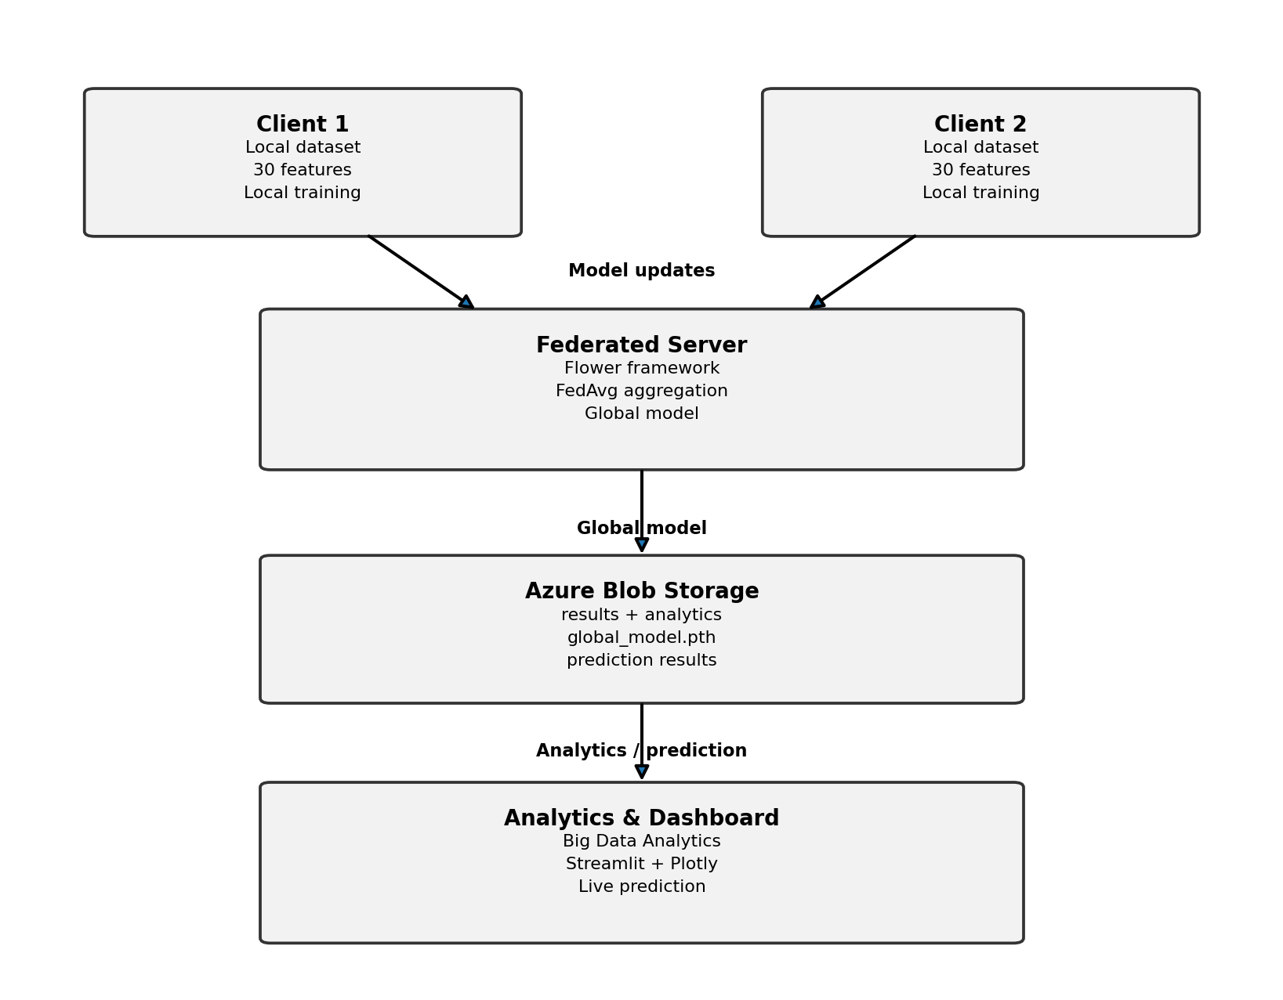
Figure 3.1. Proposed system architecture.
The architecture is organized into five functional layers. The Client Layer contains two local datasets and local training workflows. The Federated Layer uses Flower and FedAvg to aggregate model updates. The Cloud Layer uses Azure Blob Storage to persist the global model, results and analytics. The Analytics Layer computes round-wise accuracy, client statistics, class distributions and independent model evaluation. The Dashboard Layer uses Streamlit and Plotly to expose results and live prediction.

System Interfaces
- Client-to-server interface: Flower communication endpoint on port 8080.
- Server-to-model interface: PyTorch state_dict serialization of FederatedModel.
- Server-to-cloud interface: Azure Blob Storage SDK using environment-based connection configuration.
- Cloud-to-dashboard interface: JSON retrieval from Azure and local fallback files.
- User-to-model interface: 30 numerical feature inputs in Streamlit.

Engineering Calculation - Federated Accuracy Improvement
The reported improvement is the difference between the first and final recorded federated accuracies: Improvement = 93.4066% - 92.9670% = 0.4396 percentage points, reported as +0.44 percentage points.

Azure Prediction Accuracy Check
Independent accuracy is computed from 201 correct predictions out of 228 test samples: 201 / 228 x 100 = 88.1579%, reported as 88.16%.

3.6 Trade-off Analysis
Design Decision | Alternative Considered | Benefit | Disadvantage | Final Decision & Justification
Two clients | Many clients | Simple reproducible demonstration | Limited scale | Selected because capstone timing and resources support two-client validation
FedAvg | More advanced aggregators | Simple, established and easy to demonstrate | May be less robust to non-IID data | Selected to meet project scope and explainability
Azure Blob Storage | Database / local files only | Simple cloud persistence and retrieval | Credential/network dependency | Selected to satisfy cloud integration objective
Streamlit | Desktop GUI | Rapid web dashboard, Python-based | Not a full production deployment | Selected for demonstration and usability
Feed-forward NN | CNN/Transformer | Lightweight, 30-feature classification | Less expressive for complex modalities | Selected because current dataset is tabular

3.7 Sustainability, Ethics, Safety, Risk & Security
Domain | Consideration | Evidence Evaluated | Impact on Final Decision
Sustainability | Compute and storage footprint | CPU-based training, lightweight model, 19,537-byte model | Avoided unnecessary model complexity and large artifact storage
Ethics | Raw-data locality and honest reporting | Client-local datasets; independent evaluation reported separately | No claim of differential privacy/secure aggregation; limitations disclosed
Health & Safety | Software-only prototype | No physical hardware or direct clinical deployment | No hardware safety risk; clinical use excluded from scope
Security | Cloud credentials and artifact integrity | Connection string stored in .env; SHA-256 model comparison | Environment-based secrets and integrity verification included
Risk | Client/server/network failures | Azure VM + Windows testing logs | Recovery steps and validation commands documented

Risk Register
Risk | Likelihood | Severity | Risk Level | Mitigation | Residual Risk
Port 8080 conflict | Medium | Medium | Medium | Check ss -lntp and terminate stale server process before restart | Low
Client cannot reach server | Medium | High | High | Test Azure VM port 8080 and use correct FL_SERVER_HOST | Low
Empty global model file | Medium | High | High | Wait for successful FedAvg aggregation; validate file size before upload | Low
Wrong label/data shape | High | High | High | Validate X/y shapes and use reshape(-1,1) for BCE loss | Low
Azure upload of empty model | Medium | High | High | Check local model size and integrity before upload | Low
Credential exposure | Low | High | Medium | Store connection string in .env and do not commit it | Low
Accuracy interpretation confusion | Medium | Medium | Medium | Report federated and independent Azure evaluations separately | Low

Security Architecture
The implemented security posture is based on data locality, environment-based Azure credentials and model-file integrity verification. The project does not claim cryptographic secure aggregation. Raw client data is not uploaded by the federated workflow; only model parameters/updates participate in aggregation. Azure artifacts are stored under predictable blob prefixes, allowing controlled management and auditing.

Privacy Boundary
CLIENT DATA -> LOCAL PREPROCESSING -> LOCAL TRAINING -> MODEL PARAMETERS/UPDATES -> FEDERATED SERVER -> GLOBAL MODEL -> AZURE

CHAPTER 4

IMPLEMENTATION, TESTING & RESULTS, PROJECT MANAGEMENT

4.1 Development Approach & Resources
Development followed an incremental software-engineering approach. The project first established the PyTorch model and local dataset utility, followed by Flower client/server communication. After successful federated rounds, analytics generation and Azure integration were added. The final phase focused on artifact verification, independent prediction, dashboard visualization and documentation.
Resource | Purpose | Stage Used
Python | Main implementation language | All stages
PyTorch | Model definition, training, inference | Model and prediction
Flower 1.30.0 | Federated client/server communication | Federated training
scikit-learn | Dataset and scaling utility | Data preparation
Pandas / NumPy | Analytics and numerical operations | Analytics
Azure Blob SDK | Cloud storage and retrieval | Cloud integration
Streamlit / Plotly | Dashboard and charts | Presentation
Ubuntu Azure VM | Federated server environment | Cloud execution
Windows PowerShell | Local client, validation and dashboard | Local execution

4.2 Hardware / Software / Modern Tools Used
The federated server was validated on an Ubuntu 24.04.4 LTS Azure virtual machine. Local project validation was performed from Windows PowerShell. The Python virtual environment on the Azure VM used Python 3.12.3. Flower version 1.30.0 was verified during setup. The software-only prototype did not require dedicated fabrication or specialized physical hardware.

Project File Structure
server.py
client.py
model.py
data_utils.py
analytics.py
azure_storage.py
azure_model.py
azure_predict.py
azure_upload_prediction.py
dashboard.py
results.json
analytics_results.json
azure_prediction_results.json
global_model.pth
azure_global_model.pth

4.3 Test Plan & Verification
Requirement | Test Method | Acceptance Criterion | Achieved | Status
Federated server | Start server on 0.0.0.0:8080 | Server listens successfully | 3-round run completed | PASS
Client participation | Run client 1 and client 2 | Both clients complete local training | Both completed all rounds | PASS
Model generation | Inspect global_model.pth | Non-zero valid model file | 19,537 bytes; 4,097 parameters | PASS
Azure upload | Run azure_storage.py | Model blob exists with non-zero size | 19,537-byte model uploaded | PASS
Azure download | Run azure_model.py | Downloaded model loads | azure_global_model.pth downloaded and loaded | PASS
Independent prediction | Run azure_predict.py | Produce prediction accuracy | 201/228 correct | PASS
Integrity | Compare SHA-256 | Hashes identical | Identical hashes | PASS
Dashboard | Run streamlit dashboard | Metrics and controls visible | Dashboard loaded | PASS
Analytics | Run analytics.py | Totals match local client data | 2 clients, 455 train, 228 test, 30 features | PASS

4.4 Results

4.4.1 Federated Learning Results
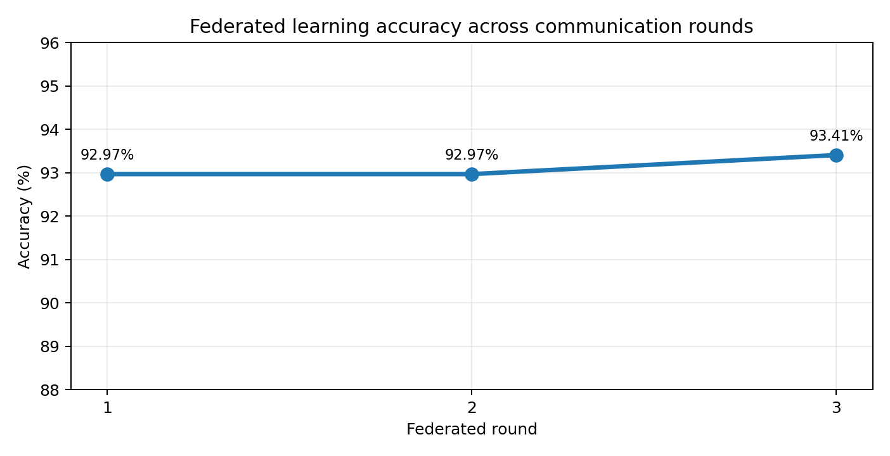
Figure 4.1. Federated learning accuracy across the three communication rounds.
Round | Federated Accuracy
1 | 92.97%
2 | 92.97%
3 | 93.41%
The final round achieved 93.41% accuracy, compared with 92.97% at the first recorded round. The measured improvement is 0.44 percentage points.

4.4.2 Big Data Analytics Results
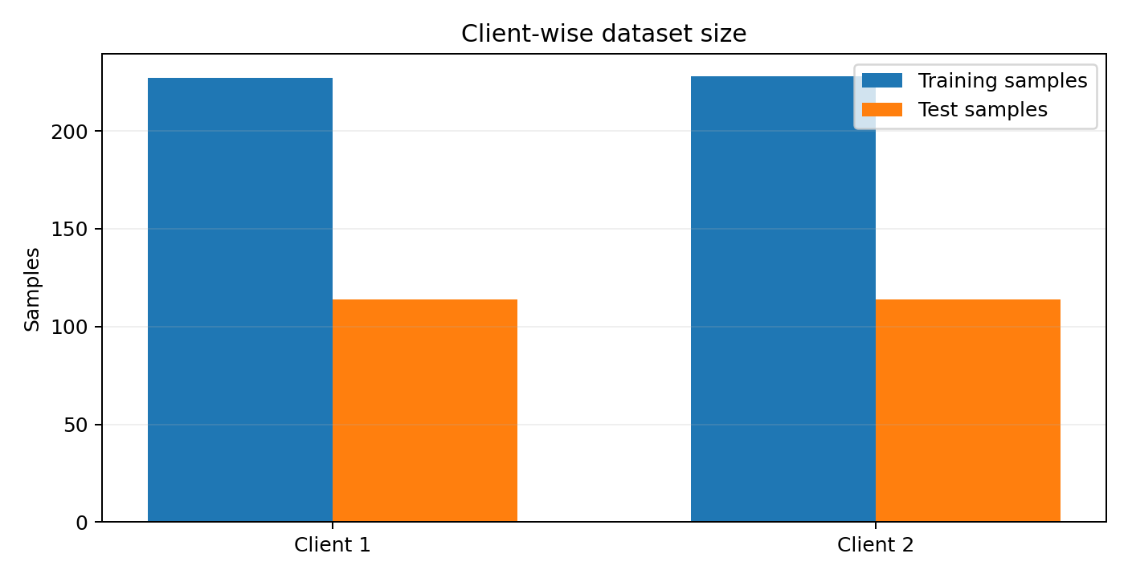
Figure 4.2. Client-wise dataset size.
Metric | Value
Total clients | 2
Training samples | 455
Test samples | 228
Features | 30
Class 0 | 169
Class 1 | 286
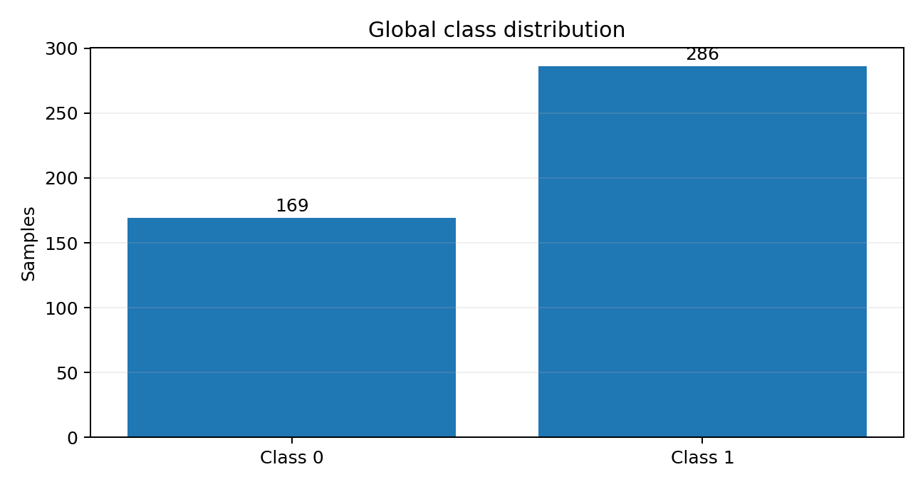
Figure 4.3. Global class distribution.
4.4.3 Azure Cloud Integration Results
Azure Blob Storage was successfully connected using the project environment configuration. The container used was federated-results. The final model, results, analytics and prediction output were stored under separate blob prefixes. A later verification listed the expected objects and confirmed the global model size as 19,537 bytes.
federated-results/
results/results.json
analytics/analytics_results.json
models/global_model.pth
predictions/azure_prediction_results.json

4.4.4 Independent Azure Global Model Evaluation
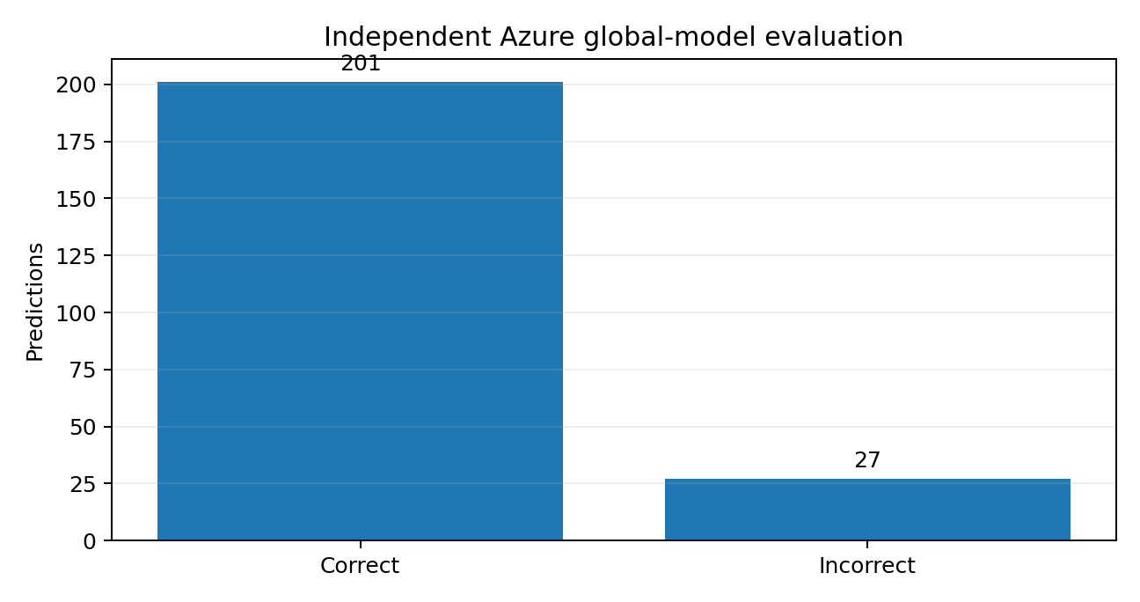
Figure 4.4. Independent evaluation of the global model downloaded from Azure.
Prediction Metric | Value
Test samples | 228
Correct predictions | 201
Incorrect predictions | 27
Accuracy | 88.16%
The model downloaded from Azure is evaluated on the combined 228-sample test dataset. The result of 201 correct predictions gives 88.16% independent accuracy. This value is intentionally reported separately from the 93.41% federated server evaluation metric because the two values come from different evaluation stages.

4.4.5 Model Integrity Verification
The locally stored global model and the Azure-downloaded model were compared using SHA-256. Both files were 19,537 bytes and produced the same hash, demonstrating byte-level identity of the files used in the local and cloud verification path.
SHA-256
7CDF372873E274ABA2705A489018E02219F7A46C0A5EE8B2989F2DBC8CC7FA4E

4.4.6 Streamlit Dashboard
The final Streamlit dashboard presents federated rounds, accuracy, dataset analytics, client-wise statistics, class distribution, Azure prediction results, global-model metadata, model-integrity status, live prediction, system architecture, privacy information and final system status. The dashboard reads results from Azure when available and uses local JSON files as fallback sources.
4.5 Data Analysis & Engineering Judgment
The federated accuracy trend shows a small but positive improvement across three rounds. The increase from 92.97% to 93.41% suggests that additional local training and parameter aggregation improved the measured server-side performance. However, the magnitude of improvement is modest, so the project should not claim that additional rounds would necessarily produce continued gains without further experimentation.
The independent Azure evaluation is lower at 88.16%. Because the model file downloaded from Azure is identical to the local global model, the difference cannot be attributed to cloud model corruption. Instead, it should be interpreted as a difference between the federated server evaluation metric and the independent post-training evaluation path. The dashboard therefore reports both values transparently.
The class distribution is imbalanced toward Class 1 (286 versus 169 for Class 0). This imbalance is important when interpreting accuracy alone. A future evaluation should include precision, recall, F1-score and a confusion matrix so that class-specific behavior is visible. The current prototype deliberately reports the verified measurements that were implemented and does not invent additional metrics.
The model is computationally lightweight: 4,097 parameters and a 19,537-byte serialized state_dict. This supports a practical demonstration on CPU and a compact cloud-storage footprint, but it also reflects the simplicity of the feed-forward architecture. The selected model is appropriate for tabular 30-feature classification but is not intended for image, audio or sequential data.

4.6 Comparison with Existing Solutions & Achievement of Objectives
Objective | Evidence | Achievement
Design multi-client FL system | 2 clients implemented and completed training | Fully Achieved
Local training without raw-data transfer | Client-side training; privacy statement and logs | Fully Achieved
FedAvg aggregation | Flower strategy completed 3 rounds | Fully Achieved
Big Data Analytics | 455 train, 228 test, 30 features, class distribution | Fully Achieved
Azure integration | Artifacts uploaded and verified | Fully Achieved
Global-model retrieval | 19,537-byte model downloaded | Fully Achieved
Independent evaluation | 201/228 correct = 88.16% | Fully Achieved
Model integrity | Identical SHA-256 hash | Fully Achieved
Streamlit dashboard | Dashboard with analytics and prediction | Fully Achieved

4.7 Strengths & Limitations

Strengths
- End-to-end federated workflow with two independently running clients.
- Cloud persistence of model and analytics artifacts.
- Independent download and evaluation of the stored global model.
- Explicit model-integrity verification using SHA-256.
- Interactive Streamlit dashboard with live prediction.
- Clear separation between local raw data and cloud-stored model/results artifacts.

Limitations
- Only two clients and three communication rounds are evaluated.
- Dataset size is limited to 455 training and 228 test samples.
- The model is a lightweight feed-forward neural network.
- Advanced privacy mechanisms such as differential privacy and secure aggregation are not implemented.
- Accuracy alone is insufficient for detailed class-wise evaluation; Azure and server accuracy come from different evaluation paths.
4.8 Project Planning, Roles & Budget

Project Milestone Plan
Milestone | Activities | Responsible | Evidence
1. Problem definition | Select FL + Big Data + Cloud problem | Both | Problem statement
2. Architecture | Design clients, server, Azure and dashboard | Both | Architecture diagram
3. Core model | Build PyTorch model and data utility | Mohanram | model.py, data_utils.py
4. Federated training | Implement Flower server/client and FedAvg | Mohanram | server/client logs
5. Analytics | Generate client/global statistics | Jothiprakash | analytics_results.json
6. Azure integration | Upload/download model and JSON artifacts | Mohanram | Azure logs
7. Dashboard | Streamlit visualization and prediction | Mohanram + Jothiprakash | dashboard.py
8. Validation | Integrity check, prediction, documentation | Both | Hashes + final outputs
9. Presentation | PPT/report/viva preparation | Both | Final submission

Estimated Project Cost
Item | Estimated Cost | Actual Cost / Basis
Existing personal computers | 0 incremental | Existing resources
Azure VM / cloud usage | Variable | Academic/project usage; actual billing depends on subscription
Azure Blob Storage | Variable | Small project artifacts; actual billing depends on account tier
Internet connectivity | Existing | Existing connection
Software libraries | 0 | Open-source Python ecosystem
The project is primarily software based. Exact Azure billing was not captured in the project logs, so no fabricated monetary amount is reported. The cost section is therefore presented as an engineering resource statement rather than an invented invoice total.

CHAPTER 5

CONCLUSION, FUTURE WORK AND REFLECTION

5.1 Conclusion
The project successfully implements a Federated Learning-Based Privacy-Preserving Big Data Analytics on Cloud system using Python, PyTorch, Flower, Microsoft Azure Blob Storage and Streamlit. Two clients perform local training, and the Flower server aggregates the participating model updates using FedAvg. Three federated communication rounds were completed, with recorded federated accuracy improving from 92.97% to 93.41%.
The global model contains 4,097 parameters and is stored as a 19,537-byte PyTorch state file. The model, federated results, analytics and prediction output are persisted in Azure Blob Storage. The model was successfully downloaded from Azure and independently evaluated on the combined 228-sample test dataset, achieving 201 correct predictions and 88.16% accuracy. SHA-256 comparison confirmed that the downloaded model is identical to the locally stored model.
The Streamlit dashboard integrates the project outputs into a single operational view. It displays the federated learning summary, accuracy graph, client-wise analytics, global class distribution, Azure model evaluation, model integrity, live prediction, architecture, privacy status and system status. Overall, the project achieves its intended role as an academic engineering prototype demonstrating distributed learning, cloud integration and privacy-aware data handling.

5.2 Future Work
- Increase the number of federated clients and evaluate scalability.
- Increase the number of communication rounds and compare convergence behavior.
- Use larger and more diverse real-world datasets.
- Add differential privacy to formalize privacy guarantees.
- Add cryptographic secure aggregation.
- Evaluate precision, recall, F1-score and confusion matrix.
- Investigate non-IID client data and fairness-aware aggregation.
- Deploy the federated server and dashboard as managed Azure services.
- Add authentication, authorization and monitoring.
- Implement model versioning and automated cloud pipelines.
- Evaluate stronger neural-network architectures where the data modality requires them.
- Add real-time analytics for client participation, training performance and communication metrics.

5.3 Professional Learning & Individual Reflection

Student 1 - MOHANRAM
The most difficult engineering problem encountered was integrating the federated server, two clients and the Azure cloud workflow while handling model-file persistence. The initial empty-model issue required checking server execution order, successful aggregation and file size before upload. A key engineering decision was to verify the Azure model with SHA-256 rather than assuming a successful download implied correctness. This project strengthened my understanding of distributed model training, Linux/Azure VM operation, Python environment management and cloud artifact validation.

Student 2 - JOTHIPRAKASH M
A key engineering contribution was supporting the dataset analytics and client-wise result presentation. The project required careful interpretation of client sample counts, feature dimensions and class distributions so that dashboard values matched the underlying JSON output. The work strengthened my understanding of distributed-data analytics, federated-learning concepts and technical documentation. If repeated, I would add richer evaluation metrics and automate result validation earlier in the workflow.

Overall Reflection
The project demonstrated that successful engineering is not only model training: deployment, validation, reproducibility, artifact integrity, user-facing visualization and honest interpretation of results are equally important. The team learned to distinguish an implementation warning from a functional failure, to validate outputs at each integration boundary and to document limitations rather than overstate system capabilities.

REFERENCES
[1] T. R. Gadekallu, Q.-V. Pham, T. Huynh-The, H. Feng, K. Fang, S. Pandya, M. Liyanage, W. Wang, and T. T. Nguyen, “Federated learning for big data: A survey on opportunities, applications, and future directions,” Engineering Applications of Artificial Intelligence, vol. 166, Part B, Art. no. 113614, 2026, doi: 10.1016/j.engappai.2025.113614.
[2] M. Baduwal, P. Paudel, and V. Chaudhary, “Federated Learning: A Survey of Core Challenges, Current Methods, and Opportunities,” Computers, vol. 15, no. 3, Art. no. 155, 2026, doi: 10.3390/computers15030155.
[3] M. Alsofyani, I. Alturaiki, and H. Mathkour, “A Fairness Perspective on Client Selection and Aggregation Methods for Non-IID Mitigation in Federated Learning: A Survey,” Electronics, vol. 15, no. 14, Art. no. 3178, 2026, doi: 10.3390/electronics15143178.
[4] A. Djemaa, D. Djenouri, and P. Legg, “Heterogeneity-Aware Poisoning Attacks and Mitigation in Federated Learning: A Comprehensive Survey and Taxonomy,” Electronics, vol. 15, no. 13, Art. no. 2876, 2026, doi: 10.3390/electronics15132876.
[5] L. Zhu, B. Zhao, and R. Peng, “Blockchain-Enabled Federated Learning: A Survey on System Design, Key Challenges, and Future Directions,” Electronics, vol. 15, no. 8, Art. no. 1572, 2026, doi: 10.3390/electronics15081572.
[6] Y. Li, Z. Guo, N. Yang, H. Chen, D. Yuan, and W. Ding, “Threats and Defenses in the Federated Learning Life Cycle: A Comprehensive Survey and Challenges,” IEEE Transactions on Neural Networks and Learning Systems, vol. 36, no. 9, pp. 15643-15663, 2025, doi: 10.1109/TNNLS.2025.3563537.
[7] S. Guo, L. Yang, and Z. Wang, “Intent-based agentic AI framework for privacy-preserving cross-cloud federated learning and green big data analytics in edge-cloud networks,” Computer Communications, vol. 257, Art. no. 108611, 2026, doi: 10.1016/j.comcom.2026.108611.
[8] B. McMahan et al., “Communication-Efficient Learning of Deep Networks from Decentralized Data,” Proceedings of AISTATS, 2017.
[9] P. Kairouz et al., “Advances and Open Problems in Federated Learning,” Foundations and Trends in Machine Learning, 2021.
[10] PyTorch Documentation, “PyTorch: An Open Source Machine Learning Framework.”
[11] Flower Documentation, “Flower Federated Learning Framework.”
[12] Microsoft Documentation, “Azure Blob Storage Documentation.”
[13] Streamlit Documentation, “Streamlit Documentation.”

APPENDICES

Appendix A - Detailed Calculations
A.1 Federated improvement: 93.40659286949661 - 92.96703504992055 = 0.43955781957606 percentage points, rounded to +0.44 percentage points.
A.2 Azure independent accuracy: 201 / 228 x 100 = 88.1578947368421%, rounded to 88.16%.
A.3 Client training total: 227 + 228 = 455 training samples.
A.4 Client test total: 114 + 114 = 228 test samples.
A.5 Class total: 169 + 286 = 455 labelled training samples represented in the analytics output.
A.6 Model parameter count: 30x64 + 64 + 64x32 + 32 + 32x1 + 1 = 4,097 trainable parameters.

Appendix B - Engineering Drawings / Schematics

Figure B.1. Detailed architecture schematic.

Appendix C - Source Code / Code Repository Information
The final project directory contains the server, client, model, data utility, analytics, Azure integration and dashboard modules. The following file groups should be maintained with the submitted source repository:
- Federated learning: server.py, client.py, model.py, data_utils.py
- Analytics: analytics.py, analytics_results.json
- Azure: azure_storage.py, azure_model.py, azure_predict.py, azure_upload_prediction.py
- Dashboard: dashboard.py
- Validation/output: results.json, azure_prediction_results.json, global_model.pth, azure_global_model.pth
Full source code is maintained separately in the approved project directory/repository; this report records only the essential implementation structure and evidence.

Appendix D - Experimental / Raw Data

D.1 Federated Results JSON
{
"rounds": [1, 2, 3],
"accuracy": [0.9296703504992055, 0.9296703254783546, 0.9340659286949661]
}

D.2 Analytics Results JSON
{
"total_clients": 2,
"total_training_samples": 455,
"total_test_samples": 228,
"total_features": 30,
"class_distribution": {"class_0": 169, "class_1": 286}
}

D.3 Azure Prediction Result
{
"test_samples": 228,
"correct_predictions": 201,
"incorrect_predictions": 27,
"accuracy": 0.881578947368421,
"accuracy_percent": 88.1578947368421
}

Appendix E - Azure Storage Evidence
Final verified Azure container structure:
federated-results/
results/results.json
analytics/analytics_results.json
models/global_model.pth
predictions/azure_prediction_results.json
The Azure upload workflow reported a successful connection to the federated-results container, uploaded the model at 19,537 bytes and verified the expected blob objects.

Appendix F - Model Integrity Evidence
Local global model and Azure-downloaded model were both 19,537 bytes and produced the following identical SHA-256 hash:
7CDF372873E274ABA2705A489018E02219F7A46C0A5EE8B2989F2DBC8CC7FA4E

Appendix G - Project Meeting / Progress Records
Stage | Progress Evidence | Outcome
Environment setup | Python virtual environments, Flower installation, Azure VM setup | Working
Federated communication | Server and two client logs | Three rounds completed
Model persistence | global_model.pth generated and validated | Working
Azure integration | Upload/download/verification logs | Working
Analytics | JSON output and dashboard metrics | Working
Dashboard | Streamlit execution | Working
Final validation | Hash + prediction + cloud verification | Passed

Appendix H - User / Industry Feedback
No formal external industry feedback was collected during this academic prototype. The project was evaluated through technical execution, dashboard demonstration, validation scripts and faculty-oriented presentation requirements.

Appendix I - Publications / Patents / Competitions / Product Outcomes
No publication, patent or commercial product outcome is claimed in this report. The primary outcome is a functional academic software prototype and its supporting documentation.

Appendix J - Individual Contribution Evidence
The individual contribution statement in the front matter records the two-member team allocation. Supporting evidence includes source-code modules, execution logs, dashboard work, analytics files and validation records maintained in the project directory.

Capstone Project Outcome Mapping Sheet
Outcome Evidence | SO / Area | Location in This Report
Complex engineering problem formulation | SO1 | Chapter 1, Chapter 2
Engineering design under constraints | SO2 | Chapter 3
Written/oral technical communication | SO3 | Whole report + Viva
Ethics and professional responsibility | SO4 | Chapter 3.7
Teamwork and leadership | SO5 | Chapter 4.8 + contribution statement
Experimentation, analysis, engineering judgment | SO6 | Chapter 4.3-4.6
Independent acquisition of knowledge | SO7 | Chapter 5.3
Standards and technical conventions | SO2 | Chapter 3.2 + References
Sustainability and societal impact | SO2/SO4 | Chapter 3.7
Risk assessment and mitigation | SO2/SO4 | Chapter 3.7
Security considerations | Relevant SO | Chapter 3.7
Integrated/system-level engineering | SO1/SO2 | Chapter 3.5
Project planning and management | SO5 | Chapter 4.8
Individual contribution | SO1-SO7 | Contribution Statement + Chapter 4.8

