COMMON COURSE ASSIGNMENT FORMAT

Cloud-Based Hostel Complaint Management System Using Zoho Creator

A. ASSIGNMENT INFORMATION
Particular | Details
Department | IT
Programme | B.tech
Course Code & Course Name | CLOUD COMPUTING AND BIG DATA ANALYTICS
Academic Year / Batch | 2026–2027
Faculty Name | Dr. Santhiya Lakshmi K
Assignment Title | Cloud-Based Hostel Complaint Management System Using Zoho Creator
Date of Issue
Date of Submission
Maximum Marks | 100
Course Outcome(s) – CO | CO2 – Understand the architecture and concept of different cloud models: IaaS, PaaS and SaaS
Bloom's Taxonomy Level | L4 – Analyze and Apply
SDG Mapping | SDG 9 – Industry, Innovation and Infrastructure
Industry / Societal Relevance | Digital hostel administration and cloud-based service automation

B. ASSIGNMENT PROBLEM / CHALLENGE
Hostel students regularly experience problems such as electrical failures, plumbing leakage, damaged furniture, room maintenance issues and cleanliness problems. In many hostels, complaints are communicated verbally or written in a register. This manual approach does not provide a centralized digital record and makes it difficult for students and administrators to track whether a complaint has been received, reviewed or resolved.
The problem is therefore to create a simple but practical cloud-based complaint management system. The system must allow a student to submit a complaint online, store the complaint information in a centralized cloud environment and provide reports for viewing and organizing the submitted records.
The engineering challenge is not only to create a form but also to demonstrate how a cloud service can be used to provide application access, centralized data management and report-based analysis without the student having to install or maintain a separate physical server.

C. PROBLEM STATEMENT
Design and develop a simple Cloud-Based Hostel Complaint Management System using Zoho Creator to demonstrate Software as a Service (SaaS). The system shall allow students to submit hostel-related complaints through an online form. The complaint information shall be stored in the cloud and organized using available data fields such as complaint type, hostel and room information. Where Priority and Status fields are configured in the final application, the system can additionally organize and track complaints according to urgency and resolution progress.
The system shall provide a practical report view for submitted complaints and support simple analysis of complaint records. The final result should demonstrate an actual working cloud application rather than only a theoretical design.

D. REQUIREMENTS AND CONSTRAINTS

1. Functional Requirements
- The system shall provide an online form for submitting hostel complaints.
- The form shall capture Student Name and Student ID.
- The form shall capture Hostel Name and Room Number.
- The user shall be able to select a Complaint Type.
- The user shall be able to enter a detailed Complaint Description.
- The complaint submission date shall be recorded.
- Submitted complaint records shall be stored in the Zoho Creator cloud application.
- The system shall provide a report for viewing submitted complaint records.
- The system shall support filtering, grouping or charting of available complaint fields where configured.

2. Data Requirements
Field | Purpose / Use in System
Student Name | Identifies the student who submitted the complaint.
Student ID | Provides a student identification reference.
Hostel Name | Identifies the hostel or hostel block.
Room Number | Identifies the location where the problem occurred.
Complaint Type | Classifies the complaint into a relevant category.
Complaint Description | Stores a detailed explanation of the problem.
Complaint Date | Records when the complaint was submitted.
Priority | Optional management field indicating urgency, if configured.
Status | Optional management field indicating complaint progress, if configured.

3. Technical Requirements
Requirement | Selected Technology / Resource
Cloud Development Platform | Zoho Creator
Application Type | Web-based cloud application
Cloud Service Model | Software as a Service (SaaS) demonstration
Data Management | Zoho Creator application records
Input Interface | Zoho Creator form
Output / Viewing | Zoho Creator reports
Client Access | Web browser
Connectivity | Internet connection

4. Constraints
- The system requires internet connectivity for cloud access.
- Available functions may depend on the Zoho Creator account plan and permissions.
- The application is dependent on the availability of the cloud platform.
- Only authorized users should be allowed to access administrative complaint records.
- The current assignment implementation focuses on core functionality and does not include every feature of a full production hostel management system.

5. Security and Privacy Considerations
The application stores student-related complaint information. Therefore, only information required for complaint management should be collected. Access to reports should be controlled through appropriate application permissions. Administrative users should handle complaint information responsibly and avoid exposing student information to unauthorized users.

E. STUDENT WORK

1. Problem Understanding and Formulation

1.1 Nature of the Problem
A hostel requires a reliable way to receive and organize maintenance complaints. A complaint may involve an electrical item, water supply, plumbing, furniture, room maintenance or cleanliness. When complaints are handled only verbally, the administrator may not have a reliable record of the complaint, and students may not know whether action has been initiated.
The problem can therefore be formulated as the need for a centralized digital complaint record that can be accessed through the internet. The system must collect the required complaint information in a structured manner and make the stored records available for viewing and analysis.

1.2 Expected Outcomes
- A real online complaint submission form.
- A cloud-based application containing submitted complaint records.
- A working report showing stored complaint records.
- A clear demonstration of SaaS using a browser-based cloud platform.
- A structure that can be extended with priority, status, notifications and additional reports.

1.3 Information Available
The information used by the system is obtained directly from the complaint submission form. Each record represents one complaint. The record contains student information, hostel and room information and the description and category of the reported issue. This structured record can be used later for filtering and analysis.

1.4 Assumptions
- Students can access the application through an internet-connected device.
- The student enters valid information in the complaint form.
- Hostel staff or an authorized administrator can access complaint reports.
- The cloud platform remains available during normal use.
- The application is used for legitimate hostel complaint management.

2. Application of Course Knowledge

2.1 Cloud Computing Concept Applied
Cloud computing enables applications and computing resources to be accessed through the internet. Instead of building a local server, installing database software and maintaining physical infrastructure, the proposed prototype uses a cloud application platform. The complaint form and records are accessed through a browser-based environment.
The application demonstrates the following cloud characteristics in a practical way:
- Internet-based access to the application.
- Centralized management of application records.
- Reduced need for local infrastructure for the prototype.
- Ability to access the application from different authorized devices.
- Use of a service provided and managed through a cloud platform.

2.2 SaaS Model
Software as a Service (SaaS) is a cloud service model in which users access software through the internet. The user does not need to install and maintain the underlying application infrastructure. In this project, the complaint management application is created and accessed through Zoho Creator, allowing the project to demonstrate a browser-based cloud application service.
STUDENT / ADMINISTRATOR
|
v
WEB BROWSER
|
v
ZOHO CREATOR CLOUD SERVICE
|
v
HOSTEL COMPLAINT APPLICATION
|
v
CENTRALIZED COMPLAINT RECORDS

2.3 Relationship to IaaS, PaaS and SaaS
The course outcome covers IaaS, PaaS and SaaS. The direct focus of this assignment is SaaS because the user interacts with the complaint application as an online service. The underlying infrastructure is not managed directly by the student. The platform also provides application development capabilities; however, the report primarily presents the project as a practical SaaS demonstration because that is the assignment objective.

3. Solution / Design / Methodology

3.1 Proposed Architecture
+---------------------------+
| STUDENT |
| Opens complaint form |
+-------------+-------------+
|
| Internet
v
+---------------------------+
| ZOHO CREATOR |
| Form + Cloud Application |
+-------------+-------------+
|
v
+---------------------------+
| COMPLAINT DATA / RECORDS |
| Centralized cloud records |
+-------------+-------------+
|
v
+---------------------------+
| REPORTS |
| View / Organize / Analyze |
+---------------------------+

3.2 Detailed Workflow
- The student opens the Hostel Complaint Management System in a web browser.
- The student selects the Submit Complaint form.
- The student enters Student Name and Student ID.
- The student selects or enters Hostel Name and Room Number.
- The student selects the appropriate Complaint Type.
- The student writes a detailed Complaint Description.
- The complaint date is recorded.
- The student submits the form.
- Zoho Creator stores the submitted record in the cloud application.
- The stored record is viewed through the complaint report.
- Authorized users can review the available complaint information.
- Where additional fields and reports are configured, the records can be filtered and analyzed further.

3.3 Form Design
Field | Input Type | Validation / Purpose
Student Name | Single Line | Required student identification information.
Student ID | Single Line | Required identification reference.
Hostel Name | Dropdown / Selection | Identifies hostel or block.
Room Number | Single Line | Identifies complaint location.
Complaint Type | Dropdown | Provides complaint categorization.
Complaint Description | Multi Line | Captures detailed issue information.
Complaint Date | Date | Records date of submission.
Priority | Dropdown if added | Can represent Low, Medium, High or Critical.
Status | Dropdown if added | Can represent Submitted, In Progress, Resolved or Closed.

3.4 Complaint Type Classification
Complaint Type | Example
Electrical Issue | Fan, light, switch or electrical power problem.
Plumbing Problem | Water leakage, tap or drainage issue.
Room Maintenance | General maintenance requirement.
Cleanliness Issue | Cleaning or hygiene problem.
Furniture Issue | Damaged bed, chair, table or cupboard.
Internet / Wi-Fi Issue | Network connectivity issue.
Other | Complaint not included in the listed categories.

4. Use of Modern Tools

4.1 Zoho Creator
Zoho Creator was used as the main modern cloud development tool. The application was created through the web interface, and the complaint form was configured using the platform's form builder. Submitted records were then viewed through a report.

4.2 Tool Usage Activities
- Creating the cloud application.
- Creating the Submit Complaint form.
- Adding complaint-related fields.
- Saving the form configuration.
- Submitting test complaint records.
- Opening the generated report.
- Attempting report configuration and analysis.

4.3 Evidence of Tool Usage
The final assignment submission should include screenshots from the actual Zoho Creator application. The screenshots provide direct evidence that the system was implemented and tested. The screenshots should be inserted into the placeholders provided later in this report.

5. Implementation Procedure

5.1 Step 1 – Creating the Application
A new Zoho Creator application was created for the project. The application was named Hostel Complaint Management System. This application acts as the cloud container for the form and the stored complaint records.

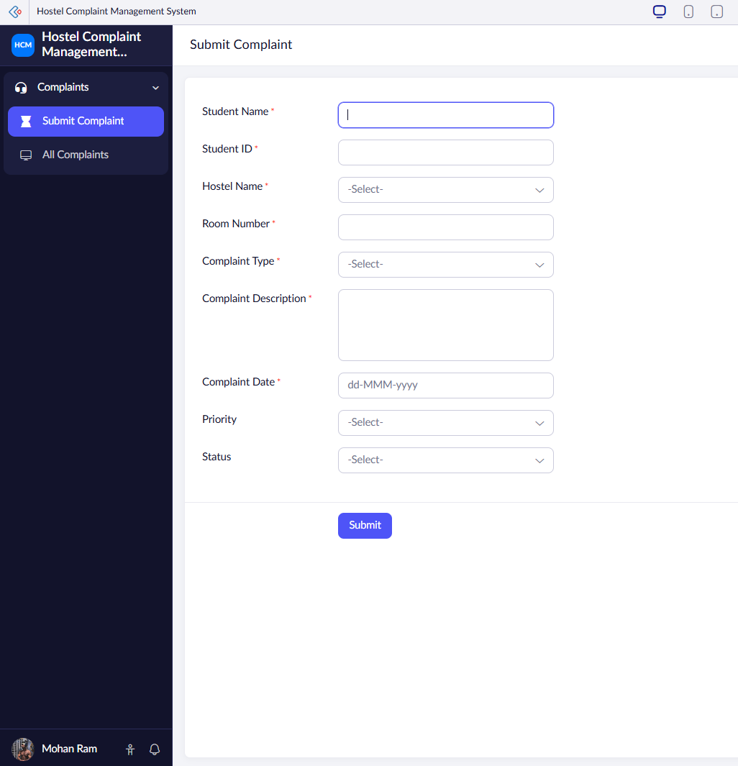
Figure 1. Actual Zoho Creator application screen

5.2 Step 2 – Creating the Submit Complaint Form
A form named Submit Complaint was created. The form provides the user interface through which students enter hostel complaint information. The fields were arranged to make the data entry process simple and understandable.

5.3 Step 3 – Configuring Complaint Fields
Fields for student information, hostel details and complaint details were added to the form. The use of different field types, such as single-line text, multi-line text, dropdowns and date fields, allows the information to be stored in a structured format.

5.4 Step 4 – Testing Record Submission
A test complaint was entered and submitted. This test verifies the basic end-to-end process: user input through the form, submission to the cloud application and storage of the complaint record.
Test Input | Example Value
Student Name | Sample Student
Student ID | STU001
Hostel Name | Selected Hostel Block
Room Number | A-204
Complaint Type | Electrical Issue
Complaint Description | Ceiling fan is not working properly.
Complaint Date | Current submission date

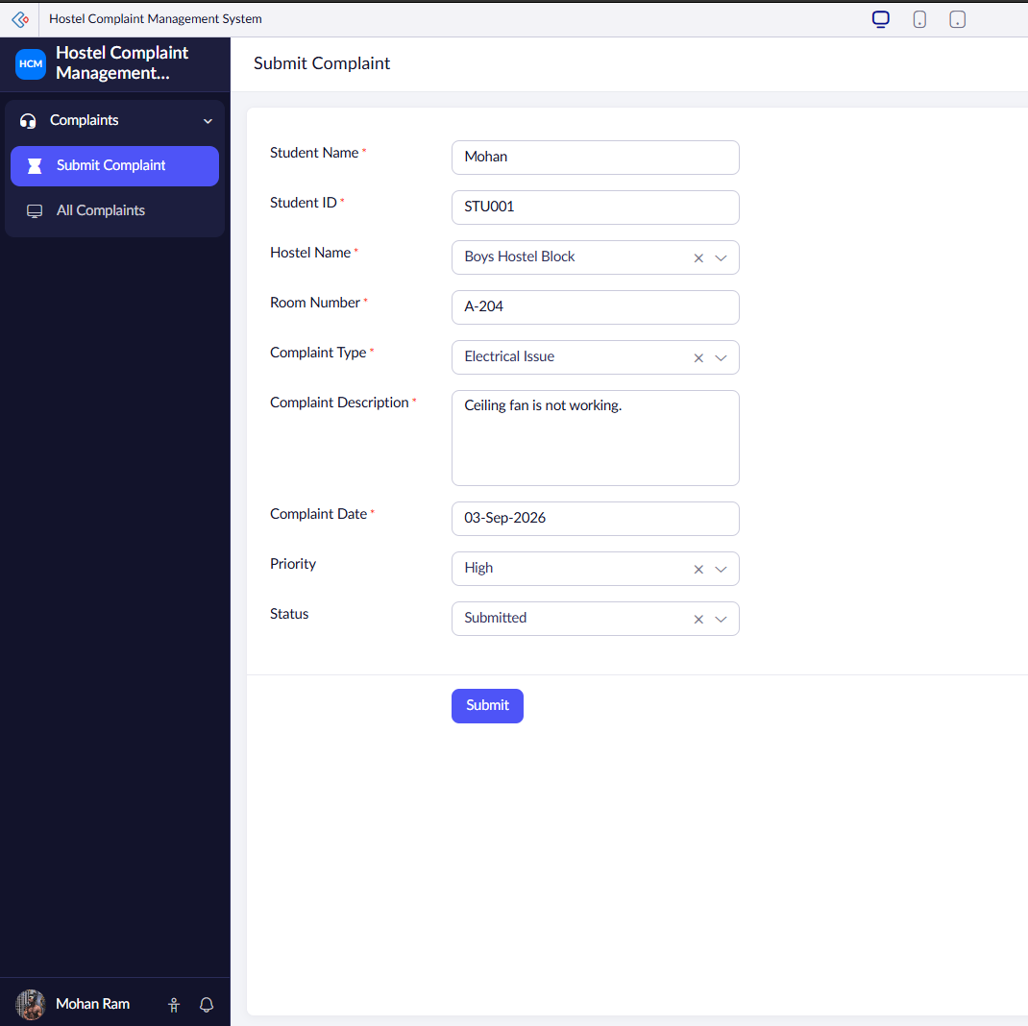
Figure 4. Submitted complaint record or confirmation

6. Results and Validation

6.1 Result of Form Submission
The complaint form provides a structured interface for entering the required information. When a complaint is submitted successfully, the record is stored in the Zoho Creator application. This demonstrates that the core data collection requirement has been implemented.

6.2 All Complaints Report
The complaint report provides a centralized view of the submitted records. This report is important because it confirms that the data entered through the form can be retrieved and viewed after submission.
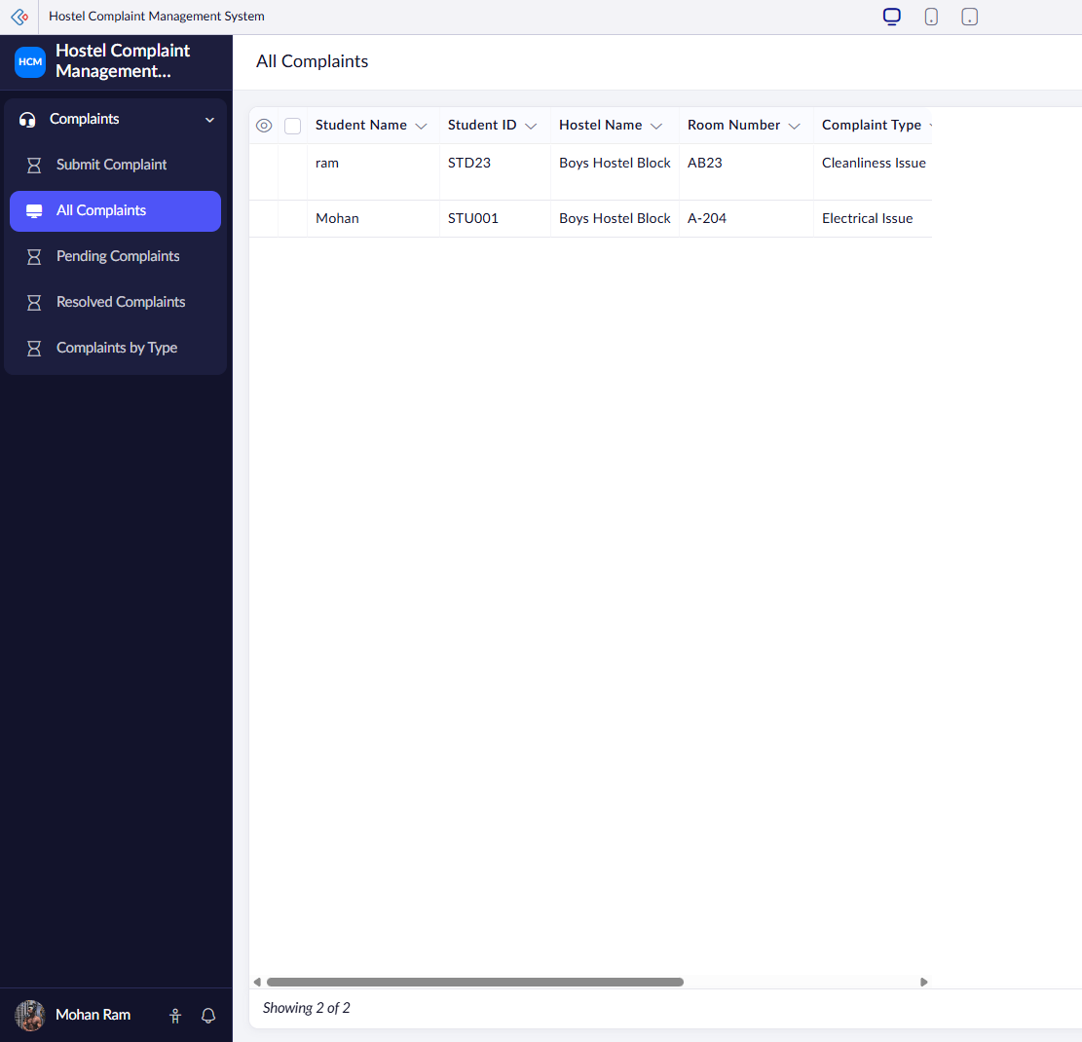
Figure 3. Actual All Complaints report showing submitted records

6.3 Report-Based Analysis
The available complaint fields can be used for report configuration and analysis. Complaint Type is a suitable category for identifying the distribution of complaint records. Additional categories such as Priority and Status should only be included in the final results if those fields are actually present and working in the submitted application.

6.4 Validation Test Cases
Test No. | Test Case | Expected Result | Observed Result
T1 | Open cloud application | Application should open in browser. | Successful during implementation
T2 | Open Submit Complaint form | Form should be available for data entry. | Successful
T3 | Enter complaint information | Fields should accept relevant values. | Successful
T4 | Submit complaint | Record should be stored in cloud application. | Successful
T5 | Open complaint report | Submitted record should be visible. | Successful
T6 | Configure category analysis | Records should be organized by selected available field. | Demonstrate using final configured report

The validation results show that the core application workflow—from online complaint entry to cloud record viewing—was successfully implemented. Optional management and analytics features should be validated separately after they are added to the actual application.

7. Analysis and Engineering Decision

7.1 Manual System versus Cloud-Based System
Manual / Traditional Approach | Cloud-Based Proposed System
Complaints may be verbal or written in a register. | Complaints are submitted through an online form.
Records can be difficult to search. | Records are centrally available in a report.
Analysis requires manual counting. | Available fields can support report-based grouping and analysis.
Paper records can be misplaced. | Records are stored within the cloud application.
Access is limited to the physical location. | Authorized access can be provided through the internet.

7.2 Benefits of the Proposed Solution
- Centralized complaint information.
- Online submission process.
- Reduced dependence on paper registers.
- Structured complaint data.
- Improved ability to review records.
- Foundation for future status and priority management.
- Practical application of cloud computing concepts.

7.3 Trade-Offs and Limitations
The use of a cloud platform provides speed and simplicity, but the application depends on internet connectivity and the features available under the selected Zoho Creator plan. The prototype also has a smaller feature set than a large-scale commercial complaint management system. These trade-offs are acceptable for the assignment because the objective is to build and demonstrate a simple working cloud application.

7.4 Justification for Final Technology Selection
Zoho Creator was selected because it allowed the application to be developed quickly and tested in a real cloud environment. Building the same prototype from scratch would require additional work for server configuration, database development, authentication and deployment. The selected tool therefore provides a suitable balance between practical implementation and the assignment learning objective.

8. Broader Considerations and Professional Responsibility

8.1 Societal Relevance
A hostel complaint management system can improve communication between students and hostel administration. A structured digital system can make it easier to document issues and review the information required for maintenance decisions.

8.2 Sustainability
Replacing paper-based complaint registers with digital records can reduce paper usage and manual storage requirements. A centralized cloud-based record also reduces duplication of complaint information.

8.3 Economic Considerations
For a prototype, a cloud development platform reduces the need to purchase and maintain dedicated hardware. For a larger deployment, subscription costs, user management and long-term data administration would need to be evaluated.

8.4 Accessibility
Because the application is web-based, it can be accessed through compatible internet-connected devices. The form design should remain simple so that users can understand the fields and submit complaints without specialized technical knowledge.

8.5 Privacy and Ethics
Student information should be handled responsibly. Only required information should be collected, and complaint records should not be shared with unauthorized persons. Administrative access should follow appropriate institutional practices.

9. Conclusion
The Cloud-Based Hostel Complaint Management System was designed and implemented as a practical cloud application using Zoho Creator. The system provides an online Submit Complaint form and stores complaint records in a centralized cloud environment. Submitted records can be viewed through reports, demonstrating a complete basic workflow from user input to cloud-based record management.
The project demonstrates the Software as a Service concept because the application is accessed through the internet using a web browser and a cloud service platform. The implementation provides a practical example of how cloud computing can be applied to solve a real hostel administration problem.
The core requirements of online complaint submission, cloud-based record storage and report-based viewing were achieved. The application can be expanded in the future with priority, status tracking, notifications, image evidence, technician assignment and advanced analytics.

10. Future Improvements
- Add a Priority field with Low, Medium, High and Critical values.
- Add a Status field with Submitted, In Progress, Resolved and Closed values.
- Create Pending Complaints and Resolved Complaints reports after Status is implemented.
- Allow image uploads as evidence for maintenance issues.
- Send email or application notifications when complaint status changes.
- Assign complaints to maintenance staff or technicians.
- Measure average complaint resolution time.
- Create monthly complaint trend reports and dashboards.
- Implement role-based access for students, administrators and maintenance staff.

11. Student Reflection
This assignment helped me understand how cloud computing can be applied to a practical real-world problem. I learned that a cloud application does not always require building and maintaining physical servers. By using Zoho Creator, I was able to create an online form, store records in a cloud environment and view the submitted data through reports.
The assignment also improved my understanding of the SaaS model. Instead of installing a traditional application locally, the system is accessed through a browser and operates through a cloud platform.
If I were given additional time and resources, I would improve the project by completing priority and status management, adding notifications and image uploads, assigning complaints to maintenance staff and creating a more detailed dashboard for administrators.

12. References
- Zoho Creator – Cloud application development platform and product documentation.
- Cloud Computing course material – cloud computing concepts and service models.
- Course Outcome material covering IaaS, PaaS and SaaS.
- SIMATS Engineering Common Course Assignment Format – assignment structure and evaluation criteria.

APPENDIX – SCREENSHOT AND SUBMISSION CHECKLIST
Before final submission, replace every screenshot placeholder with your own actual Zoho Creator screenshot. Do not insert screenshots of another project. The following evidence is recommended:
- Application creation screen or application home.
- Submit Complaint form.
- Configured complaint fields.
- A completed test complaint submission.
- All Complaints report showing stored records.
- Any chart or filtered report that is actually implemented.
Important: The final written report must match the final working application. Features such as Priority, Status, Pending Complaints and Resolved Complaints should only be presented as completed implementation if they are actually configured and visible in Zoho Creator.

